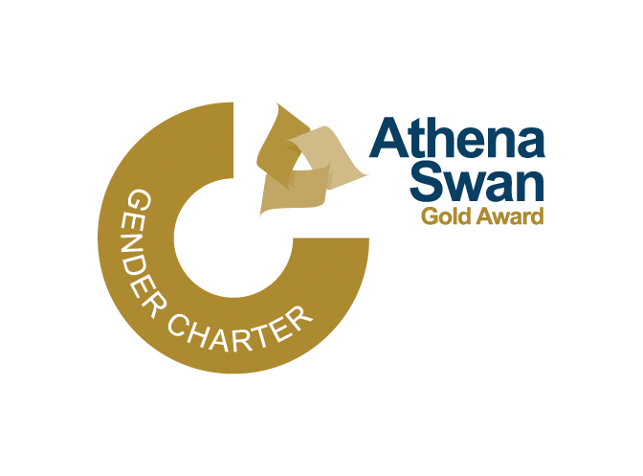

SHW professional and support staff mentorship scheme
Request to receive mentorship

Please provide the following information to assist in the matching of mentors and mentees
Your personal information
Name | Click or tap here to enter text.
Gender | Choose an item.
Job title | Click or tap here to enter text.
Job family | Choose an item.
Grade | Choose an item.
SHW unit | Choose an item.
Work email | Click or tap here to enter text.
Work tel number | Click or tap here to enter text.
Your mentorship preferences
Gender
If possible, I would prefer my mentor to be… | Choose an item.
Location
If possible, I would prefer my mentor to be located… | Choose an item.
Grade
If possible, I would prefer my mentor to be… | Choose an item.

Please indicate which kind of mentor, overall, you think you would find most helpful, based on the following descriptors | Choose an item.
We are asking for this information to help us with the matching process. The type of mentoring you receive may include elements of any of the styles listed here, and will not be limited by your choice on this form.
Advocate mentor
Someone with the skills of networking and the enthusiasm to help the mentee to meet the “right” people. They will have a lot of contacts and can refer the mentee to people who can impact on their life and work. In this role they will probably relish making things happen for their mentee, and in making opportunities for the mentee to demonstrate their skills and qualities.
Teacher mentor
Someone who has the knowledge of the mentee’s sector and the skills required to succeed. In this role, they will have ability to put ideas across to the mentee in a way that helps the mentee understand and learn from their knowledge and experience.
Supporter mentor
Someone who enjoys nurturing their mentee. They will delight in helping their mentee to explore their thoughts and feelings – about such topics as work-life balance, for example – and assist them in finding their own solutions.
Critical friend mentor
A role ideal for someone who works best in a challenging environment. They will love playing devil’s advocate and challenging the mentee’s thinking. This type of mentor uses great questions and may push their mentee to really examine their motives for growing their career.
Data sharing
The information provided on this form will be used to facilitate the matching process. It will be kept confidentially in a secure J drive location and accessible only to the SHW admin team.
PLEASE NOTE
Once we have matched you to a mentor, we will ask you to confirm that this is appropriate pairing before releasing your information. If, for any reason, you are unhappy with the match we have made, you may request an alternative mentor.
The privacy notice for mentees is available on page 3 of this document or from the SHW website. Please refer to it before signing this form.
Are you agreeable to a copy of this form being passed to your mentor, once you have approved the matching? | Choose an item.

Signature  (electronic or signed by hand) |  | Date | Click or tap to enter a date.

Please return your completed, signed form to shwadmin@glasgow.ac.uk
SHW professional and support staff mentorship scheme
Privacy notice (for mentees) To be retained by the data subject
Your personal data
The University of Glasgow will be what’s known as the ‘Data Controller’ of your personal data processed in relation to being paired with a mentor as part of School of Health & Wellbeing (SHW) mentorship scheme. This privacy notice will explain how The University of Glasgow will process your personal data.
Why we need it
We are collecting your basic personal data such as your name; gender; job title; job family and grade; SHW unit; work email and phone number; your mentorship preferences in order to assist the SHW admin team to fulfil the matching process. We will only collect data that we need in order to provide and oversee this service to you.
Legal basis for processing your data
We must have a legal basis for processing all personal data. In this instance, the legal basis is: ‘Consent’
What we do with it and who we share it with
All the personal data you submit is processed and accessible by the SHW admin team of the University of Glasgow in the United Kingdom. All information collected will be kept confidentially in a secure J drive location which is only accessible by the SHW admin team
You will be asked if you consent to your information (as detailed above) being provided to your proposed mentor only once you have advised that you are happy with any proposed pairing. If you do not consent to this information being shared you will not be excluded from being paired with a mentor.
How long we keep it for
Your data will be retained by the university for as long as we require it to oversee your mentorship, or when you request that we cease processing it. Data will then be securely deleted.
What are your rights?*
Under data protection laws individuals have certain rights: to request access to, copies of and rectification or erasure of personal data and to object to processing. In addition, you may have the right to restrict the processing of the personal data and to data portability.
*Please note that the ability to exercise these rights will vary and depend on the legal basis on which the processing is being carried out.
You can request access to the information we process about you at any time. If at any point you believe that the information we process relating to you is incorrect, you can request to see this information and may in some instances request to have it restricted, corrected or, erased. You may also have the right to object to the processing of data and the right to data portability. If you wish to exercise any of these rights, please contact dp@gla.ac.uk
Complaints
If you wish to raise a complaint on how we have handled your personal data, you can contact the University Data Protection Officer who will investigate the matter. Our Data Protection Officer can be contacted at dataprotectionofficer@glasgow.ac.uk. If you are not satisfied with our response or believe we are not processing your personal data in accordance with the law, you can complain to the Information Commissioner’s Office (ICO) https://ico.org.uk/
Contact details
If you have any questions relating to this consent form or the way we are planning to use your information please contact shwadmin@glasgow.ac.uk.

