GAs Case Study by Dr Matthew Barr

Succeeding at university: Graduate Attributes

‌University life offers up opportunities to try new things wherever you go: lectures, labs, the library, the sports field, the theatre and the unions: it’s almost impossible not to get involved.
But thousands of students graduate from Glasgow University each year, so what will make YOUR time here unique? What will you have to show for your time here other than some great memories?

If someone were to ask you what you did at university, you’d probably name the subjects you study. But you’re actually learning to do all sorts of other things as well. For example:

- Writing essays develops critical thinking and research skills
- Posters and presentations are great practice in public speaking and communicating your ideas
- Playing for a sports team improves your ability to communicate and work within a team
- Running a club or society requires leadership and motivation
- Working part time in the service sector develops confidence in working with others

With a little thought, you can see that almost everything you can do at university is designed to help you develop useful skills, qualities and abilities – elements of yourself that you might never have discovered had you not come to Glasgow University. We refer to these collectively as our graduate attributes, and they are listed in the table below (or, for easier viewing, at the following web link: http://www.gla.ac.uk/media/media_183776_en.pdf)

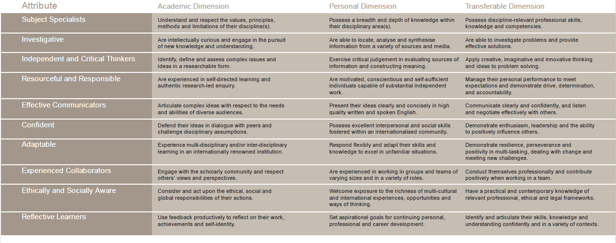

ACTIVITY 1: Where have you had the opportunity to develop Graduate Attributes (GAs)?
Pick two GAs you feel are important, write down, then discuss with the person next to you how you developed these in your first year at university.

Graduate Attribute | Example where you have demonstrated this skill/attribute
Subject Specialist
Investigator
Independent and Critical Thinkers
Resourceful and Responsible
Effective Communicators
Confident
Adaptable
Experienced Collaborators
Ethically and Socially Aware
Reflective Learners

Think about your Level 1 courses, any assessments and your experiences outside of university (jobs, hobbies, volunteering).

ACTIVITY 2: Write down two Graduate Attributes that you would like to work on this semester.

ACTIVITY 3: What are you planning to do in Level 1 to develop your chosen graduate attributes further? Think about the assessments/activities you are doing this year (e.g., presentations, projects), and your experiences outside of university (jobs, hobbies, volunteering). Note down two action points

ACTIVITY 4: SMART Goals
SMART Goals
When making a plan, whether it’s for the next piece of coursework, the coming exams, getting fit, or just starting something new, it’s important to make your goals achievable. One way of doing this is to use SMART Goals:

- Specific
- Measurable
- Attainable
- Relevant
- Time-bound

In small groups, look at the plans that you wrote down in activity 3.
Are these SMART goals? Can they be made SMARTer?

Specific
Is your goal well-defined? Avoid setting unclear or vague objectives; instead be as precise as possible.

Instead of: To do well in my exams

Make it specific: To increase study time to 30hrs per week and attend all scheduled revision sessions

Measurable
Be clear how will you recognise when you have achieved your goal. Using numbers, dates and times is one way to represent clear objectives.

Instead of: To get fit

Make it measurable: Swim 20 lengths, twice a week this term

Attainable
Setting yourself unfeasible goals will only end in disappointment. Make your goals challenging, but realistic.

Instead of: Give up smoking, drinking, sex and chocolate, all at once.

Make it attainable: Only drink alcohol at weekends

Relevant
Try and step back and get an overview of all the different areas of your life: Academic, Personal and Career. Consider how relevant each objective is to the overall picture.

Time-bound
Set a time scale for completion of each goal. Even if you have to review this as you progress, it will help to keep you motivated.

Instead of: Sort out CV and research job market.

Make it time-bound: Compile CV by end of Easter holidays, and set up interview with careers centre before end May.

ACTIVITY 5
In pairs:
From your answers in activity 3 above, identify one of the Graduate Attributes that you don’t have much experience with, but would like to gain more confidence in.
Write out a SMART goal of how you could develop this skill.

ACTIVITY 6: What support/resources would you need to do this? For example, careers service, student services, tutors, peers.

ACTIVITY 7: In addition to study related issues, your adviser of studies can support you in personal development planning (PDP) and goal setting. Note down a question that you would like to ask him/her when you next meet them.

Acknowledgements: Thank you to Dr Eric Yao for a previous version of this document. Thank you to Dr Maxine Swingler for sharing this version.

