

School of Chemistry

SAFETY MANUAL FOR THE USE OF OZONE

No researcher should use ozone unless they have read and understood these notes, and agree to abide by the general recommendations, protocols and prohibitions contained therein. Your research supervisor must be aware that you are using ozone. The protocols outlined in this manual constitute a COSHH assessment.

2013
Ozone
1. Hazards
Ozone is a highly irritating and toxic gas (TLV exposure limit of 0.1 ppm). Exposure to ozone causes irritation of and damage to the eyes and skin. On inhalation, ozone attacks the mucous membranes, the lungs and the central nervous system. It is a powerful oxidising agent and reacts with a wide range of organic molecules. At low temperatures, it condenses to form a blue liquid and it is easy to saturate organic solvents (e.g. dichloromethane) with ozone at temperatures < –50 °C.
The neat liquid and concentrated solutions in inert organic solvents pose a severe explosion risk if they are allowed to come into contact with reducing agents. The fact that ozone is such a powerful oxidant means that the reducing agents which pose a danger cover a wide spread of compound types. For example, concentrated solutions of ozone may explode on contact with aniline even though aniline is usually regarded as a very mild reducing agent. Consequently, it is crucially important to assess the chemical situation before adding reagents to blue ozone solutions, or before condensing ozone gas at low temperature into an organic mixture. Initial experiments should be conducted on a small scale.

2. Assessment
Two factors have to be taken into consideration:
- The hazards associated with the ozonolysis experiment itself.
- Hazards arising from the properties of the reaction products.
Ozonolysis operation
This must be conducted inside an efficient fume hood. Ozone emerging from the vent of the apparatus must be passed through an aqueous solution of NaI or KI and these scrubbers must be replaced at regular intervals. All spillages of ozone solutions should be treated with aqueous NaI and then flushed to drain.
Reaction products
The purpose of an ozonolysis reaction is usually cleavage of an unsaturated compound. Reductive work-up is required and this usually involves treating the primary ozonolysis products with either triphenylphosphine or dimethyl sulfide. Unfortunately, ozonolysis reactions can give rise to ozonides and a variety of hydroperoxides, dialkyl peroxides or other peroxidic compounds which are resistant to degradation and frequently survive to room temperature, even after a reductive work-up or chromatography. An alternative and more vigorous reductive work-up procedure involves the use of zinc and acetic acid (see: Kočovský, P.; Procházka, Ž. Collect. Czech. Chem. Commun. 1974, 39, 1905), but this may not be suitable in all cases. A qualitative test for peroxides is the liberation of free iodine from an aqueous acetone solution of NaI or KI, but dialkyl peroxides can be slow to react. Do not heat or distil products arising from an ozonolysis until you are absolutely sure that peroxides/ozonides have been fully destroyed in the chemical work-up.

3. Use of Ozonolysis Equipment
Read the operating instructions for the ozone generator and decide whether you are going to use an excess of ozone or an equivalent amount (based on the amount of substrate).
Use of specific amounts of ozone
If you wish to use a specific amount of ozone, this can be done in two ways:
- Pass the ozone from the generator through aqueous KI for a fixed time (t) and at a known rate (V). Back-titrate the I₂ against standard aqueous solution of sodium thiosulfate and calculate the amount of ozone generated under the fixed conditions t and V, from the titre. If V is kept constant for your ozonolysis experiment, then the amount of ozone required can be obtained by appropriately scaling the time (t) of its passage. Note: The instruction manual with the generator will give more information about its calibration.
- Prepare a saturated solution of ozone in a suitable solvent at a given temperature (T). If the solubility of ozone in the solvent at T °C is known, then the quantity required can be obtained by taking the appropriate volume of the ozone-saturated solvent. For CH₂Cl₂ at a temperature of –78 °C, saturation occurs at 0.04 M in ozone (see: M. Rubin, J. Chem. Educ., 1964, 41, 388). The solubility in other solvents at given temperatures can be determined by reaction of a known quantity of the ozone-saturated solvent with aqueous KI, and then titrating the I₂ liberated against standard thiosulfate.
Connecting your apparatus to the ozone generator (Figure)
When connecting your apparatus to the generator, the following precautions must be observed:
- Make sure the fume hood fan is on and working efficiently.
- Renew any lengths of perished or chemically-hardened plastic tubing on the apparatus.
- Connect up the O₂ line as indicated in the instruction manual and on the generator fascia using the threaded connectors. The outlet from the generator is connected first to a Drechsel bottle. The bottle is to guard against suck-back and so is inserted the ‘wrong way round’. The exit pipe from the bottle (PVC tubing) is attached to the bottle’s dip tube and then to a 3-way tap. The first exit from the 3-way tap is connected to two Drechsel bottles in series containing fairly concentrated NaI or KI ‘the right way round’ so that the gas from the generator forms bubbles in the solutions. The other exit from the 3-way tap is connected to the gas delivery tube of your apparatus. The purpose of the 3-way tap is to allow you to interrupt the flow of ozonised oxygen into the reaction vessel, but without venting ozone into the air.
- Connect the vent pipe from your apparatus to three Drechsel bottles attached in series, using PVC tubing. The first bottle again is empty and inserted ‘the wrong way round’. The other two should contain freshly prepared solutions of fairly concentrated NaI or KI. The NaI/KI solutions must be renewed when they become opaque brown. The venting of ozone directly to the atmosphere is strictly forbidden and it must be chemically scrubbed with aqueous iodide as indicated above.
During and after the ozonolysis reaction
- Follow the manufacturer's instructions with the generator for establishing the oxygen flow and for switching on.
- Turn off the current to the generator at the end of your experiment, but maintain the oxygen flow to purge the equipment and your reaction mixture of excess ozone. If your reaction mixture is at low temperature, the purging process may take a long time before the dissolved ozone is fully removed. Solutions containing ozone are blue only at low temperatures, and when fairly concentrated.
- Remove your apparatus and any debris from around the equipment. Empty the aqueous iodide solutions down the sink and flush well with water. Rinse out the Drechsel bottles.
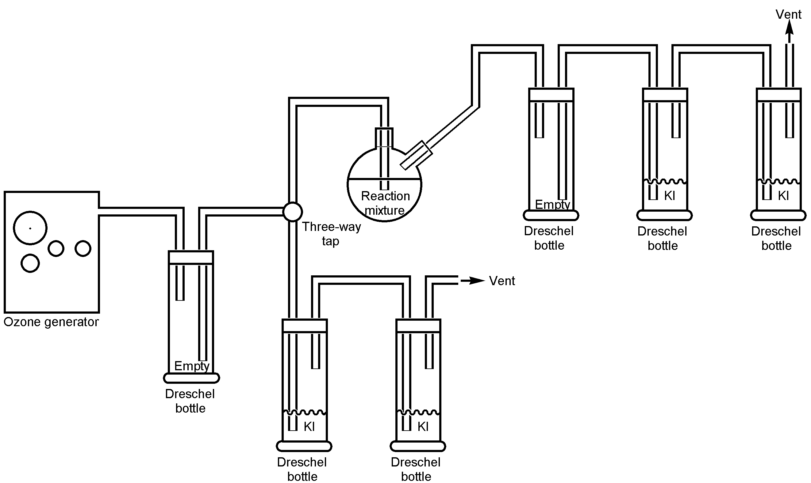
Figure

