Welcome to Manager Dashboard
Table of Contents
Login 3
Manager Dashboard 5
Navigate to Employee Dashboard or Back Office 6
My Team 8
View Team Details 9
Approvals 11
Requests 14
Raise Manager Request 16
My Team Diary 19
Raise Staff Request 23
Search Existing Posts 26
Create New Request – only use if no existing post found 29
Copy Staff Request 30
Navigation icons 30

Login
Navigate to the CorePortal login page using the link below:
https://hrportal.mis.gla.ac.uk/pls/coreportal_live/cp_por_public_main_page.display_login_page
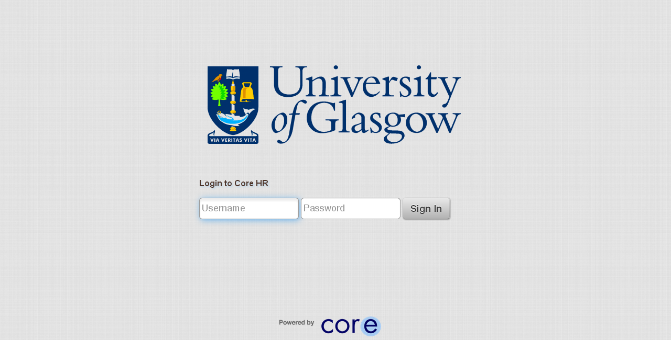

Enter your GUID in the username field > enter your password in the password field > press enter or select Sign In:
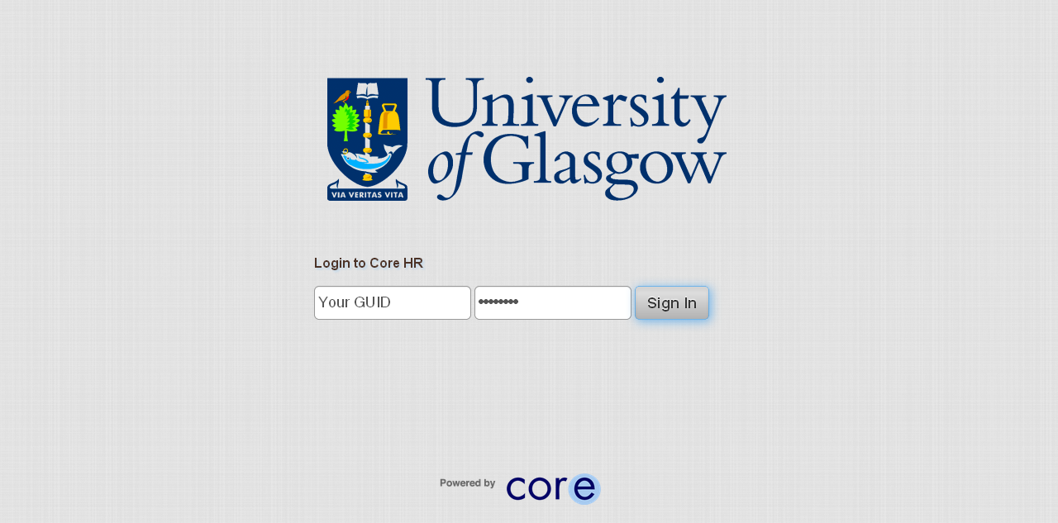

Manager Dashboard
You are now viewing your Manager Dashboard. You can select the Home button to return here at any point:
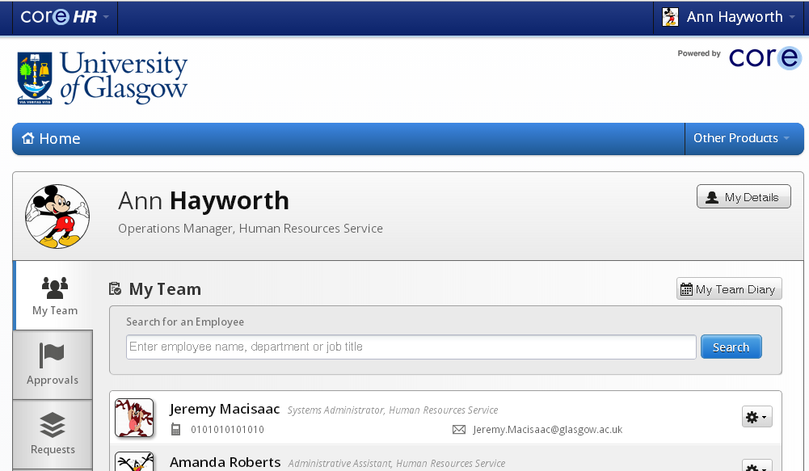

Navigate to Employee Dashboard or Back Office
To move from your Manager Dashboard to Employee Dashboard click on CoreHR Logo
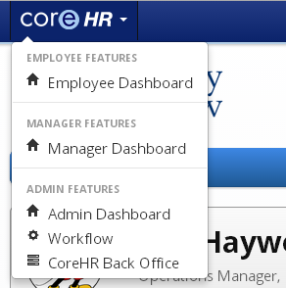
Then select Employee Dashboard
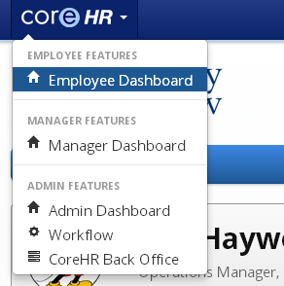

My Team
Your team will be displayed in the My Team Tab – this is the default view in the Manager Dashboard
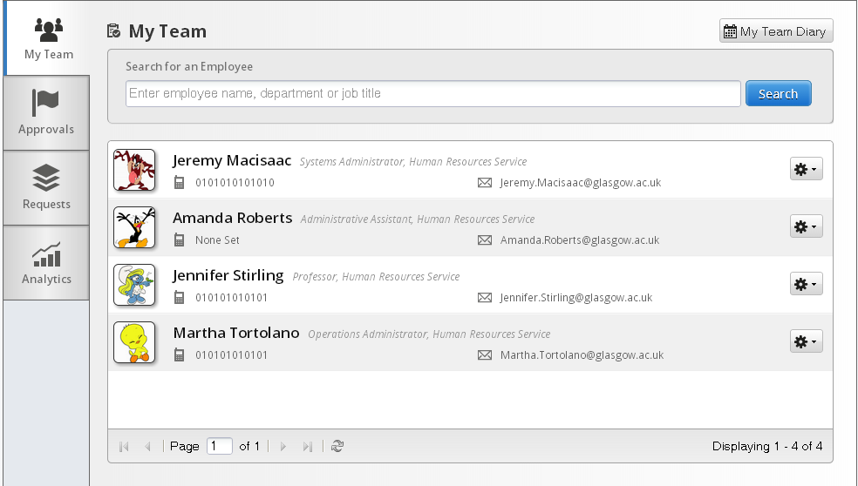

View Team Details
You can view more details by clicking on the tools icon
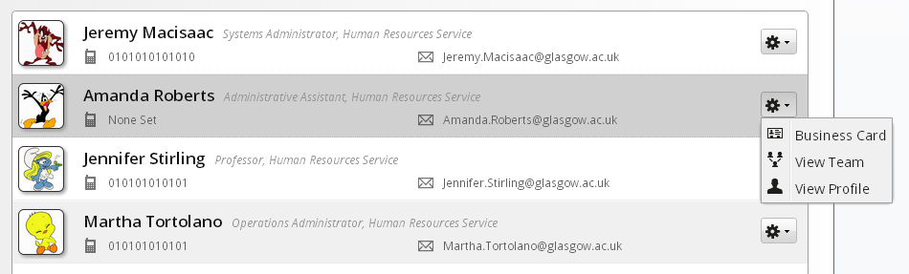
Click on View Team and you can view that person’s team
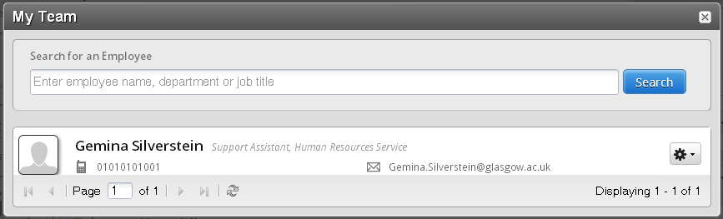

Click on View Profile and you can view the employee’s profile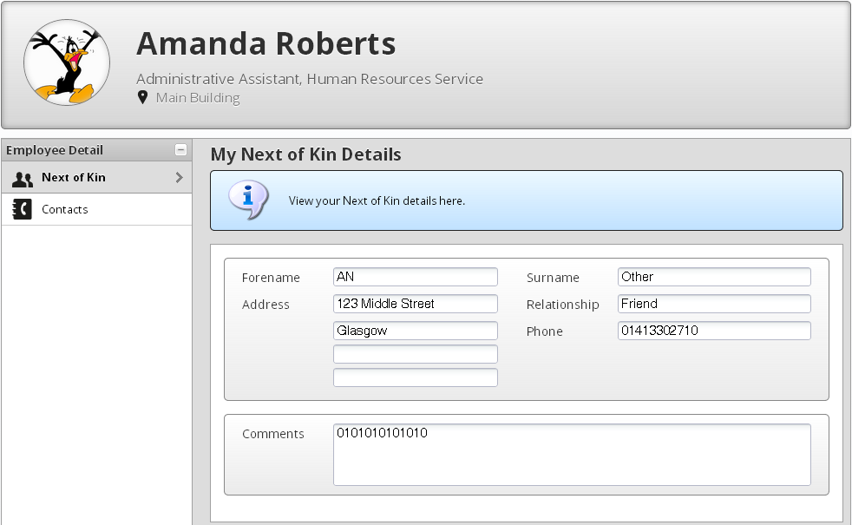
This page is similar to what you would see when viewing your own employee profile.

Approvals
Click on the Approvals tab to view all your approvals. Leave Requests and Expense Requests will be listed in the table as shown. The Other Approvals portlet will detail any approvals you need to make as part of your Organisational Role.
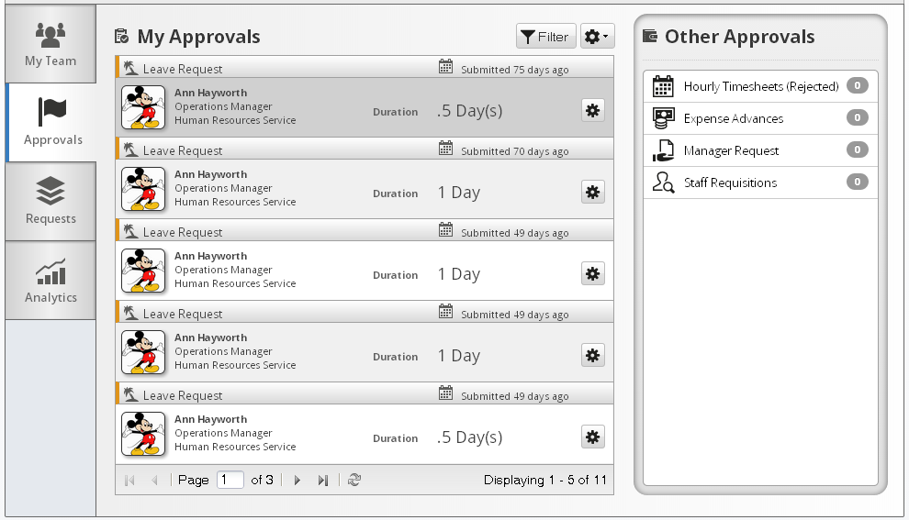
Click on the tools icon to open the request.
From this screen you will be able to Approve or Reject the request.
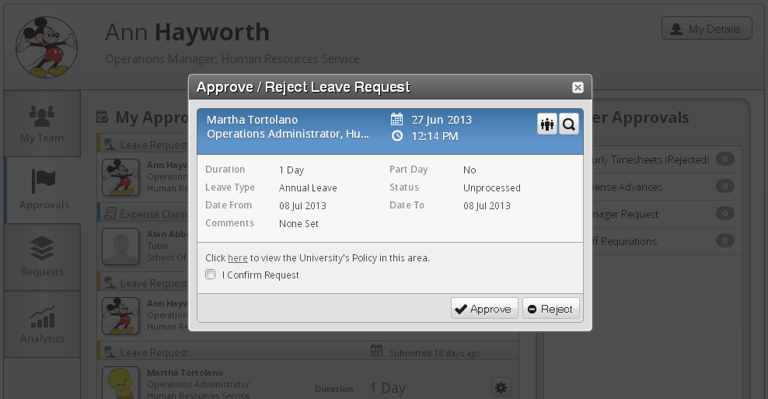
To either Approve or Reject (if rejected is selected then a further box will appear for comments), input the tick box for confirming the request then click on the relevant button

When you approve or reject the request, a message will appear on the screen to advise you. The item will then disappear from the My Approvals screen.
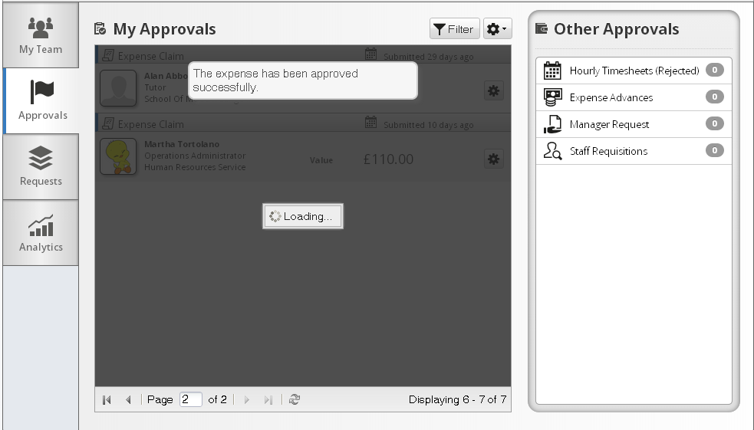

Requests
Click on the Requests tab to view the Manager Requests that you have submitted, and to raise new requests.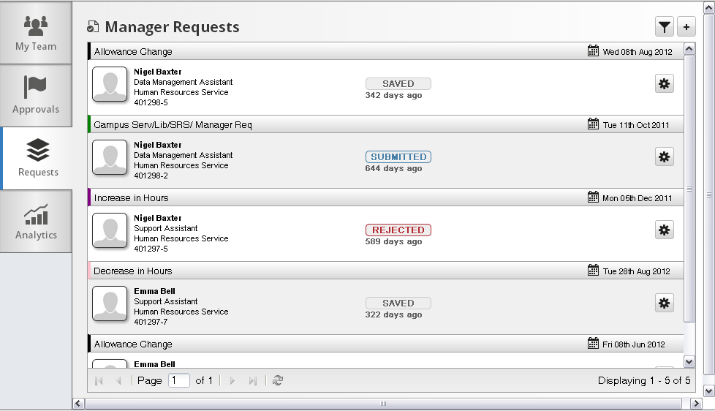
The table will show all the Manager Requests that you have saved or submitted, and show theirs progress. You can use the filter to narrow down the results.
You can click on the tools icon to view the request
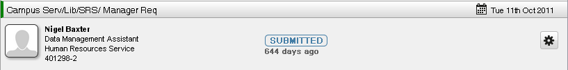
The Manager Request form will then open
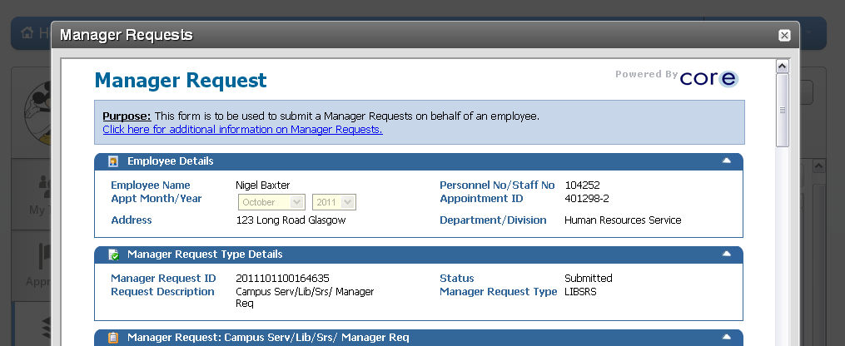
You will be able to view the status of the submitted requests and submit any saved requests.

Raise Manager Request
To raise a new request you need to click on the + icon
A Window will appear for you to select the request type from
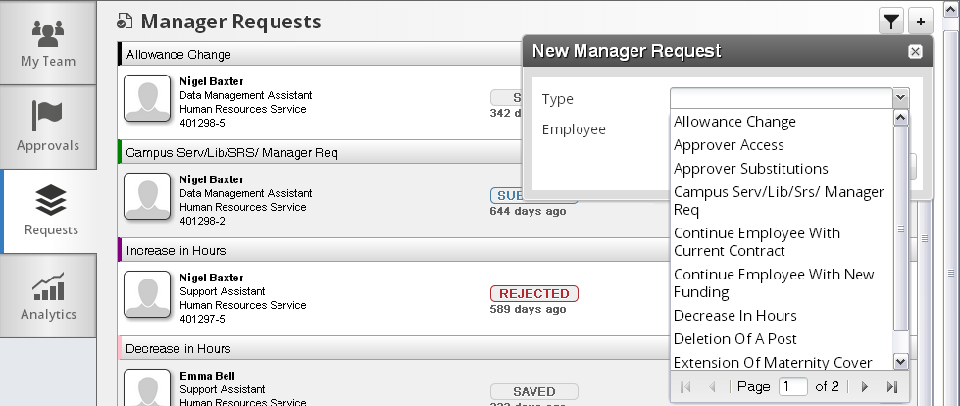

When you have selected the appropriate request type, you will then need to select the employee that this request relates to. The click Go
The form will then open and you will be able to complete the Manager Request as normal
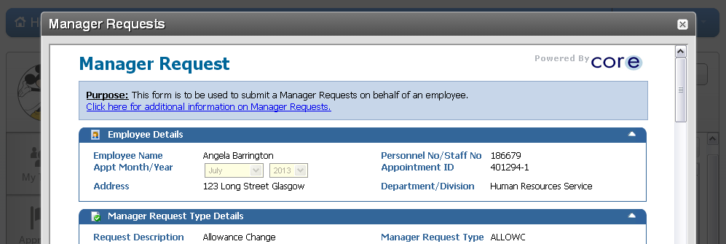
When the request has been submitted, you will then be able to track the progress from the Requests tab

My Team Diary
You can view your Team’s diary to see Holidays, Work Patterns, and Absence for your Team. Click on Home to return to the Manager Dashboard.
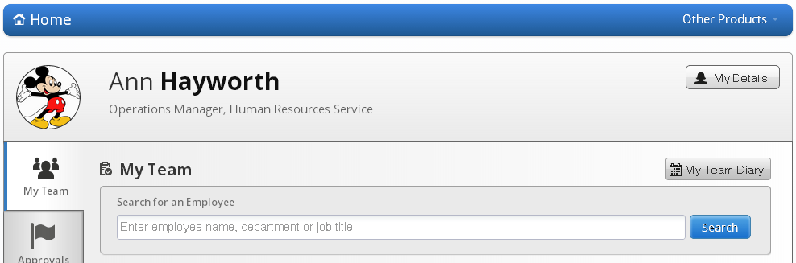
Then click on My Team Diary
The Team Diary will then display
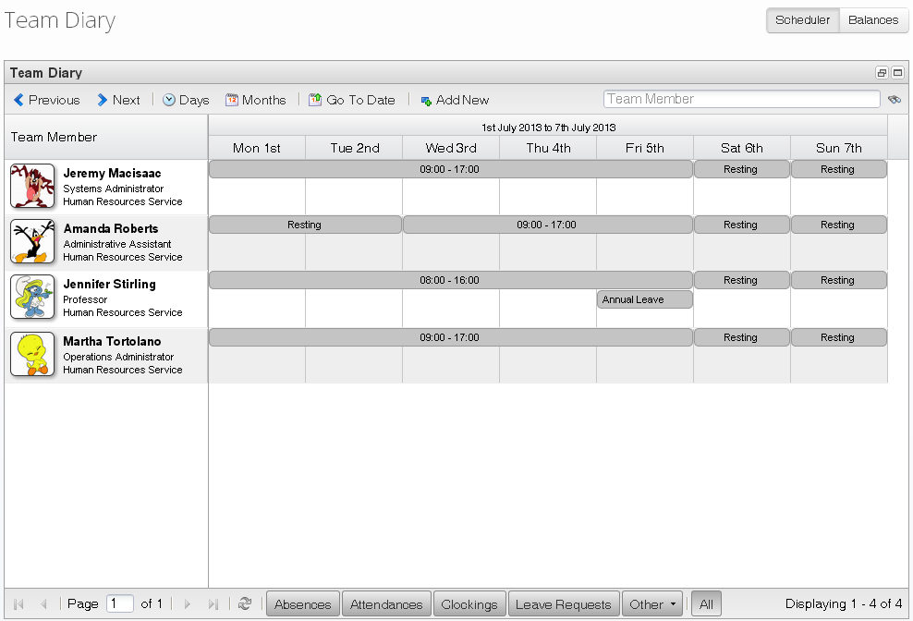

You can use the navigation bar to modify the results on display
You can use Days or Months to determine the view on display, or select Go To Date for a specific date. Previous & Next can be used to move through the weeks or Months and you can search for a specific Team Member by entering their name is the search field and clicking on the binoculars icon.
You can also use the options at the bottom of the screen to narrow down the absences on display
You can select as many options as you like, or select ALL for all absences
You can now click on Add New to add an absence through Portal.
The New Absence Record screen will open
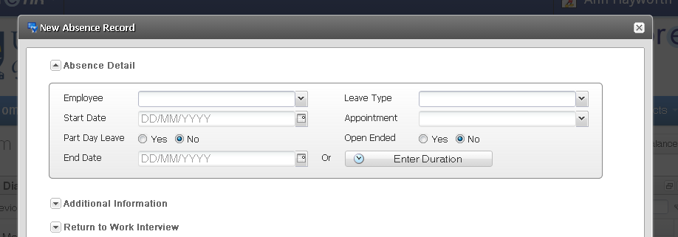

Raise Staff Request
To raise a Staff Request you should click Home to return to the Manager Dashboard
Click on Other Products then select e-Recruitment
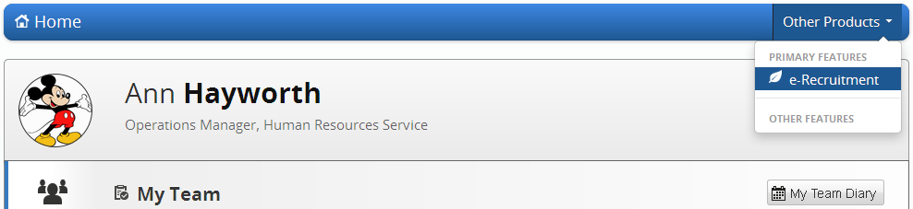
The e-Recruitment page will now open. Select My Staff Requests.
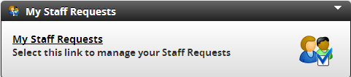
The Staff Requests page will now open. In most browsers it will try to open in a new Window. Make sure your pop up blocker is disabled.
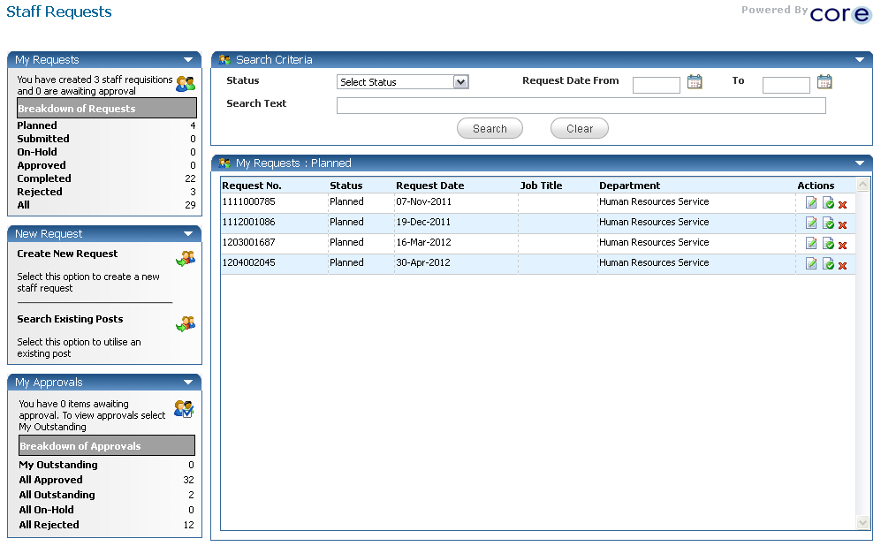
When raising a Staff Request, you can either Copy Existing Request ; Search Existing Posts ; Create New Request

Search Existing Posts
You should only use the Create New Request option if the post does not exist. In all other situations Search Existing Posts should be used
Click on Search Existing Posts to bring up the search screen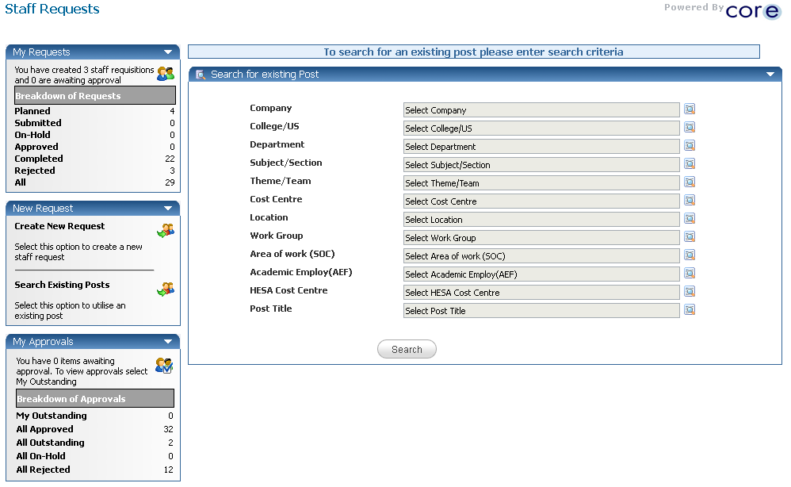
Click Search. The search results will then appear on the screen
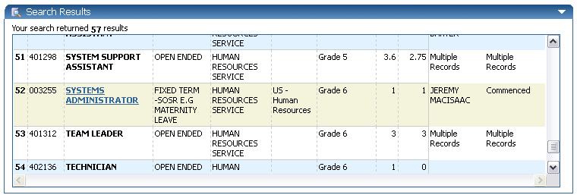
Find the appropriate Post and then click on the Job Title to bring up the post details.
If the Staff Request is to replace an existing employee then you should try to find the post that the person is currently in. You would then select the person from the drop down list that is being replaced.
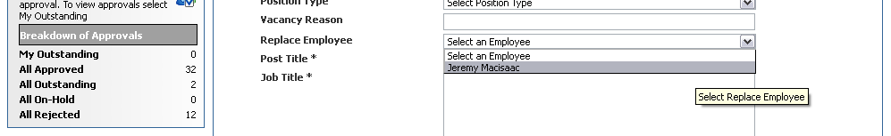
Complete the rest of the form with the required details. You must save the form before you can submit it.

When the request has been submitted you will be able to see it under My Requests as submitted
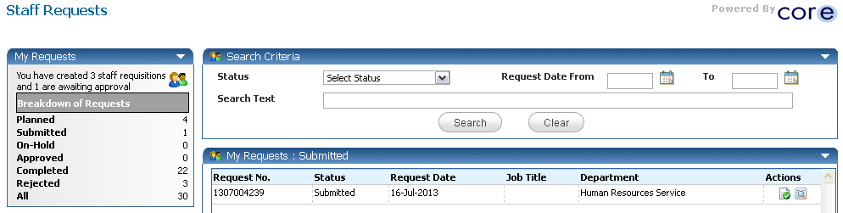
You will be able to track the progress of your requests in this screen.

Create New Request – only use if no existing post found
You should only use the Create New Request option if the post does not exist. In all other situations Search Existing Posts should be used
Click on Create New Request and the New Request page will open
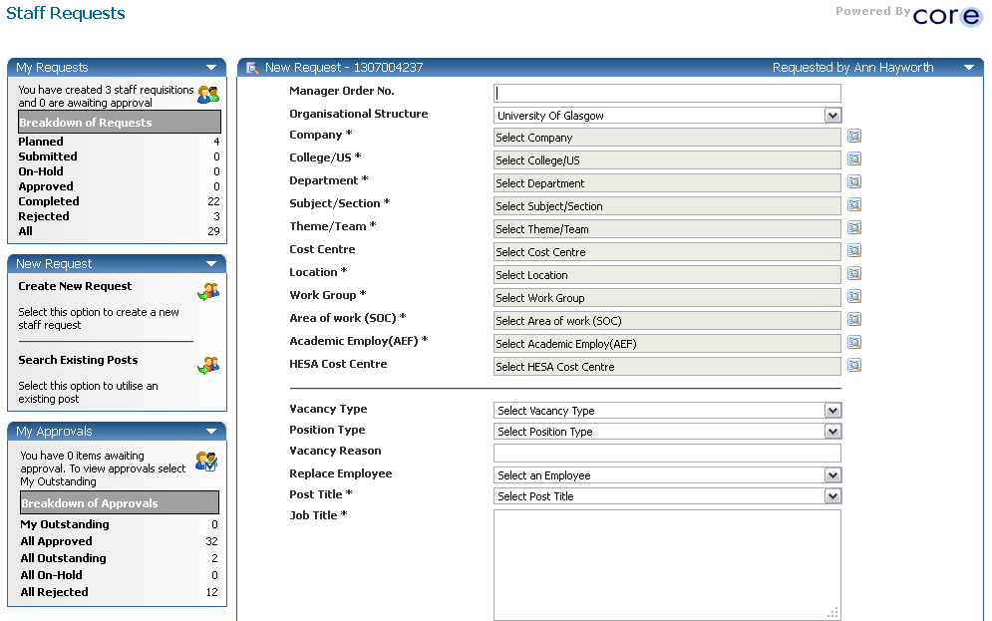
Fully complete all the details on the form. You will need to save the form, and then review it before submitting

Copy Staff Request
This can be used like a template if you have many appointments of the same type
Click on the
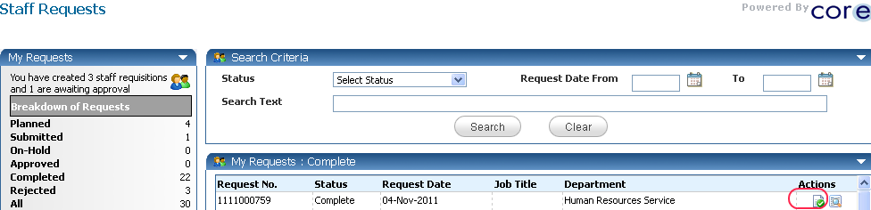
Prompt will appear
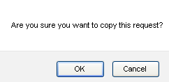
Click OK and amend any details as required, save and submit

Navigation icons

Some of the useful navigation features in CorePortal include the following:
The Tools icon is available on different parts of CorePortal and selecting this will often give you relevant options for the section you are editing or updating.
The Filter icon is also available on many screens and will allow you to filter the results of what you are looking at, such as leave request type.
The View iconopens up a window to allow you to view details and sometimes to edit those details further along with other options.
The Calendar icon and provides a calendar view for you to choose dates when selected:
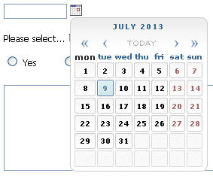 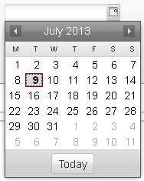
The Select Appointment icon allows you to select a different post/appointment if you have more than one job:
