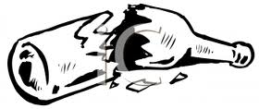
UNCONTAMINATED SODA GLASS WASTE

