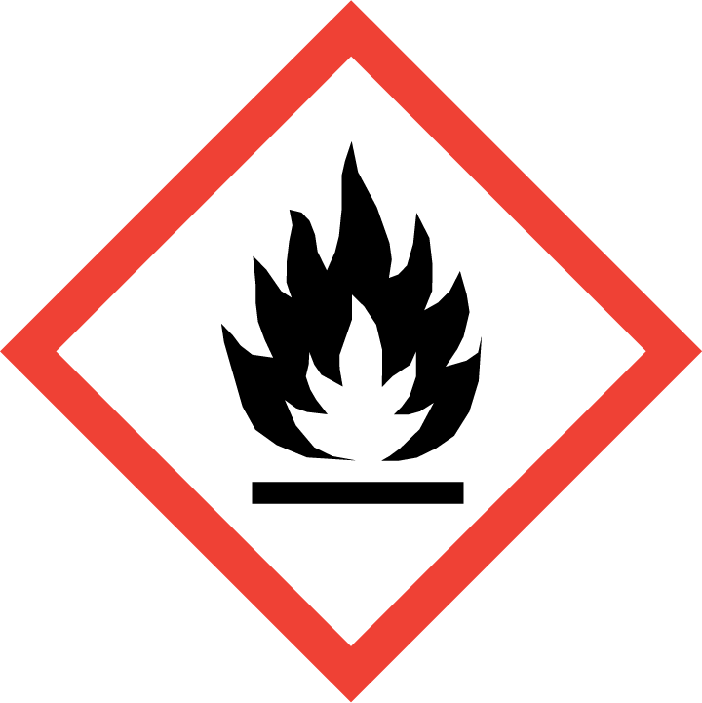
FLAMMABLE LIQUID WASTE

