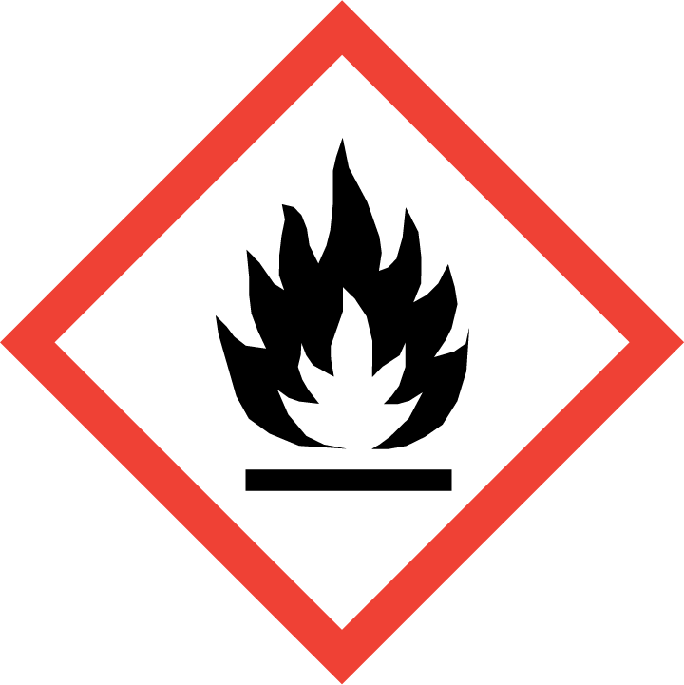
NON FLAMMABLE LIQUID WASTE

