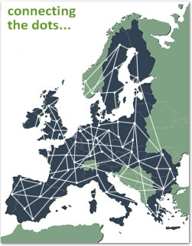
This is an important message. EUROlocal has moved into top gear.

LEARN ABOUT EUROlocal

EXPLORE the EUROlocal KNOWLEDGE BASE

CONTRIBUTE to EUROlocal at http://eurolocal.info/

EUROlocal is the European storehouse on the local and regional dimensions of lifelong learning – why don’t you access the link and find out what it is all about.



