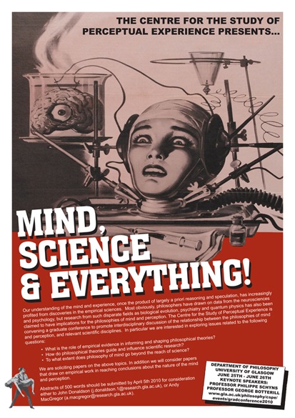
Mind, Science
& Everything!

Graduate Conference

Centre for the Study of Perceptual Experience

Department of Philosophy

University of Glasgow
Friday June 25th – Saturday June 26th, 2010

Please complete all relevant sections and return no later than the registration deadline of Sunday 20th of June, either by email to John Donaldson (j.Donaldson.1@research.gla.ac.uk) or Andy MacGregor (a.Macgregor.1@research.gla.ac.uk); or by post to Mind Science and Everything! Conference, Department of Philosophy, 67-69 Oakfield Avenue, University of Glasgow, Glasgow, United Kingdom, G12 8QQ.

Title:

First name:

Surname:

Institution:

Area(s) of specialisation:

Email Address:

Phone number:

Home Address:

Attending conference dinner on Saturday 26th of June (£15 extra charge):
Yes No

Any dietary or other requirements:

I confirm my attendance at the Mind Science and Everything! Graduate conference, and I enclose, or will forward to the above address before the registration deadline, a cheque or postal order, made payable to the University of Glasgow, for the sum of (select as appropriate): .

Signed (type name if submitting by email):

