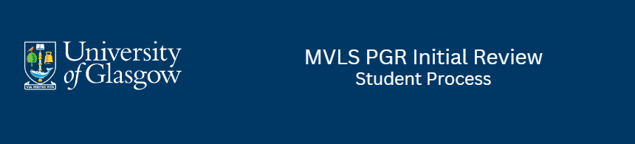
IMPORTANT
Initial reviews should be started within 3 months of starting your research programme. It is recommended that you arrange meetings with your supervisors and panel reviewers as soon as possible.
If you started after March, you may need to combine your initial review with your annual review. Discuss this with your school PG convenor.

CONTENTS
- START
- COMPLETE SELF-ASSESSMENT FORM
  - ATTACH SUPPORTING DOCS
  - CONFIRM AND SUBMIT
- PGR SUPERVISOR REPORTS
- REVIEW PANEL RECOMMENDATION AND YOUR STUDENT STATEMENT
- INITIAL REVIEW RECOMMENDATIONS
- COMPLETE AND SUBMIT YOUR STUDENT STATEMENT
- VIEW THE FINAL RECOMMENDATION

- START
- Your local School PGR admin will create the initial review form in MyCampus.
- You should receive a notification email similar to this with a link to access your Student Self-Assessment.
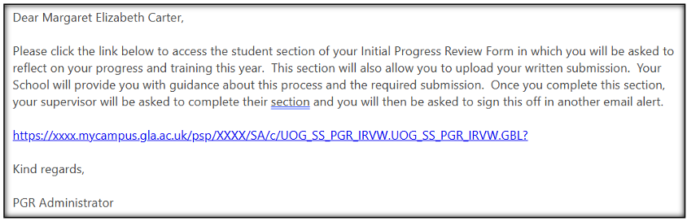
- CLICK THE LINK - You will be taken to the PGR Initial Review page where your form should be listed with the status ‘Pending Student Assessment’.
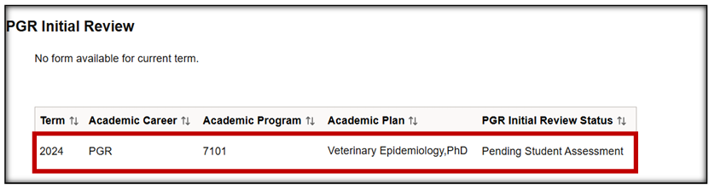
- Click on the row to access your form.
- The form will open on the Student Self-Assessment page. If it does not open, ensure you have disabled pop-up blockers for the site in your internet browser.
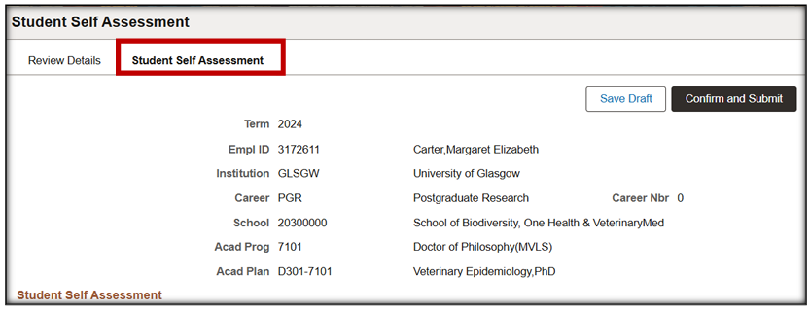

- COMPLETE SELF-ASSESSMENT FORM
- Add your responses to the self-assessment questions. Use Save Draft periodically to ensure your answers are retained if you lose connection or navigate away from the page.
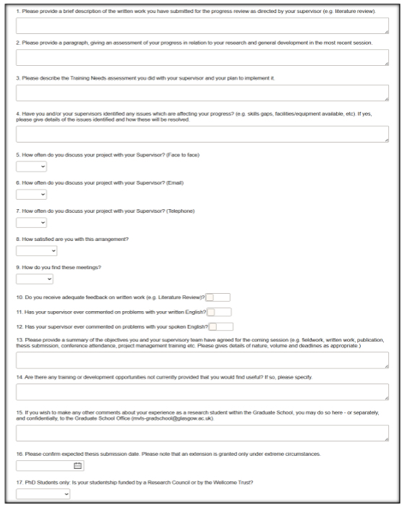
ATTACH SUPPORTING DOCS
- Before clicking confirm and submit, upload any supporting docs and CLICK SAVE DRAFT.
- After submission you can view the documents but no longer add or delete.
- There is a 5MB individual file size limit. To reduce file size, it is recommended you upload files in PDF format. If your file is larger than 5MB it must be split into multiple files to upload.
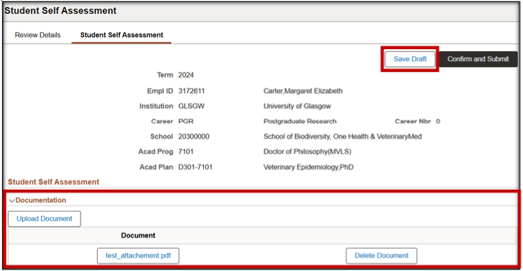

- Click ‘Upload Document’ to attach documents supporting your Student Assessment submission.
- Click ‘Save Draft’ to save the documents. DO NOT CLICK CONFIRM AND SUBMIT YET
- Once submitted the documents will be available to view by PGR staff with access to the form.

CONFIRM AND SUBMIT
- When satisfied the final form is checked and complete with any docs attached, now click ‘Confirm and Submit’.
- Click ‘OK’ on the saved message to close.

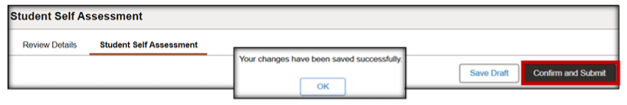

- The Student Self-Assessment will now be read only. If you need to amend anything after submission, please contact your School.
- Uploaded docs can still be viewed but not added or deleted.
- If you submit prematurely or are asked to make a change after submission, contact your School. The PGR Administrator can set the form back to ‘Pending Student Assessment’, reopening it for you to edit.

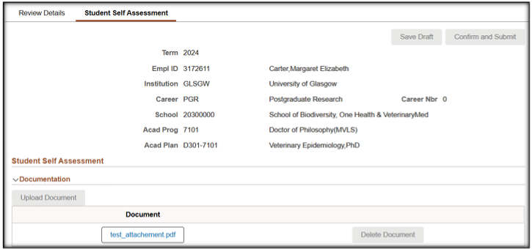
- The form status on the Review Details tab is now ‘Pending Supervisor Assessment’.
- An email notification has been sent to your Primary Supervisor, informing them the review is ready for their attention.
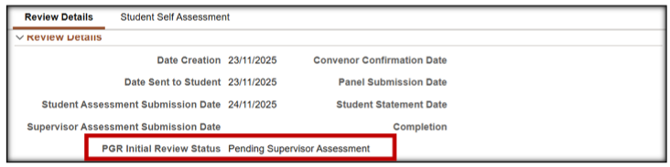

- PGR SUPERVISOR REPORTS
- Both primary and secondary supervisors will complete their reports. The initial review form will update to ‘Pending Review Panel Submission’.
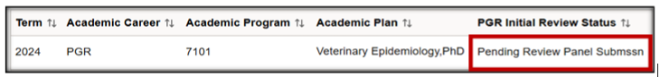
- You will not receive an automated email about this change.
- No action is required from you at this point. You will have access to see the supervisor reports and any attached docs they have attached.

- REVIEW PANEL RECOMMENDATION AND YOUR STUDENT STATEMENT
- After your meeting with the review panel, they will submit their recommendation, which you will be able to see.
- The form the status will change to ‘Pending Student Statement’.
- A notification email is sent to you, asking you to access the Initial Review form and complete your Student Statement.
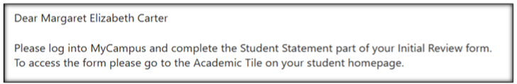
- Log in to the Student Homepage in MyCampus.
- Click the Academics tile.
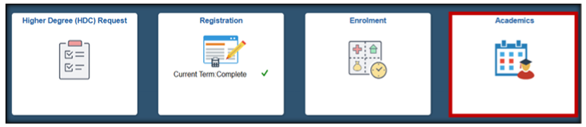

- Select ‘PGR Initial Review’ from the menu.
- The Review Status will be ‘Pending Student Statement’.
- Click on the row to open the form.
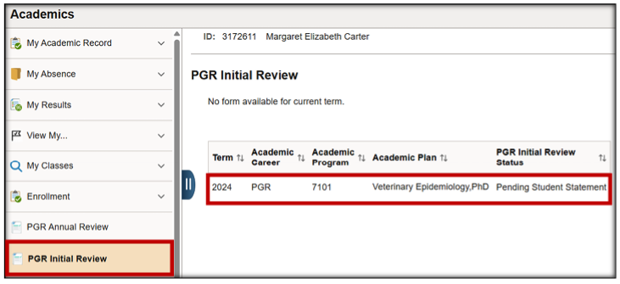
- REVIEW RECOMMENDATIONS
- The form will open on the Student Statement page.
- To view the recommendation, navigate to Review Details.
- Expand the Review Details subsection.
- Expand the Review Panel Recommendation subsection to view the content.
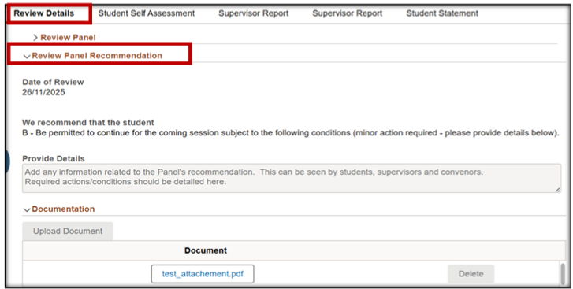

- COMPLETE AND SUBMIT YOUR STUDENT STATEMENT
- When you have reviewed the Supervisor Reports and Panel Recommendation, and have concluded any related discussions or actions, you are ready to complete the Student Statement.
- Access the Student Statement Tab and tick all boxes to indicate you have completed all the listed required actions.
- When complete, click ‘Confirm and Submit’.
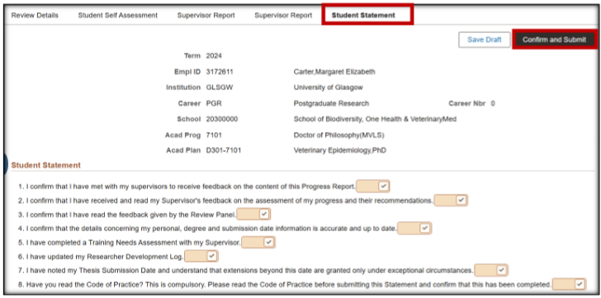
- The status will change to:
  - STUDENT PROCESS COMPLETE: Review Status is ‘Pending Convenor Confirmation’.
- Your school PG Convenor will now review your initial review form and submit a final recommendation.
- The form status will change to ‘Complete’.
- You will have read only access to the form through the Academics tile.
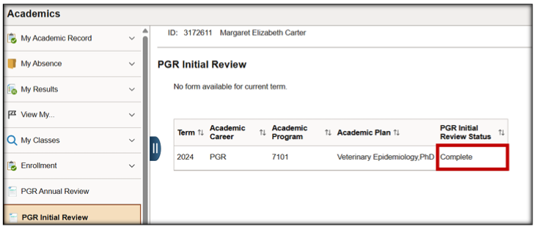

- VIEW THE FINAL RECOMMENDATION
- In the Review Details TAB expand the Review Details subsection.
- You should be able to expand all tabs individually.
- Expand the Final Recommendation subsection to view the detail.
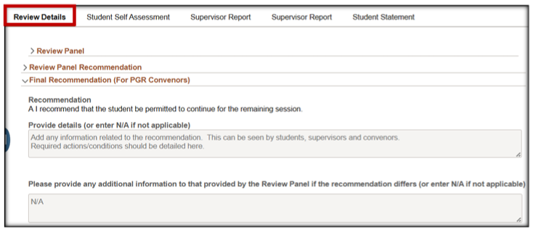

YOUR INITIAL REVIEW IS NOW COMPLETE

