History of the University of Glasgow Reading List – Project Overview
Anna Lightowlers and Adam Clarke

Project brief
In 2026, the University of Glasgow marks its 575th anniversary. This is an opportunity to reflect on the institution’s past and critically re-evaluate key published works that have shaped the University’s historical narrative to date.
Work began on this with the publication of the report ‘A Critical Reappraisal of the University of Glasgow’s History, 1870- 2024' by PhD researcher Taylar Carty. This report compiled key published works and assessed the extent to which these histories reflect the University community, identifying gaps, shortcomings, and absent voices. The bibliography was based on one created by Archives & Special Collections in 2014.
One recommendation from this report was a widening of the core bibliography to include more recent works and those which speak to the perspective of students and marginalised groups.
This project seeks to implement this recommendation by expanding on the bibliography and making it more accessible to students, staff and the wider University community.

Outcome
The reading list can be accessed at:
History of the University of Glasgow - Lists - Talis Aspire Reading Lists
The other part of the project involved investigating how to extract and present the key works for use by the University community during the 575 commemorations.

Options
- If books are available in the library perhaps a section dedicated to them could be set up either on the second floor as you enter, or on the third floor near the high demand section. E.g. – display table with information included about the 575 commemorations
- Flyers / Posters could be created with key information and a QR code which could lead to more detailed points about section 3 – these could be displayed throughout university buildings such as the JMS, the Fraser Building, the Library, etc.
- A reading list dedicated to only the key works could be created

Below are two sketches demonstrating the options:

First suggestion:
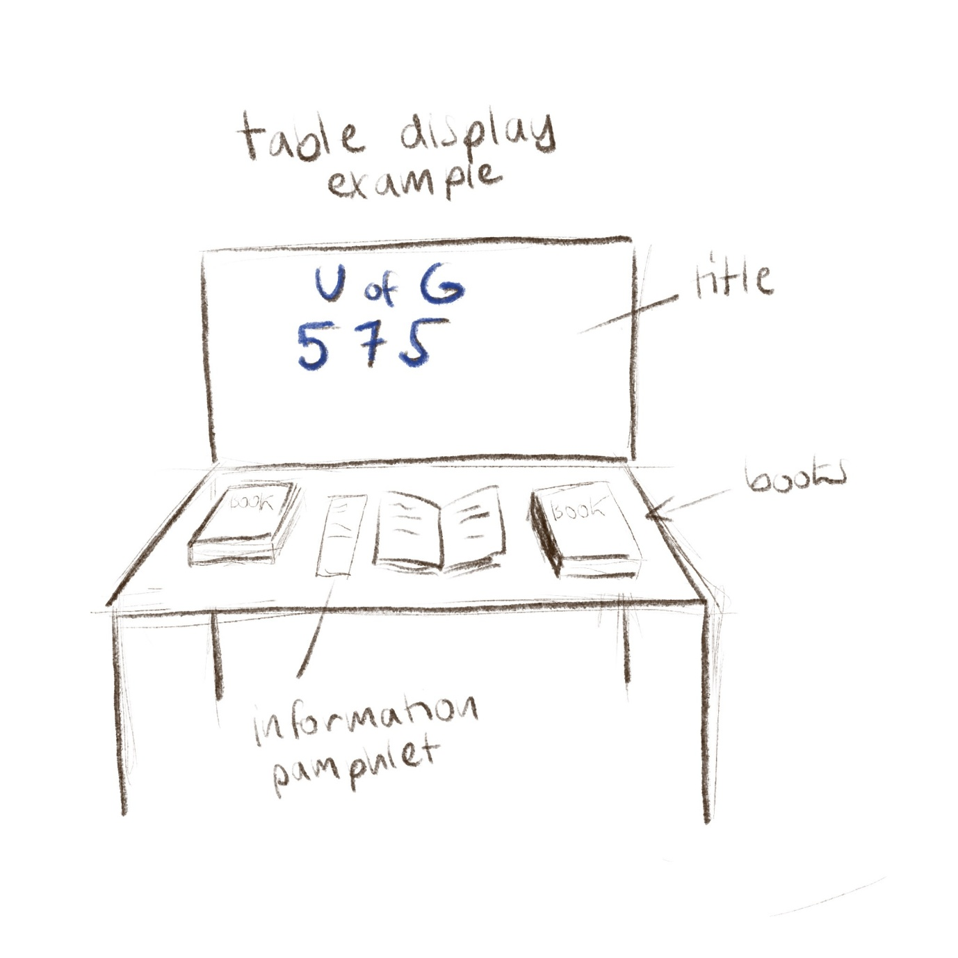

Second suggestion:
