The Fishbowl Method: Open Roundtable
Method description and panellist briefing note

The Glasgow Changing Futures programme aims to nurture and advance a creative, collaborative environment within and beyond the University to address the societal challenges that will shape the future. With a strong focus on inclusivity and equity we are engaging with a diverse range of diverse range of colleagues in academia, communities, the public and third sectors, and industry to work together to co-create innovative, meaningful solutions to complex local, national, and global challenges.
To support this aim, the Glasgow Changing Futures team have used the Fishbowl method to facilitate engagement and knowledge exchange across different disciplines and groups. This method combines the principles of a roundtable discussion with an interactive engagement approach. The core concept entails convening participants in a circle in the middle of the room, symbolising equality, inclusiveness and sharing, rather than positioning speakers as “experts”. The "open" aspect introduces an additional layer of structure – those in the audience can become speakers, and speakers merge back into the audience.
What sets this format apart is its dynamic interactivity and that, unlike in small group discussions, everyone can listen to everyone else. Another strength is its inclusiveness. It enables a larger number of individuals than is typical to actively contribute and addresses potential imbalances in representation between those already routinely engaged in this work and those who are newer to the topic.
The following panellist briefing note provides more detail on how to set up and facilitate an interactive Fishbowl open roundtable session.

Examples of the rich discussion supported by this method are described in this Healthy and Equitable Futures Fishbowl case study.

Please acknowledge Glasgow Changing Futures if you use this document. Do let us know, if you do: we welcome your feedback on how your helpful it was in running your own Fishbowl.
Our email address: gcf@glasgow.ac.uk

Panellist briefing note

Context for the session
[Provide an orientation and overview of relevant context]

Purpose of this open roundtable event
[Brief statement of the purpose of the engagement – what is the topic of the conversation and what kind of conversation would you like to have]

Format for the Open Roundtable
We are expecting around [Number] attendees at the event. To maximise the opportunity for as many people as possible to hear and be heard, we will adopt an open roundtable format, combined with an opportunity to feed in via [e.g. Slido, Menti, PostIts]. The discussion structure combines the principles of a roundtable discussion with an interactive engagement approach. The core concept entails convening participants in a circle in the middle of the room, symbolising equality, inclusiveness and sharing, rather than positioning speakers as “experts”. The "open" aspect introduces an additional layer of structure – those in the audience can become speakers, and speakers merge back into the audience.

Example room set up …
…for a smaller gathering:  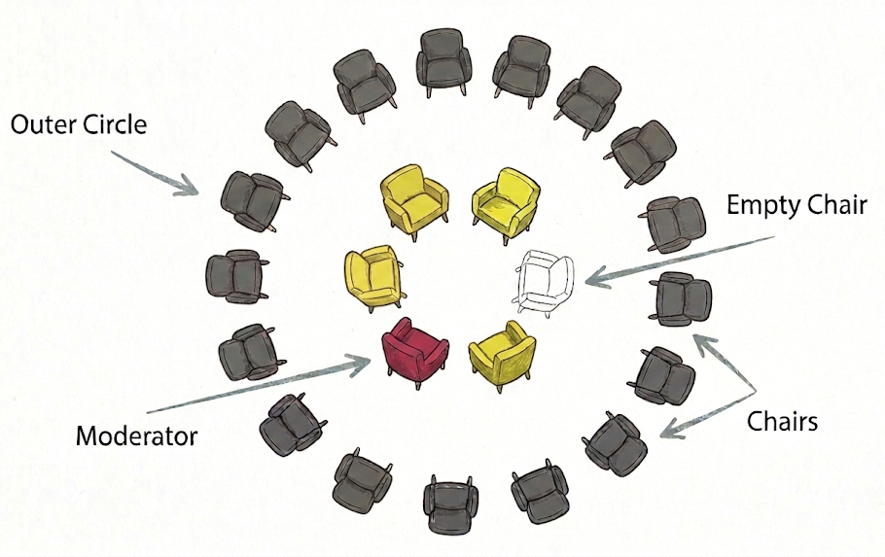 | …for a larger gathering e.g. conference  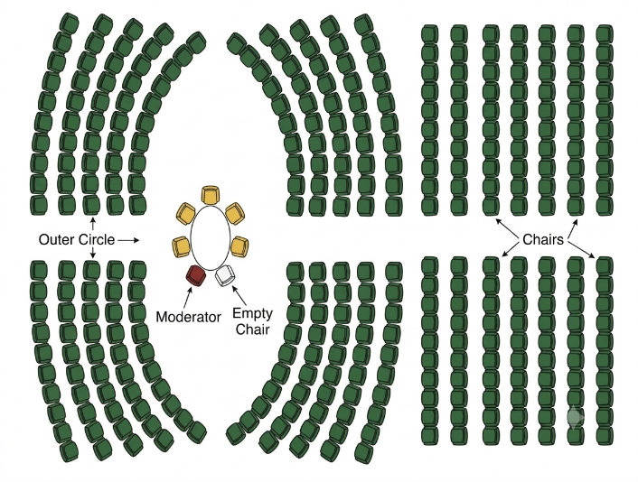

Panellists in the Inner Circle
We will have a round table with [7] chairs in the middle of the room. Handheld microphones will be provided on the table. Initial “panellists” (listed below) take seats in this inner circle, leaving two chairs empty. The facilitator will briefly introduce the initial panel and start the conversation by asking you, in the order below, to offer your initial reflections/provocations.

Starter panel:
- [name]
- [name]
- [name] etc

[Insert a few questions or directions to guide these initial reflections]

You will each only have 2 minutes for your initial contributions, which do not need to cover all (or any) of the above as long as they are on the theme of [insert core theme of the Fishbowl]. Please focus on just a few main thoughts or provocations, and try to connect your contribution to those of preceding speakers where possible. Importantly, you are invited as individuals from a diversity of backgrounds – not to represent a discipline or research area.
We will spend a few minutes deepening our conversation. The facilitator will invite audience members to walk up as soon as we have heard some initial thoughts, each taking an empty chair in the row closest to the roundtable. The facilitator will bring audience members into the conversation to add their thoughts on what they’ve heard.
The first two contributors [Names] should discreetly leave as soon as the first audience members arrive, and merge into the audience, making space for others to join. All panellists will be encouraged to merge back into the audience once they have had a chance to contribute, for as long as there are audience members interested in taking their place.

Audience members can:
- Observe, listen and reflect
- Join the conversation if they wish to contribute directly to the dialogue. To do so they will take one of the empty seats at the central table. Once a contribution has been made, the person will then return to the outer ring ensuring that others have a chance to contribute if they wish.
- Capture and share individual thoughts and reactions in writing. In parallel to discussions in the room, everyone will be invited to share their ideas via Menti, either before or after the session.
What sets this format apart is its dynamic interactivity and that, unlike in small group discussions, everyone can listen to everyone else. Another strength is its inclusiveness. It enables a larger number of individuals than is typical to actively contribute and addresses potential imbalances in representation between those already routinely engaged in this work and those who are newer to the topic. However, airtime for each speaker is very limited - something I will keep a keen eye on and ask for your help with. This is why we have tried to create several different opportunities for participants to contribute.

Recording and output from the discussions
The team plan to take written notes, photos and audio-record the discussion so a summary can be shared, alongside contributions on [Menti or other, as above], after the event. If you have any concerns about this, please let the team know.

Thanks for agreeing to support this event. Any questions or concerns, just ask!

You can contact me [your name and email address]

