

Logistics-Transport Services

Guidance
on the Use of
University Vehicles

Guidance v6.5

Mission Statement

The provision of a reliable, cost-effective, high-quality transport service and vehicle and equipment maintenance facility to the University of Glasgow. To offer support, advice and guidance on transport related matters. Included in our objective is the aspiration to identify and develop potential and suitable commercial business opportunities.

Hiring a University Fleet Vehicle.

- Fleet vehicles can be hired by staff at the University of Glasgow.

- The driver must first be approved to drive a university vehicle.

- To become an approved driver – follow the instructions in the following link:
https://www.gla.ac.uk/myglasgow/transportservices/bookingadrivingassessment/

- Once completed, the driver will be invited to attend a vehicle assessment, if successful, vehicle bookings can be placed.

- To book a vehicle - submit an online request at:
https://glasgow.saasiteu.com/Modules/SelfService/Login.aspx?ProviderName=University%20of%20Glasgow&Role=SelfServiceMobileStaff&Tab=ServiceCatalog&CommandId=NewServiceRequestByOfferingId&Template=824F381AFA9D45E3BE3FB9C9BE2F4E51

- If you have any queries regarding your booking, please contact Estates Business Hub: estates-business-hub@glasgow.ac.uk

Table of Contents

1. Introduction 4
2. The Law 4
3. Management of University Fleet Vehicles 4
Vehicle Fleet Insurance Details 5
Advice if Involved in a Vehicle Accident/Incident 5
When to Call the Police/Ambulance 5
What Information to Record at The Accident/Incident Scene 5
If University Vehicle Needs Recovered Due to an Accident/Incident (not breakdown) 6
SAFEZONE Phone App 6
All drivers should download the SAFEZONE app. 6
Advice in the Event of a Vehicle Breakdown 7
Advice if Vehicle Breakdown Occurs on the Motorway 8
Advice if Roadside Repair or Recovery to Base is Needed: 8
Fleet Maintenance 8
Use of Privately-owned Vehicles 9
External Vehicle Hire 9
How do I Hire a University Vehicle? 9
4. Use of University Vehicles 10
Minibus Driver Eligibility UK 11
Electric Vehicles (EVs) 12
Dash Cams/Tracker 12
Speed Limiters 12
Off-Road Driving 12
Towing 12
General Towing Advice 12
Tractors, Trailers & Forklift Trucks 13
Conveyance of Hazardous Substances 13
Movement of Livestock 14
5. Licence Requirements 14
Non-UK Driving Licences 15
6. Health & Safety 15
Pre-Journey Vehicle Check List 15
Journey Planning 15
Parking and Traffic Offences 16
Drink Driving/Driving Whilst Under Influence of Drugs 16
Licence Endorsements 16
Mobile Phones 17
Driving Outside the UK 17

Roles and responsibilities

As part of their management structure Colleges/Schools/Research Institutes are advised to review the level of provision they have made for ‘road risk assessment’ in the same manner they deal with other H&S issues. Risk assessments are more than just a legal requirement they also enable informed decisions to be made on the level of driver training required.

1. Introduction

More than a quarter of all road traffic incidents may involve somebody who is driving as part of their work at the time.

Health and safety law applies to work activities on the road in the same way as it does to all work activities. Risks to drivers need to be managed as part of health and safety arrangements.

Effective management of work-related road safety helps reduce risk. It could also result in, for example:
- fewer injuries to drivers.
- reduced risk of work-related ill health.
- reduced stress and improved morale.

2. The Law

University of Glasgow has duties under health and safety law for on-the-road work activities. The Health and Safety at Work Act 1974 states you must ensure, so far as reasonably practicable, the health and safety of all employees while at work. The University must also ensure that others are not put at risk by your work-related driving activities.

Individuals also have duties under road traffic law, e.g. the Road Traffic Act and the Road Vehicles (Construction and Use) Regulations, which are administered by the police, and other agencies such as the Driver and Vehicle Standards Agency (DVSA).

In most cases, the police will continue to take the lead on investigating road traffic incidents on public roads. HSE will usually only take enforcement action where the police identify that serious management failures have been a significant contributory factor to the incident.

If one of our employees is killed, for example while driving on behalf of the University of Glasgow, and there is evidence that serious management failures resulted in a ‘gross breach of a relevant duty of care’, the University could be at risk of being prosecuted under the Corporate Manslaughter and Corporate Homicide Act 2007.

3. Management of University Fleet Vehicles

The University has a legal duty to put in place suitable arrangements to manage our fleet of vehicles and to ensure that health and safety arrangements are in place for staff, students, or others authorised to drive university insured vehicles.

Vehicle Fleet Insurance Details

Zurich Municipal
Policy number: NHE-06CA02-0013-52

Advice if Involved in a Vehicle Accident/Incident

- Stop the vehicle as soon as safely possible – it's an offence not to do so.
- Switch the engine off.
- Switch the hazard lights on.
- Check for any injuries to yourself or your passengers.
- If it's a minor collision and there are no apparent injuries to either party, make a note of it in case the 3rd party claim for an injury.
- Try to remain as calm as possible – its normal to be shaken after an accident/incident, take a few deep breaths and try to take stock of the situation the best you can.
- Do not apologise or admit responsibility for the accident/incident until you're completely aware of what happened. This could protect you from liability if it was not your fault.
- No admission of liability, either written or verbal, should be offered. Money should not be offered (or accepted) as payment toward accident repair.
- Exchange motoring details. (See- What Information to Record at The Accident/Incident Scene)
- If the accident/incident caused damage or injury share your name and the University address with everyone involved – you are legally required to do this.
- Note down details of any other passengers and witnesses to the accident/incident.

When to Call the Police/Ambulance

- If accident/incident occurs on live lane of a motorway.
- If the road is blocked by accident/incident.
- If there are injuries to drivers, passengers or pedestrians.
- If the other driver or drivers leave the scene without giving details.
- If you think the other driver or drivers have no insurance or are under the influence of drink or drugs.
- If you suspect that the other driver or drivers caused the collision deliberately.
- If you were unable to exchange details at the scene, if anyone was injured, or if you suspect that the other driver or drivers may have committed a driving offence.

What Information to Record at The Accident/Incident Scene

- The make, model, colour, and vehicle registration of all vehicles involved in the accident/incident.
- The time and date of the accident/incident.
- Any injuries to drivers, passengers, or pedestrians.
- The driving conditions, including the weather, lighting, and road quality i.e. whether it's wet or muddy, condition of the road surface, streetlights on etc.
- What sort of damage was caused to vehicles/property and pinpoint where – e.g. nearside front wing and door damaged, garden wall damaged etc (nearside is the passenger's side of your vehicle, offside is the driver's side).
- The names and contact details of any witnesses.
- If safe to do so, use your mobile phone to take pictures of the scene, the positions of the vehicles involved, and damage to the vehicles or property.
- If no one else is involved in the accident/incident, e.g. you caused damage to private property or a parked car, you should leave a note where the owner can see it with your details. If you leave the scene of an accident/incident without leaving your details, you could be prosecuted.
- It is the driver's responsibility to complete a Motor Vehicle Incident Report giving details of any accident/incident involving a university vehicle or hired vehicle on university business, no matter how minor. The report must be completed and submitted to Transport Services as soon as possible. (* see link below)
- Drivers are reminded that they are legally obliged to inform their personal insurance provider of any accidents/incidents resulting in an insurance claim.
- All university insurance claims are always submitted in the name of the driver.

Report an accident/incident: https://www.gla.ac.uk/myglasgow/transportservices/

If University Vehicle Needs Recovered Due to an Accident/Incident (not breakdown)

- Call the University insurers Zurich Municipal on 0800-055-6767 and select opt 2 then opt 1…Urgent Roadside Assistance.
- Give full details to operator. what3words app can be used for your exact location https://what3words.com/
- Wait in a safe place for recovery team.
- Inform Transport Services asap - 0141-330-5330 or ecs-logistics@glasgow.ac.uk

SAFEZONE Phone App

All drivers should download the SAFEZONE app.

- Press the ‘EMERGENCY’ tab on the app.
- This will connect directly to the Security Gatehouse on both Campuses 24/7.
- Security team will call and offer advice on process and procedure.

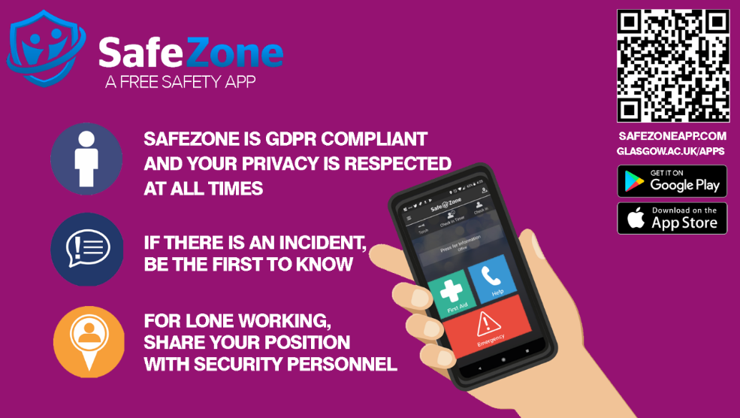

Accidents/Incidents – Repair Costs

The following applies to all accidents and incidents involving university insured vehicles:

- The department concerned is liable for all repair costs up to and including £1000.
- University insurance will cover repair costs exceeding £1000, however the department concerned is liable for the insurance excess of £1000.

Exceptions – third party involvement:

- Third party deemed not at fault - department concerned is liable for insurance excess of £1000 if repair to university vehicle necessary.
- Third party deemed at fault - no departmental cost.

Advice in the Event of a Vehicle Breakdown

If you need to stop your vehicle in the event of a breakdown, try to stop in a place of relative safety. This is where you, your passengers and your vehicle are less likely to be at risk from moving traffic.
The safest place to stop is a location which is designed for parking. On motorways and other high-speed roads, the safest place to stop is a service area. Other places of relative safety include

- lay-bys
- emergency areas
- hard shoulders

Be aware that the hard shoulder provides less protection than other places of relative safety as its next to a live lane and high-speed traffic.
You and your passengers should, where possible, keep well away from your vehicle and moving traffic, moving traffic could collide with your vehicle forcing it into you and your passengers.
- Think of all other road users and get your vehicle off the road if possible and safe to do so.
- Do not put yourself in danger by attempting even simple repairs.
- Warn other traffic by using your hazard warning lights if your vehicle is causing an obstruction.
- Help other road users see you by wearing light-coloured or fluorescent clothing in daylight and reflective clothing at night or in poor visibility.
- If safe to do so, place the warning triangle on the road at least 45 metres behind your broken-down vehicle, on the same side of the road (warning triangle can be found within all fleet vehicles) Always take great care when placing or retrieving them. Never attempt to place a warning triangle on a motorway.
- If possible, keep your sidelights on if it is dark or visibility is poor.
- Do not stand (or let anybody else stand) between your vehicle and oncoming traffic.
- At night or in poor visibility do not stand where you will prevent other road users seeing your lights.

Advice if Vehicle Breakdown Occurs on the Motorway

- Pull on to the hard shoulder and stop as far to the left as possible, with your wheels turned to the left.
- If your vehicle breaks down in a live lane on a motorway, your immediate priority is safety. Turn on your hazard lights. Try to move your vehicle to the leftmost lane and as far off the road as possible, ideally onto the hard shoulder or into an emergency area. Exit the vehicle on the passenger side (away from traffic) contact emergency services immediately, preferably using an emergency roadside phone if available and wait behind the barrier.
- If you cannot reach the hard shoulder or an emergency area, stay in your vehicle with your seatbelt on and contact emergency services immediately.
- Never attempt to place a warning triangle on a motorway.
- Do not put yourself in danger by attempting even simple repairs.
- Ensure that passengers keep away from the carriageway and hard shoulder, and that children are kept under control.
- If your vehicle is stopped on the hard shoulder or emergency area, walk to an emergency telephone on your side of the carriageway (these are situated at approximately one-mile intervals along the hard shoulder). The emergency telephone is free of charge and connects directly to an operator. Use these in preference to a mobile phone as help will arrive quicker. Always face the traffic when you speak on the phone.
- Give full details to the operator, including passenger numbers. what3words app can be used for your exact location https://what3words.com/
- Return and wait near your vehicle (well away from the carriageway and hard shoulder).
- If you feel at risk from another person, return to your vehicle by a left-hand door and lock all doors. Leave your vehicle again as soon as you feel this danger has passed.

Advice if Roadside Repair or Recovery to Base is Needed:
- Within the Glasgow area during normal working hours (Mon- Fri., 8.30am - 4.15pm), contact Logistics-Transport Services for advice or assistance on 0141-330-5330 or ecs-logistics@glasgow.ac.uk

- Out with the local Glasgow area or outside normal working hours contact the breakdown recovery service for your vehicle. Details are on each vehicle windscreen, in the vehicle folder or with your department administrator.

For vehicles covered under RAC contract – 0333-202-3000

*Repairs by local garages are not permitted without the express consent of Logistics-Transport Services.

*All vehicle recoveries should be to Logistics-Transport Services, 13 Thurso St, G11 6PE. If outside normal working hours, please contact the Main Gatehouse to arrange access to Transport Services secure compound on 0141-330-4282

Fleet Maintenance

Planned and preventative maintenance and legal requirements pertaining to university vehicles and related equipment are, in general, the responsibility of Logistics-Transport Services and are covered under an annual maintenance/inspection scheme.

Any maintenance, defects or damage issues: Logistics-Transport Services must be contacted immediately.

Use of Privately-owned Vehicles

Within the provisions of the University, managers (or responsible persons) that encourage staff/students to use privately owned vehicles on university business are advised to take adequate measures to ensure that all such vehicles are properly insured and maintained in a roadworthy condition.

It is the responsibility of owners to inform their insurers of their intention to use their personal vehicle for business purposes and to ensure that any such vehicle is properly and adequately maintained and insured.

Colleges/Schools/Research Institutes that require staff/students to engage in driving duties are strongly encouraged to include driver training as an important element of their Health & Safety and Duty of Care Policy (e.g. defensive driving, carriage of loads etc).

External Vehicle Hire

If hiring for four days or more, university insurance can be used but the driver must be an Approved Driver ie have sat and passed an internal driving assessment.
If hiring for three days or less, hire companies’ insurance should be used and therefor driving assessment is not required.

Whenever university insurance cover is being used, staff/students are advised that the insurance cover is only valid when a vehicle is being used on official university business.

When collecting a vehicle from a commercial hire company the customer should always satisfy themselves that there is no obvious damage to the vehicle, inside and outside, prior to accepting it. Should any damage be noted, however minor, the customer is advised to ensure the damage is recorded by the hire company before accepting the vehicle. Stone chips should also be reported. Where necessary obtain a copy of all reported damage and retain for your records.

Upon return of a vehicle to the hire company, staff and students are again advised to ensure that the hire company accepts the vehicle as having been returned in good order. This is to ensure that the University (and driver) is absolved from damage claim liability and that no charges for damage will be submitted at later date.

How do I Hire a University Vehicle?

To become an Approved Driver and have the use of university vehicles and hire vehicles covered by university insurance, please follow the instructions on link below.

https://www.gla.ac.uk/myglasgow/transportservices/bookingadrivingassessment/

4. Use of University Vehicles

University vehicles represent a considerable investment and are a valuable resource which must always be treated with due care and respect.

University vehicles may only be used for official university business.
No unauthorised passengers or materials should be conveyed in university vehicles. Drivers and passengers travelling in university vehicles must observe and comply with all legal requirements.

Passengers carried in a university vehicle must be conveyed free of charge. Failure to comply with this rule could render the University and the driver in breach of the law and open to prosecution. In event of an accident/incident insurance cover could be deemed invalid.

Drivers and passengers are requested to ensure that the interior of the vehicle they have been allocated is kept in a clean and tidy condition.

Alcohol must not be consumed by any person whilst they are travelling in a university vehicle.

Smoking/vaping in university vehicles is strictly prohibited.

Whilst on a journey, drivers are responsible for the safety and behaviour of their passengers as well as the security of the vehicle during the period it is entrusted to their care.

Drivers are solely responsible for all traffic offences associated with any university insured vehicle during the period it is assigned to their care.

Where fitted, seat belts must always be worn during a journey.

Vehicle Usage Logs must be fully and accurately completed for each journey. This is a legal requirement. Information should be printed clearly and be legible.

It is the responsibility of drivers to ensure that all loads are properly and securely stowed and that the safe load-carrying capacity of the vehicle is not exceeded.

All accidents, involving university insured vehicles, no matter how minor, must be reported to Logistics-Transport Services as soon as possible.

In the interests of security and safety the keys of all university vehicles parked on campus overnight and at weekends must be lodged with Security staff at the Main Gatehouse.

Minibus Driver Eligibility UK

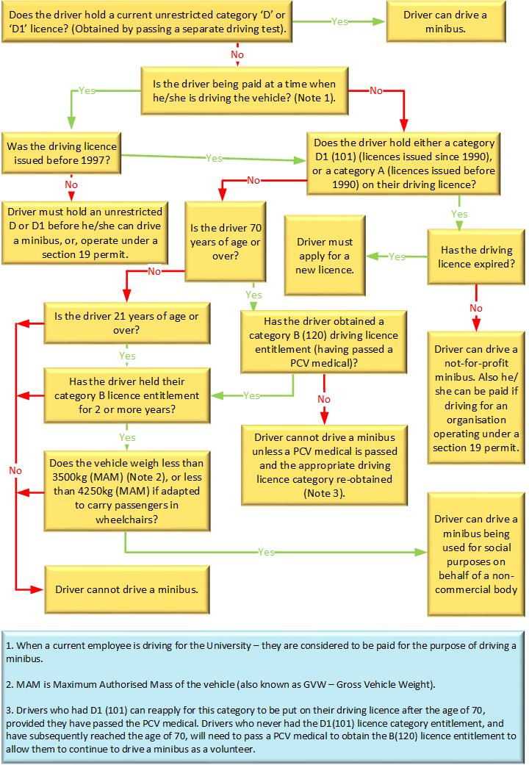

Electric Vehicles (EVs)

Specific training on using EVs will be given by Logistics-Transport Services before access to them is granted. All drivers wishing to use an EV must be assessed in an EV.

Dash Cams/Tracker

For reference to university guidelines on the use of dashcams and trackers in fleet vehicles, please see the Logistics webpage: https://www.gla.ac.uk/myglasgow/transportservices/.

Speed Limiters

With effect from 1st January 2008 all vehicles weighing more than 3.5 tonnes or minibuses (with more than 8 passenger seats) legally require to be fitted with a speed-limiter which will restrict top speeds to 62mph.

It is now university policy to speed limit all university vehicles.

All such vehicles are prohibited from using the outside lane of a motorway.

Off-Road Driving

Off-road driving can present numerous hazards. College/School/Research Institutes requiring drivers to operate 4x4 vehicles in off-road conditions are advised to contact Logistics-Transport Services who can offer practical advice and will arrange appropriate training. Training for all off-road driving is compulsory. For clarification purposes, any surface other than tarmac or concrete is deemed off-road.

Towing

Towing with minibuses with more than 9 seats is strictly prohibited.
Towing abroad with university vehicles is strictly prohibited.

Drivers wishing to tow with a vehicle up to 9 seats must have undergone appropriate certificated training. Please contact Logistics Dept. for advice.

General Towing Advice
- Check the permissible MAM (maximum authorised mass) or GVW (gross vehicle weight) of the vehicle and trailer combination. The MAM/GVW can be found on the vehicle chassis plate.
- Check the suitability and security of the tow hitch.
- Check the operation of all lights and marker boards (where appropriate)
- Check wheels and tyres.
- Check operation of brakes, including break-away cable and handbrake.
- Check jockey wheel.
- Check chassis/body condition.
- Check security of load.

Further guidance can be found at: https://www.gov.uk/towing-with-car

Tractors, Trailers & Forklift Trucks

Only trained and authorised persons holding a suitable driving licence may operate mechanically/electrically driven forklift/pallet trucks, tractors, trailers and other similar types of vehicles.

Appropriate certificated training is compulsory and can be arranged by contacting Logistics Dept.

Drivers of slow-moving vehicles such as tractors must display a working beacon whilst the vehicle is operating or travelling on public roads.

Slow moving vehicles towing trailers must ensure that such units are properly secured to the towing vehicle and must clearly display rear lamps in working order. The trailer must have a number plate bearing the number of the towing vehicle as well as displaying ‘red reflecting triangles’ that identify the unit as a trailer.

Exercise extreme caution when reversing or manoeuvring a trailer using a banksman where possible.

Conveyance of Hazardous Substances

Fuels should only be moved in approved containers, e.g. their original packaging or containers designed for the purpose such as plastic fuel containers (up to 5litres in size) and approved metal containers e.g. jerry cans. They should not be transported in passenger carrying compartments such as vehicle cabs and where possible should be in separate compartments or the boot of the vehicle. If re-used containers should be inspected regularly, and they should be properly sealed. Where practical they should be appropriately restrained and where vehicles are fitted with suitable fire-resistant lockers these should be used for the transport of fuels.

The below guidelines have been taken from the ADR: European Agreement Concerning the International Carriage of Dangerous Goods by Road, 1st January 2017.

Further guidance can be found at: http://www.unece.org/fileadmin/DAM/trans/danger/publi/adr/adr2017/ADR2017E_web.pdf

International agreement covering transport of hazardous substances on the roads:
  - Driver training
  - Safety equipment
  - Documents (e.g. instructions in writing)
  - Signage and placarding
  - Packaging
  - Emergency procedures
  - Generally intended to cover large quantities / hazardous materials
  - Several exemptions and relaxations for small / limited quantities

Relaxations for Small Loads (ADR 1.1.3.6):
  - Several key requirements relaxed for substances moved in small amounts
  - DGSA not required
  - No requirement for exterior signage / placarding
  - Instructions in writing not required
  - Loading / unloading in public places permitted
  - Remaining requirements*
  - General awareness training for drivers (with training record kept)
  - Provision of one 2kg dry powder fire extinguisher
  - Correct stowage of dangerous goods in vehicles

Small Load Thresholds (ADR1.1.3.6.3):
  - Exemptions apply where total quantity of hazardous substance is below a set limit.
  - Limit based on Transport Category of substance.
  - (Category listing and limit can be found at ADR 3.2.1)
  - Equivalency needs to be calculated where mixed loads transported.
  - All substances commonly moved by Transport Services fall below the threshold (provided in ADR Publication, section cited above).

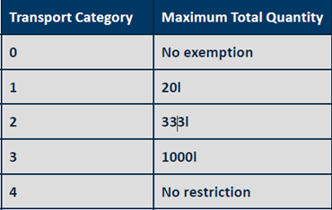

Movement of Livestock

All schools/departments and drivers involved in the transportation of livestock must be aware of and comply with current regulations governing the conveyance, treatment and welfare of animals whilst in transit.

Further guidance can be found at: https://www.gov.uk/guidance/farm-animal-welfare-during-transportation

5. Licence Requirements

Any person wishing to drive a university insured vehicle must be the holder of a current and valid UK driving licence appropriate to the category of vehicle they intend using.

Further guidance can be found at: https://www.gov.uk/driving-licence-categories

Driving licences must be made available for inspection at least once a year or as requested. If it is the intention of a member of staff or student to drive a university insured vehicle, they must inform Logistics in writing of any traffic offence and/or changes in driver circumstances without delay.
Drivers who were issued with a photo-card as part of their driving licence are advised the photo-card is valid for 10 years only. Drivers must renew their photocard licence when it expires. If they fail to renew their licence, they will be breaking the law and risk a fine of up to £1,000 and will not be permitted to drive a university insured vehicle until the photocard licence has been renewed.

Further guidance can be found at: https://www.gov.uk/renew-driving-licence.

Non-UK Driving Licences

The University requires all staff/students with a non-UK licence, who wish to use university insured vehicles, to exchange to a UK licence.

Further guidance can be found at: https://www.gov.uk/exchange-foreign-driving-licence

6. Health & Safety

The University has assessed the risks from work-related road safety and vehicle use.
Below are considerations that need to be applied.

Pre-Journey Vehicle Check List

Drivers are reminded that under the Road Traffic Act it is they who will be prosecuted if the vehicle they are driving on a public road is found to be in an un-roadworthy condition. Therefore, drivers should satisfy themselves daily that any vehicle they intend driving is roadworthy. It is in the interest of all persons intending to drive a university vehicle to carry out the following basic checks prior to driving the vehicle on the public highway: -

• Carry out all engine checks when the engine is cold, never when the engine is running. Do not remove the radiator cap when an engine is hot.
• Check tyre-pressures and visually examine the tyres for obvious damage or wear.
• Clean windscreen, windows, lights, mirrors and number plates.
• Check all fluid levels including windscreen wash.
• Ensure all lights are in working order.
• Check heater blower/demister is working.
• Check that all in-cab warning lights/gauges are functioning.
• Check operation of windscreen wipers and washers.
• Check spare wheel, jack and wheel key are in place.
• Minibus: ensure a Section19 Bus Permit is in place.
• Check brake fluid and top up if required.
• Report immediately any fluid leaks or abnormal noises from the vehicle.
• Adjust door wing/mirrors before moving off.
• Ensure that minibuses have a suitable fire extinguisher and first aid kit, warning triangle and drivers Hi-Viz vest.
• Report all suspect defects to Transport Services immediately.

Journey Planning

• Drivers should familiarise themselves with the vehicle’s controls and instrumentation before driving off.
• Plan all journeys in advance and allow ample time for the trip. Allow for changing weather conditions.
- On longer journeys, it’s safer to split the driving between two drivers or more, with regular breaks. This can help prevent driver fatigue.
• Drivers must ensure that the vehicle is not overloaded. When using a luggage/roof rack it is the driver’s responsibility to ensure the load is properly and safely secured
• When towing a trailer ensure it is coupled securely to the vehicle. After coupling a trailer check that all lights and brakes are working properly.
• When driving in traffic always keep a safe distance from the vehicle in front. Apply the two-second rule. (four-second rule in wet conditions).
• Allow additional braking distance when driving a laden vehicle - the additional weight of passengers/equipment requires a greater stopping distance.
• Use dipped headlights when visibility is poor or if it is raining.
• Ensure that all vehicle doors can be easily opened from the outside in event of an emergency.
• Be aware of your speed always. Do not take unnecessary risks.
• Do not use a vehicle for a short journey when you could just as easily walk.
• Look and plan. Decelerate when approaching a queue of traffic or a red traffic light; this practise will reduce the need for hard braking and will reduce fuel costs.
• Check tyre pressures (and condition) regularly – underinflated tyres can increase fuel consumption by up to 3%.
• Do not leave vehicles idling unnecessarily not only will this waste fuel and contribute to exhaust pollution it is unlawful and drivers are liable to a fine.
• Check with Met Office for local weather conditions and weather warnings.

Parking and Traffic Offences

Drivers will be held responsible and fully accountable for all traffic offences associated with any university vehicle or vehicle hired on behalf of the University during the period that such a vehicle is assigned to their care. Such offences might include parking, speeding etc.

All authorised drivers (staff/students) who have been charged with a traffic offence must notify Logistics Dept. in writing without delay.

Drink Driving/Driving Whilst Under Influence of Drugs

Any member of staff or student who is charged and ultimately found guilty of a drink-driving or drug related offence will be banned from driving university vehicles.

The carriage of alcohol intended for consumption by the driver or passengers during any part of a journey is strictly prohibited.

Licence Endorsements

To help manage the health & safety risk to university drivers and the public, approved drivers who accumulate licence penalty points will be given advise/training as follows

6 points: driving safety conversation
9 points: driving re-assessment

Further external training can also be offered.

Mobile Phones

The Road Traffic Act states it is an offence to use hand-held mobile phones whilst driving a vehicle. This includes sending or receiving oral or text messages. If a driver carries a mobile phone the device should only be used once the vehicle has been safely parked with the keys removed from the ignition. (except in certain cases of extreme emergency).
Further guidance can be found at: https://www.gov.uk/using-mobile-phones-when-driving-the-law

Driving Outside the UK

When planning a driving trip abroad make sure you carry your driving licence, a copy of the vehicle registration document, or proof of ownership, and arrange any necessary insurance cover.

Ensure the vehicle has a first aid kit, headlamp deflectors, a warning triangle, high-viz jacket, breathalysers, and basic breakdown kit (spare bulbs etc).

Use of university minibuses abroad is not permitted.

For further guidance: https://www.gov.uk/driving-abroad.

Available from DVLA –

INF28 - Driving a Minibus
INF30 - Towing Trailers in Great Britain
INF38 - Driving in Great Britain as a Visitor Resident
INF90 - A General Guide to Driver Licensing

Logistics-Transport Services
13 Thurso Street
Glasgow G11 6PE
Tel: 0141-330-5330 (internal calls - ext. 5330)
Email: estates-business-hub@glasgow.ac.uk

Security and Operational Support (24h cover)
Tel: 0141-330-4282 (internal calls – ext. 4282)
Email: security-main-campus@glasgow.ac.uk

