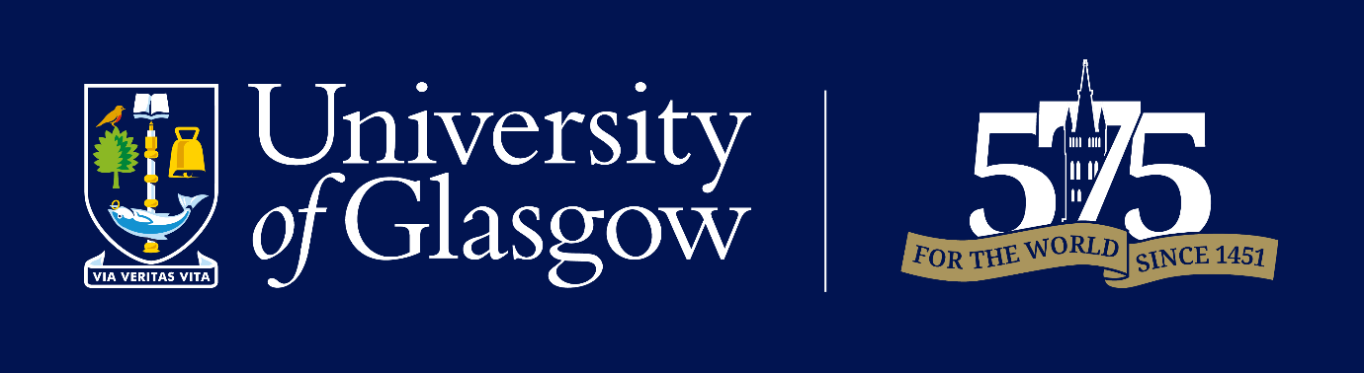
School of Biodiversity, One Health & Veterinary Medicine
VMCAS Pre-requisites
September 2027 Entry

Minimum of 3 years Animal Science/Pre-Vet degree required
Subject | Required | Recommended
Biology/Zoology | 
Biochemistry
Chemistry
Organic Chemistry (2 semesters, with Lab)
Physics
Maths/Statistics

Additional subjects considered:
- Cellular Biology
- Microbiology
- Animal Science
- Anatomy
- Genetics
- Biological Sciences



