PGR Recruitment Pack – Interview Questions and Tasks

Examples of Interview tasks

Wellcome-UoG Integrated Infection Biology programme

Shared three papers 4-5 days prior to the interview. These covered different aspects of infection biology and students were asked to pick one paper to read. They were told there was no need to read the Supplemental data.

Papers were picked based on:
- Length: aim was for shorter Nature/Science type length
- Breadth: covered different types of infection and different types of science (e.g. molecular, fieldwork, animal model)
- Complexity: avoided papers that the management team had to read several times to understand.
- Robust: the aim was not to get stuck on a discussion about poor research

At the interview, applicants were asked which paper they picked and why. The aim of this question was to find out about motivation and curiosity.

Applicants scored poorly if, for example, they picked a paper because this is what they had worked on previously and knew the most amount; they scored well if they had a strong justification – e.g. wanted to learn more about a topic, could connect to a specific aspect of the topic for a particular reason.

They were then asked if it was their project what would they have done differently or what would they do next. The aim of his question was to find out about creativity.

The main part of the score was based on the second question. Applicants scored poorly if, for example, their response was mainly another version of what has been done in the paper, e.g. a different time point, infection with/or of a related species, ask same question in a slightly different setting. Applicants scored well if their answer showed in-depth knowledge of a technique or technology, or showed insight into the wider question addressed by the paper, or demonstrated range of knowledge by expanding the question to a very different setting/field.

Reflection: this task is likely to bias towards applicants with strong academic backgrounds who have been environments where they are encouraged to read papers and have their own opinions of papers. It may bias against applicants who have not been in environments where their opinion on scientific progress has been sought.

CVR data questions
Applicants were shown the data for the first time in the interview.

Data Analysis Exercise 2025

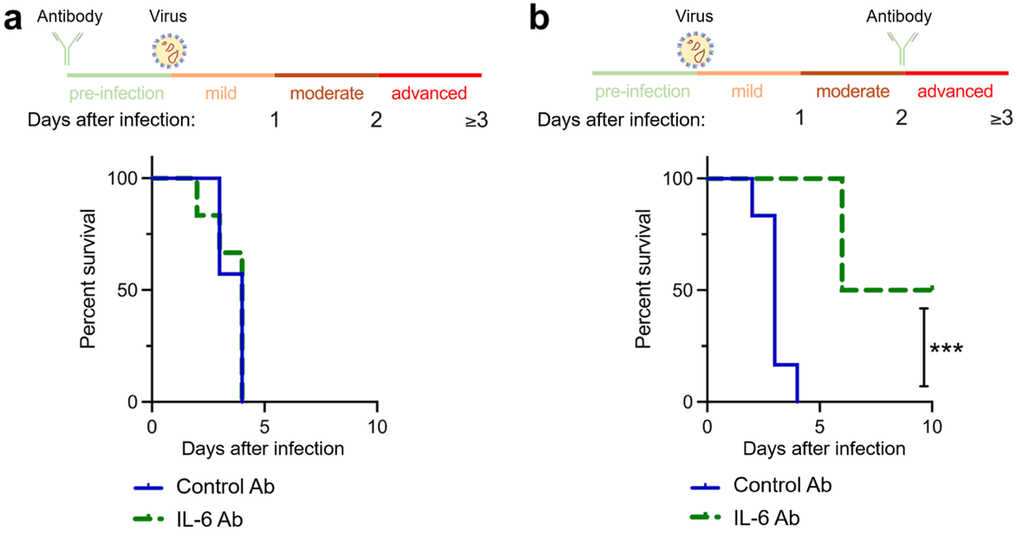

Figure Legend: Groups of mice were given a control antibody (blue) or an anti-IL-6 antibody (green) either (a) 2 days before infection, or (b) 2 days after infection. They were then infected with a virus and the survival over time was plotted. Data are presented as percent survival. The coloured lines at the top of the figures show stages of viral disease progression in the infected mice. Asterisks (***, P < 0.001) indicate statistical significance.

IL-6: Interleukin-6
Ab: Antibody

Questions:

- What can you conclude/hypothesise from these data on the role of IL-6 during virus infection?

- How would you assess/confirm your hypotheses?

- Would you recommend the use of anti-IL6 antibodies as a therapy for virus infection based on these data?

CVR Data analysis question 2024

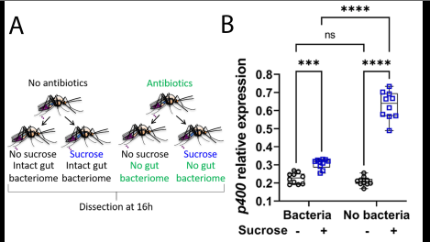

Figure Legend: A. Mosquitoes, treated or not with antibiotics (microbiota eliminated), were either not fed or fed with a sucrose solution. B. Expression of antiviral genes in the gut was measured by RTqPCR. One representative gene (p400) shown as an example.

Questions:

What can you conclude/hypothesize from this experiment on the role of sugar feeding and of microbiota on antiviral immunity?

How would you assess/confirm your hypotheses?

Interview questions

Questions if there has been a research presentation
Likely to be project specific questions that may cover: controls; next steps; technical based questions to see if they understood what had been done; what they enjoyed/were proud of about the project.

Questions about motivation
What is your motivation for doing a PhD? (motivation & suitability)
What is your motivation for applying to this PhD/specific programme/specific location/these projects within a PhD programme? (motivation & suitability)

Questions about past experiences
Tell us about a time you overcame a challenge. (creativity & potential)
Tell us about a time you used your initiative to solve a problem/in the lab. (creativity & potential)
Tell us about a time you worked together in a team and what role you played. (suitability & potential)

Questions about knowledge of the programme/subject area
What do you know about the research at location X/in lab X? (motivation & suitability)
What do you know about the subject area of this programme? (motivation & suitability)
Why do you think research into the area is important? (suitability & vison)
Can you give us an example of the type of research questions in this area and why do you think these are important questions? (suitability & vison)
What do you think will be the next break through in the field? (vison & potential)
What up and coming technology will make a difference to research in this field? (vison & potential)
If you had substantial funding, what new technologies would you invest in? (vison & potential)
Tell us about a scientific paper you have found interesting – what did you find interesting about it (suitability)

Career questions (note may be some overlap with motivation)
How will the PhD enable your next step in career plans? (motivation & vision)
What sort of career are you planning after your PhD? motivation & vision)

Question that test communication skills
Can you summarise the PhD project/the lab project you presented/a paper to someone with a high school level of education in science? (suitability & potential)

Questions that test knowledge of commitment/suitability require for PhD study
What qualities do you think successful PhD students need to have? (suitability & potential).
What qualities do you have that will make you a successful PhD student and what areas may you need to develop? (suitability & potential).
What do you think you will find most challenging as a PhD student? (suitability & potential).
What do you think you will find most enjoyable as a PhD student? (suitability & potential).

Miscellaneous questions
What will cause the next pandemic/be the next the next big challenge in health research? (vision& potential)
If you could spend £10M on someone else's research, how would you choose what to spend it on? (vision& potential)

The topic you are going to study has been intensively worked on for decades - can you tell us something about it that we still don't understand? (vision& potential)

Notes on scoring

Scores could either be assigned per question or based on characteristics. For example, grouping questions that relate to motivation, suitability, vision, and/or potential (see italics above).

Provide each interviewer with a scoring sheet for each applicant and/or a table to fill in to collect the score at the end of each interview. Encourage interviewers to includes some notes to inform discussions and provide feedback of relevant.

