

IMPORTANT
The process for annual reviews should start toward the end of May and concluded by July 31st.
This means you should book appointments with your supervisors and panel reviewers for during the summer months to avoid any delays due to annual leave.
It also allows for you to be progressed on MyCampus and will be able to register for the new academic term
If delays are expected, contact your school admin or the graduate school. Be mindful that you will not be able to register until your annual review has been completed.

CONTENTS
- START
- TRAINING NEEDS ANALYSIS AND TRAINING LOG
- COMPULSORY COURSE COMPLETION
- TRAINING LOG AND UPLOADING INKPATH TRAINING RECORD
- REVIEW SUPERVISOR ASSESSMENT & STUDENT CONFIRMATION
- REVIEW OUTCOME FROM PANEL REVIEWERS /PG CONVENORS & STUDENT ACKNOWLEDGEMENT
- AFTER PROCESS COMPLETION
- HELPFUL INFORMATION
  - ACCESS FORM VIA STUDENT HOMEPAGE
  - THESIS PENDING / WRITING UP PERIOD
  - NEED TO CHANGE INFORMATION AFTER SUBMISSION

- START
- Your local School PGR admin will create the initial review form in MyCampus.
- You should receive a notification email similar to this with a link to access your Student Self-Assessment.
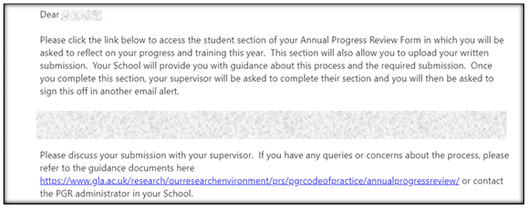

- CLICK THE LINK IN THE EMAIL - You will be taken to the PGR Annual Review page where your current form should be listed with the status ‘Pending Student Assessment’.
- CLICK THE CURRENT FORM
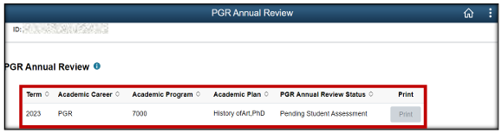
- The form will open on the Student Assessment page. If it does not open, ensure you have disabled pop-up blockers for the site in your internet browser.
- You must complete this section unless instructed otherwise. If you are in thesis pending/writing up, contact your supervisor or PG Convenor.
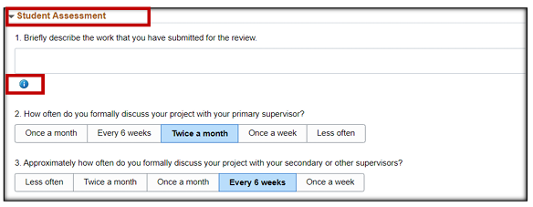

- Enter the requested information on the form. Blue information icons will reveal guidance on what detail is required.

- TRAINING NEEDS ANALYSIS AND TRAINING LOG

- Expand the training needs analysis and training log to reveal subsections Compulsory Course Completion and Training Log.
- Expand the two subsections.
- Here you will add details of any training taken, planned or required.
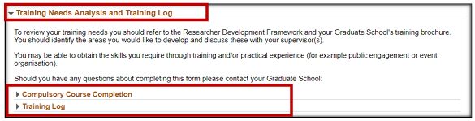

- COMPULSORY COURSE COMPLETION

- Enter the completion dates for any mandatory workshops you have completed. You should have completed at least 5 in your first year.
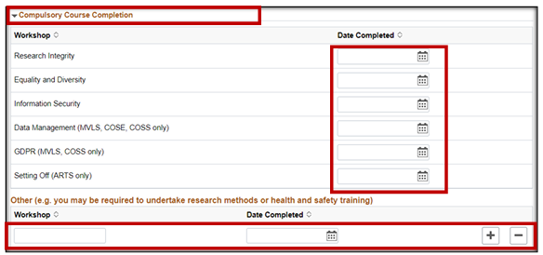

- TRAINING LOG AND UPLOADING INKPATH TRAINING RECORD

- Enter additional training, courses, workshops, external activities you have taken, and any training and development plans for the year ahead.
- If you are a year 2+ student will can review your previous training logs.
- Do not complete the credits box. It is not required MVLS.

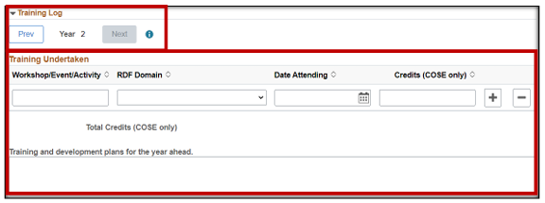

- INKPATH TRAINING LOG
  - If you have a training log in Inkpath you can download it and upload it to the DOCUMENTATION sub-section in this form.
  - There is a 5mb individual file size limit. Reduce the size if necessary.
  - The file name must be 20 characters or less.
  - CLICK ‘UPLOAD DOCUMENT’ – attach documents supporting your student assessment
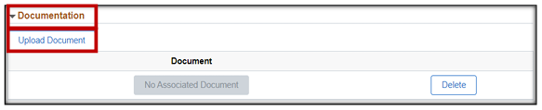

  - CLICK ‘SAVE DRAFT’ – this saves the form and the documents allowing it to be completed at a later date. This does not submit the form to your supervisors for review.
  - You are encouraged to save your drafts regularly to avoid losing any data.
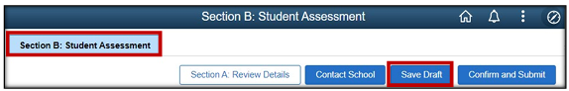
  - CLICK ‘CONFIRM AND SUBMIT’ – When you have checked over your form and attached docs and are ready to submit the form to your supervisors for review.
  - A pop-up box will check if you want to proceed.

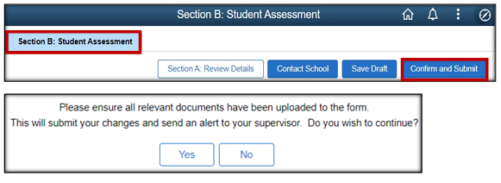

- Clicking YES completes the form and makes it available to your supervisors for review.
- Your supervisors will receive an email notification to log in and review your form.
- If you need to change any part of your student assessment form, contact your school admin or graduate school and they can re-open it for you.
- If you need to upload a document that you forgot to add, contact your school admin or graduate school and they can upload it for you.

- REVIEW SUPERVISOR ASSESSMENT & STUDENT CONFIRMATION

- When your supervisors have reviewed your form and completed and submitted their assessment, you will receive a notification email similar to this:
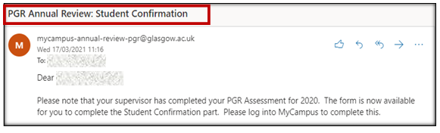
- Log in to your Student Homepage > Academics tile > PGR Review to access your review.
- The form will open and you will see a new subsection called ‘Student Confirmation’.
- You have access to ‘Section C: Supervisor Assessment’ to read the supervisor report.
- Read the report and if you are happy with it complete the student confirmation and CLICK CONFIRM AND SUBMIT.
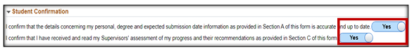

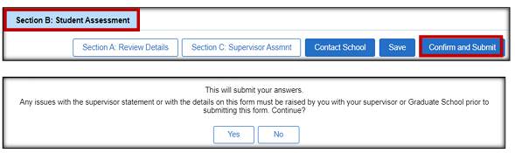

- REVIEW OUTCOME FROM PANEL REVIEWERS /PG CONVENORS & STUDENT ACKNOWLEDGEMENT

- The form will now go to your panel reviewers and PG Convenor for review. They can access all sections of the form.
- After your review meeting, the panel will complete their section, ‘Section D – Review Panel’
- The PG convenor will add an outcome.
  - A = Student progress approved
  - D = Student progress approved – submit as planned (if you are in thesis pending)
  - E = Student progress approved subject to addressing minor issues (you can’t register until issues are dealt with)
  - F = student progress only if substantial issues are addressed and /or further review. (you can’t register until issues are dealt with)
- You will receive an email notification to log in to your form and review the outcome.

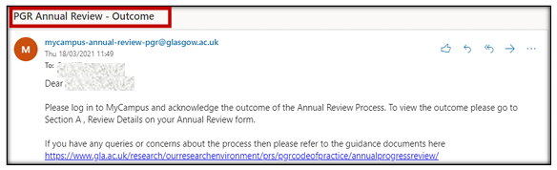

- Log in to your Student Homepage > Academics tile > PGR Review to access your review.
- The form will open and you will see a new subsection called ‘Student Acknowledgement’.
- You have access to ‘Section D: Review Panel’ to read the report and the PG convenor comments.
- After reading the report, if you are in agreement with it, CHANGE STUDENT ACKNOWLEDGEMENT TO YES.
- You must ensure that both the STUDENT CONFIRMATION AND STUDENT ACKNOWLEDGEMENT sections are complete. Failure to do this will cause issues with your form and may prevent MyCampus from allowing you to register.

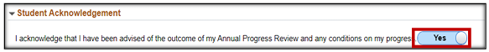

- CLICK CONFIRM AND SUBMIT

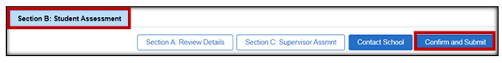

- AFTER PROCESS COMPLETION

- You will retain access to your Annual Review Form, in read only format, via the Student Homepage > Academics Tile.
- The form status will state ‘Pending Outcome Processing’ until your school PGR admin processes the review outcome.
- Once this has been actioned the form status will state ‘Complete’.

THIS CONLUDES YOUR ANNUAL REVIEW

HELPFUL INFORMATION

- ACCESS FORM VIA STUDENT HOMEPAGE
- If you lose an email with a link in it your form can be accessed here:
Student Homepage > Academics tile > > PGR Annual Review
- If no new form is listed, it has not been created by your local school admin.
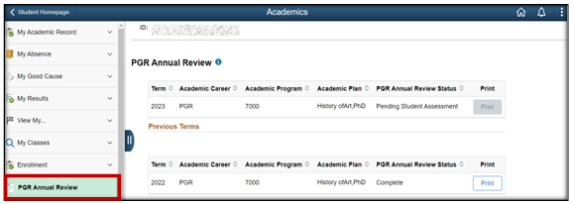

- THESIS PENDING / WRITING UP PERIOD
- Some schools do, or do not, require thesis pending students to complete an annual review.
- Your supervisor should discuss this with you.
- Your school PGR admin can decide to not create an annual review form, and you will not receive any MyCampus notifications.
- Alternatively, they could create a form and your PG convenor will add outcome A or D, and progress you to ensure you have access to be able to register.
- You must always register every year until graduation.

- NEED TO CHANGE INFORMATION AFTER SUBMISSION
- Once you have submitted your form and clicked ‘Confirm & Submit’, you will be unable to submit changes.
- Contact your local school PGR admin or the Graduate School.
- You should be able to upload any docs.
- Once done let your school PGR admin know and they can update the form status.

