Recording a Keeping In Touch (KIT) day

- Log in to Core Portal using your GUID and password.
- Click on the dropdown navigation menu at the top left of the screen and select ‘Manager Dashboard’. When the Manager Dashboard loads, select ‘Manager/Staff Requests’ on the left side of the screen and then ‘Create Request’ in the Manager Requests widget.
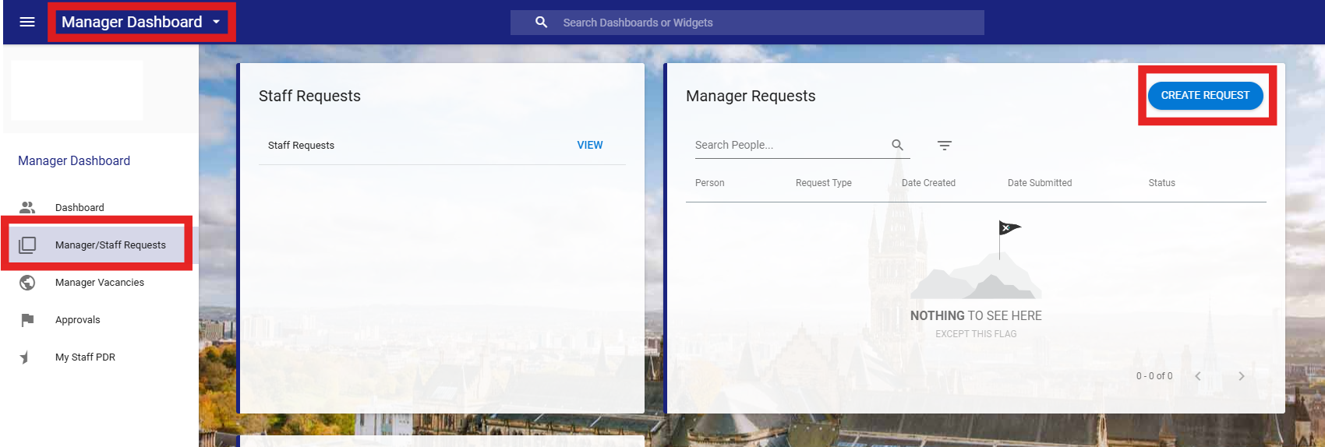

- In the Create Request screen, start to type the colleagues name in the ‘Employee’ section, the system will start to filter and populate options for you; select the correct colleague and press tab on your keyboard, the system will then auto populate the employee number and Job Title. If the employee has more than one appointment, please ensure you have selected the correct one.
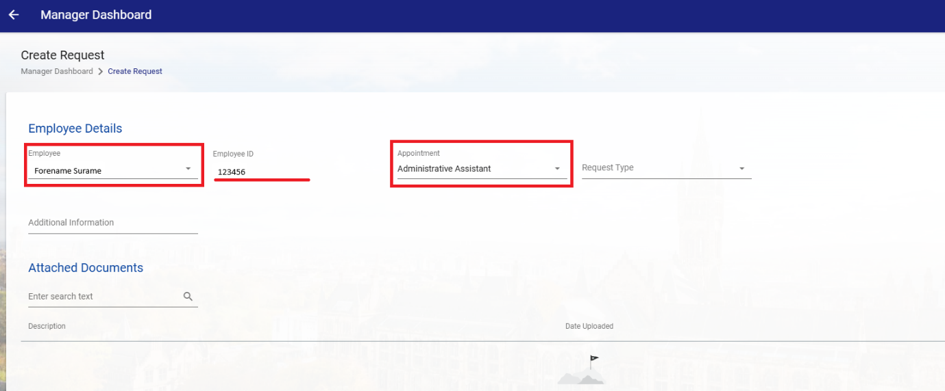

- Select the ‘Request Type’ – “Keeping in touch days”. This will then open more options below.
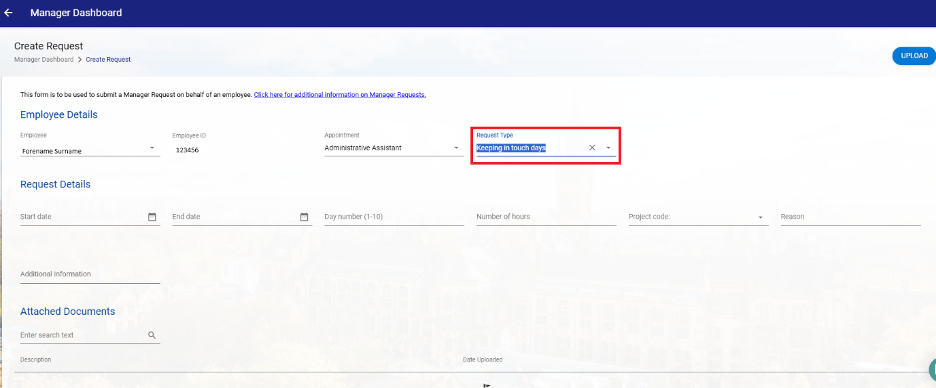

- In the ‘Request Details’ section, add the details of the KIT day.
- Record the KIT day number, 1 being the first day used. Please keep a note of the days used as the next day you add should be 2 then 3, until a maximum of 10 days.
- Always include the number hours worked – this level of detail is used to ensure correct payment is made to the colleague.
- Press Save and then Submit in the bottom right corner of the page.
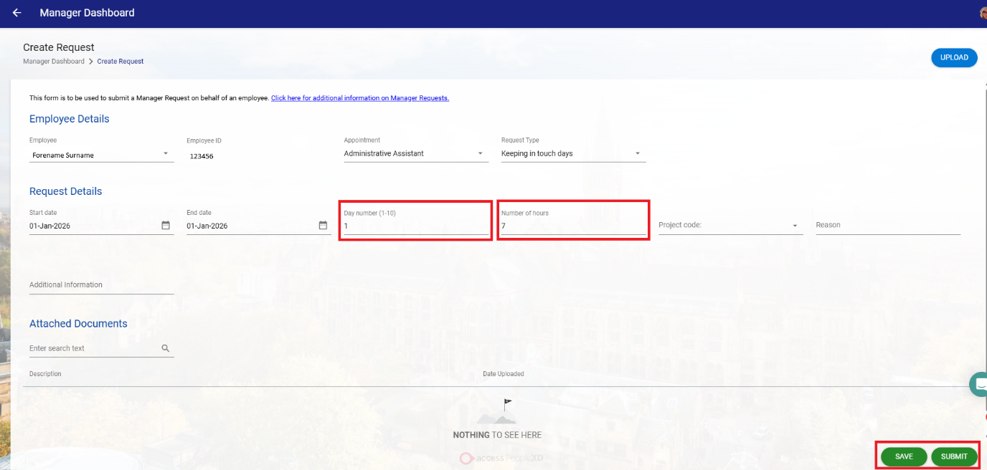

- Once submitted, the request will send a notification directly to payroll for payment to be processed. A payment will be made directly to the colleague however nothing will show in the colleague’s calendar. Payment is made on the last working day of the month – payroll deadlines will apply therefore payment might be made the following month.

