

Taster Week and University Experience Week 2026

Registration Guidance Notes

To register for Taster Week and University Experience Week, you’ll need to complete your registration through the University’s Direct Admissions System.

The Direct Admissions Form for Taster Week and University Experience Week is broken down into several sections: Personal Details, Contact Information, Widening Participation, Source of Information, Submit, Application Overview.

Section 1: Register an Account on the Direct Admissions System

- Go to www.glasgow.ac.uk/tasterweeks and click Apply Now to access the Direct Admissions System.

- Select Create New Account

- Please register using a valid email address.

Note:
We will communicate with you using this email address prior to the programme beginning, so please ensure that you will have access to this email address and that you check this regularly.

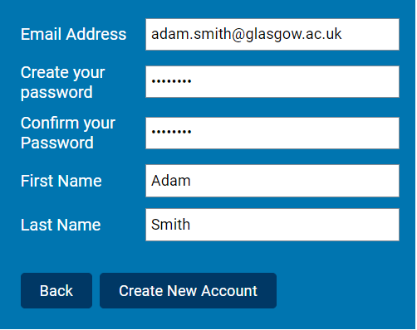

- Select your Country of permanent residence from the drop-down menu as United Kingdom – Scotland. The Mode of Study is Part-Time.

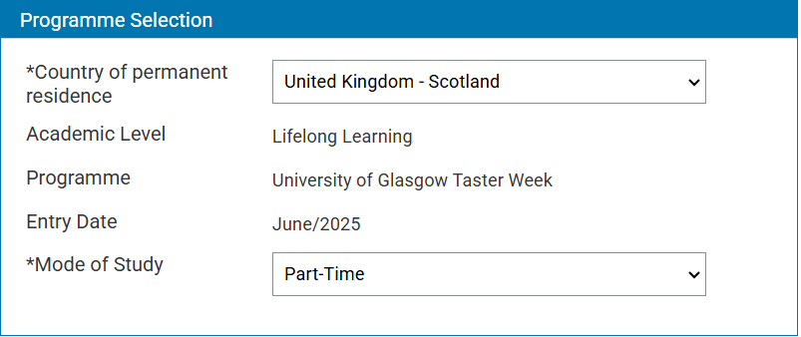

Once you complete a section on the registration form, you will see a green tick on the menu on the left of your screen.

Note:
If you do not see a tick next to a section, this means that it is incomplete.

Section 2: Personal Details

- Please input your Personal Details

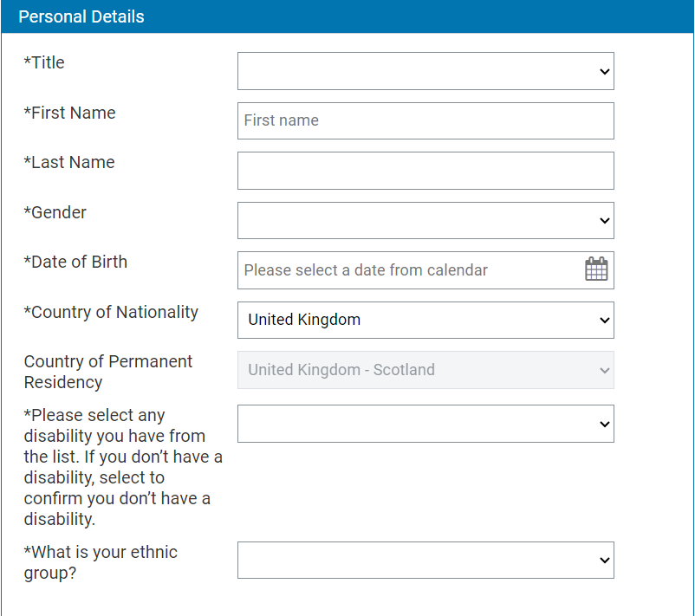

Section 3: Contact Information

- Input your Home Address, including postcode. You can click the button at the bottom of this section if your Mailing Address is the same as your Home Address.

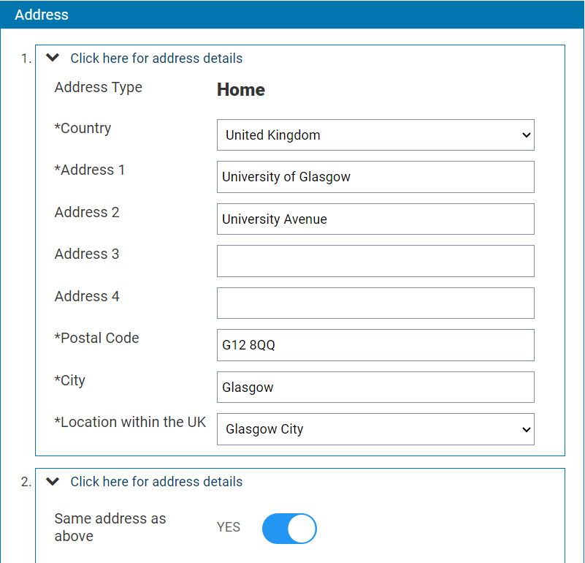

- Please input your Phone Number. Your Email Address will be automatically imported in from your login information.

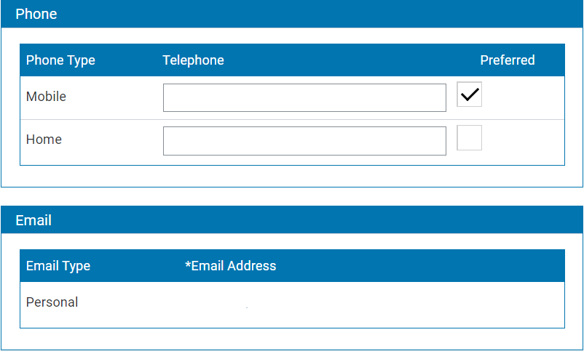

Section 4: Widening Participation

- If you meet any of the following Widening Participation criteria, please tick the boxes. There is no limit on the number of boxes you can tick.

If you do not meet any of these criteria, you can leave this part blank.

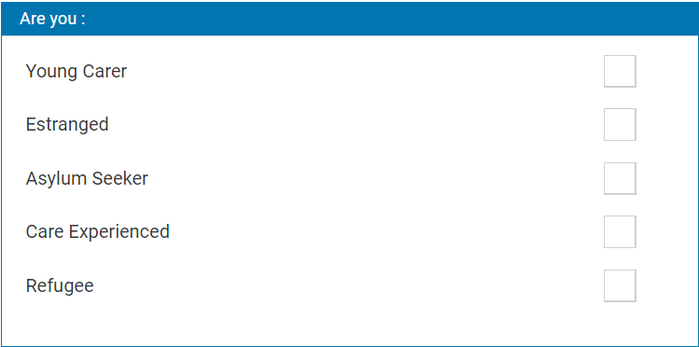

- If you are in receipt of any of the listed benefits, please indicate this. There is no limit on the number of boxes you can tick.

If you are not in receipt of any of these benefits, you can leave this part blank.

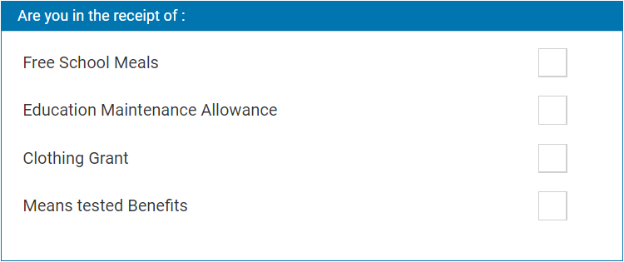

- Please indicate if you have any additional support needs and provide us with as much detail as you can so we can ensure that you receive the best possible support during the programme.

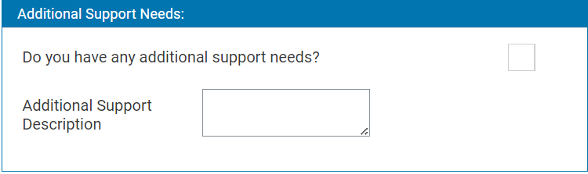

- Please input the Local Authority as Glasgow City.

Please select your school from the Current School drop-down list and select your School year.

Once you have selected your school year, please select your Subject Stream for your assigned programme.

Note:
If you are in S4, you will be participating in Taster Week. If you are in S5, you will be participating in University Experience Week.

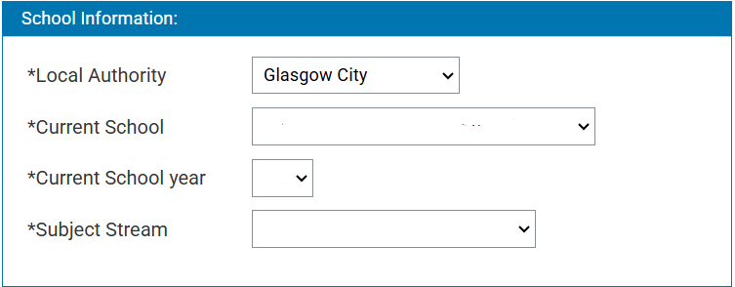

- Please input your Scottish Candidate Number (SCN), if known.

If you have applied for a degree programme at UofG, please tick the box on this form and input your UCAS ID, if known.

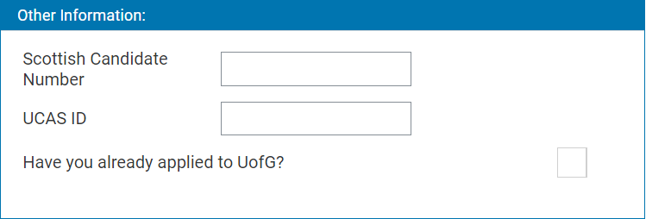

- If you have previously participated in another Widening Participation programme, please indicate this here. There is no limit on the number of programmes you can tick.

If you participated in a Widening Participation programme which is not listed, please tick None of above. If you have not participated in any Widening Participation programme, you can leave this part blank.

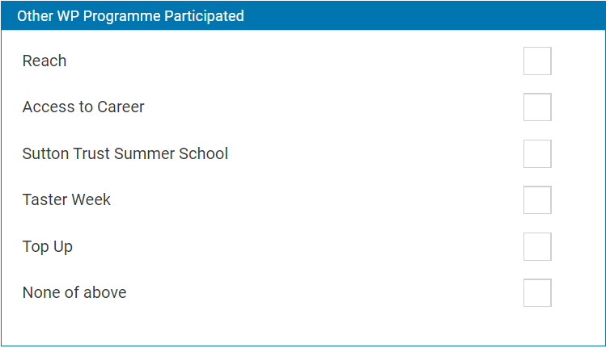

Section 5: Source of Information

- Please select from the drop-down how you heard about Taster Week or University Experience Week.

You can also leave further information about how you heard about Taster Week or University Experience Week, although this is not required.

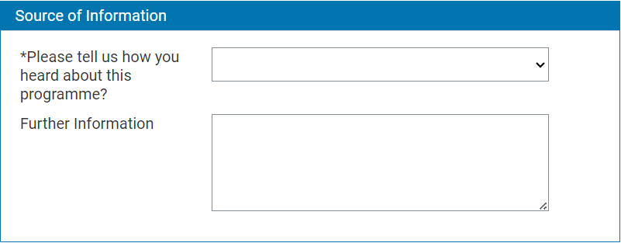

Section 6: Privacy Notice

- Here you will need to agree to the University’s Declaration and Privacy Notice.

Note:
If you have any questions about how the Widening Participation team uses your information, please contact us at wpsummerschool@glasgow.ac.uk.

Section 7: Overview and Submit

- This section allows you to view your registration form. By clicking each of the coloured boxes, this will pull all the information you have entered for each section. You can edit any piece of information by clicking the relevant section on the menu on the left-hand side of the page.

Note:
We would highly recommend that you thoroughly check your registration form before submission.

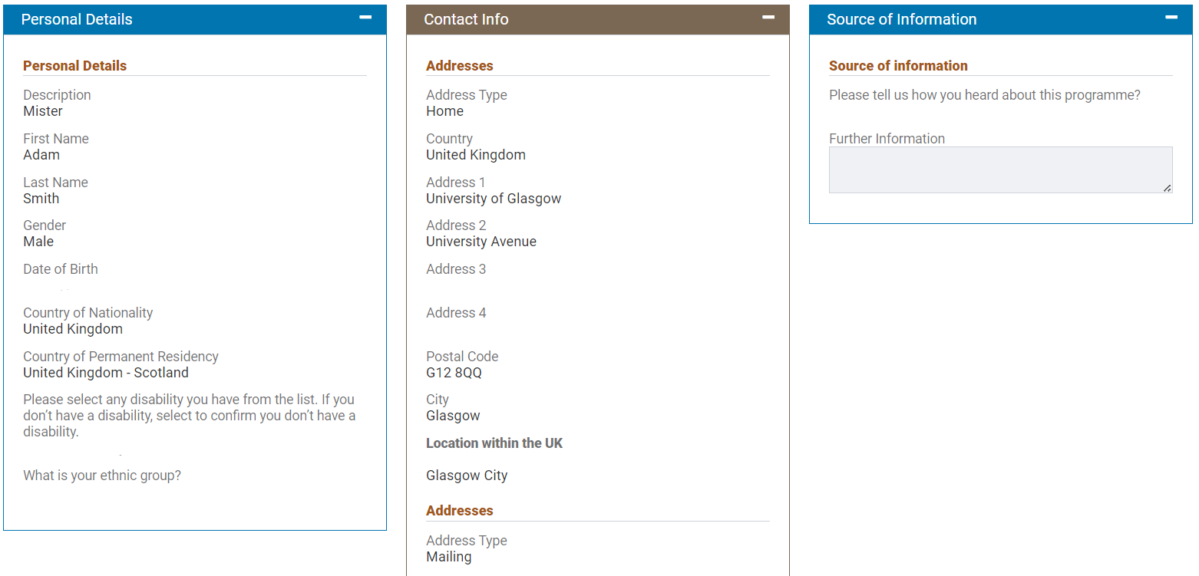

Once you are satisfied that your registration form is completed, please click Confirm details and submit. Your registration will not be submitted if you do not click this button!

Note:
You can come back and complete your registration later, by clicking the Save button and then click Logout. However, you must complete your application within 42 days of starting, as after this time any data is wiped, and you will have to start from the beginning.

