
BACKGROUND INFORMATION
This user guide is the process for PGR Admin detailing managing the initial review process after the initial set-up and how to assist others.
This is for the College of MVLS to use. No other Colleges use it.
When you create the initial review forms, you can access them throughout all stages of the process to review and perform any required administrative actions.
You should be able to see all of your students on plan codes assigned to your school. You can also search for any of your students who are on a plan code in another school. Make sure to change the PG Convenor in those ones.
You may also see students on your school plan codes that are not your students, they will be from another school. Leave them alone. The other school admin will have access to the form.
Initial review forms are linked to the information on a student’s MyCampus Student Summary page. It’s important to make sure your students are on the correct plan code and have the correct supervisors listed.
 Initial Set-Up
- Before generating any initial review forms, make sure you have completed the set-up process to add PG convenors and supervisors to the Initial review Portal. See the standard operating procedure Initial Review - Admin Set-up
CONTENT LINKS
- START
- USING THE SEARCH FUNCTION
- STUDENT SELECTION AND CREATE FORM
  - PREPARATION
  - IMPORTANT NOTES
  - CREATE FORM
  - AFTER YOU CREATE FORMS
- ADD THE REVIEW PANEL
- SEND FORMS TO STUDENTS
- CHECKING FORM STATUS
- STUDENT SELF-ASSESSMENT
- UPLOAD AND VIEW DOCUMENTS
- SUPERVISOR REPORTS
- PANEL REVIEW REPORTS
- STUDENT STATEMENT
- PG CONVENOR FINAL RECOMMENDATION
- FINAL REVIEW DETAILS

START
- Log in to the MyCampus Homepage and you’ll see some tiles.
- Click on the ‘PGR Reviews’ tile.
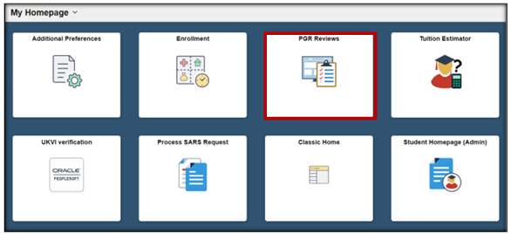
- The dashboard will open to the search function and the left-hand menu.
- The dashboard always opens to the main annual review search page not the initial review page.
- On the left-hand menu, click ‘Initial Reviews (MVLS)’
- This takes you to the ‘Create Initial PGR Review’ page.
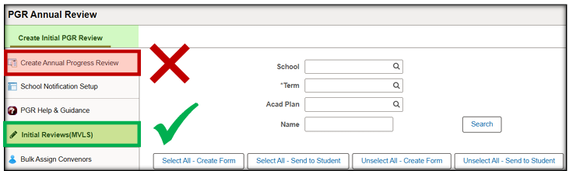

USING SEARCH FUNCTION
- SCHOOL: Enter your school cost code, for example, 20300000 (mandatory)
- TERM: Enter the current academic term (mandatory)
- ACAD PLAN: You don’t need to add any plan codes unless required (non-mandatory)
- NAME: You don’t need to, but you can search by forename or surname but not both. Does not recognize spaces but % wildcard can be used (non-mandatory)

STUDENT SELECTION AND CREATE FORM
PREPARATION
- Make sure you have a master list of your new students. You can get this from MyCampus using the query viewer and using this query: UOG_PGR_BENCHFEE_SCH
- Use this to compare against the list of students that will appear when you view the list of students in the initial review portal under your school cost code.
IMPORTANT NOTES
- Students starting in or around October and will be expected to do an initial review in the January of the New Year, create an initial review form by clicking ‘Create Form’ then PROCESS.
  - You can do this in bulk.
- Students who are not in your school and are on one of your school’s plan codes, leave them alone and their school admin will create their form.
- Students who are late starts on/after 1st March, the initial review/annual review may be combined. If this is the case create an initial review form and leave a note in the convenor section to say that the two reviews will be combined at annual review, then complete the form.
- Students starting after May, do not create an initial review form. If you do it by mistake, click IGNORE.
  - Also do not create an annual review form, click ignore. Contact the grad school and they can progress the student’s milestone.
  - The initial/annual reviews should be combined the following year where you can create an annual review form as normal.
- Students who are in your school and are on another school’s plan code, you can search for them using the other school’s cost code and create a form. Be sure to change the PG convenor.

CREATE FORM
- When you input your school details to the search function you should see a list similar to this:
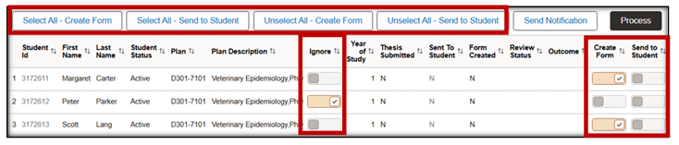
- Set the Create Form toggle on the right to ON for all students you wish to generate a form for.
- You can do this in bulk if all of the students listed are in your school by using the SELECT ALL – CREATE FORM button.
- Click PROCESS
- If there are students in the list to be omitted, use the Ignore toggle or don’t create a form in the first instance. SEE IMPORTANT NOTES ABOVE.
- Set those students to Ignore and then use the Select All option.

AFTER YOU CREATE FORMS
- The FORM CREATED column changes to ‘Y’
- REVIEW STATUS column changes to FORM CREATED
- The Create Form toggle is disabled
- Send to Student toggle is enabled.
- The Student ID is now a link for Administrator access to the Initial Review form.
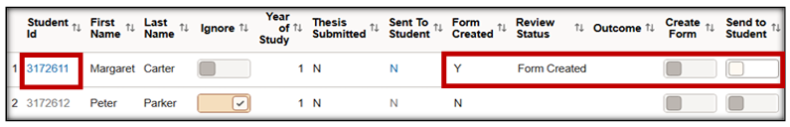

ADD THE REVIEW PANEL NOW
- Add the Review Panel Members to each student’s form after creating the form but before sending the form to students.
- This ensures Review Panel Members are added in time.
- When the final Supervisor completes their section, the form status changes to ‘Pending Review Panel Submission’, triggering an email notification to the Panel Member listed on the form, giving them access to complete the Panel Recommendation. If the panel review has not been assigned this will cause you issues.
- Use the student ID link to enter the form.
- Click on the RECOMMENDATION tab.
- Search for each Panel Member using their MyCampus EmplID or by name using the search function.
- If more than one Panel Member needs to be added, use the plus symbol to add more rows.
- Click SAVE

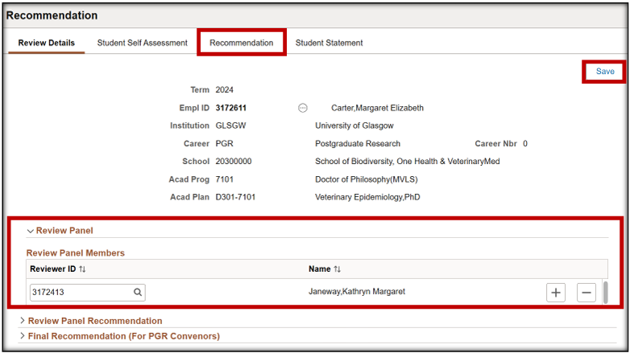

NOW SEND FORMS TO STUDENTS
- Click SELECT ALL – SEND TO STUDENT for all students who are to complete a review.
- Click PROCESS.
- If there are students in the list to be omitted, use the Ignore control. Set those students to Ignore and then use the Select All option.
- Students will receive an email asking them to complete the form and containing a direct link to the form.
- Students can also access the form via the Academics tile in their Student Homepage.
- Sent to Student column has changed to ‘Y’.
- Review Status has changed to ‘Pending Student Assessment’.
- Send to Student process control is now disabled.
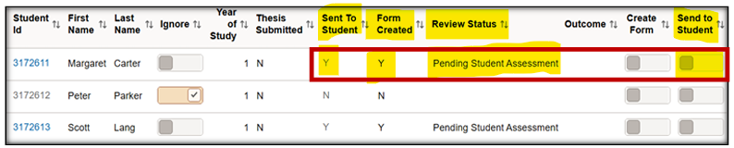

CHECKING FORM STATUS
- You can quickly check the status of each student’s form at a glance from the main student list.
- The REVIEW STATUS column will show different stages:
  - Form Created
  - Pending Student Assessment
  - Pending Supervisor Assessment
  - Pending Review Panel Submission
  - Pending Convenor Confirmation
  - Pending Student Statement
- Click on the student ID link to open the form.
- The REVIEW DETAILS main page will open showing read only student data pulled form MyCampus.
- Use the arrows to expand each subsection.
- If any information is incorrect the student record should be updated in the main student record. The MVLS Graduate School can make any changes.
- It is particularly important that the Plan and Supervisor details are correct. This validation should have been completed in advance of the form generation.
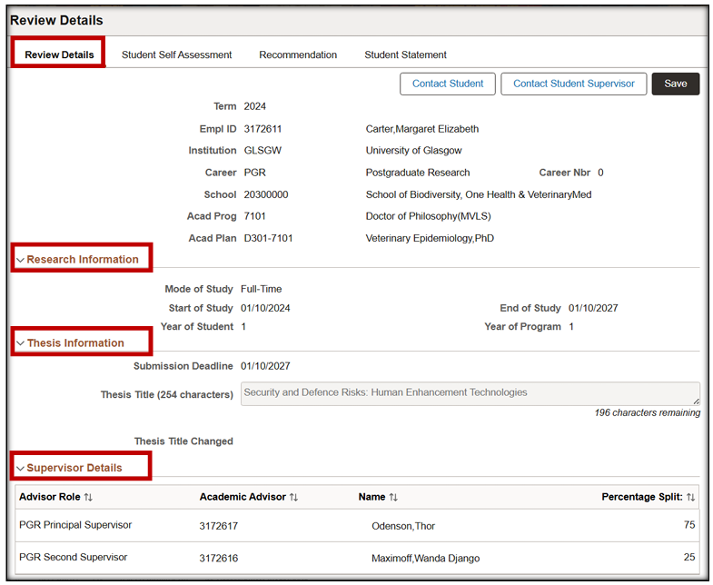

STUDENT SELF-ASSESSMENT
- The student does not have access to their form until the Administrator runs the Send to Student process.
- This changes the form status to ‘Pending Student Assessment’ allowing for them to complete.
- Only the student can update their self-assessment responses.
- If a student submits their form in error or requests access to make a change, the Administrator can change the status back to ‘Pending Student Assessment’ on the Review Details page, restoring editable access to the student.

UPLOAD AND VIEW DOCUMENTS
- You have read only access to the content added by the student but can assist them by uploading or deleting supporting documentation if required.
- There is a 5MB individual file size limit. To reduce file size, it is recommended you upload files in PDF format.
- There is also a max 20 character limit for the file name.
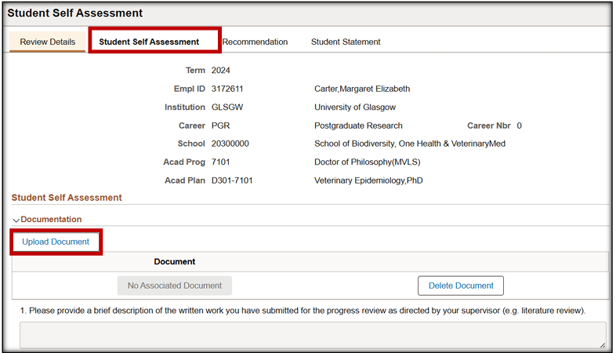

SUPERVISOR REPORTS
- The Supervisor Report pages are hidden until the Secondary Supervisor submits and the status changes to ‘Pending Review Panel Submission’.
- Administrators can then view the responses and attach any documentation.
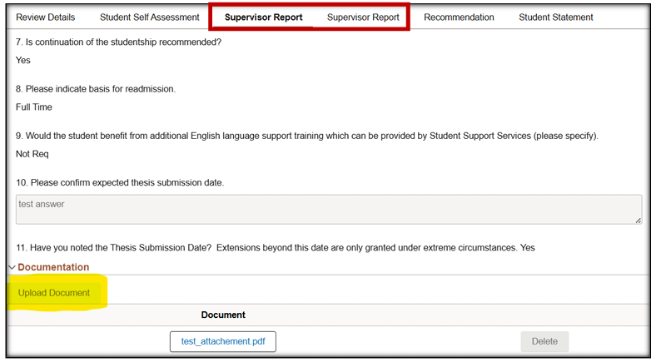

PANEL REVIEW REPORTS
- When the final Supervisor submits their form, the status changes to ‘Pending Review Panel Submission’
- This triggers an email notification to the Panel Member listed on the form, giving them access to complete the Panel Recommendation.
- You will have read only access to this but can upload any docs if required.
- There are two sections:
  - Review Panel Recommendation
  - Final Recommendation from your PG Convenor
- The review panel complete their form and recommendation first before the PG convenor:
  - A – Be permitted to continue - no further action required
  - B - Be permitted to continue subject to conditions - minor action required
  - C - NOT be permitted to continue unless substantial action is taken
  - D - Be excluded from further study
- When panel reviewers click CONFIRM AND SUBMIT the status changes to Pending Student Statement
- The student receives an email notification asking them to complete the student statement.

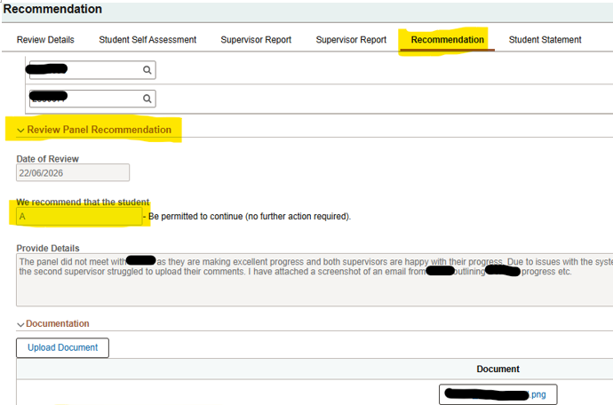

STUDENT STATEMENT COMPLETION - MANDATORY
- Students log in and review the supervisor reports and panel review reports.
- Students access the Student Statement Tab and must tick all boxes to indicate they have completed all the listed required actions.
- When complete, they click ‘Confirm and Submit’.
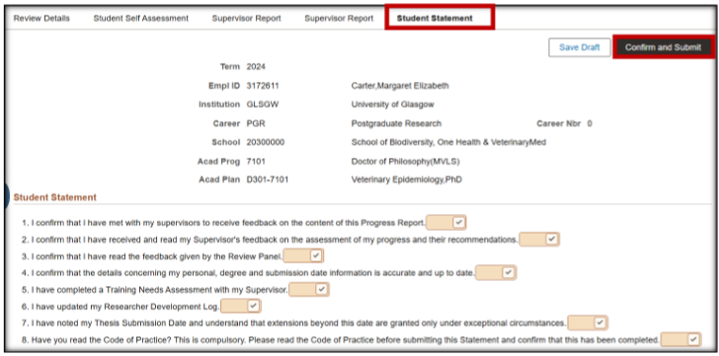

PG CONVENOR FINAL RECOMMENDATION
- The status in the Review Details Tab will change to ‘Pending Convenor Confirmation’.
- Your school PG Convenor will can now review the initial review form.
- They must submit a final recommendation and add information relating to the decision, including any required actions/conditions.
  - A – I recommend the student be permitted to continue for the remaining session.
  - B – I recommend the student be permitted to continue subject to conditions - minor action
  - C – I DO NOT recommend the student be permitted to continue unless substantial action is taken
- They should click ‘CONFIRM & SUBMIT’.
- Or they can click ‘Safe Draft’ to save without submitting the form, allowing them to complete at a later time.
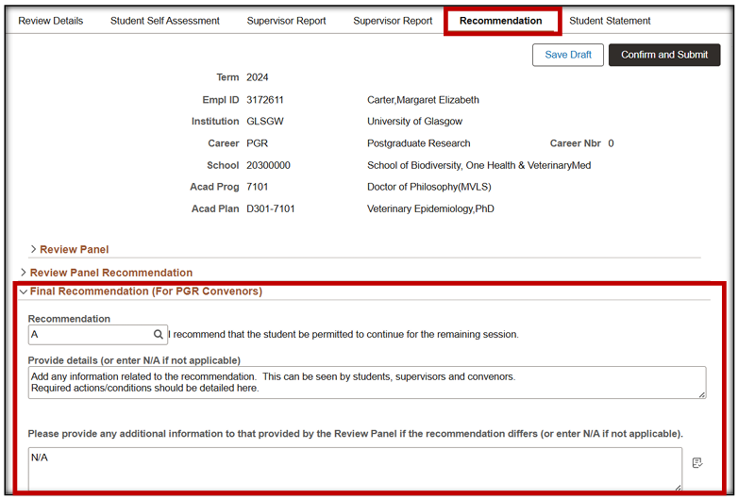

FINAL REVIEW DETAILS
- All fields within the form will now be read only.
- the Review Status is ‘COMPLETE.
- Dates should all be populated.
- If for any reason you need to set the form back to another status if a part of a section needs adjustments, you can do this, other sections will not delete or disappear. But you will need to bring the status back to the correct status once adjustments have been made. The system will not do this.
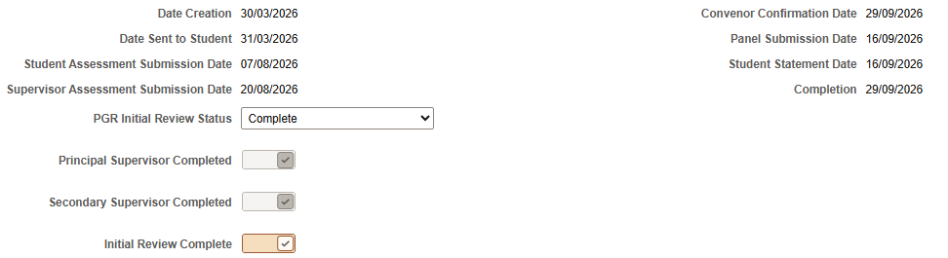

PGR INITIAL REVIEW FORM COMPLETE

