
BACKGROUND INFORMATION
- This initial set up is to make sure PG convenors and supervisors are added to the system and your new student records. It’s not to create initial review forms.
- School PGR admin only needs to set up initial reviews once per year for new incoming year 1 students.
- This set up of PGR convenors and multiple supervisors will stay on students’ records throughout the annual review process also. And each can be changed if required.

CONTENTS
- ACCESS PGR REVIEW TILES IN MYCAMPUS
  - WARNING
- ADD PGR CONVENORS TO YOUR SCHOOL
- ACTIVATE SECONDARY SUPERVISORS
- NOTES FOR FUTURE REFERENCE

- ACCESS THE PGR REVIEW TILES IN MYCAMPUS
- All administration pages required for both Annual and Initial PGR Reviews are located within the PGR Reviews dashboard.
- PGR Administrators can access this dashboard via the PGR Reviews tile on their MyCampus home page.
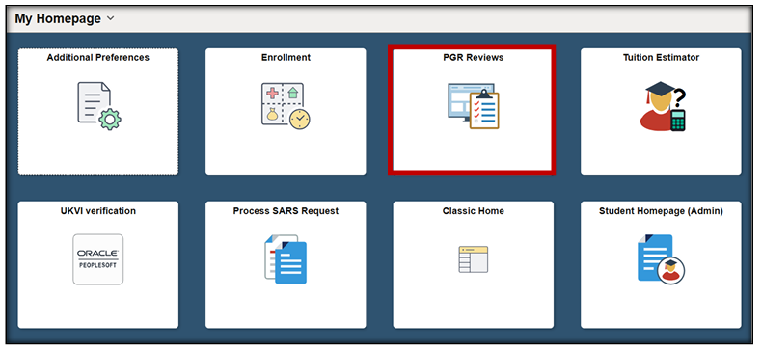

 WARNING!
- The dashboard opens on the first page listed in the side menu: Create ANNUAL Progress Review.
- This page is very similar to Initial Review.
- Before searching for forms, ensure you have navigated to Create INITIAL PGR Review, by clicking on Initial Review (MVLS) in the side menu.
- The title of the active page can be seen above the menu.

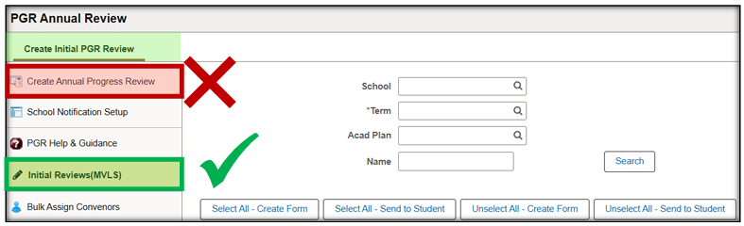

- ADD PGR CONVENORS TO YOUR SCHOOL
- You are able to add your school PGR Convenors/Deputy Convenors to your school.
- You do not need add to each student.
Setup Steps
- Select PGR IR Convenor Setup (MVLS) from the menu.
- Enter or search for your School.
- Enter or search for the Convenor EmplID.
- Use the plus button to add any additional Convenors.
- Set the Send Email Notification control to ticked.
Click Save.
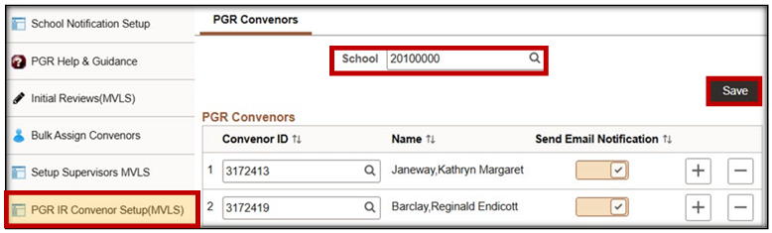
- This set up is for all students on plan codes that belong to your school.
- You may find that you have some students on your plan codes, but their supervisors are in another school. This means that student belongs to another school.
- You may also have students who are on plan codes that belong to a different school, but their primary supervisor is in your school. This means they are your students.
- At the start of term make sure to have a master list of all of your students based on who their supervisor is in your school. It makes it easier to keep track.

- ACTIVATE SECONDARY SUPERVISORS ON THE FORM (MULTI SUPER)
- The initial review form allows for both primary and secondary supervisors to complete reports on the form.
- WARNING: If not actioned before generating the forms, only one supervisor can submit a report.
Set Up Steps
- Select Setup Supervisors MVLS from the menu.
- Enter or search for your School.
- Set the Allow Multi Supervisor Screen control to ticked.
- Click Save.
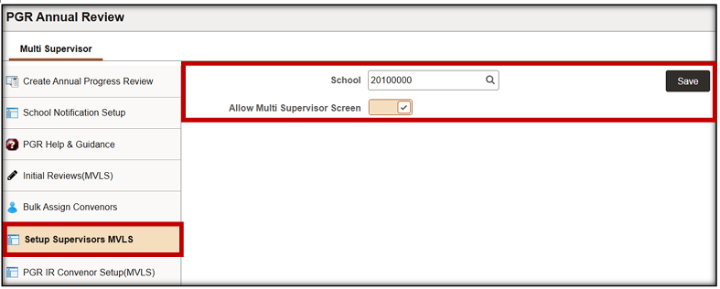

- NOTES FOR FUTURE REFERENCE
- When a student submits their self-assessment, the Principal Supervisor receives an email containing a direct link to complete their section of the form.
- When the Principal submits their report, an email is generated to the Secondary Supervisor, containing a direct link to complete the additional supervisor report.
- Supervisors can also access forms via the PGR Initial Review Supervisors tile on their MyCampus landing page

