Microsoft Teams Webinar and Meeting Guide for University of Glasgow Staff

Overview: Meetings vs Webinars
Meetings: Collaborative sessions where all participants can speak, share video, and interact freely (up to 1,000 participants).
Webinars: Structured events for larger audiences (up to 1,000 interactive participants or 20,000 view-only). Attendees have limited permissions; presenters control the flow.

Setting Up a Microsoft Teams Meeting

Step-by-Step
- Open Teams → Click Calendar on the left sidebar.
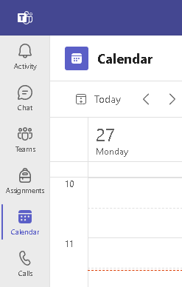
- Schedule a Meeting: Click New Meeting, add Title, Date/Time, and Description, invite participants.
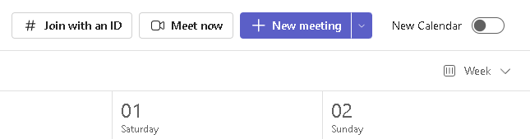
- Customize Options: Click Meeting Options, configure lobby bypass and presenter permissions.
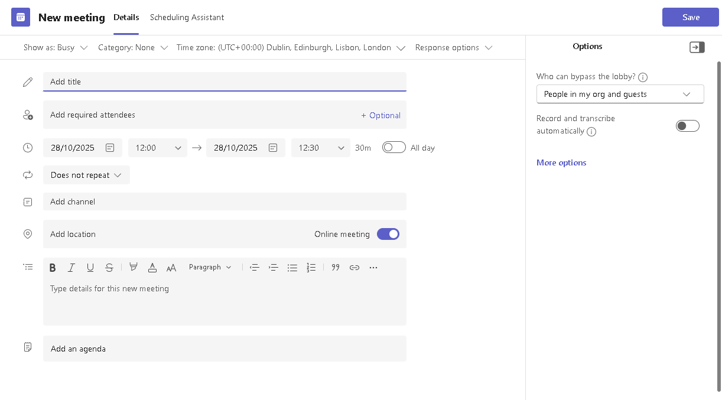

- Send Invite: Participants receive a link via email.
- During the Meeting: Use Raise Hand, Chat, Share Screen, Reactions, record if needed.
- After the Meeting: Access recordings, transcripts, and shared files via the calendar invite.

Setting Up a Microsoft Teams Webinar

Step-by-Step
- Create Webinar: Go to Calendar → Click dropdown arrow beside New Meeting → Select Webinar.
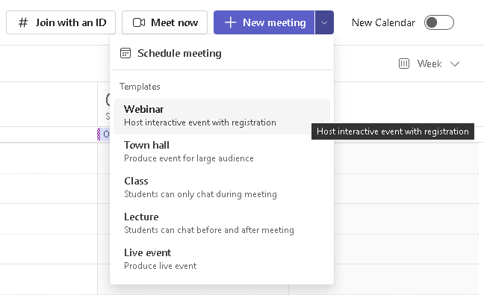
- Enter Details: Title, Date/Time, Description, add Presenters and up to 10 Co-organizers.
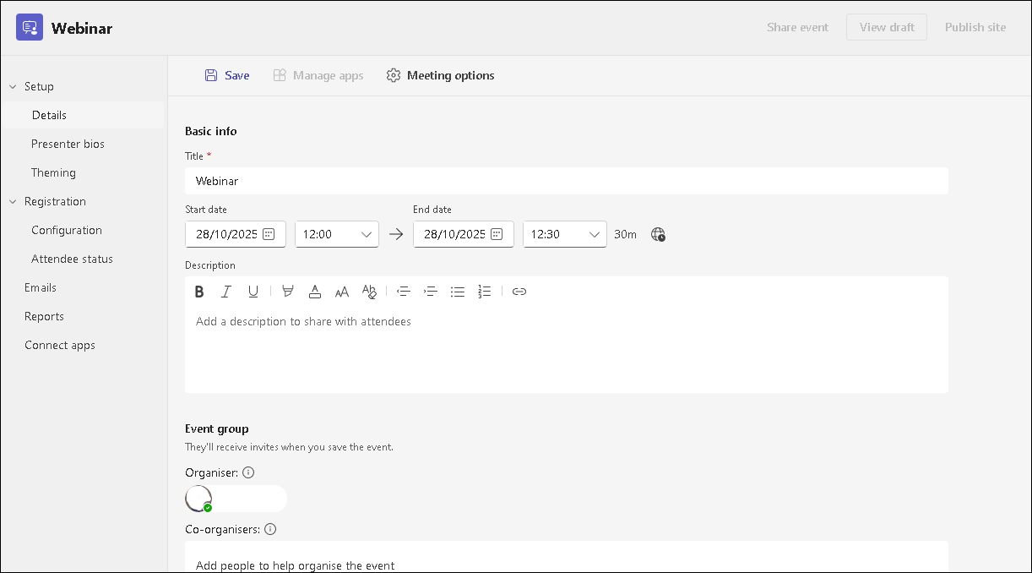

Microsoft Teams Webinar Setup Tabs Breakdown
This table provides a breakdown of the main tabs and sections available when setting up a Microsoft Teams Webinar, including their purposes and key features/options.
Tab / Section | Purpose | Key Features & Options
Details | Basic event information and scheduling. | - Title, Date & Time  - Description  - Location (optional)  - Add Presenters and Co-organizers (up to 10)  - Choose Public or Organization-only access.
Registration | Configure attendee registration and form. | - Enable/disable registration  - Add custom questions (text, multiple choice)  - Include legal terms  - Set capacity limits, manual approval, waitlist (Teams Premium)  - Registration start/end dates (Premium).
Presenter Bios | Showcase speaker details on the event page. | - Add photos, names, titles, bios for presenters.  - Helps attendees know who is speaking.
Theming | Customize branding for the registration page and emails. | - Upload logo, banner, and choose color scheme.  - Aligns event with university branding.
Meeting Options | Control attendee interaction and event behavior. | - Enable/disable Q&A, chat, polls.  - Allow/disallow attendee mic/camera.  - Enable Green Room for presenters to prep before attendees join.  - Control who can present and bypass lobby.
Reports | Access analytics before and after the event. | - View registration insights (sign-ups, cancellations).  - post-event: attendance, engagement, duration.  - Export data for follow-up.

Roles and Permissions

Meeting Roles
Role | Permissions
Organizer | Full control: schedule meeting, manage options, start/stop recording, change roles, manage breakout rooms.
Co-organizer | Similar to organizer but cannot change meeting details before start.
Presenter | Share content, admit/remove participants, mute/unmute, change roles.
Attendee | Limited: view content, chat, turn audio/video on/off (if allowed).

Webinar Roles
Role | Permissions
Organizer | Creates webinar, configures registration, branding, and permissions.
Co-organizer | Helps manage event, edit registration, customize theme (cannot change date/time).
Presenter | Shares content, manages Q&A, interacts with attendees.
Attendee | Joins via registration link, limited interaction (chat/Q&A only).

Key Tips and Best Practices
- Always test audio/video before starting.
- For large events, enable Q&A moderation and disable attendee mics/cameras for control.
- Share recordings and analytics post-event for engagement tracking.

Useful Resources
- Microsoft Support: Get Started with Webinars - https://support.microsoft.com/en-us/office/get-started-with-microsoft-teams-webinars-42f3f874-22dc-4289-b53f-bbc1a69013e3
- Roles in Teams Meetings - https://support.microsoft.com/en-us/office/roles-in-microsoft-teams-meetings-c16fa7d0-1666-4dde-8686-0a0bfe16e019

