SSLC Quick Guide for Staff

Ahead of the SSLC:
Academics will be given a link to student comments by the DA and then have 5 working days to respond to the comments and return to the TO.
Minor issues such as understanding handwriting, difficulty hearing a lecturer, problems with lecture halls, etc. should have already been flagged by students via the new Feedback QR Code and actioned outside of this meeting.
https://forms.office.com/e/8Efeepgkvn
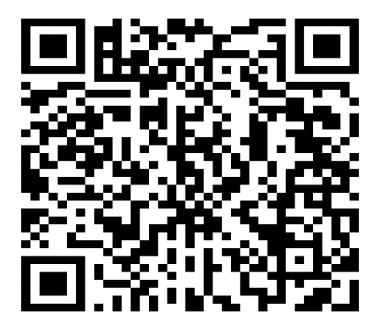
An information tile is also available on the Student Information Moodle page and all academic staff have been issued with a copy to add to their lecture slides.
The action column should have already been populated from the previous SSLC meeting and circulated before the current SSLC.

At the SSLC:
The Head of Discipline and/or Deputy Head of Discipline should be in attendance throughout the SSLC as well as the Senior Advisor (minimal representation).
All SSLC meetings should be chaired by a 4th or 5th year student representative, who should be decided before the actual meeting takes place.
Only actions that are outstanding from the previous meeting should be addressed.
Each year group has a maximum of 15 minutes to discuss any issues. This will be noted on the agenda of each SSLC. There is no need to go through all comments - if the issue has already been answered in comments provided before the SSLC and the student representatives are happy with the answer then this is noted and the meeting moves on.
As well as course issues, SSLC should address wider issues that affect all students.

