SSLC Quick Guide for Students

Ahead of the SSLC:
Student reps should be aware that they do not have to wait until the SSLC meeting to get in contact with staff or the Head of Discipline with issues.
Minor issues such as understanding handwriting, difficulty hearing a lecturer, problems with lecture halls, etc. should be flagged to the appropriate members of staff and actioned outside of this meeting.
The new Feedback QR Code should be used by students for these purposes.
https://forms.office.com/e/8Efeepgkvn
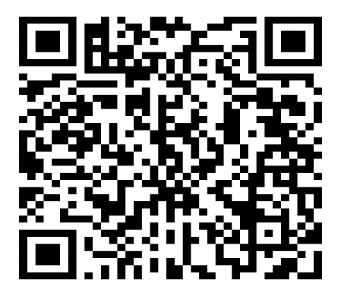
An information tile is also available on the Student Information Moodle page and there are posters placed all over campus. Furthermore, all academic staff have been issued with a copy to add to their lecture slides.

Comments for SSLC meeting:
Student reps should contact their student groups for feedback 2-3 weeks ahead of the SSLC.
All comments that the student reps have collated must be provided within 10 working days using the form sent out to them by the Teaching Office.
Student reps are expected to look at the comments from the previous session to see if previous actions have been addressed.
The Student Chair should note that there is no need to go through all comments - if the issue has already been answered in comments provided before the SSLC and the student representatives are happy with the answer then this is noted and the meeting moves on.

At the SSLC:
All documents required for the meeting will be provided in advance electronically via email from the Teaching Office and in hard copy form at the actual meeting.
All SSLC meetings should be chaired by the 4th or 5th year student representative, who should be decided before the actual meeting takes place.
Each year group has a maximum of 15 minutes to discuss any issues within the course. This will be noted on the agenda of each SSLC.
The Chair of the meeting must ensure that the meeting keeps to time and year groups do not run over. The Chair should be aware if the discussion is deviating from the topic and pull the discussion back.

