DERMATOLOGY HISTORY FORM
Thank you for taking the time to fill out the Dermatology History Form. We kindly ask that you submit this form at least 24 hours before your visit. This information is essential for us to prepare adequately for your appointment and to ensure that we can provide the best possible care for your pet.
Your cooperation is greatly appreciated!
Date:
Owner Name:
Telephone No:
Email:
Pet Name:
Species and breed:
Weight:

1. Current status
- Reason(s) for the consultation:

- How long has this problem been present?

- At what age did the problem first appear?

- Disease course - Improved - Worsened - Remained the same

- Seasonality:
- No, not saisonal - Yes, saisonal: - Spring - Summer - Autumn - Winter - All year round

- Improvement with change of environment (e.g. holiday, moving house, trips to other places, etc.)
yes/no/comment:

- List Medications you used (tablets, injections, sprays, shampoos, creams, ear drops, etc) and indicate if they worked or not:

- List Diagnostic tests already performed (when vet is not sending data):

2. Itching (includes scratching, licking, chewing, excessive grooming, or even twitching of the skin and sudden running)
- Is there any itching?
- No - Yes
- Scratching present - Head shaking present
- Licking/chewing present - Biting present
- Sliding on its hindquarters or licking anus present

- Which body areas are affected?
- Head - Belly - Armpits - Paws - Ears - Tail
- Back - Generalised (everywhere) - Anal glands/anus. - Other:

- Onset of itching
- First itching - First skin changes - Itching and skin changes appeared together – Difficult to say

How severe is your pet's itching?
The scale on the left indicates the severity of your pet's itching. Itching manifests itself through scratching, licking,
chewing, excessive grooming, or even twitching of the skin and sudden running.

Please read the descriptions and mark the point on the left-hand scale that corresponds best to the itch severity
of your pet.

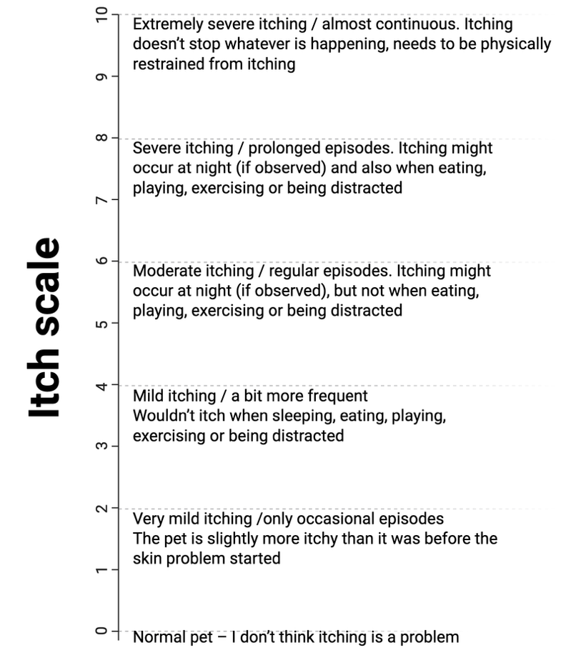

3. Ear infections
- No - Yes
- How often? - Left ear only - Right ear only - Both ears

4. General condition
- General well-being
- Normal - Reduced

- Appetite
- Normal - Reduced - Increased - How much?

- Amount of drinking water
- Normal - Reduced - Increased - How much?

- Weight loss
- Yes - No - If yes, how many kilograms: - Over what period of time:

- Weight gain
- Yes - No - If yes, how many kilograms: - Over what period of time:

- Activity
- Normal - Reduced
- Vomiting
- Yes - No
- How often per month/week/day:
- Do you observe Food/mucus/hairballs

- Coughing, gagging
- Yes - No
- How often per month/week/day:

- Urination
- Normal - Reduced - Increased
- Bowel movements
- Normal How many times/day:
- Urge to defecate/tenesmus

- Stool quality
- Normal
- Altered, such as:

- Eye discharge
- No. - Yes

- Heat
- Normal - When last time:
- Abnormal:

- Other symptoms:

- Other illnesses and problems:

5. Food
- What do you feed your pet:
- Tinned food (brand):
- Dry food (brand):
- Raw diet, what
- Food supplements (brand):
- Treats (brand, type):
- Table scraps: yes/no/what:

- Have you ever fed your pet a special (eg. allergy) diet:
- No
- Yes
- If yes, what diet food did you feed?
- How long did you feed it?
- Did you feed your pet anything else during this time, such as bones, treats, table scraps, chews, etc.?
- Yes - No - If yes, what:

6. Housing and skin care
- Pet Origin
- From breeder
- Private owner
- Have the pet since puppy/kitty
- Taken in at ... years old

- Access to outdoors (Free-range)
- No - Yes

- Stay in animal shelter
- No
- Yes, when last time:
- How often:

- Pet daycare
- No
- Yes, when:
- How often:

- Does your pet go into the water?
- No
- Yes, occasionally
- Yes, often

- Do you have other pets?
- No - Yes
- Cat - Dog - Birds - Other
- I live on a farm

- Does any of the other pets in your household have a skin problem?
- No - Yes
- What:

- Did your pet stay abroad
- No
- Yes, how often:
- When and where:

- Vaccination
- No - Yes
- Date last vaccination and which vaccine/disease:

- Deworming
- No - Yes
- What and how often:
- Last treatment:

- Ectoparasite treatment (against fleas, mites, ticks, etc.)
- No - Yes
- What and how often:
- Last treatment:

- Does any person in your household have skin problems?
- No - Yes

- Is anyone in your household immunocompromised?
- No - Yes

- Does any other animal in your pets litter have skin problems?
- No - Yes - I do not know

- Does your pet go to the groomer?
- No - Yes
- When last time?

