EMJM Education in Musuems & Heritage (EDUMaH)
Self-Funding Application Form
Programme Start Date: September 2026

Please complete this application form then print, sign, scan and upload as a PDF document to your International Master in Education Museums and Heritage (EDUMaH) application along with all other supporting documentation.

http://www.gla.ac.uk/postgraduate/apply/

Note: The EDUMaH Consortium will only accept references on headed paper. References must be uploaded at time of application. At least one must be an academic reference and, if appropriate, the other can be a professional reference from employment you have undertaken within 12 months prior to application date. References must be dated within the last two years of the date of submission of your application; be on headed paper or have an official stamp; be signed (either digitally or by hand - Please note that a typed name is not sufficient). If your referee prefers their reference to remain confidential, they can email the reference to erasmusreferences@glasgow.ac.uk, provided the email is from your referee’s professional email account and contains the full employee name and address.
- Personal and Contact Information
Title | Click here to enter text.
First name | Click here to enter text.
Family name | Click here to enter text.
Date Birth dd/mm/yyyy | Click here to enter a date.
Country of Birth | Click here to enter text.
City/Town of Birth | Click here to enter text.
Nationality | Click here to enter text.
Passport number | Click here to enter text.
Country of Residence | Click here to enter text.
Address:
Street, Number | Click here to enter text.
City, State, Postal Code | Click here to enter text.
Country | Click here to enter text.
Email | Click here to enter text.
Phone number | Click here to enter text.
Mobile number | Click here to enter text.
Special Needs (Please detail where applicable) | Click here to enter text.

- Please select the study tracks you are applying for:

The EDUMaH Consortium will make every effort to assign you to your first-choice options for Semesters 2 and 3. However, please be aware:

- Your first-choice option is not guaranteed.
- You may be placed in your second or third-choice options, depending on availability and programme requirements.
- If you ask to change your preference later, you may be placed on a waitlist.

Thank you for your understanding and cooperation.

Semester 2
☐ University of Tartu - Intangible Cultural Heritage

☐ University College Cork - Digital Cultures and Humanities

Semester 3
☐ University of Malta - Museum and Heritage Education

☐ Radboud University - Arts and Culture

- Supporting Personal Statement (Guidance)

- Please be as precise when writing your supporting personal statement.
- Do not repeat yourself and do not exceed the word limit.

You should make sure that you address the following issues in your personal statement:

- You should outline your motivation for choosing the EDUMaH programme (i.e., how it complements and develops your previous studies; how it relates to your career path; how it relates to your personal and academic interests).
- Explain why you think you are a good candidate for the programme given your previous studies and the courses offered on the programme in both years.
- Briefly indicate what you see as being the topic of your year 2 dissertation (this can change later).
- You should highlight your participation in conferences, internships, non-governmental organisations, summer schools, and other socially sensitive or political activity; as well as any prizes/awards received even if these activities are not specially connected to the area of Museum Education

Note: Samples of academic work will not be taken into consideration and should not be submitted.

- Supporting Personal Statement

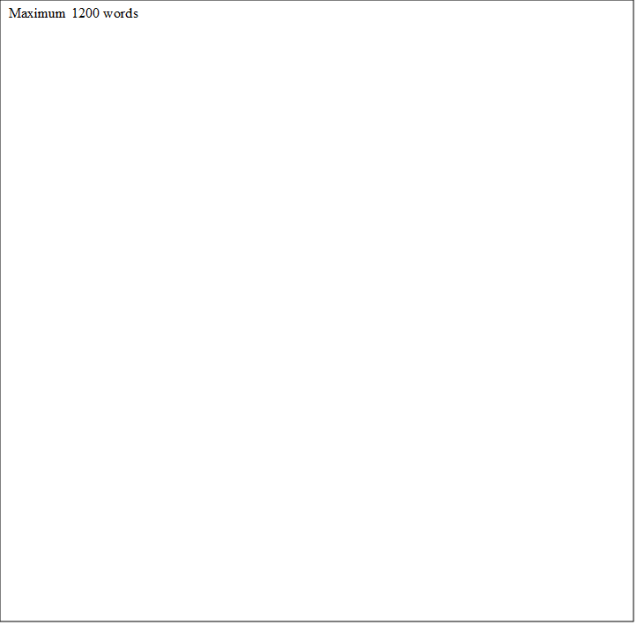

- Declaration

I hereby declare that:

- I have addressed all the entry requirements described on EDUMaH website
- I have completed all sections above

Signature................................................................................ Date: ……………………………..

