**BACKGROUND**

This is the process for when students need changes made to their supervised research period or thesis pending period.

The HDC Form is used for the following:

* Suspension of studies of supervised research period
* Extension to thesis pending period
* Changes to status from full time to part time or reversed.
* Change degree

**HOW TO SUBMIT A REQUEST**

* Log in to your MyGlasgow Student Portal Homepage in MyCampus: <https://www.gla.ac.uk/myglasgow/students/>

* You should see a section of tiles.
* To submit a request to send to the Higher Degrees Committee, click the HDC Request tile:

* You will see the ‘SUBMIT A REQUEST’ page:
* Make sure to read the PGR Code of Practice and University Regulations to make sure what you want to request meets the guidelines.
* If it does, click ADD NEW REQUEST

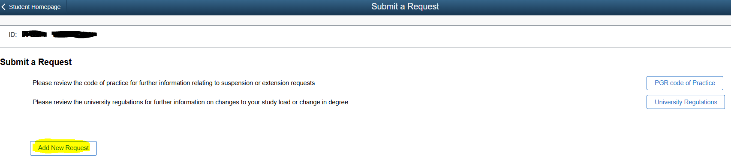

**COMPLETE THE FORM**

**SUBMIT APPLICATION**  
Change the toggle to yes

**SUPERVISOR**  
Select your supervisor

**SUPPORTING DOCS**  
Upload all supporting docs required, i.e., medical certs, visa docs if required.

**REQUEST**  
When you request a suspension or extension you will be asked to choose from/to dates.

A free text box is available for you to provide more info.

**FEES**  
If you do not know this info, contact your local school PGR admin, or the MVLS Graduate School.

* Once you have completed the form you will receive an email that your request has been submitted.
* Your supervisor will receive an email letting them know that you have submitted a request and to take action. They will review your request.
* **Correct Form:** If your form has been completed correctly, your supervisor will submit their comments. The PG Convenor will then be notified of your application.
* **Incorrect Form:** If they think information is missing or incorrect, they can send it back to you with additional notes.
* You will receive an email that looks similar to this:

* Log back in to your request, adjust your form and resubmit. Your supervisor will review and submit the form to the PG Convenor for review.
* The PG Convenor reviews your application and goes through the same process.
* All HDC forms will be collated by the MVLS Graduate School in time for the next HDC meeting. Your request will be discussed between the Higher Degrees Committee and a decision made.
* The MVLS Graduate School will inform you once a decision has been made via an automated email:

* The MVLS Graduate School will follow up on this with more detailed information.
* Your MyCampus record will be updated as appropriate if your request has been successful and changes are required.

If you have any questions, contact the MVLS Graduate School.