Lead Graduate School & Research Network Retreat

Hsiao-Chiang Wang (Hope)

With the support of CIVIS and SoE, I am very glad to have the opportunity to participate in the [LEAD Graduate School & Research Network](https://uni-tuebingen.de/forschung/forschungsschwerpunkte/lead-graduate-school-research-network/) 2025 Retreat and to lead a special interest group discussing creative methods in educational research. LEAD focuses on interdisciplinary and empirical education research, building international networks and offering structured graduate training.

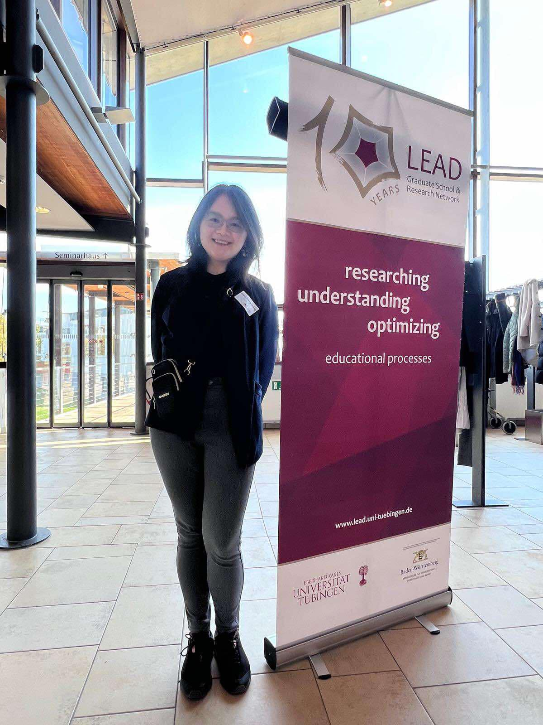

Figure I participated in the LEAD Graduate School & Research Network 2025 Retreat. Source: Zhipeng.

The LEAD Retreat 2025, held in Schwäbisch Gmünd, Germany, between 9th and 11th April 2025, brought together researchers, educators, and graduate students for three days of collaboration, learning, and discussion. The keynotes bring valuable insights into crucial topics, such as machine learning to improve teaching, global teacher shortages, digital technology on adolescent mental health, and learning analytics. The poster presenters showcased diverse research themes, from motivation and gifted education to educational technology. We also had two social walks and one dance between the intensive academic events. I could feel the academia atmosphere is international, and encouraging critical thinking.

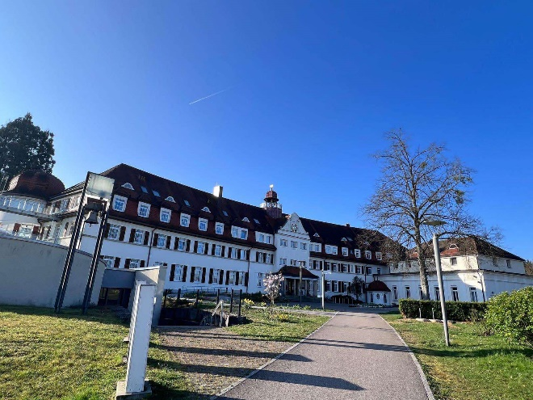

Figure The LEAD Retreat 2025, held in Schwäbisch Gmünd, Germany. Source: Hope

On the second day of the retreat, I facilitated a workshop structured around five letters to explore the uses of creative methods in educational research. During the session, I discussed these methods' terminology, applications, and implications, emphasising their relevance to contemporary research. Drawing on my experience designing six workshops for my PhD research, I adopted a participatory approach and shared insights from my own projects to engage and contribute to the participants.

The workshop attendees came from diverse backgrounds and were at various stages of their research journeys, which enriched the discussion and deepened our collective understanding. Their feedback, informed by their unique perspectives, greatly enhanced the shared exploration of creative education methods.

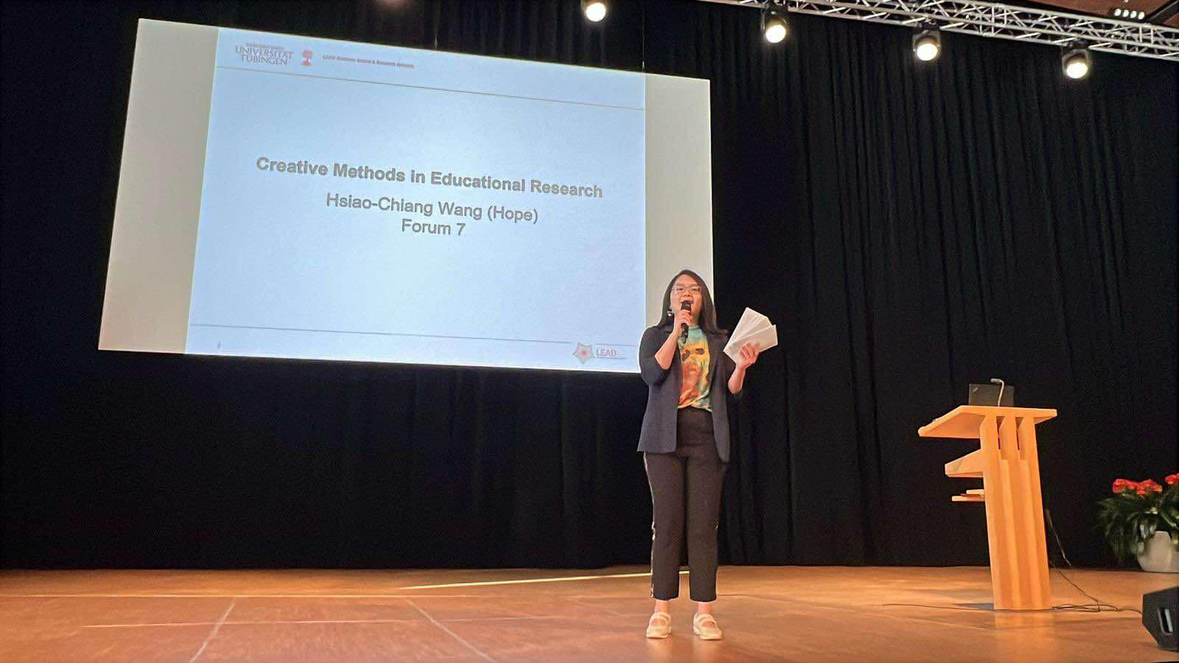

Figure I facilitated the creative methods in educational research workshop. Source: Zhipeng.

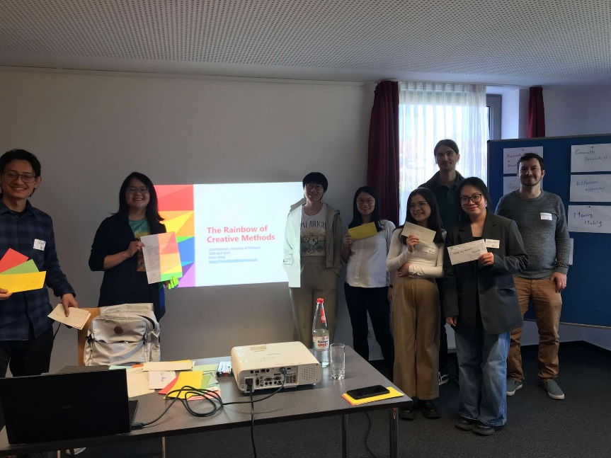

Figure Participating scholars and me. Source: Hope

The LEAD Retreat 2025 was an eye-opening experience, and I learned so much from it while immersing myself in a very different academic culture. At the University of Glasgow's School of Education, many of my colleagues, including myself, tend to use qualitative research approaches or mixed methods. However, in the LEAD network, quantitative research clearly dominates. There is a strong emphasis on the scientific spirit, as nicely opening speech by Co-director Prof. Ulrich Trautwein, who said, ‘As researchers, we speak the truth to power.’ This philosophy was reflected in the work presented by LEAD researchers, who primarily collect quantitative data to test hypotheses rigorously. The research is then used to make policy recommendations or design technology that improves learning systems and methods.

This gave me a moment to reflect on how different our focus is at Glasgow. In our work, we’re more about ‘listening to and speaking for those disempowered.’ That’s why many of us choose qualitative approaches that let us deeply engage with target communities, or apply creative methods to uncover truths that tend to be overlooked or misunderstood. These differences clearly highlight how different values and contexts shape the research paradigms across the two institutions. The two different research values are not in conflict, instead, I see the potential for collaboration. As a researcher who aims to make marginalised groups of people heard and understood, and make real changes to the world. We need to speak to the powers and empower more people.

I had some fantastic conversations with LEAD colleagues during the retreat, and it was exciting to find common ground and potential opportunities for collaboration. For instance, some of the researchers I met are exploring creativity but are approaching it quantitatively. I suggested that incorporating creative methods and qualitative approaches could really add depth and a new perspective to their work on this topic.

Another highlight of the retreat was a thought-provoking discussion on the concept of ‘fast science,’ introduced by Jacob Stegenga. It made us all reflect on our roles as education researchers and how we manage the balance between producing timely research and maintaining depth and integrity in our work.

Overall, I am incredibly grateful for the chance to attend the LEAD retreat. It was a truly enriching experience, and I hope the CIVIS network can keep bringing researchers together to exchange ideas and inspire each other. Collaborations like these not only build connections but also sharpen our perspectives, making our work stronger and more impactful.

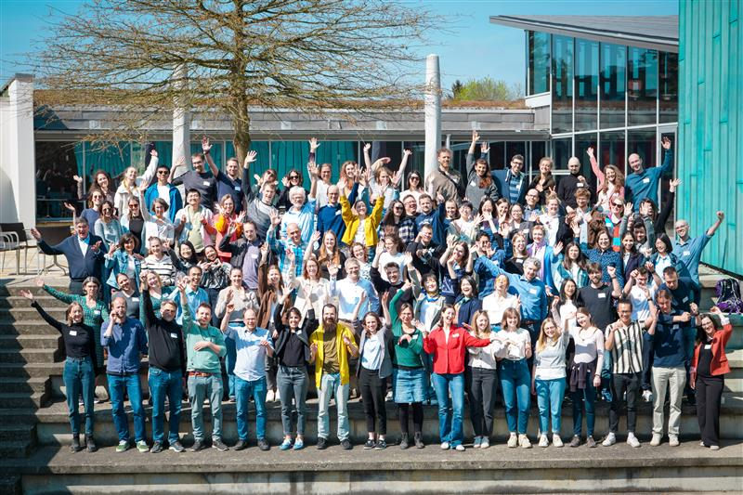

Figure the group photo of LEAD Graduate School & Research Network. Source: the LEAD