

Staff Equality Monitoring Report 2023-24

# Executive Summary

This is the thirteenth annual staff equality monitoring report produced by the Equality and Diversity Unit and follows largely the same format as the previous reports. This report supports the University’s obligations to publish annual staff equality monitoring data as part of the Public Sector Equality Duty (PSED) under the Equality Act 2010.

The publishing cycle reflects the previous academic cycle (August 2023 –July 2024).

The report shows the following important points, changes and challenges:

* The KPI’s set in the [University strategy](https://www.gla.ac.uk/explore/strategy/) has three diversity components, the variance this year are:
  + Senior women has increased by 1.2% to 35.0%
  + Declared disability has increased from 6.8% to 9.1%.
  + UK Black, Asian and Minority Ethnic (‘Minority Ethnic’) representation up from 5.7% to 6.7%.
* The University has maintained good progress in reducing the percentage of ‘Unknowns’ across all categories since 2022-23. This has contributed most meaningfully to the following:
  + Disability status ‘Unknown’ category reduced to 3.8% from 7.2% in 2022-23.
  + Minority Ethnic ‘Unknowns’ reduced to 6.3% from 11.6% in 2022-23.
  + Religion or Belief ‘Unknown’ category reduced to 20.3% from 27.2% in 2022-23.
  + Sexual Orientation ‘Unknown’ statistics reduced to 16.3 from 22.8% in2022-23.
* The percentage of all Minority Ethnic colleagues has increased by 2.4% since 2022-23 to 17.7%.
* The balance of colleague distribution by Sex is fairly static, with 55.2% female and 44.8% male.
* Science and Engineering saw an increase in female colleagues by 1.5%, reversing last year’s drop.
* The largest cohort of colleagues declaring a disability have a long-term illness or health condition, followed by those who declared a learning difference such as Dyslexia and ADHD.
* In Religion or Belief, the largest cohort of colleagues state they have no religion, increasing by 4.1% to 40.1%. Of those with a declared faith, Christian remains the largest demographic at 20.1%%.
* Declaration rates within the University’s LGB community are rising, increasing by 1.3% to 8.5%.
* Our colleagues who identified as a different gender identity to that registered at birth is growing, with a 45% increase to 99 colleagues since 2022-23, however numbers are small relative to whole staff profile.
* Arts and Humanities saw the largest increase of Disability declarations, by 4.5% of all Colleges/US.
* Of all job families, the MPA job family had the largest increase in Disability declarations, 3.1% since 2022-23.
* There has been a significant increase in the proportion of colleagues raising Grievances who are either Disabled or from a Minority Ethnic background. It is unclear from this summarised data what the driving factors of this may be and as such, this warrants further investigation.

# Introduction

The Staff Equality Monitoring Report allows the University to have a standard base for all staff equality information across the organisation. This report meets one of the University’s obligations under the Public Sector Equality Duty (PSED).

The aim of this report is to provide transparent data for all functions in the institution to use when equality information is required, such as when conducting Equality Impact Assessments (EIA).

# Structure

This report has been structured to provide a ‘Whole University’ overview by all the main protected characteristics plus full/part time working, and maternity leave followed by specific sections on Age, Disability, Ethnicity, Sex and Sexual Orientation with a breakdown of data by the following:

* College
* Grade 10 staff
* Job Family Profiles
* Grade
* Full/Part Time
* Contract Type
* Nationality
* Recruitment – by all applicants and successful applicants

We have not provided a further breakdown beyond ‘Whole University’ on data for religion and belief as the proportion of staff answering these questions is too small to give meaningful information.

Further information has then been provided on:

* Academic Promotions – by Sex
* Regrading for Professional & Support Staff – by Sex
* Case management - by Sex, Ethnicity and Disability
* Sickness Absences - by Age, Disability, Ethnicity, Sex, and Sexual Orientation

# Notes and definitions

This report is based on a census date of **31 July 2024**, unless otherwise stated. This date captures staff at their grade prior to any promotions which take effect on 1 August. Percentages have been provided, as there are some instances where numbers are very small and using actual numbers carries the potential to be able to identify individual staff. Overall proportions for each of the sections have been provided in Tables 1-6 below.

Whole University - Total head count is **10449** (up 288 on last year). This is the head count for all staff in the University; those with multiple contracts are only counted once. The three previous year’s total headcount figures were 9380 (2020-21), 9595 (2021-22) and 10161 (2022-23).

College/University Services Split

When using the term ‘By College’ later in this report University Services is also included.

|  |  |  |  |
| --- | --- | --- | --- |
| Table 1 - College | %2021-22 | %2022-23 | %2023-24 |
| Arts & Humanities | 8.5% | 8.5% | **8.4%** |
| MVLS[1] | 29.4% | 28.0% | **28.8%** |
| Science and Engineering | 21.8% | 21.8% | **21.1%** |
| Social Sciences | 16.7% | 16.5% | **16.5%** |
| University Services | 23.6% | 25.2% | **26.0%** |

Job Family Profile

Some members of the Senior Management Group (SMG) may be classed as ‘Research & Teaching’ or ‘Clinical’ under the Job Family profile. For reporting purposes, they will have been moved into SMG, and the original Job Family figures amended accordingly.

|  |  |  |  |
| --- | --- | --- | --- |
| Table 2 - Job Family | %2021-22 | %2022-23 | %2023-24 |
| Clinical | 3.3% | 3.1% | **3.3%** |
| Management, Professional and Administrative (MPA) | 27.5% | 29.9% | **31.4%** |
| Operational | 7.8% | 7.5% | **7.3%** |
| Research & Teaching[2] | 52.9% | 52.0% | **46.0%** |
| Senior Management Group (SMG) | 0.1% | 0.1% | **0.1%** |
| Technical & Specialist | 8.4% | 7.3% | **11.9%** |

By Full/Part Time

All staff who work less than one FTE are considered Part Time.

|  |  |  |  |
| --- | --- | --- | --- |
| Table 3 - Full Time / Part Time | %2021-22 | %2022-23 | %2023-24 |
| Full Time = FTE 1.0 | 63.5% | 63.3% | **65.0%** |
| Part Time = FTE - 0 + anything < 1.0 | 36.5% | 36.7% | **35.0%** |

By Contract Type

The contract types are as follows;

**F** = Fixed term as per FT & OE Contract policy

**O** = Open ended with funding end date

**P** = Open ended + Permanent in Temporary Fixed Term Appointment

**S** = Fixed term - SOSR e.g. Maternity leave cover

|  |  |  |  |
| --- | --- | --- | --- |
| Table 4 - Contract Type | %2021-22 | %2022-23 | %2023-24 |
| F = (F) Fixed term | 20.8% | 15.7% | **11.4%** |
| O = (O) Open ended with funding end date | 14.6% | 13.4% | **13.4%** |
| P = (P) Open ended + (C) Permanent in Temporary Fixed Term Appointment (Head of College/Principal/Vice Principal roles) | 56.1% | 58.5% | **60.8%** |
| S = (S) Fixed term - SOSR e.g. Maternity leave cover | 8.5% | 12.4% | **14.4%** |

In recent years the University has moved some colleagues from Fixed term contracts to SOSR contracts, these have in the main part been GTAs, Tutors and Demonstrators. This is reflected in the continued decrease in Fixed Term contracts and the increase in SOSR contracts.Grade Grouping

|  |  |  |  |
| --- | --- | --- | --- |
| Table 5 - Grade Grouping | % 2021-22 | % 2022-23 | %2023-24 |
| Grade 1 | 1.6% | 1.1% | **0.9%** |
| Grade 2 | 3.8% | 4.2% | **4.2%** |
| Grade 3 | 4.2% | 3.7% | **4.1%** |
| Grade 4 | 5.6% | 5.3% | **5.3%** |
| Grade 5 | 14.6% | 15.1% | **14.4%** |
| Grade 6 | 20.7% | 20.8% | **20.5%** |
| Grade 7 | 17.7% | 18.2% | **18.3%** |
| Grade 8 | 12.9% | 13.0% | **12.9%** |
| Grade 9 | 8.1% | 8.0% | **8.3%** |
| Grade 10 (see Table 6 for definition) | 6.9% | 7.1% | **7.6%** |
| Clinical | 3.3% | 3.1% | **3.3%** |
| Other[3] | 0.5% | 0.4% | **0.3%** |

|  |  |  |  |
| --- | --- | --- | --- |
| Table 6 – Grade 10 staff  (based on Actual Grade Description) | % 2021-22 | % 2022-23 | %2023-24 |
| Professor & Equivalent MRC Grades | 88.5% | 87.1% | **86.9%** |
| Senior Administrative Group | 9.4% | 11.0% | **11.4%** |
| Senior Management Group (SMG) | 2.1% | 1.9% | **1.8%** |

Age

Two charts are provided for the whole University age data, using 5-year groupings and then 10-year age groupings. For all subsequent charts, the age data is provided using the 10-year age groupings only.

Disability

Disability statistics include colleagues who have self-identified as ‘disabled’, as well as those who have provided details of an impairment or long-term health condition, whether they have self-identified as ‘disabled’ or not.

Two charts have been provided for the whole University disability data, whether staff have stated they have a disability, and then by impairment category. For all subsequent charts the disability data is only provided by whether staff have stated they have a disability or not. HESA made minor changes to the impairment categories in 2022-23, and therefore reports prior to that date will not truly match to following years.

Ethnicity

Two charts have been provided for the whole University ethnicity data. For all subsequent charts all ethnic minority categories have been combined and shown as ‘Minority Ethnic’[4].

The University understands this is not a collective experience, however, small numbers prevent disaggregation of data into smaller subsets.

The figures shown in the report’s Ethnicity section as ‘Unknown’ includes the category option ‘Not known’ where staff genuinely do not know their ethnicity, for example those who were adopted.

HESA made minor changes to the ethnicity categories in 2022-23, and therefore reports prior to that date will not truly match to following years.

Maternity

This outlines the percentage who returned to work, the percentage still on leave and due to return, those whose contract ended within the period and those who resigned within the reporting period.

Gender Reassignment

To collect information in relation the protected characteristic of gender reassignment the University currently uses the 2022-23 HESA recommended question ‘Does your gender identity match your sex as registered at birth?'. Responses are based on the staff member’s own self-assessment. Due to the wording of the HESA recommended question, it is possible people who identify as Non-binary may be included in the statistics.

The University now also asks ‘Do you consider yourself to be trans, or have a trans history?’ and we report on this for the first time in this report.

Nationality

This is based on information provided by staff about their right to work in the UK. For the purpose of this report, we have used the following categories: UK, EU/EEA and International.

Sexual Orientation

For the purposes of this report, the sexual orientation categories of Lesbian, Gay and Bisexual have been combined and shown as LGB. The whole University data shows the full breakdown, including where information has not been declared.

Due to high undeclared rates, all subsequent charts only rates of declared sexual orientation or ‘prefer not to say’ data is provided. The ‘Unknown’ figures have been excluded from those graphics but have been included in the statistics used to create them. This allows for more meaningful visual comparison across annual reports.

Recruitment - Applications and Successful Applicants

The census date is based on the date the post was first advertised, 01 August 2023 – 31 July 2024. The data excludes direct appointments. The data also excludes those who withdrew during the application process or prior to an offer decision. The data will include individuals more than once if they applied for multiple roles during the time period. Some roles have more than one post available and so have more than one successful applicant. Data is provided for applicants and successful applicants.

We continue to have high numbers of instances where we receive no monitoring data from applicants; this is recorded as ‘Unknown’ in the data set. We continue to work with the University’s Recruitment Team to understand the causes and engage with them to seek and implement solutions to minimise this in the future.

This year, we have been unable to report on Recruitment by Age due to the overwhelming number of blank fields connected with ‘Age’ and ‘Date of Birth’. We continue to work with our system provider to address this and will rectify any issues for subsequent reporting years.

Case Management

This section provides data on formal employment related procedures - Managing Attendance, Discipline and Grievance cases during the report period 01 August 2023 – 31 July 2024. Data is provided by Sex, Disability and Ethnicity. Grievance case numbers are based on the staff member who raised the Grievance.

Additionally, within this section data is provided on Sickness Absences between 01 August 2023 –

31 July 2024. Figures are based on staff who had at least one absence of 20 or more continuous working days. Charts are provided by Age, Disability, Ethnicity, Sex and Sexual Orientation.

Academic Promotions and Professional & Support Staff Regrading

The data for promotion is only provided by Sex as further disaggregation carries a risk of identifying individual staff.

Pay Gap Information

In accordance with the Public Sector Equality Duties, the Gender Pay Gap and Equal Pay information for Disability and Ethnicity are provided in line with our legislative requirements in a separate report.

# Whole University Profile

## Age

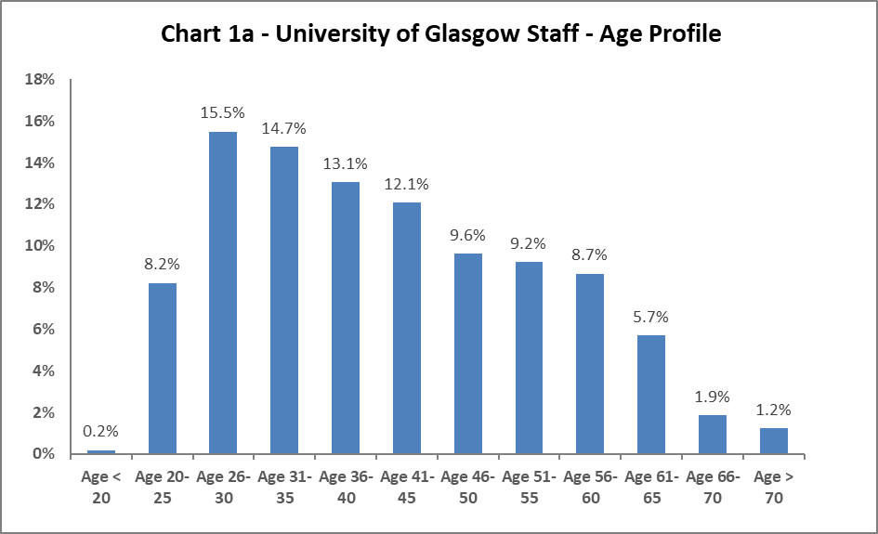

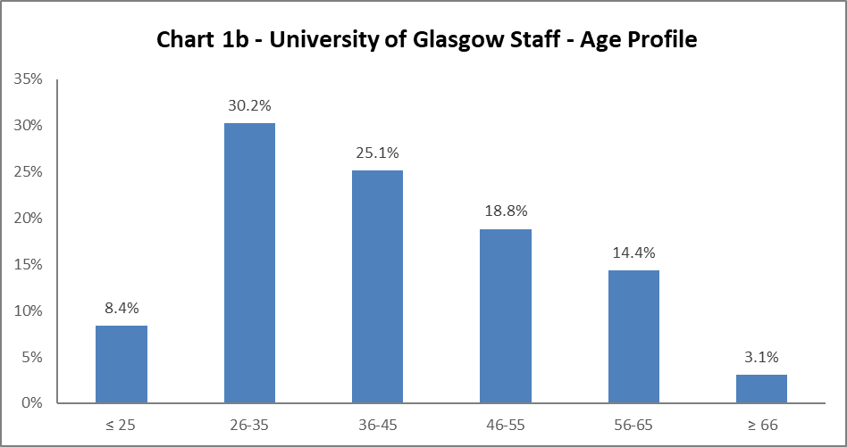

The University's age profile in 2023-24 is very similar to the previous year. There are minor reductions in the ≤ 25category and increases in the 26-55 age categories.

## Disability

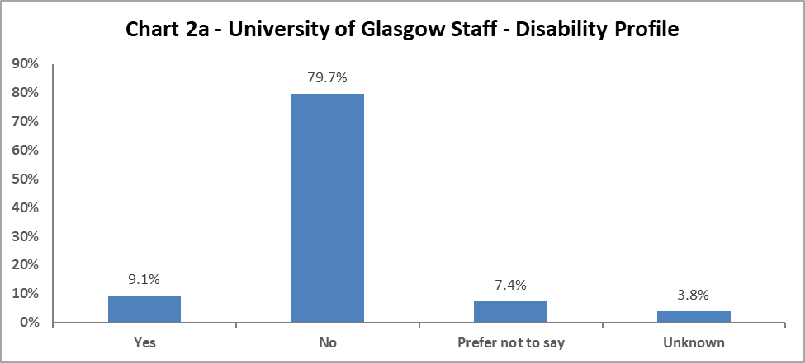

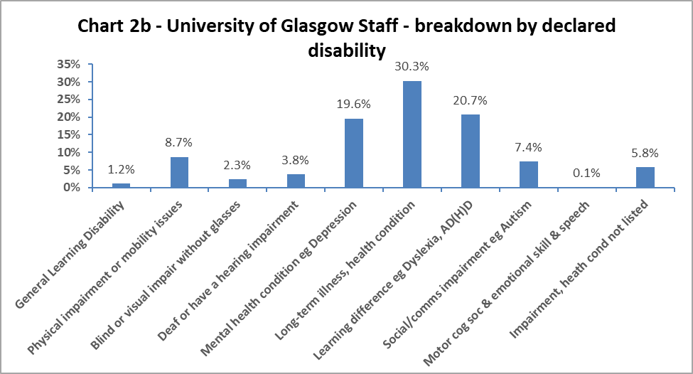

Chart 2a shows 9.1% colleagues have declared a disability; this is a 2.3% increase from last year. In addition, the proportion of ‘Unknowns’ dropped from 7.2% in 2022-23 to 3.8% in 2023-24, while there were slight increases in ‘Prefer not to say’ from 6% in 2022-23 to 7.4% in 2023-24. There has been a specific drive to improve data quality within People and Organisational Development (P&OD), with monthly reminders sent to colleagues who have not completed this data.

When considering declared impairment type, in Chart 2b, the largest cohort continues to be those reporting a ‘long-term illness or health condition’. The next highest category is colleagues reporting a ‘learning difference’, up by 3.2% on 2022-23. For other impairments, the data shows there has been an increase of 0.8% of both those who are ‘Blind or have a visual impairment without glasses’ and those reporting a ‘physical impairment or mobility issues’. There has been a notable decrease of 1.5% of those with a ‘mental health condition since 2022-23.

## Marital Status

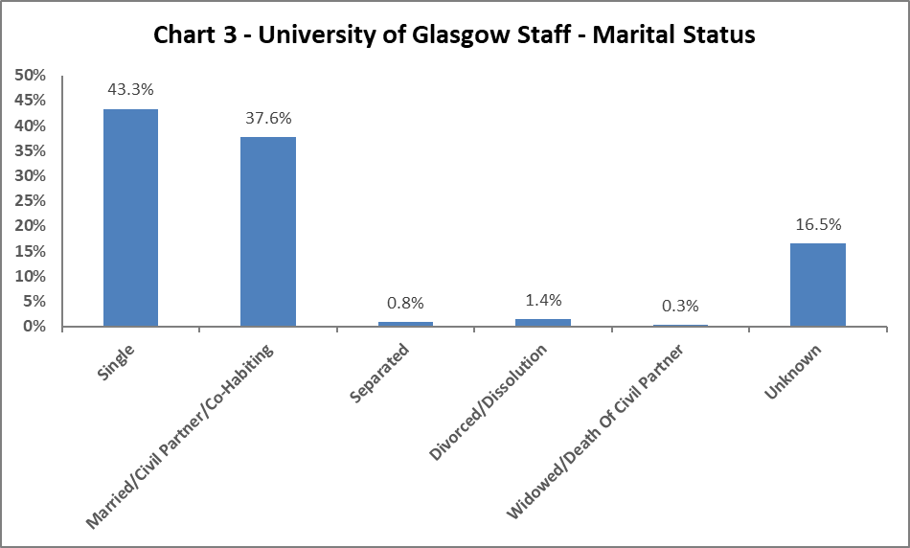

Chart 3 shows the largest percentage of colleagues are single, with a minor decrease from 2022-23 of 1.5%, and a 0.7% increase in those who are married/civil partnership/co-habiting. All other marital status areas have remained the same, save for those who are separated, which increased by 0.1%.

## Full Time/Part Time

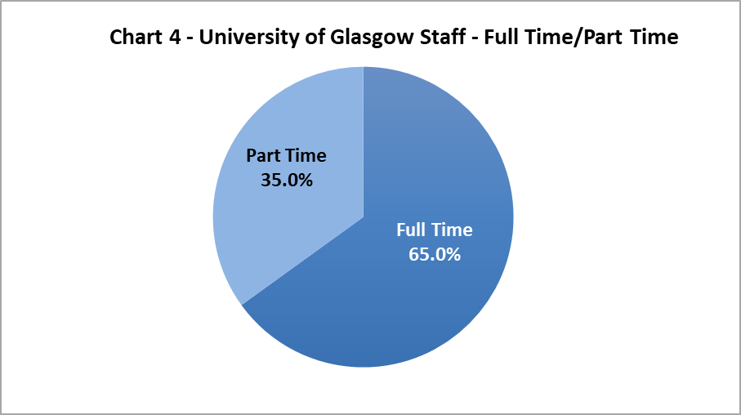

Chart 4, above, shows just under two thirds of colleagues work full time and over one third work on a part time basis. These proportions have only seen minor changes since 2022-23, with a 1.3% reduction in those working part time.

## Nationality

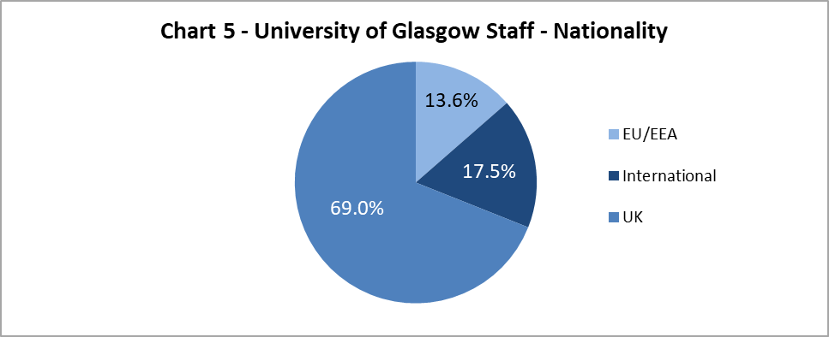

The data shows the University continues to grow our International colleague cohort, with a modest 0.5% increase since 2022-23, this adds to the 2.5% increase seen in 2021-22. The proportion of EU/EAA colleagues has dropped slightly by 0.7% since last year, with UK colleague proportions remaining fairly static.

## Ethnicity

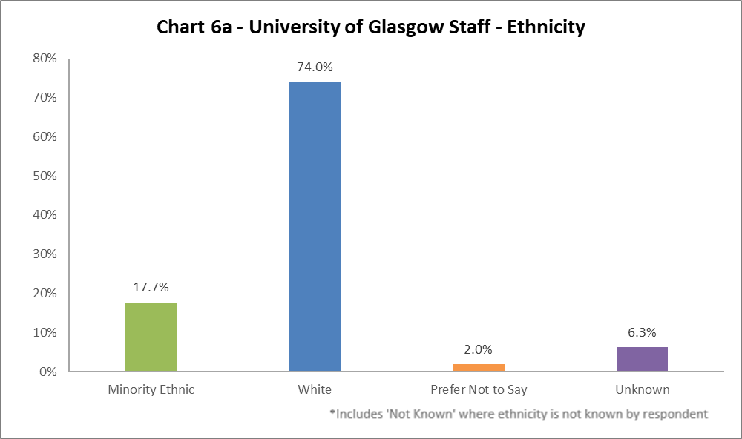

Chart 6a shows the University has seen an increase of 2.4% in declarations colleagues from a Minority Ethnic background, to 17.7%. There has been a 2.6% increase of colleagues from White backgrounds and a 5.3% decrease in the ‘Unknown’ category. There has been a specific drive over recent years by P&OD to improve the data quality, with monthly reminders sent to colleagues who have not completed this data. This work should continue in earnest.

Chart 6b, below, shows the breakdown of ethnicities. There have been slight increases of 0.8% of colleagues who are Asian Chinese or British Chinese, and 0.7% for those identifying with Any other Asian Background. The largest increase was amongst White English, Welsh, Northern Irish or British group, which has increased by 4.2%.

## Chart 6b - Profile by detailed Ethnicity. Categories match those used in the Scottish Census. 36.4% have identified as 'White Scottish' and 30.1% have identified as 'Any other White Background'. The next largest declared category is 'White English, Welsh, N Irish or British' at 6.1%, followed by 4.5% 'Asian Chinese or Chinese British' and 3% 'Asian or Asian British - Indian'. 2% have chosen 'Prefer not to say', with 3% as 'Not known' and 3.3% have not declared any ethnicity.

## Religion and Belief

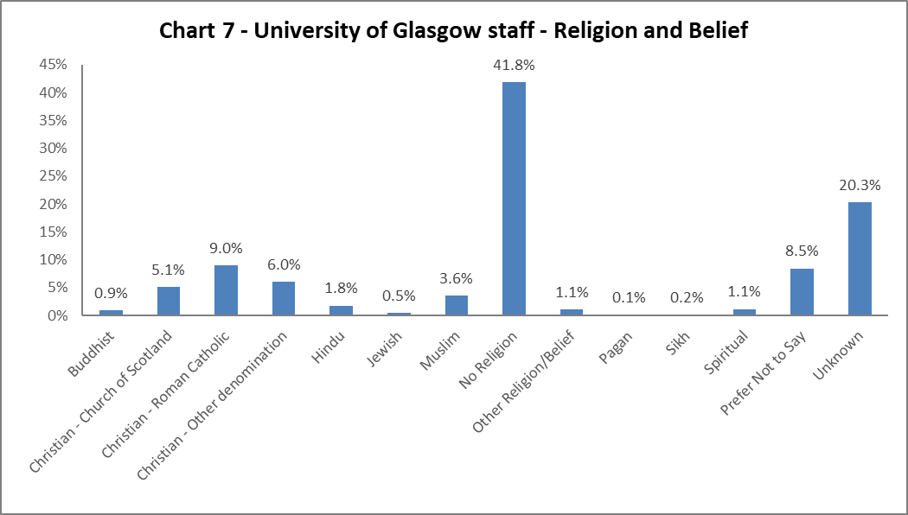

The largest component of colleagues declaring continue to state they have no religion, an increase of 4.1% from 2022-23. 20.1% of colleagues state they are Christian, an overall increase 1.4% from 2022-24. There has been a slight increase in colleagues identifying as Buddhist and, Jewish by 0.1% and an increase of 0.7% amongst colleagues identifying as Muslim, since 2020-21. There has been a 6.9% decrease in the ‘Unknown’ category.

**Sex**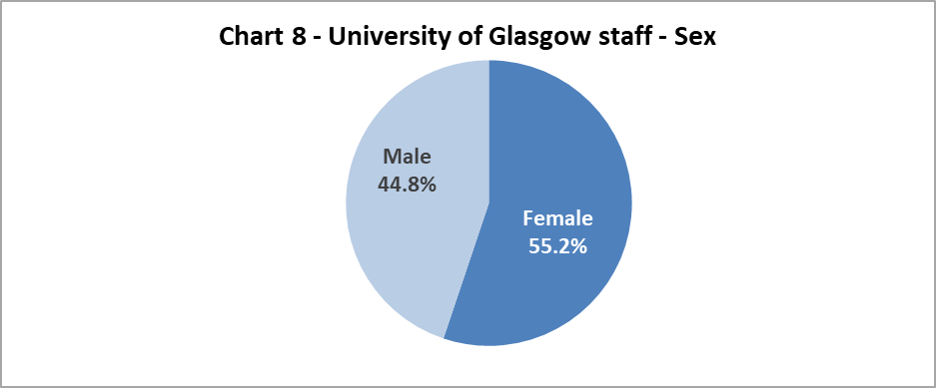

Chart 8 shows the proportion of colleagues by Sex, this only changed by 0.5% between the sexes, towards Female, from 2022-23.

## Sexual Orientation

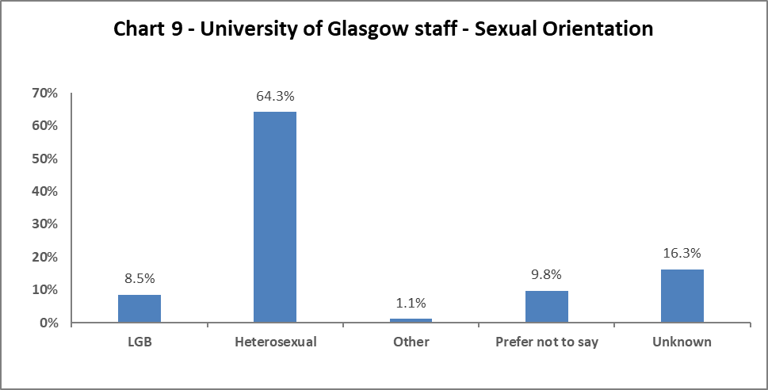

Chart 9 shows the percentage of colleagues who identify as Lesbian, Gay or Bisexual (LGB)– this has increased by 1.3% to 8.5% since the previous report. There has been a drop of 6.5% of ‘Unknown’ category, with a 0.8% increase in those who ‘Prefer not to Say’ and an increase of 4.2% of those who are Heterosexual.

## Maternity Leave

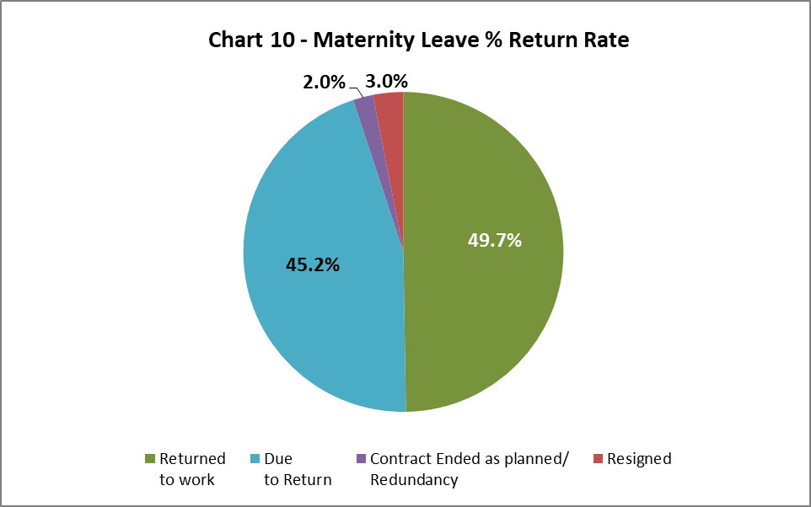

There has been a 0.1% decrease in resignations post maternity leave from 2022-24. Colleagues’ contracts ending whilst they are on Maternity Leave has seen a 2.1% decrease from 2022-23.

## Gender Reassignment

99 people answered negatively to the HESA recommended question relating to gender identity: ‘Does your gender identity match your sex as registered at birth?’.

29 colleagues answered affirmatively to the newly recommended question:

'Do you consider yourself to be trans or have a trans history'. Some colleagues have answered both questions and so there are 107 unique respondents to these questions.

# Profile by Age

## By College

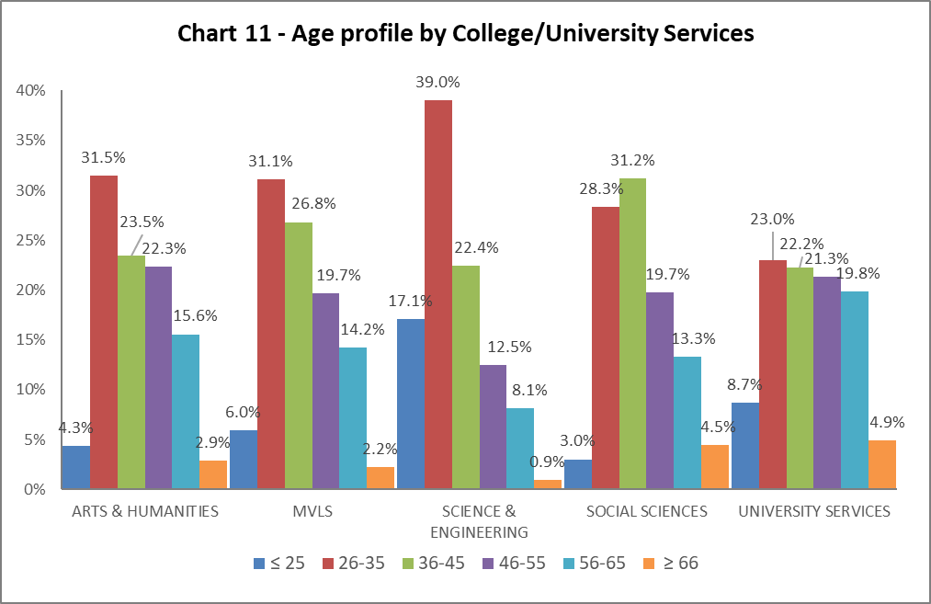

|  |  |  |  |  |  |
| --- | --- | --- | --- | --- | --- |
| Table 7 | ARTS & HUMANITIES | MVLS | SCIENCE & ENGINEERING | SOCIAL SCIENCES | UNIVERSITY SERVICES |
| Age Range | **%** | **%** | **%** | **%** | **%** |
| ≤ 25 | 4.3 | 6.0 | 17.7 | 3.0 | 8.7 |
| 26-35 | 31.5 | 31.1 | 39.0 | 28.3 | 23.0 |
| 36-45 | 23.5 | 26.8 | 22.4 | 31.2 | 22.2 |
| 46-55 | 22.3 | 19.7 | 12.5 | 19.7 | 21.3 |
| 56-65 | 15.6 | 14.2 | 8.1 | 13.3 | 19.8 |
| ≥ 66 | 2.9 | 2.2 | 0.9 | 4.5 | 4.9 |

Chart 11 above is a visualisation of the distribution of ages in each College/US which can be compared with the Whole University distribution in Chart 1. Table 7 above gives the relevant percentages. There is a mainly consistent picture between 2022-23 and 2023-24, with the majority of colleagues across the College/US aged 45 and under. We continue to have a significantly younger population in Science and Engineering compared to other Colleges and US.

## By Grade 10 staff

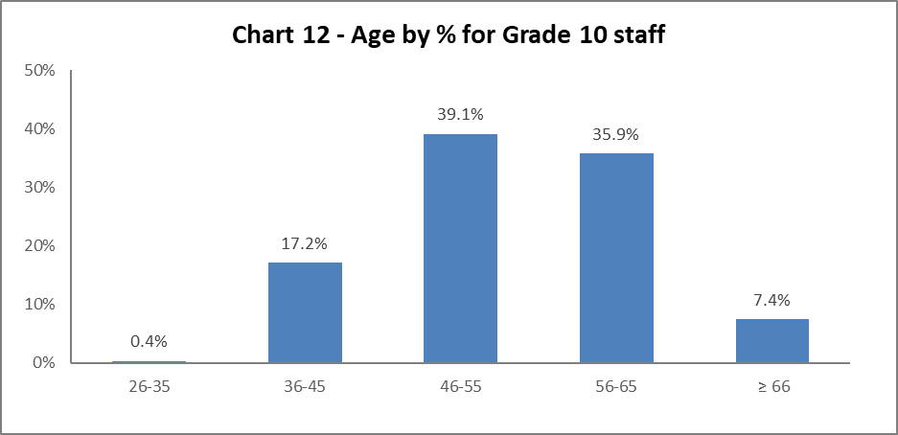

Chart 12 above shows most Grade 10 colleagues are aged 46 or over. This is a fairly static picture compared to previous years.

## By Job Family Profile

## Chart 13 shows the age profile b Job Family. Nearly two thirds of Clinical staff are aged under 46. MPA job family staff fall into a bell curve across the age groups. More than 60% of all Operational staff are aged 46 and over. Just over a third of Research and Teaching staff are aged 26-35. Nearly two thirds of those in the SMG are aged 56 and over with only 7.1% aged under 46. Just under 65% of Technical and Specialist staff aged under 36.

Chart 13 above outlines the age distribution by job family. Technical and Specialist job family shows a change in age profile since 2022-23, with the proportion of staff aged 46 and older decreasing from 35.9% to 21.5%. The profiles across all other job families are largely the same since 2022-23. Operational job family continue to have an older demographic, with the highest proportion of staff (c.9%) over the age of 66. Table 8 below gives the relevant percentages.

|  |  |  |  |  |  |  |
| --- | --- | --- | --- | --- | --- | --- |
| Table 8 | Clinical | MPA | Operational | Research & Teaching | SMG | Technical & Related |
| Age Range | **%** | **%** | **%** | **%** | **%** | **%** |
| Age ≤25 | 0.0 | 7.9 | 8.3 | 4.9 | 0.0 | 25.8 |
| Age 26-35 | 28.3 | 25.4 | 17.0 | 33.6 | 0.0 | 38.9 |
| Age 36-45 | 33.2 | 26.5 | 14.1 | 28.3 | 7.1 | 13.8 |
| Age 46-55 | 20.8 | 22.5 | 19.0 | 18.3 | 28.6 | 10.5 |
| Age 56-65 | 13.9 | 15.1 | 32.8 | 12.0 | 57.1 | 10.0 |
| Age ≥66 | 3.8 | 2.7 | 8.7 | 2.9 | 7.1 | 1.0 |

## By Grade

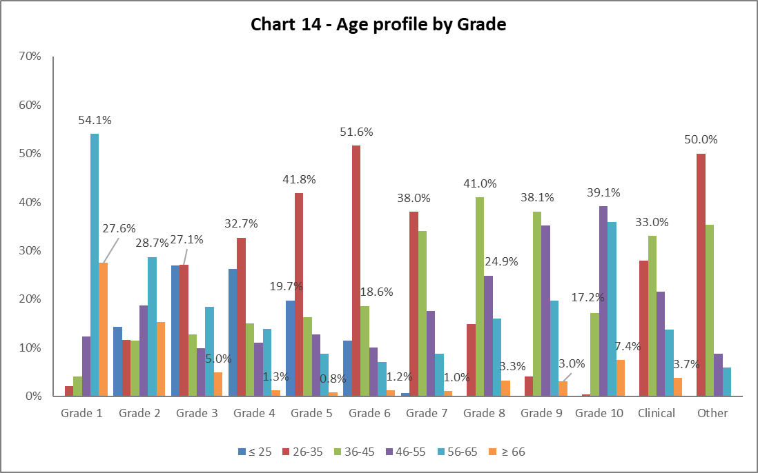

|  |  |  |  |  |  |  |  |  |  |  |  |  |
| --- | --- | --- | --- | --- | --- | --- | --- | --- | --- | --- | --- | --- |
| Table 9 | Grade 1 | Grade 2 | Grade 3 | Grade 4 | Grade 5 | Grade 6 | Grade 7 | Grade 8 | Grade 9 | Grade 10 | Clinical | Other |
| Age Range | **%** | **%** | **%** | **%** | **%** | **%** | **%** | **%** | **%** | **%** | **%** | **%** |
| Age ≤ 25 | 0.0 | 14.4 | 26.9 | 26.2 | 19.7 | 11.5 | 0.6 | 0.1 | 0.0 | 0.0 | 0.0 | 0.0 |
| Age 26-35 | 2.0 | 11.6 | 27.1 | 32.7 | 41.8 | 51.6 | 38.0 | 14.8 | 4.1 | 0.4 | 27.9 | 50.0 |
| Age 36-45 | 4.1 | 11.4 | 12.7 | 15.0 | 16.3 | 18.6 | 34.0 | 41.0 | 38.1 | 17.2 | 33.0 | 35.3 |
| Age 46-55 | 12.2 | 18.7 | 9.9 | 11.0 | 12.7 | 10.1 | 17.6 | 24.9 | 35.2 | 39.1 | 21.6 | 8.8 |
| Age 56-65 | 54.1 | 28.7 | 18.4 | 13.9 | 8.7 | 7.0 | 8.7 | 16.0 | 19.7 | 35.9 | 13.8 | 5.9 |
| Age ≥ 66 | 27.6 | 15.3 | 5.0 | 1.3 | 0.8 | 1.2 | 1.0 | 3.3 | 3.0 | 7.4 | 3.7 | 0.0 |

Chart 14 and Table 9 above show the grade profile for age range. This largely reflects 2022-23 age range within grade. With exception of grade 1 and 2, where staff are likely to be older, reflecting the job families in these grades, generally, as the grades increase the age profile advances.

## By Full/Part Time

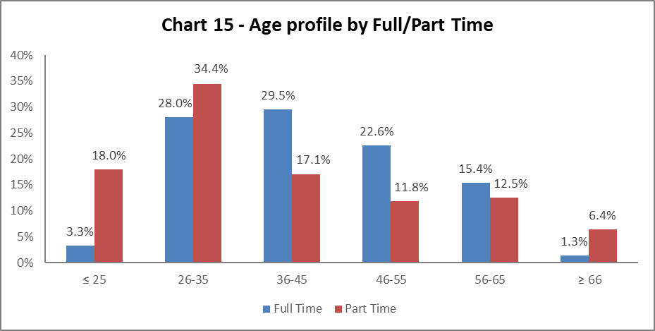

Chart 15 shows the age profile of both full time and part time colleagues. There have been minimal changes since 2022-23. The majority of colleagues working part-time are aged 35 and under, whilst the majority those working full time tend to be aged between 26 and 45.

## By Contract Type

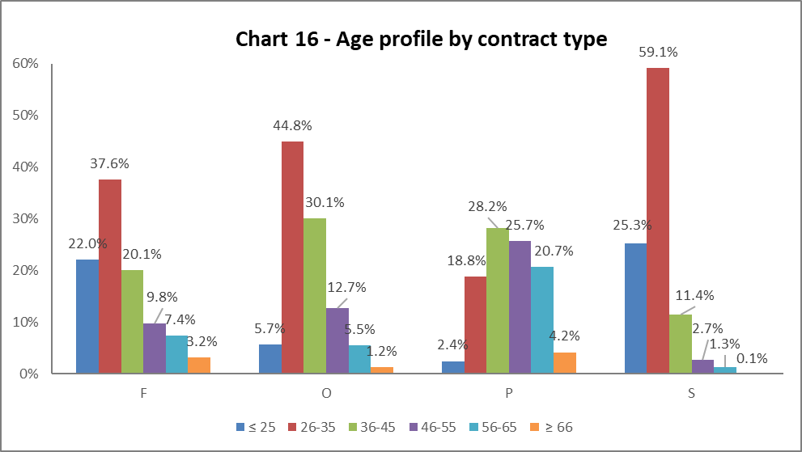

**Key**

F = Fixed term as per FT & OE Contract policy

O = Open ended with funding end date

P = Open ended (‘Permanent’) + Perm in Temp Fixed Term Appointment (HoC/Principal/VP role)

S = Fixed term - SOSR e.g. temporary cover for situations such as maternity or parental leave and long-term absence or for one-off projects

Chart 16 above shows that Open ended with Funding End Date (code O) and both types of Fixed Term (F & S) workers are generally younger (under 35), this reflects both 2021-22 and 2022-23 data. Table 10 below gives the same relevant percentages, for ease of comparison in tabular format.

|  |  |  |  |  |
| --- | --- | --- | --- | --- |
| Table 10 | F | O | P | S |
| Age Range | **%** | **%** | **%** | **%** |
| Age ≤25 | 22.0 | 5.7 | 2.4 | 25.3 |
| Age 26-35 | 37.6 | 44.8 | 18.8 | 59.1 |
| Age 36-45 | 20.1 | 30.1 | 28.2 | 11.4 |
| Age 46-55 | 9.8 | 12.7 | 25.7 | 2.7 |
| Age 56-65 | 7.4 | 5.5 | 20.7 | 1.3 |
| Age ≥66 | 3.2 | 1.2 | 4.2 | 0.1 |

## By Nationality

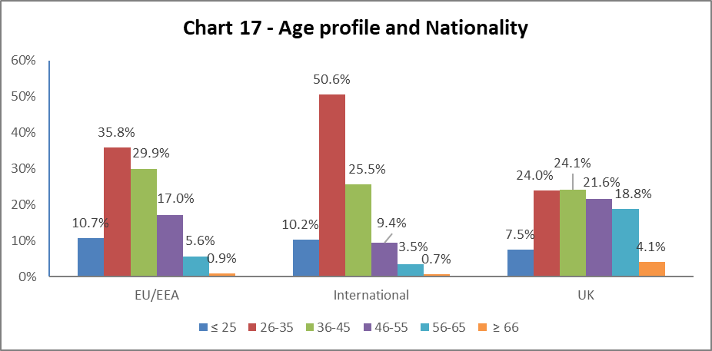

|  |  |  |  |
| --- | --- | --- | --- |
| Table 11 | EU/EEA | International | UK |
| Age Range | **%** | **%** | **%** |
| Age ≤25 | 10.7 | 10.2 | 7.5 |
| Age 26-35 | 35.8 | 50.6 | 24.9 |
| Age 36-45 | 29.9 | 25.5 | 24.1 |
| Age 46-55 | 17.0 | 9.4 | 21.6 |
| Age 56-65 | 5.6 | 3.5 | 18.8 |
| Age ≥66 | 0.9 | 0.7 | 4.1 |

Chart 17 and Table 11 shows the age range of staff within nationality group. As with previous years, a higher percentage of our EU/EEA and International staff are younger than our UK staff. This is particularly notable amongst our international staff cohorts, who often undertake early career research positions.

# Profile by Disability

## By College

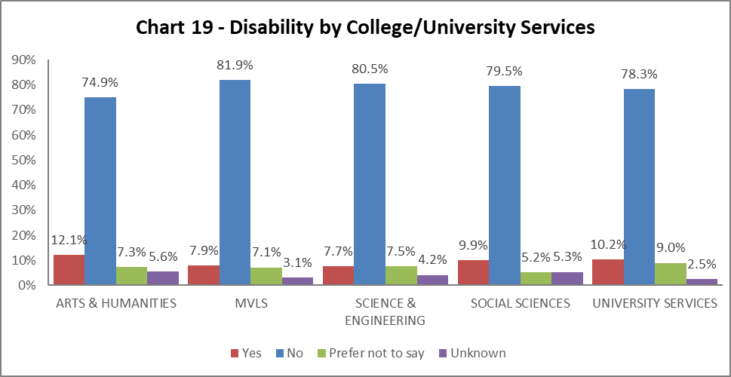

Chart 19 shows the percentage of declared disabled colleagues within College/University Services (US). All Colleges and US have seen an increase in declaration rates. The largest is Arts and Humanities with an increase of 4.5% since 2022-23. All Colleges/US have seen a reduction in the ‘Unknown’ categories, reflecting the drive to improve data quality.

## By Grade 10 staff

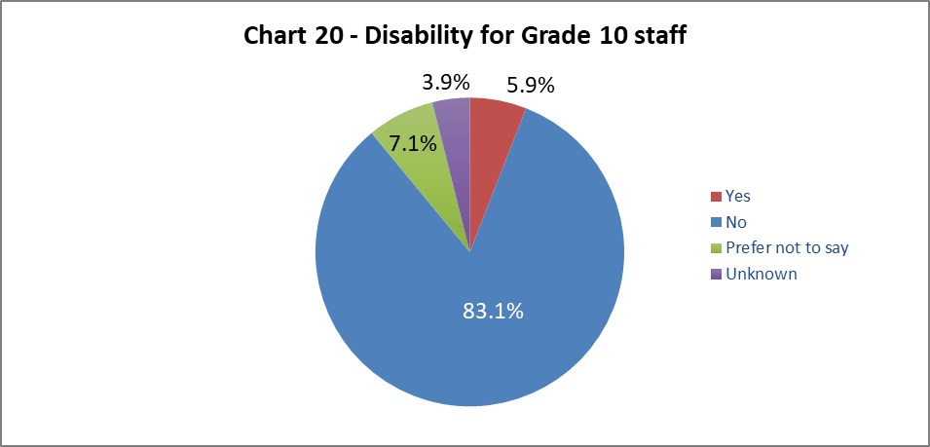

Chart 20 shows 5.9% of senior staff have declared a disability. This is an increase from last year by 1.7%, but it is still lower than the University average.

## By Job Family Profile

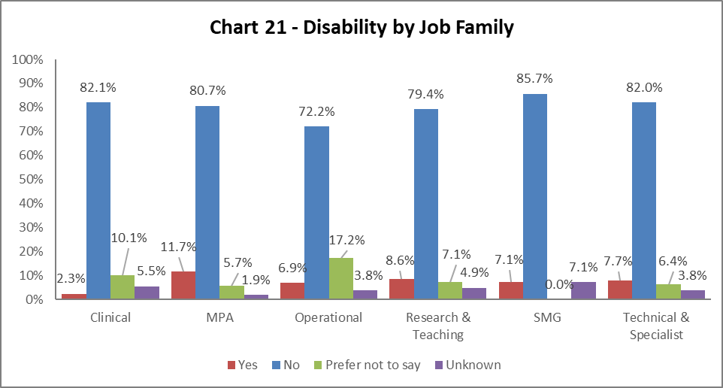

Chart 21 shows two thirds of all job families have seen increased disability declaration rates from 2022-23. The highest percentage increase is within MPA, by 3.1% since 2022-23. All job families show an increase in the in the ‘Prefer not to say’ category, while half of the Job Families show a reduction in the ‘Unknown’ category.

## By Grade

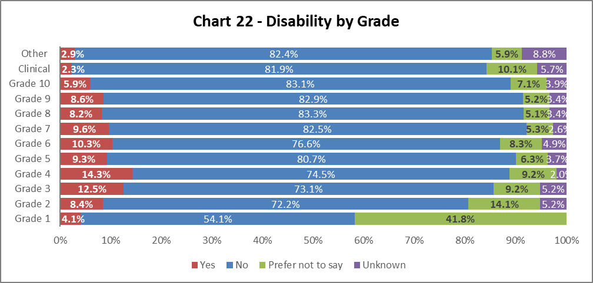

Chart 22 shows disability declaration rates by Grade. With the exception on Clinical grades, there has been an increase in disability declaration rates across all other grades, notably by 2.7% in grade 2, 2.8% in grade 3, 3.7% in grade 4, and by 3.6% at grade 6. Again, we see significant reductions across all grades in the ‘Unknown’ declarations.

## By Full/Part Time

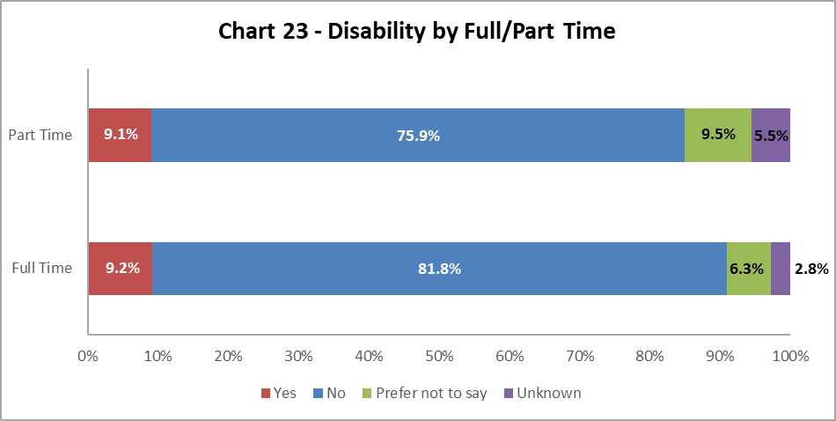

Chart 23 shows colleagues with a disability are nearly equally as likely to work on a full time or part time basis.

## By Contract Type

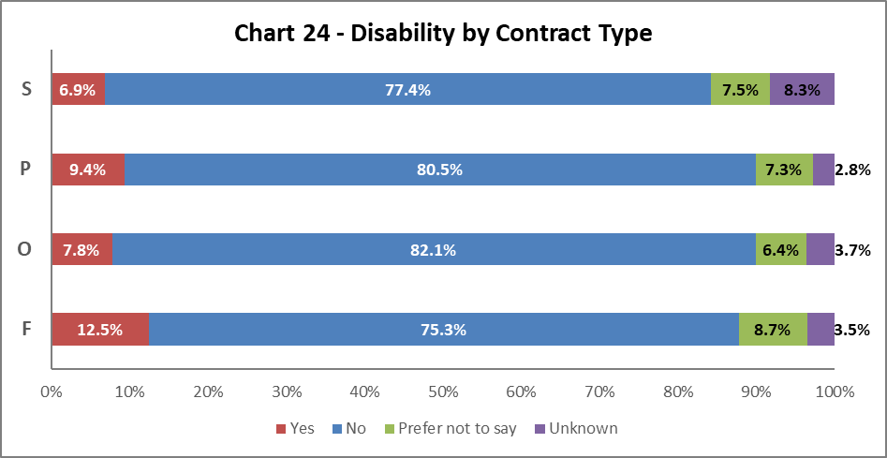

Chart 24 above shows increases in disability declarations across all contract types since last year. Most notably by 5.7% in Fixed term (code F); ‘Unknowns’ in this group reduced from 11.7% to 3.5% and ‘Prefer not to say’ increased from 4.0% to 8.7%.

## By Nationality

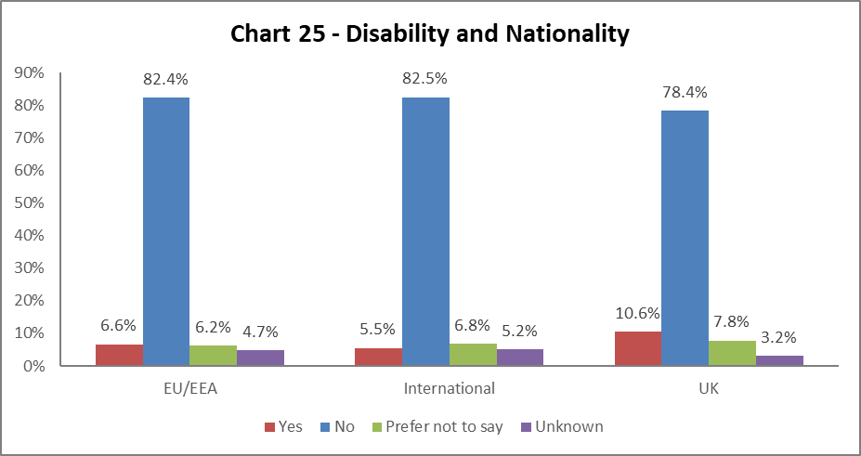  
  
Chart 25 shows a higher proportion of colleagues from the UK have declared a disability when compared to International and EU/EEA staff. All nationality groups show an increase in representation of colleagues declaring a disability since 2022-23: by 2.3% for EU/EEA; 2.0% for International; and 2.5% for UK. ‘Unknowns’ have reduced and ‘Prefer not to say’ has increased across all groups.

## BSL Users

As part of the University’s British Sign Language (BSL) Action Plan we have reviewed the number of staff who declared a level of proficiency in the use of BSL. 15 staff have declared a level of proficiency; the majority are at beginners’ level, with a small number stating they are fluent.

## Recruitment – by Applications and Successful Applicants

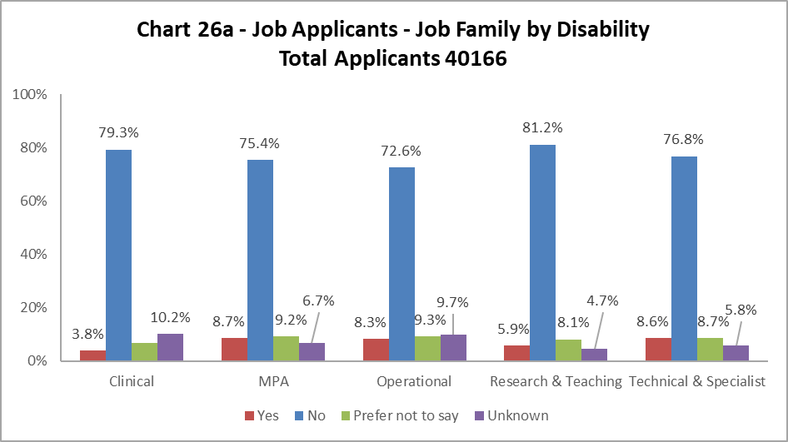

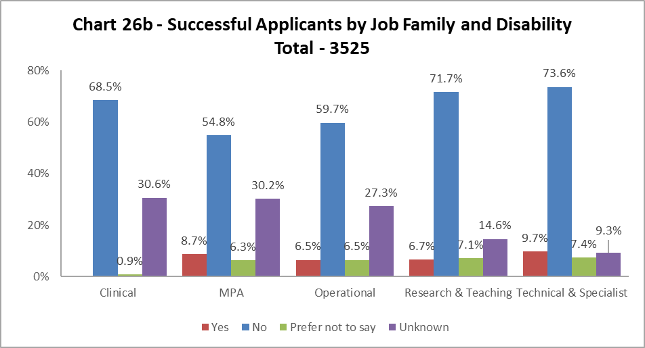

Charts 26a and 26b shows Clinical and Operational job families had slightly more disabled applicants than were successfully appointed. Across all other job families, the proportionate representation of disabled candidates was slightly higher at appointment stage than application stage. This demonstrates an improvement in disability representation amongst successful applicants compared to 2022-23, where all job families saw a slight drop between applicants and successful applicants identifying as Disabled.

# Profile by Ethnicity

## By College

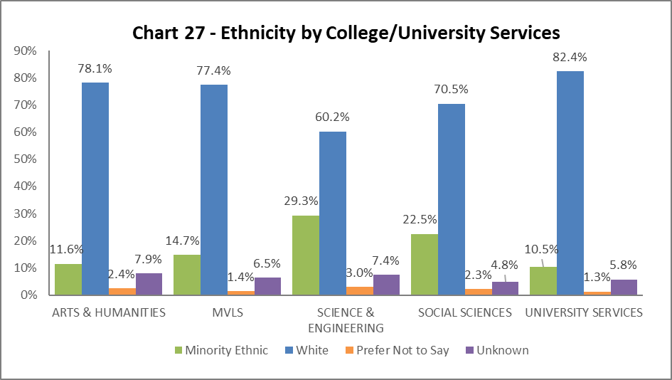

Chart 27 shows the breakdown by ethnicity of colleagues in College/US. The percentage of Ethnic Minority representation increased across all Colleges/US since 2022-23. A rise of 3.5% in Arts and Humanities; 0.5% in MVLS; 4.9% in Science and Engineering; 4.6% in Social Sciences; and 1.2% in US. All Colleges/US have seen further reductions in the percentages of ‘Unknowns’, which shows continued improvement in the data quality.

## By Grade 10 Staff

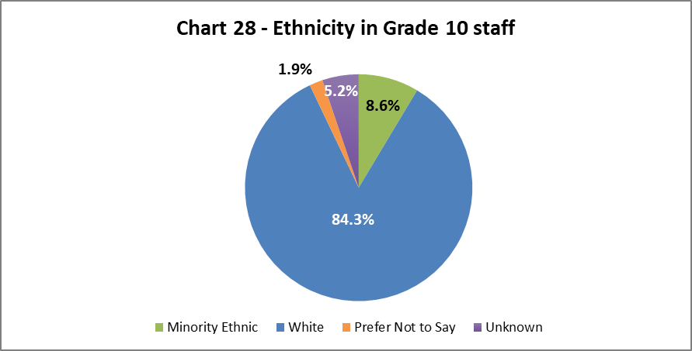

Chart 28 above show the ethnicity of staff at Grade 10. There has been an increase of 1.2% in Minority Ethnic representation amongst colleagues in senior roles since last year.

## By Job Family Profile

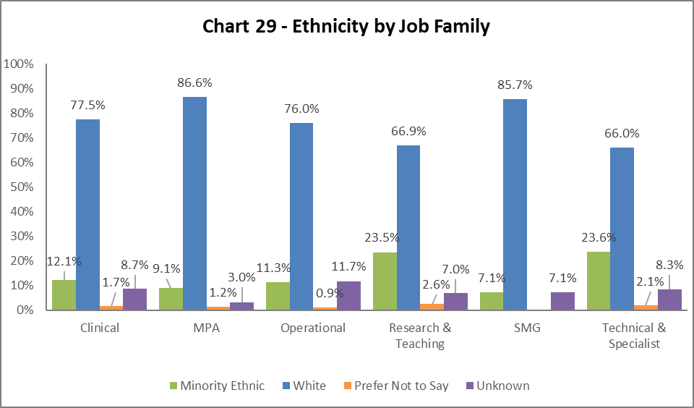

Chart 29 shows the ethnicity of colleagues by job family. Minority Ethnic representation increased across nearly all job families since 2022-23. This is most notable in Technical and Specialist job family, increasing by 12.0%. In contrast to other job families, this was not fuelled by a reduction in the ‘Unknown’ group, which also increased, by 0.6%.

## By Grade

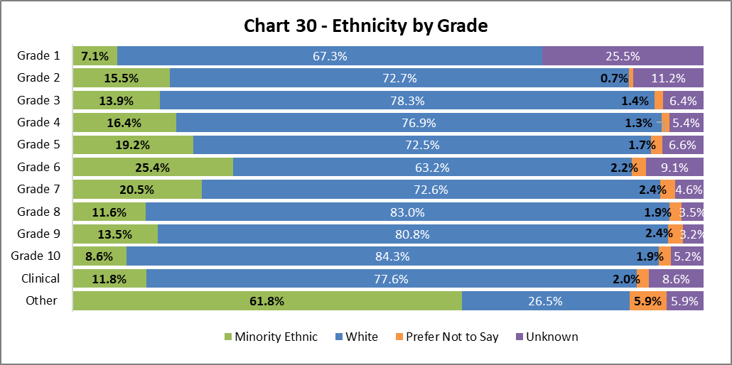

Chart 30 above shows the grade and ethnicity of colleagues. There has been an increase in Minority Ethnic colleagues across all grades. The largest increases are in Grades 4 (by 4.1%), 6 (by 5.8%) and Other (by 9.0%) since 2022-23. All grades (excl. Grade 1) have seen a reduction in the percentage of ‘Unknown’.

## By Full/Part Time

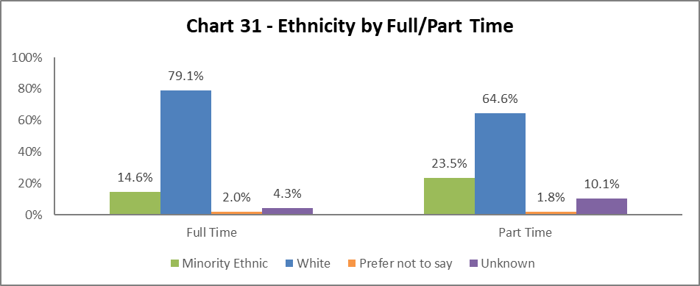

Chart 31 shows the ethnicity grouping of colleagues working full time and part time. Both cohorts have seen increased rates of Minority Ethnic representation since 2022-23, notably the part time colleagues with an increase of 5.1%, alongside a reduction in ‘Unknown’ ethnicity group from 20.9% to 10.1% in 2022-23.

## By Contract Type

Chart 32 indicates the percentage of Minority Ethnic colleagues has increased since 2022-23 across all contract types. This is highest in SOSR contracts (type S) with an increase of 8.4%. As referenced before, this is compounded by a reduction in the ‘Unknown’ categories (there was a 15 percentage points reduction amongst ‘Unknown’ categories since 2022-23 in SOSR and Fixed Term contract types).

## By Nationality

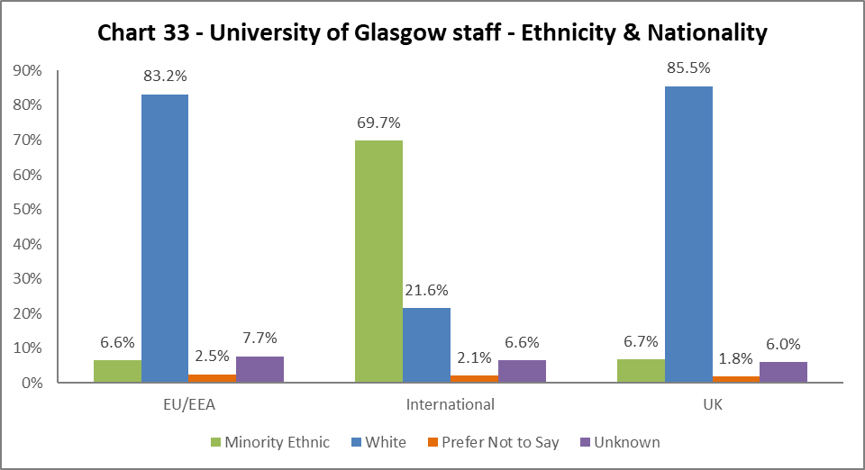

Chart 33 outlines the nationality and ethnicity grouping of our staff. 69.7% of our international colleagues are from BAME backgrounds, an increase of 7.7% from 2022-23, contributing significantly to the ethnic diversity of the University’s population. Of our UK staff, 67% are from Minority Ethnic backgrounds – this is an increase of 1.0% since 2022-23.

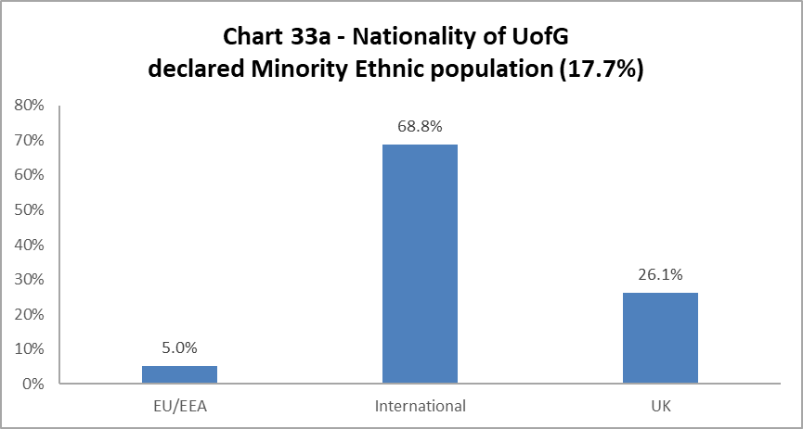  
  
Chart 33a outlines the nationality of our whole Minority Ethnic staff population (17.7 % of total – see Chart 6a). More than two-thirds of our Minority Ethnic colleagues are from international backgrounds, with an increase in UK nationality amongst our Minority Ethnic colleague population by 1.2% since 2022-23.

## Recruitment – by Applications and Successful Applicants

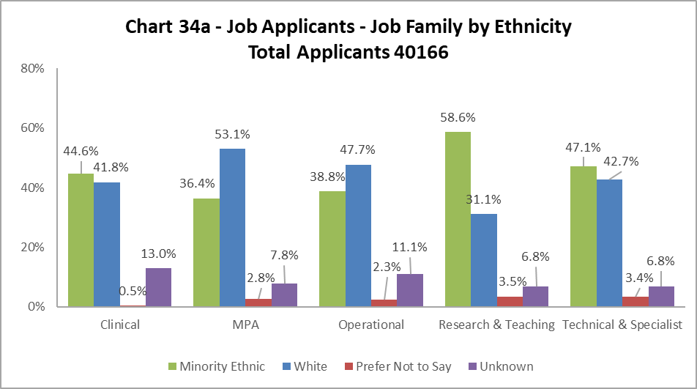

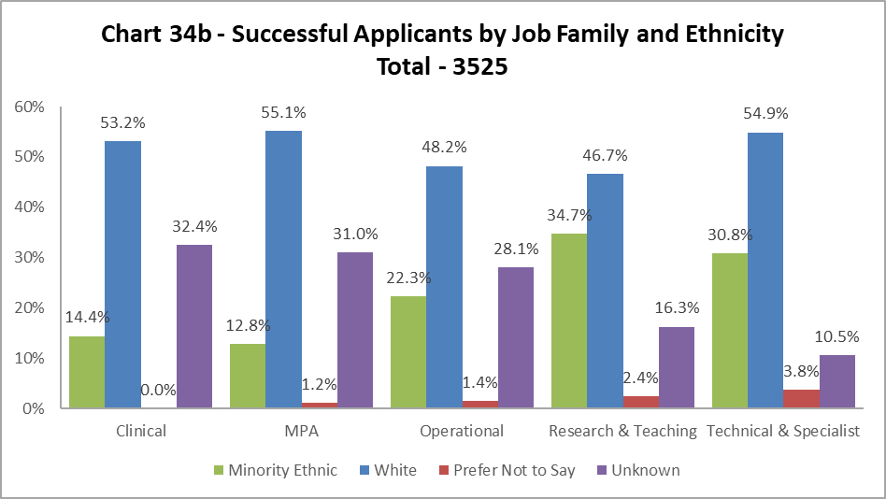

The data, as illustrated by Chart 34a and 34b, shows Minority Ethnic applicants are proportionally less likely to be successful in all job family profiles. The drop between applications to successful applicants is c.30% in Clinical job family, and in all others is over 15%. Minority Ethnic representation amongst applicants and successful applicants for Technical and Specialist roles since 2022-23; increasing from 18.5% to 30.8% amongst successful applicants. This is subject to further investigation to provide a fuller understanding.

# Profile by Sex

## By College

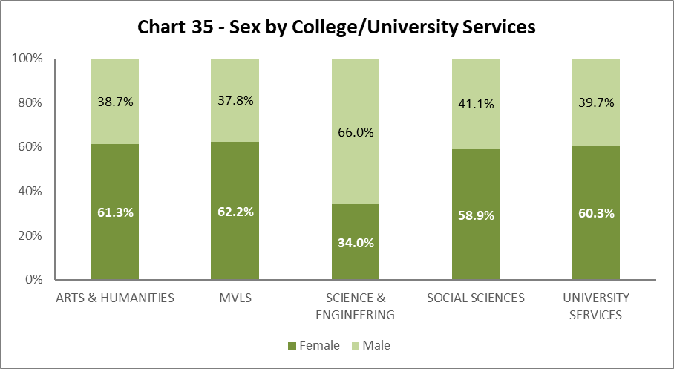

Chart 35 shows the split by Sex in College/US. Science and Engineering continues to report the largest disparity in Female/Male representation.

## By Grade 10 Staff

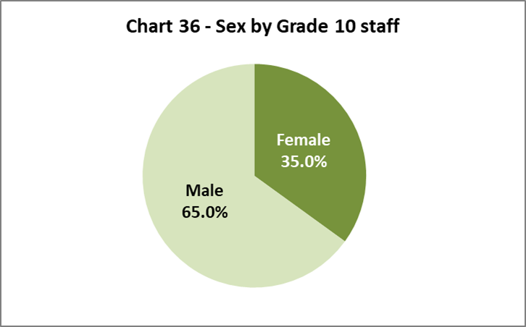

Chart 36 illustrates 35.0% of senior colleagues are Female, this a 1.2% increase from 2021-22.

## By Job Family Profile

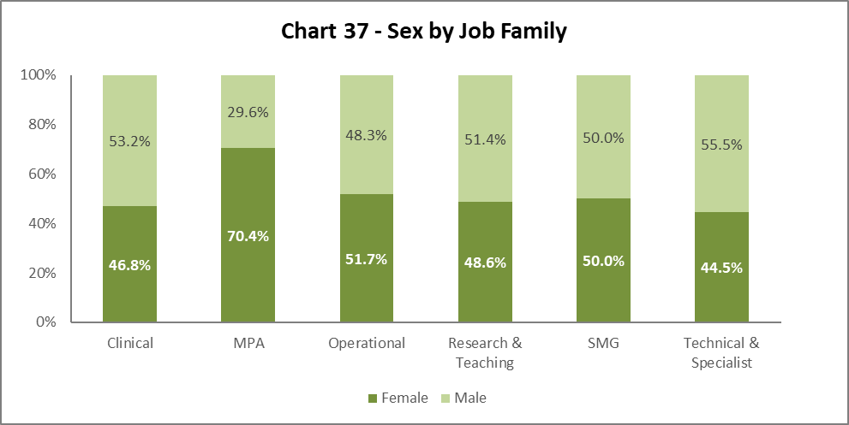

Chart 37 shows SMG is 50/50 Female to Male, as with previous years. There are other minor fluctuations across the job families, with a 5.2% drop since 2022-23 in Female representation within Technical and Specialist job family.

## By Grade

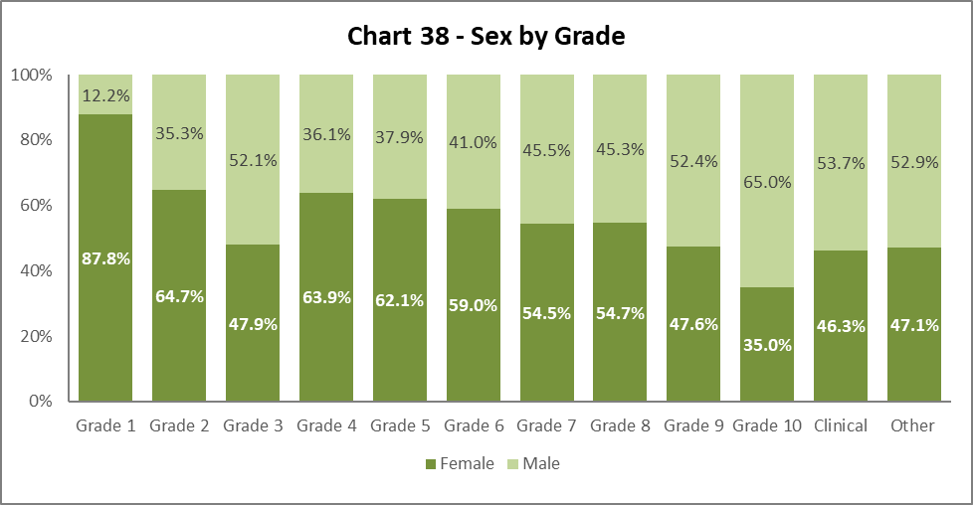

Chart 38 reflects similar proportions of Females and Males in each grade to last year, with slight increases in Female representation across grades 1-10. There are slightly higher %F increases (i.e. > 1%) in Grades 2 (by 1.8%), 3 (by 2.6%), 9 (by 1.8%) and 10 (by 1.2%).

## By Full/Part Time

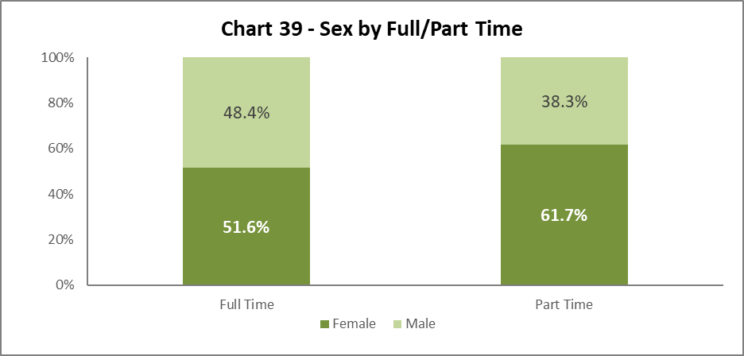

Chart 39 illustrates the breakdown by Sex of Full and Part Time staff. There has been a minor increase in the percentage of those working full time who are Female by 1.1% and in the percentage of those working part time who are female by 0.4% since 2022-23.

## By Contract Type

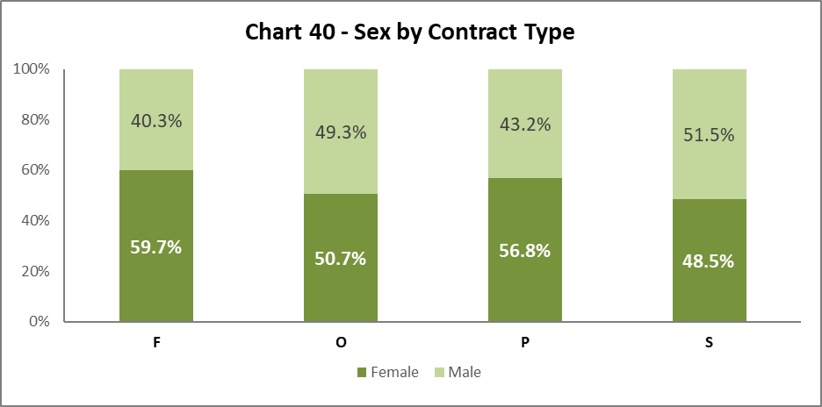

Chart 40 shows little change from 2022-23 in the sex balance within most contract types. Female representation across Fixed-Term contract type increased by 3.6% since 2022-23.

## By Nationality

Chart 41 - Sex by Nationality. 
EU/EEA - 56.4% Female, 43.6% Male.
International - 49.6% Female, 50.4% Male.
UK - 56.3% Female, 43.7% Male

Chart 41 shows a slight increase in Female representation across all Nationality groups: EU/EEA (by 1.1%); International background (by 0.6%); and UK (by 0.3%).

## Recruitment – by Applications and Successful Applicants

**Chart 42a - Job Applicants (#40166) by Sex and Job Family. 
Clinical 45.9% Female, 46.7% Male. 7.4% Unknown.
MPA 61.9% Female, 36.6% Male. 1.4% Unknown.
Operational - 52.0% Female, 43.1% Male, 4.8% Unknown
Research & Teaching - 43.9% Female, 55.1% Male, 1% Unknown
Technical & Specialist - 40.0% Female, 58.5% Male, 1.6% Unknown**

Chart 42b - Successful Job Applicants (#3525) by Sex and Job Family. 
Clinical - Female 39.6%, 38.7% Male, Unknown 21.6%.
MPA 63.1% Female, 25.3% Male. 11.6% Unknown.
Operational - 43.9% Female, 39.6% Male, 16.5% Unknown
Research & Teaching - 49.5% Female, 45.1% Male, 5.3% Unknown
Technical & Specialist - 37.6% Female, 59.3% Male, 3.2% Unknown

Charts 42a and 42b indicate Female candidates are notably more successful than Male candidates in the MPA and Research & Teaching job families; this is consistent with 2022-23. Across Operational roles, the proportionate representation of Females drops more compared to that for Males between application and appointment. Across all job families though, the increased representation of those who do not share their Sex information between application and appointment stage has an impact on the percentage differences amongst Female and Male applicants.

# Profile by Sexual Orientation

16.3% of all staff have not answered the question on Sexual Orientation, down from 22.8% in 2022-23. As such the ‘Unknown’ figures have been excluded from these graphics but are included in the statistics used to create them. This enables more meaningful visual representation and ease of comparison with previous Equality Monitoring Reports.

## By College

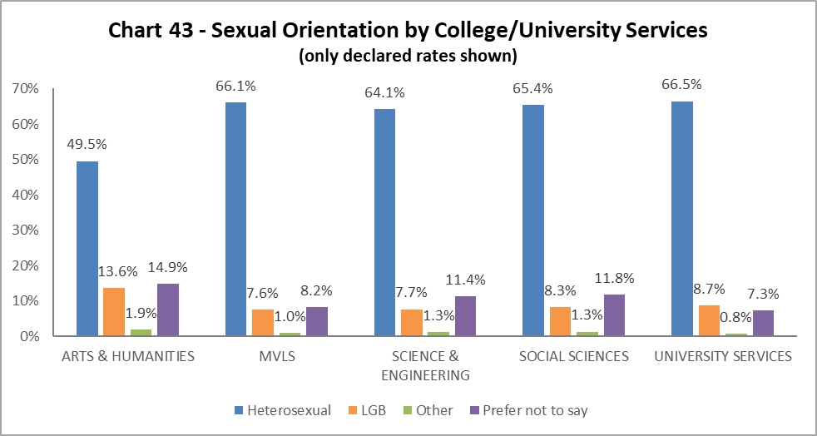

All Colleges/US have seen continued growth in the percentage of colleagues indicating they are LGB. Arts and Humanities continues to report the largest percentage of LGB staff across the University. Non-disclosure rates vary from 13.2% in Social Sciences to 20% in Arts and Humanities.

## By Grade 10 Staff

## Chart 44 - declared Sexual Orientation for Grade 10 staff. Staff who have not answered the question have been excluded from the graph. 59.5% have declared as heterosexual. 3.7% of Grade 10 staff have declared as 'LGB'. 9.3% have chosen the 'Prefer not to say' option and 0.4% have chosen the 'Other' option.

## 3.7% of Grade 10 colleagues identify as LGB, this reflects 2022-23. The non-disclosure rate at Grade 10 is 27.1%.

## By Job Family

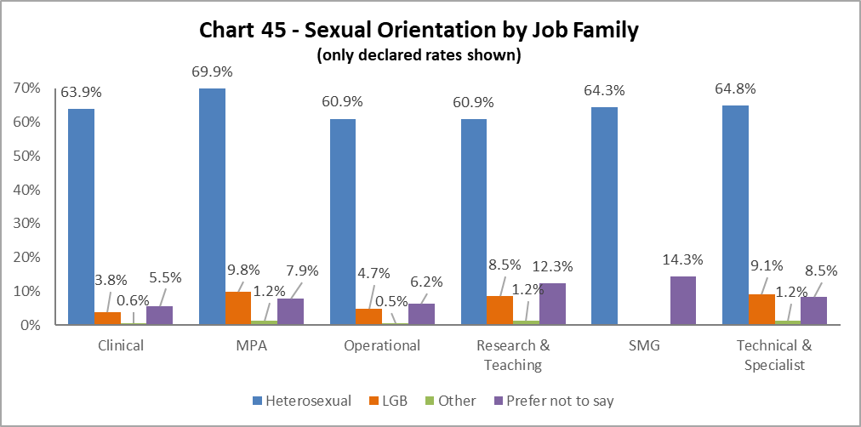

All job families (except SMG) have seen an increase in LGB representation. The most notable increases since 2022-23 are in the Research and Teaching (increase of 1.5%) and Clinical (1.9%). Non-disclosure rates range from 11.2% for MPA staff to 27.6% in Operational staff groups.

## By Grade

## Chart 46 - declared Sex Orientation Profile by Grade. Grade 1 has the lowest LGB declaration rate at 1%. Grades 3, 4 & 'Other' have the highest number of staff who have declared at 'LGB' with 14.4%, 13.7% and 14.7% respectively. Grades 6,7 & 8 all have 'Prefer not to say' rates of 10.4% While Grade 9 and 'Other' have the highest 'Prefer not to say' rates at 9.3% and 17.6%.

LGB declarations fluctuate across the grade and, within vast majority of grades, have increased since 2022-23. LGB representation amongst Grade 10 has dropped by 0.1%. Non-disclosure rates vary across grades from 54.1% in Grade 1 to 11.8% in the ‘Other’ grouping.

## By Full/Part Time

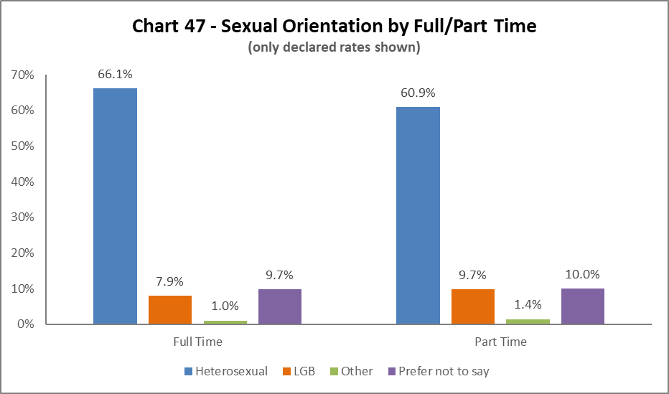  
  
In line with 2022-23, there is higher LGB representation amongst colleagues work part time, with an increase of 2.2%. This reflects a growing percentage of LBG staff working part time over a number of years. Non-disclosure rates were 15.4% amongst Full Time and 18.0% amongst Part Time cohorts.

## By Contract Type

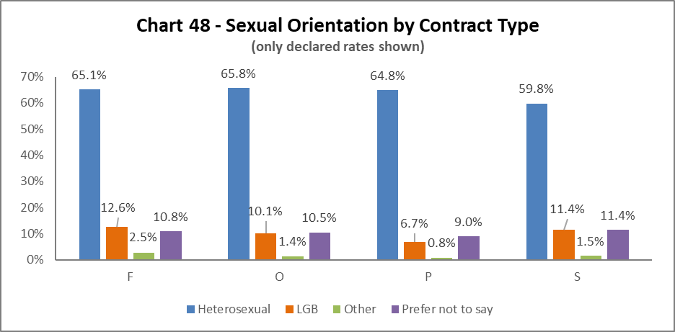  
  
LGB representation has increased by between 2-3% across most contract types since 2022-23. The smallest growth since 2022-23 is in Permanent contracts (type P) of 0.8%. Non-disclosure rates range from 9% for those on Fixed term contracts to 18.6% for Permanent contract holders.

## By Nationality

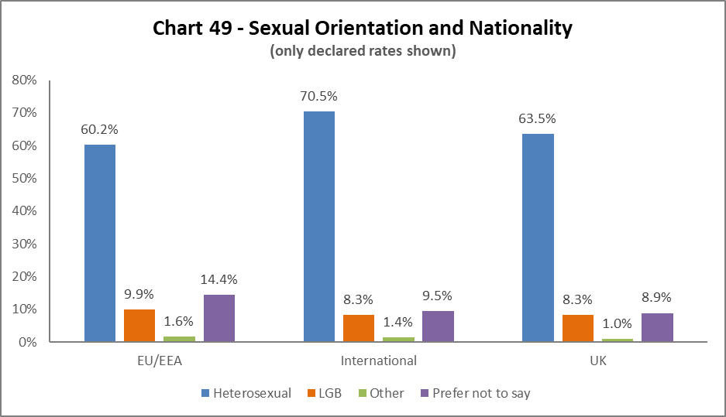  
  
As in 2022-23, LGB representation is highest amongst colleagues from EU/EEA. LGB representation has increased by 1.3% amongst colleagues of UK nationality, and by1.7% amongst ‘International’ colleagues since 2022-23. Non-disclosure rates range from 10.3% for EU/EEA group to 18.3% for colleagues of UK nationality.

## Recruitment – by Applications and Successful Applicants

**Chart 50a - Job Applicants by Sexual Orientation and Job Family (#40166).
Clinical - 7.7% LGB, Other 0.5%, 6.1% PNTS, 11% Unknown and 74.7% Heterosexual.
MPA - 14.2% LGB, 1.4% Other, 9% PNTS, 7.3% Unknown and 68.1% Heterosexual.
Operational - 11.2% LGB, 1.6% Other, 8.6% PNTS, 11.2% Unknown and 67.1% Heterosexual.
Research & Teaching - 10.5% LGB, 1.5% Other, 10.6% PNTS, 5.9% Unknown and 71.9% Heterosexual.
Technical & Specialist - 9.7% LGB, 1.1% Other, 9.3% PNTS, 6.6% Unknown and 73.2% Heterosexual.**

Chart 50b - Successful Job Applicants by Sexual Orientation and Job Family (#3525).
Clinical - 5.4% LGB, 6.3% PTNS, 31.5% Unknown, and 56.8% Heterosexual.
MPA - 12.2% LGB, 1.8% Other, 6.5% PNTS, 30.8% Unknown and 48.6% Heterosexual.
Operational - 7.2% LGB, 0.7% Other, 5.8% PNTS, 28.8% Unknown and 57.6% Heterosexual.
Research & Teaching - 13.5% LGB, 1.6% Other, 10.9% PNTS, 15.7% Unknown and 58.3% Heterosexual.
Technical & Specialist - 12.2% LGB, 2.1% Other, 10.3% PNTS, 9.9% Unknown and 65.4% Heterosexual.

The proportion of successful LGB applicants largely reflects that of the applicant pool across Clinical and MPA job families and is largely consistent with the previous reporting year. LGB candidates represented 10.1% and 9.7% of the applicant pools and 13.5% and 12.2% of those who were appointed across Research and Teaching and Technical and Specialist roles respectively.

This represents a 4% increase in LGB representation amongst successful applicants for Technical and Specialist roles from 2022-23. In Operational roles, there was a slight drop of 4% between LGB representation amongst candidates at application and appointment stage; this is consistent with 2022-23 reporting.

# Case Management – General

2023-24 saw a 13.2% increase in the number of Managing Attendance, Discipline and Grievance cases – 188 in total, compared to 166 in 2022-23, 86 in 2021-22 and 103 in 2020-21. The new system, introduced during 2022-23, to record and manage cases provides more accurate reporting. As in previous years, the majority of these employment related cases pertained to the Managing Attendance process.

It should be noted that although the number of cases has increased, in relation to the size of the workforce, the percentages below relate to relatively small numbers where small changes can have a significant effect on percentages.

## Sex

Chart 51a - Case Management - General Cases by Sex. 
Managing Attendance - Female 71.2%, 28.8% Male
Discipline - 23.1% Female, 76.9% Male
Grievance - Female 60.9%, 39.1% Male

Chart 51a shows a higher percentage of those involved in Managing Attendance cases were Female, these percentages are consistent with the previous two years. Males were significantly more likely to be subject to a Disciplinary process, again reflecting the last two years. In a change from 2022-23, Females were more likely to raise a Grievance. Last year 61.5% of those raising a Grievance were Female, compared to 39.1% who were Male.

## Ethnicity

Chart 51b below considers the ethnicity of colleagues involved in case management. The whole University Minority Ethnic population is 17.7%. The percentage of Minority Ethnic colleagues involved in Managing Attendance cases increased by 3.4% in 2023-24. The percentage of Minority Ethnic colleagues involved in Discipline processes is c.13% lower than last year. The percentage who raised a Grievance, is 10.7% higher than 2022-23.

Case Management (General) Cases by Ethnicity. 
12.2%, 23.1% and 26.1% of colleagues involved in Managing Attendance,
Discipline and Grievance procedures were from Minority Ethnic backgrounds.

## Disability

Chart 51c below considers the disability status of colleagues involved in case management cases.

The University population of disabled colleagues is 9%. The percentages involved in Managing Attendances cases is higher by c.6%, however this follows a large reduction in ‘Unknowns’ in our colleague data on disability. The percentage involved in Discipline has increased by 3.5% since 2022-23. There has a been a marked increase in the percentage of Disabled colleagues raising a Grievance by 17.6% since 2022-23.

Chart 51c - Case Management - (General) Cases by Disability. 
15.18%, 11.5% and 30.4% of colleagues involved in Managing Attendance, Discipline and Grievance procedures had declared a disability.  

# Case Management – Sickness

The sickness figures relate to colleagues who have been absent for 20 or more continuous working days between 01 August 2023 – 31 July 2024. This involves 5.5% of those under report. This is an increase of 0.6% from 2022-23.

## Age

Chart 52 - Sickness (over 20 days off) by Age Range
Nearly 60% of all those off sick for over 20 days at one time, were aged over 46. The age groups 46-55 represented 26.7 and 56-65 at 25.2% each, with those 66 or over at 5.9%.  Those aged under 25 and Under is 1.6% , those aged 26-35 13.8%, and 36-45 at 26.7%

Chart 52 shows most colleagues who required sick leave for 20 days or more, were in the 36-45 and 46-55 age groups, which is a departure from the reporting in 2021-22 and 2022-23, where we observed highest proportions amongst the 56-65 age group.

## Disability

Chart 53 - Sickness (over 20 days off) by Disability
13.6% of those off sick for over 20 days have declared a disability.
71.2% - No disability, 12.1% have chosen 'Prefer not to say'.  3.1% is 'Unknown'.

Chart 53 shows the proportion of colleagues absent for 20 days or more who identify as Disabled was 13.6%, which represents an increase of 2.4% since last year, reversing the decrease of 2.7% between 2021-22 and 2022-23.

## Ethnicity

Chart 54 - Sickness (over 20 days off) by Ethnicity
79.5% - White
9.4% - Minority Ethnic
1.4% - Prefer not to say
9.6% - Unknown

Chart 54 shows that, of colleagues who were off sick for more than 20 days, 9.4% were from a Minority Ethnic background; this is a 3.0% increase since 2022-23 but must be considered against the increase in Ethnicity declarations amongst the total staff cohort.

## Sex

Chart 55 - Sickness (over 20 days off) by Sex
67.5% - Female
32.5% -Male

As in previous years, a higher proportion of colleagues (67.5%) that have taken sickness absence for 20 days or more are Female, marking an overrepresentation compared to overall University population (55.2%F) as illustrated in Chart 8. The percentage of females on long-term sickness absence has decreased by 3.0% since 2022-23.

## Sexual Orientation

Chart 56 - Sickness (over 20 days off) by declared sexual orientation - Unknown stats have been excluded from data set.
80.1% - Heterosexual
6.9% -LGB
1.2% - Other
11.8% - PNTS

Chart 56 shows that of those who were off sick for more than 20 days, 6.9% declared as LGB. This is lower than the University wide LGB declaration rate but represents an increase of 1.3% from 2022-23.

**Chart 56 - Sickness (over 20 days off) by Sexual Orientation - 'Unknown' stats are included in this data set to allow for direct comparison with main data set, but are not shown in the graph.
60.7% - Heterosexual
5.2% -LGB
0.9% - Other
8.9% - PNTS**

Chart 56a shows the percentage of colleagues by sexual orientation of overall declaration rates. ‘Unknown’ figures have been excluded from this graphic but included in the statistics used to create it, allowing for comparison with earlier charts (43 – 50b) and pervious Monitoring Reports. It shows a reduction of LGB colleagues on long term sickness absence, and a further reduction when compared to the overall University LGB benchmark of 8.5% (Chart 9).

# Academic Promotions

|  |  |  |  |  |
| --- | --- | --- | --- | --- |
| **Table 12 - Academic Promotions 2024 - R&T and Clinical Job Families Only** | | | | |
| **Grade Applied  For** |  | **Success Rate**  **For Grade** | **Female** | **Male** |
| **GRADE 7** | Applicants |  | 57.1% | 42.9% |
| Successful |  | 55.1% | 44.9% |
| **Promoted (%)** | **87.5%** | **84.4%** | **91.7%** |
| **GRADE 8** | Applicants |  | 52.0% | 48.0% |
| Successful |  | 51.1% | 48.9% |
| **Promoted (%)** | **90.2%** | **88.7%** | **91.8%** |
| **GRADE 9** | Applicants |  | 49.1% | 50.9% |
| Successful |  | 46.8% | 53.2% |
| **Promoted (%)** | **74.5%** | **71.2%** | **77.8%** |
| **READER** | Applicants |  | 12.5% | 87.5% |
| Successful* |  | 12.5% | 87.5% |
| **Promoted (%)** | **87.5%** | **100.0%** | **100.0%** |
| **CLINICAL** | Applicants |  | 70.0% | 30.0% |
| Successful |  | 75.0% | 25.0% |
| **Promoted (%)** | **80.0%** | **85.7%** | **66.7%** |
| **PROFESSOR** | Applicants |  | 45.3% | 54.7% |
| Successful* |  | 44.8% | 41.4% |
| **Promoted (%)** | **78.1%** | **89.7%** | **68.6%** |
| **SUCCESS RATE FOR ALL APPLICANTS %** | | **82.7%** | **82.8%** | **82.6%** |

*Includes those who were unsuccessful in their application to this grade but were successful in gaining promotion to a Grade above their current Grade.

Table 12 provides breakdown by Sex of the Academic Promotions 2023-24 process. The overall success rate shows no discernible difference between Female and Male applicants. At Grades 7 and 9, Female applicants were less likely to be successful, by c.7.3% at Grade 7 and 6.6% at Grade 9. Again, this reverses the pattern observed at these Grades in 2022-23 when Females were notably more successful. Females were more successful at Professorial level and across Clinical grades in 2023-24, which reverses the success rates in 2022-23, where Males were more successful at Professor and no Females applied for promotion in the Clinical grades.

The overall success rate for those with a declared a Disability (10.1% of applicants) was 85.7%, compared to 81.0% for those who declared they did not have a disability. For those who declared a Minority Ethnic background (18.2% of applicants) the success rate was 84.1%., compared to 81.9% for those who declared as being from a White background.

# Regrading for Professional & Support Staff

|  |  |  |  |  |
| --- | --- | --- | --- | --- |
| **Table 13 - Regrading 2022-23 - Professional and Support Staff by Grade** | | | | |
| **Grade Applied For** |  | **Success Rate** | **Female** | **Male** |
| **GRADE 1-5** | **Applicants** |  | 75.0% | 25.0% |
| **Successful** |  | 66.7% | 33.3% |
| **Promoted (%)** | **75.0%** | **66.7%** | **100.0%** |
| **GRADE 6-10** | **Applicants** |  | 51.2% | 48.8% |
| **Successful** |  | 51.3% | 48.7% |
| **Promoted (%)** | **90.7%** | **90.9%** | **90.5%** |
| **SUCCESS RATE FOR ALL APPLICANTS %** | | **88.2%** | **85.7%** | **91.3%** |

|  |  |  |  |  |
| --- | --- | --- | --- | --- |
| **Table 14 - Regrading 2022-23 - Professional and Support Staff by Job Family** | | | | |
| **Job Family** |  | **Success Rate** | **Female** | **Male** |
| **MPA** | Applicants |  | 69.6% | 30.4% |
| Successful |  | 65.0% | 35.0% |
| **Promoted (%)** | **87.0%** | **81.3%** | **100%** |
| **OPERATIONAL** | Applicants |  | 100% | 0% |
| Successful |  | 100% | 0% |
| **Promoted (%)** | **100%** | **100%** | **0%** |
| **TECH & SPEC** | Applicants |  | 38.5% | 61.5% |
| Successful |  | 39.1% | 60.9% |
| **Promoted (%)** | **88.5%** | **90%** | **87.5%** |
| **SUCCESS RATE FOR ALL APPLICANTS %** | | **88.2%** | **85.7%** | **91.3%** |

Table 13 above shows applications for regrading by Sex. Males were more successful in grades 1-5 and Females were more successful in Grades 6-10. This inverts the pattern observed in 2022-23 and reflects the fact that relatively small numbers can create more notable percentage fluctuations year-on-year.

Table 14 shows much higher percentages of Females applying for regarding in the MPA job family which roughly reflects the make-up of this Job Family (Chart 37). In a reverse from 2022-23, this year Males were more likely to be successful in this job family than Females. Both the other job families reported show strong success rates, although it should be noted that fewer applications came from Females in the Technical and Specialist job family and there were no Male applicants in the Operational job family.

# Equal Pay

The University has a duty to publish pay gap information by 30th April every two years under Regulation 7 of the Equality Act 2010 (Specific Duties) (Scotland) Regulations 2012. The most recent [Equal Pay reports for Gender, Ethnicity and Disability](https://www.gla.ac.uk/myglasgow/humanresources/all/pay/equalitydiversitypaygap/) were published in April 2023.

**END.**

1. MVLS - College of Medical, Veterinary & Life Sciences
2. Since 2022/23, Graduate ‘Demonstrators’ have been re-classified as ‘Technical and Specialist’. Changes to demographics for these two job families must therefore be viewed within this context.
3. As in previous years, MRC staff have been removed from this category and reallocated to the relevant grade based on salary scales.
4. This terminology is in line with Scottish Government guidance for public bodies on the collection of data on ethnic groups.