**CRITICAL ARC – SAFEZONE**

DOWNLOAD AND REGISTRATION INSTRUCTION’S

STEP 1. Go to your Android or Apple play/App store

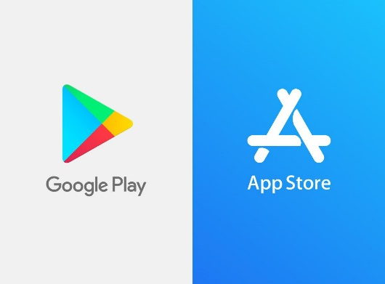

Step 2. Download Safezone App

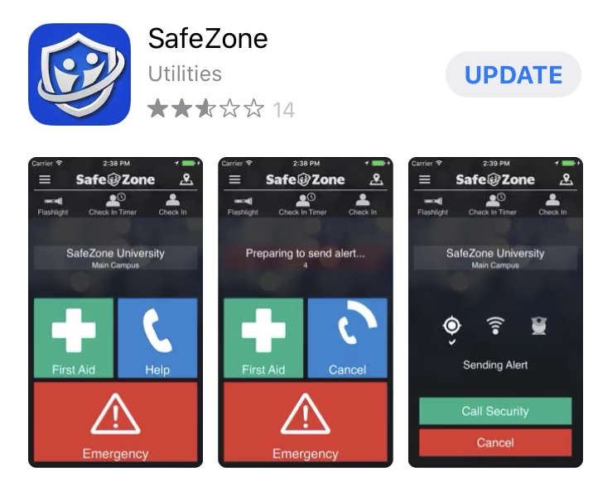

Step 3. Open the App and insert your University email address, then press next

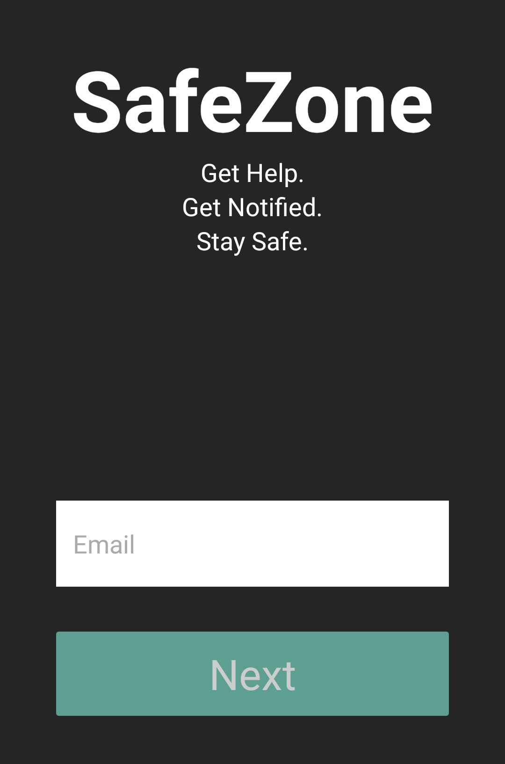

Step 4. Insert your GUID and Password and select Login

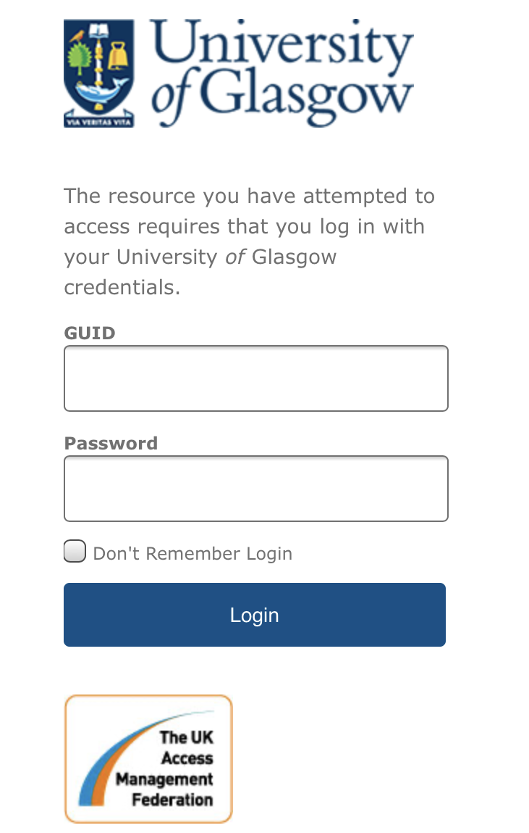

Step 5. You will now be logged into the Safezone App, if prompted please except notifications and allow Safezone to see your location, this is required to allow security to find you if you press the emergency button.

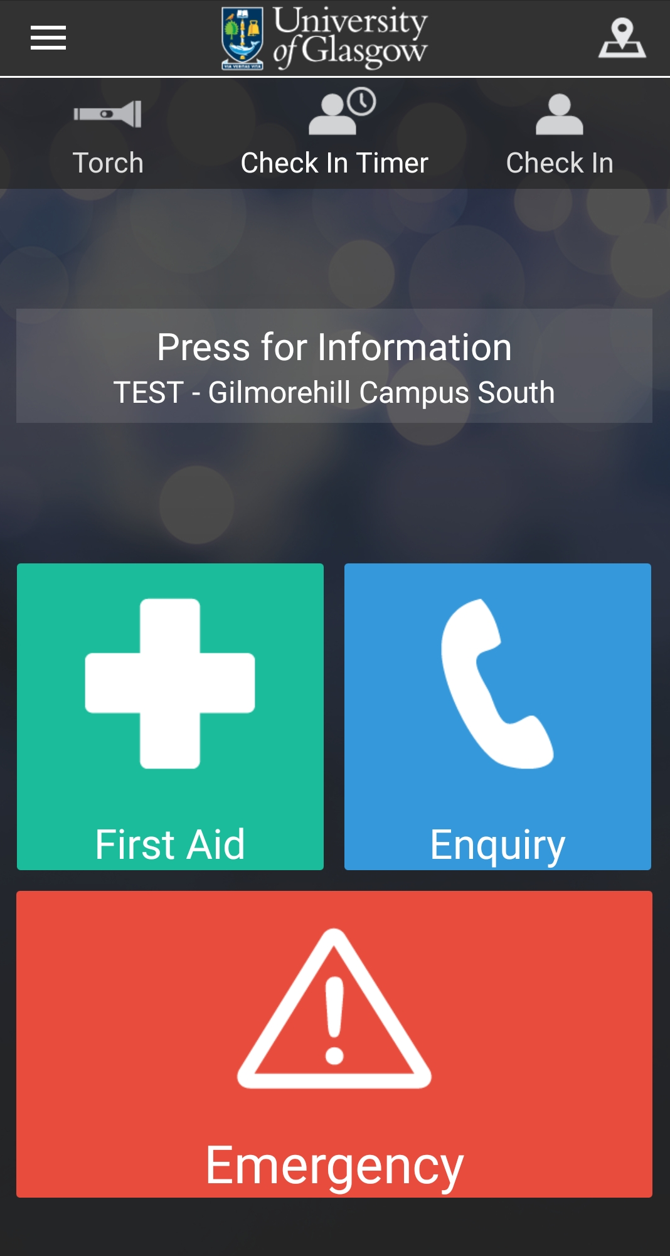

You need to press the check in button, this will show your current location on our command screen map. This is encouraged when engaged in Lone Working.

**Permissions**

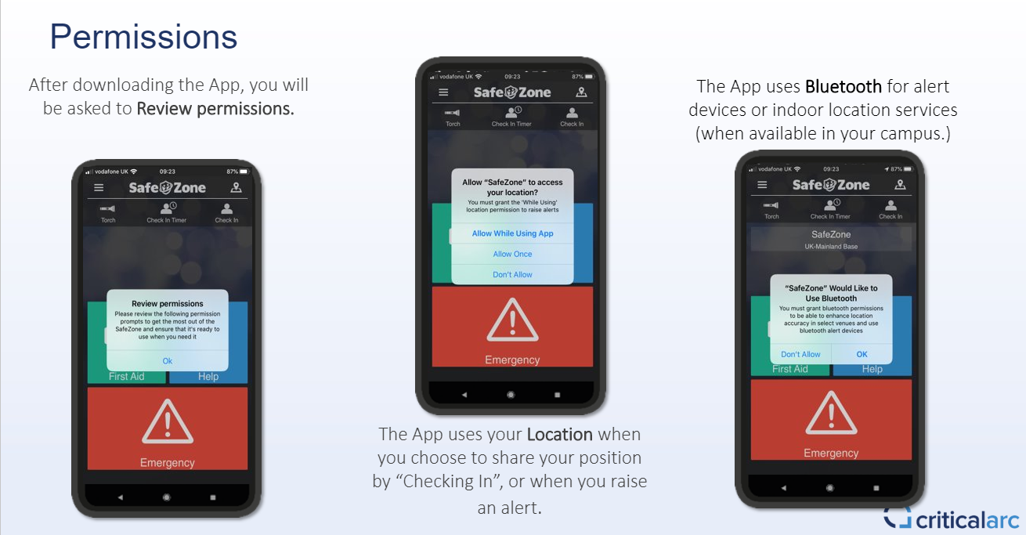

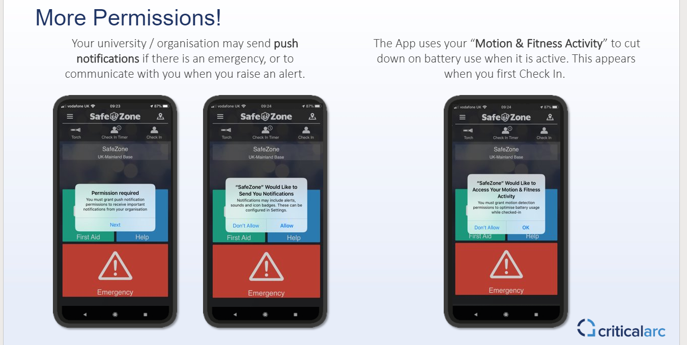

Step 6. Functions of each button.

Access your profile and other features

View your location on Google or Apple Maps

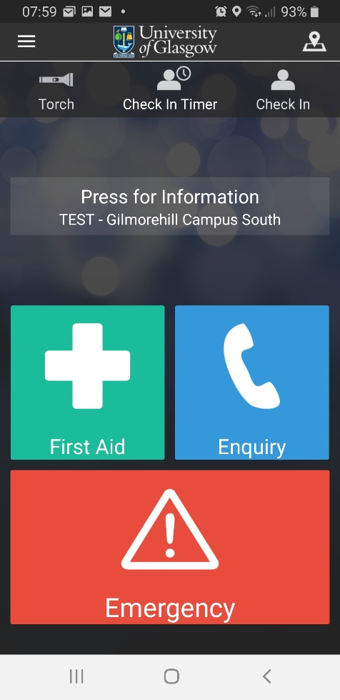

First Aid emergency press this button, it will either call emergency services or raise an alert in the Security Control Room

Set a timer and share your location for a desired time period, after which an alarm will be sent to security if you do not ‘Check Out’

Access to Torch directly through SafeZone App

In case of general help or assistance this button will either call an appropriate individual, call the Security Control Room. Raise an alert in the Security Control Room.

This will take you to an information page based on your location

Allows you to share your location with responders when checked in

In case of an EMERGENCY, this button will Call the relevant local emergency services number.

Raise an alert in the Security Control Room

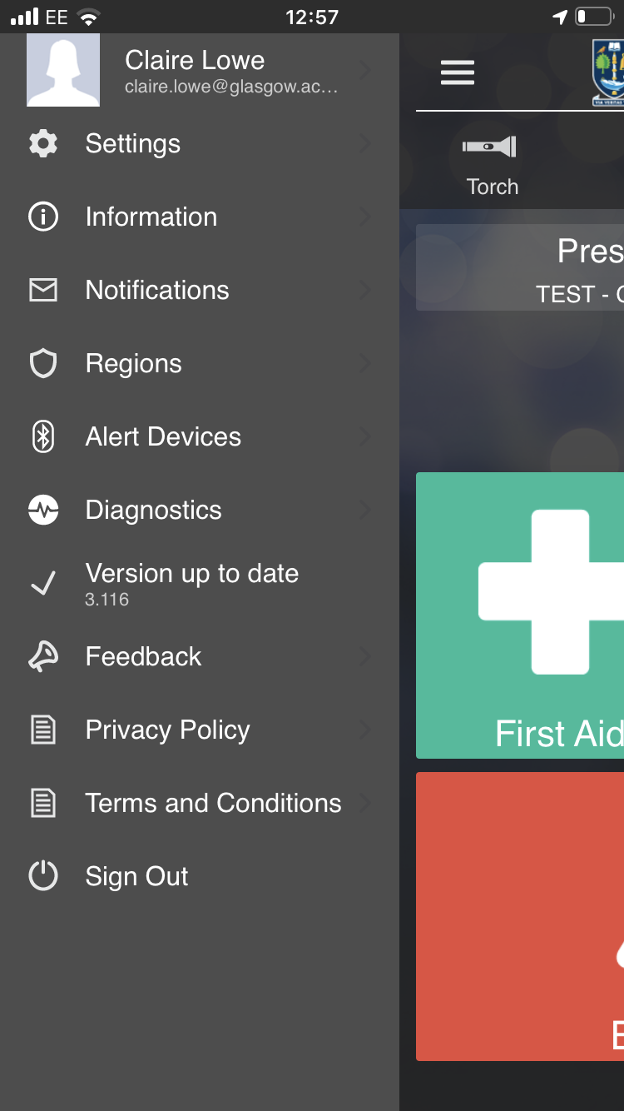

Sign Out of SafeZone

Terms and Conditions of the SafeZone App

Access to the SafeZone Privacy Policy

Allows you to access guides and contact support

View recent notifications and manage notification groups

Keep track of your App version

Takes you to your App’s diagnostic page

Allows you to connect a V.Alrt Bluetooth Panic Button

Allows you to view and select available SafeZone Regions

Takes you to an information page

(e.g. Security/App info)

Allows you to access and edit your profile

Access preferences for, automatic check in, version notifications and Language

Step 7. Sending Alerts - when you activate the emergency button it will set off an alarm in the Security Control Room on the Command Screen and your location will appear on the map.

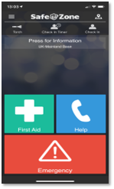 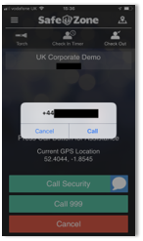 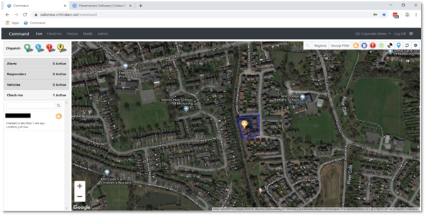

Step 8. Two-way messaging, security will send a message to your device straight away to check if you are ok or in need of assistance.

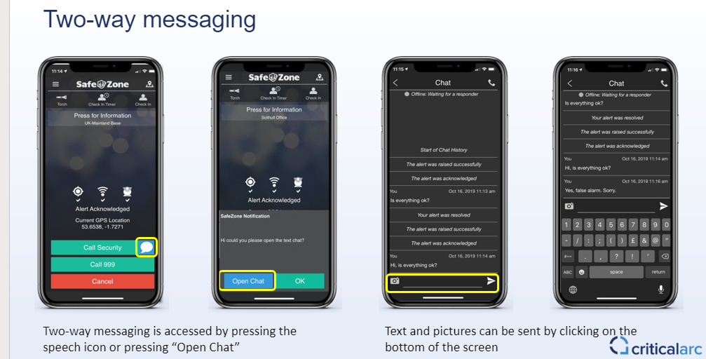

**Regions/Zones - Command Screen View**

Highlighted area is the zone that we cover, whilst in the zone and you press the emergency button, security will respond. Out with this zone the emergency services will respond. We can set up zones anywhere in the world. This will allow us to provide mass notifications should anything happen within your area of travel or to assist you with getting help in an emergency.

