

Using Moodle and Mahara

V1.1

e-mail: training@glasgow.ac.uk

web: gla.ac.uk/services/it/training

copyright © University of Glasgow

Course content created by Blair Thompson

Last edited by DL on 12/09/25

Contents

Using Moodle and Mahara 3

1 MOODLE introduction 3

2 Edit profile 5

3 MOODLE Activities 8

4 Uploading assignments 8

5 Mahara 12

Using Moodle and Mahara

# MOODLE introduction

MOODLE is a web-based learning environment in which students can **view information** (text, pictorial, and audio/audio visual),quizzes**,** assignments and course news. It also allows students to upload assignment exercises – so their lecturers and tutors can mark them later - and gives them the opportunity to discuss coursework via “chat-rooms” and “forums”. *Not all of these options are offered for every MOODLE resource.*

For your own courses, MOODLE will be used as a resource to complement direct teaching activities, including hosting of lectures and additional resources. You are also likely to be required to use MOODLE this year for the electronic submission of individual and group tasks.

**MOODLE is** available at the main MOODLE web site: https://moodle.gla.ac.uk/ (Use your student GUID and password to access this). Use the links to work your way to your particular **School** and then to your specific MOODLE resource.

You are signed up to can also be accessed via **MyGlasgow** and if you use this regularly it is a good way to access MOODLE; otherwise bookmark the MOODLE page for your School.

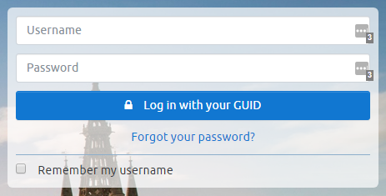You will be asked to log in. You will log in using your GUID (which you use to logon to cluster computers). This will allow you access to the courses listings.

To choose your course or other resource, click on the named link. Sometimes you will require a second password, called an *Enrolment* *Key*, which will be supplied by your lecturer/tutor, in order to access individual courses.

## Accessing your MOODLE

You will be informed by your **College/School** whether any course, part of a course or support for a course will be made available via MOODLE. If it is, you will be told the start-time (if applicable) and the heading under which it will be found on the MOODLE page.

****

**Schools** may be divided into **Subject Departments** and each of them may have its own MOODLE page, organised under its **School MOODLE** at the higher level. So for instance from the main MOODLE page (see above) you might access the **College of MVLS** MOODLE

Under the College MOODLE you’ll see the links to all its **School MOODLEs**. Linking to a School MOODLE will show all the MOODLEs for that School’s Subject Departments.

Finally, if necessary access the **Subject Department** your course MOODLE will be found in.

### Moodle Task 1

#### Access the University MOODLE web site.

#### Bookmark this (add it to your Favourites).

#### If you need to access **Site home** using the navigation menu on the left of the page

#### Using the Course Categories items at the base of the page, navigate to College of Medical, Veterinary & Life Sciences 🡺 MVLS Schools 🡺 Medicine, Dentistry and Nursing 🡺 Dental School 🡺Undergraduate Courses (if you study undergraduate courses)

#### Bookmark this and then spend a few minutes looking at this: take note of all the MOODLE options described

**Please note** that any course is publicly accessible. *You must conform to acceptable net etiquette*. You will be asked the first time you ever log in to Moodle to agree to the **Site Policy**. See also: *www.gla.ac.uk/services/it/regulationscommitteesandpolicies*

# Edit profile

You will be able to update your Profile at any later time by clicking on your avatar, which you will find at the top right of the page.

This page can also be accessed from the **Navigation** block, under **View profile** (see image above). 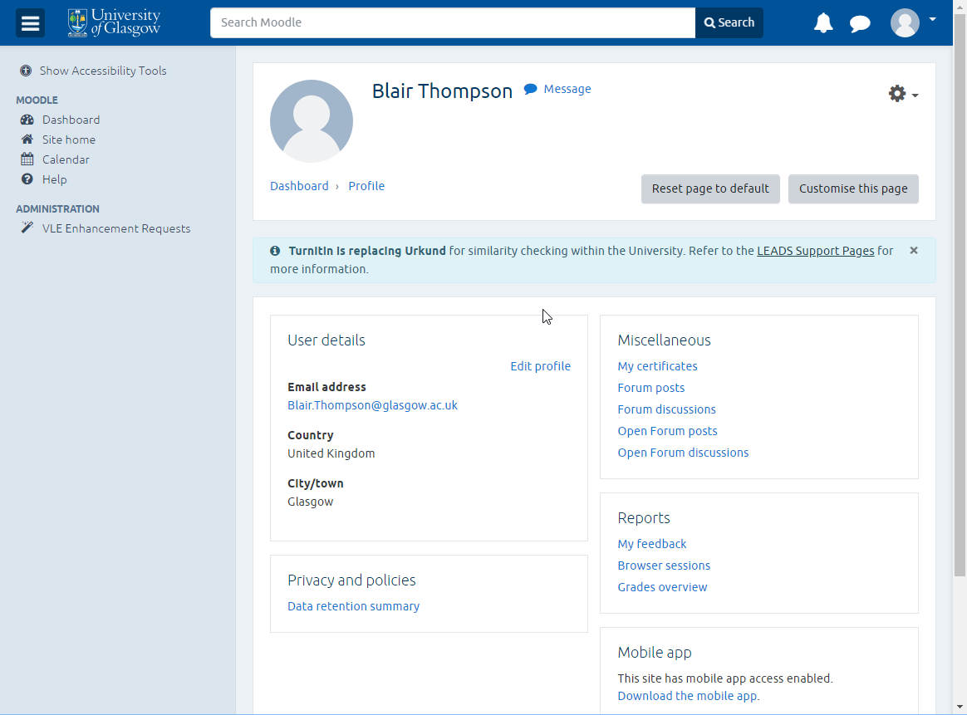

You should check that everything here is correct and if you need to amend or add anything, click on **Edit profile** in the **User details** area

The details of your profile will be shown in text boxes (see below) which you can edit to update your profile.

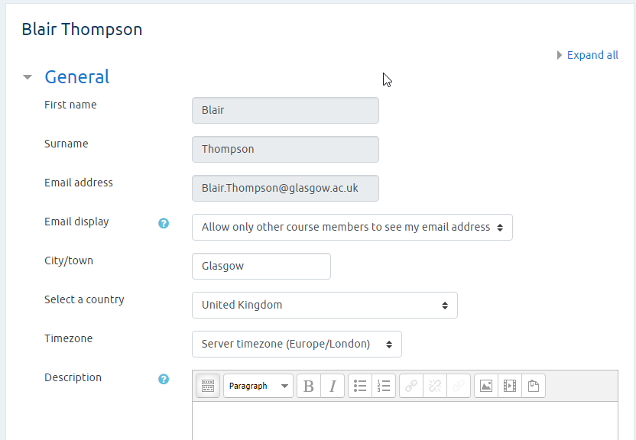

When you have finished editing your details, click on the **Update profile** button.

### Moodle Task 2

#### Click the avatar on the top right of the Moodle web page

#### From the drop down list that appears, select **Profile**

#### Take a moment to explore your profile

#### Click the **Edit profile** command in the **User Details** section of your profile

#### Scroll through the form and add some additional information to your profile Note: Some sections of the Edit profile form may be collapsed, click the headings to see the complete form

#### Click the **Update profile** button at the end of the form

#### Observe the changes made to your profile

## The MOODLE course page

**NOTE**: The examples shown and tasks given from here on will be based on IT Training MOODLES as it’s not appropriate to work with your BSc Med MOODLE on this training course.

### Moodle Task 3

#### Click the **Site home** item in the navigation pane on the top of the web page

#### From the **Course categories** section (below) select: Services 🡺 IT Services 🡺 IT Training 🡺Word processing 🡺 Introduction to Word

#### If you are prompted for a key, the key is **Wordkey**

#### When you enter a course for the first time you will often see a brief overview of the MOODLE resource at the top of the page.

The largest part of the page contains the main course material (see below). This can be plain text, though much of the material will be accessed by links – web pages, documents, images, forums, etc.

Your lecturer/tutor will explain in advance how you are to proceed through a course. (Some MOODLEs allow access to all modules at any time; in other MOODLEs, modules are removed after a set time, while new ones appear).

**Note**: when you follow any link, near the top of the MOODLE page you’ll see the “breadcrumb” trail. These form a series of **links** which you can use to navigate back to an earlier page. For instance:

Usually, only a selection of the possible options will be available for any one course. Here we have **Forums** for instance and as a result there is a **Search forums** option.

Also displayed here are **Upcoming events** (which link to your **Calendar**) and **Recent activity**.

### Moodle Task 4

#### Access the **Participants** page and view the details of one of the other students

#### Access your own **Profile**.

# MOODLE Activities

The following items are things you may come across on other MOODLE resources, particularly those which are organised as an online course.

The most obvious activity is the **Assignment**. An assignment is an activity that may be marked. If it is to be graded, the assignment page will usually tell you, as part of the instructions, how large the submission should be, what type of file formats are acceptable to the tutors (if it is to be submitted as an uploaded file) and the due date for the assignment. This is the date and time by which all assignments have to be submitted.

Assignments can be of a type that requires the student to **Upload one file** **or several files** containing the student’s assignment work. This will usually be something like an essay or report, the kind of work you are often given at lectures or tutorials. But it could potentially be any kind of file – e.g. like a database file, a *PowerPoint* presentation or a multimedia file.

In an **Offline assignment**, the instructor will give directions, and the student will complete the assignment. No document is turned in through the assignment tool, though the student may be expected to do an activity within MOODLE.

In an **Online Text assignment**, the instructor will give directions, and the student will respond in **an online text box** provided in the assignment tool. The tutor may mark or comment on the student’s work.

In an **assignment submitted as a document**, the instructor will give directions in the Moodle, and the student will complete the assignment in a suitable document format. This can be a *Word*, *Excel*, *PowerPoint* or other file format. When completed, the assignment is then **uploaded by the student**. The tutor may mark or comment on the student’s work. Uploading a file or files is discussed below.

You may also see – this depends at the moment on local School Moodle administration – a **Declaration of Originality statement.** This is a reminder that your work should follow the universities plagiarism guidelines. Read this and tick the acceptance checkbox before submitting your assignment.

# Uploading assignments

Once you have completed a submission that you need to upload, return to the section on MOODLE where the assignment was described. You will see a link to the assignment submission page – in the example here it is named “*Starting with Word*”. Click this link to go to the page where you submit your assignment.

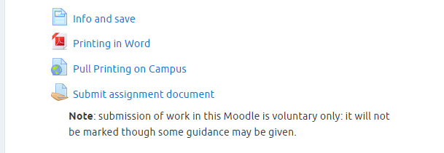

An assignment will usually appear after a serious of information pages and/or tasks.

Note the little ‘folder/paper’ icon beside its title.

You will reach the **Submission** page which displays submission information (whether anything has been submitted or graded and **Due date** and **Time remaining** to submit). If you wish to submit an assignment, click the **Add submission** button.

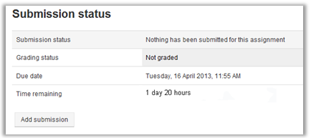

This takes you to the **File submissions** box where you can begin uploading files.

Click on the **Add submission** option to open the **File picker** window (see below). There are several options but the most common – and the default – is the **Upload a file** option.

Next, click on the **Browse** button to display a standard windows file selection box. Navigate to the place where you saved your assignment. Select it and the path and filename of the file you selected will be shown in the box to the left of the **Browse** button. If this is the correct file then click on the **Upload this file** button to choose your assignment file.

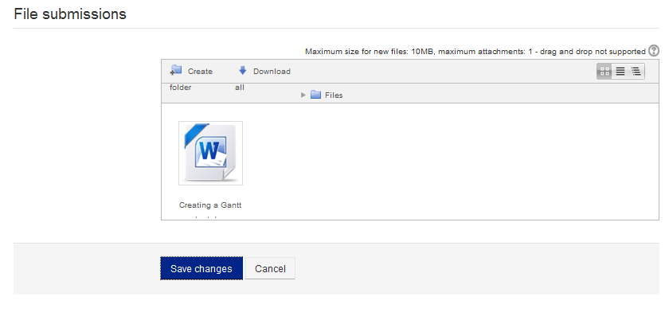

Your uploaded file will appear in the **File submissions** box. If you select the wrong file by accident, click on its icon and a dialog box will open which will allow you to delete it. Then you can choose the correct file. Click the **Save changes** button to upload it for marking.

Note: The maximum size you can upload is 1 MB.

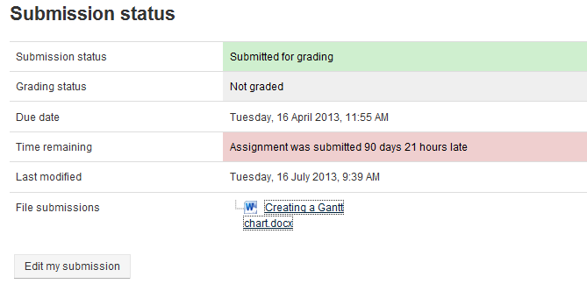

## Multiple upload

If you are to upload several files for an assignment the **Add** option will remain active until you have uploaded the maximum documents required for the assignment/s. (So your assignments can still be updated if you wish up to the point that you click the **Save changes** button).

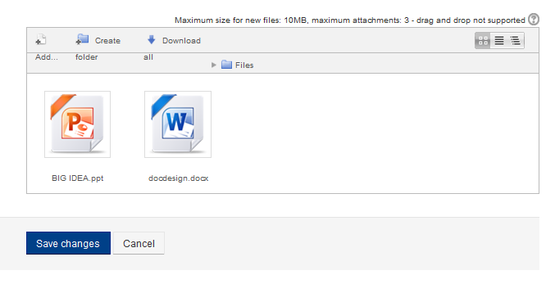

The Submission page should tell you when to send for marking and how many files you should upload. The system will not let you upload more than the required number of files – *so make sure you upload the correct ones*.

### Moodle Task 7

#### Under **Finishing off** in the **Introduction to Word Moodle** open the **Coursework Files** folder and download the *DocDesign* file you find there. Save it to your **Documents** folder.

#### Find the **Submit Assignment** option in the Moodle and go to the upload page. Here upload the *Word* file.

Although not listed as ‘assignments’, other activities may be given that require you do some work or study and you may also be asked to submit some work or at least answer some questions.

## Lessons

A Lesson is used when it is necessary to tell the students some information about the topic being taught. The topic is broken into small chunks and shown to the student bit by bit. Each part is re-enforced by requiring the students to answer questions. The students proceed through the material only by answering the questions correctly.

A **Quiz** is a series of questions, each of which allows students to choose from more than one answer and results are kept separate for each student and can be graded. Students can also receive feedback from a quiz. They can thus form part of a student’s assessment or can be used to allow a student to test his/her understanding of the material taught at any point.

**Glossaries** A glossary of terms used is a common teaching resource. In MOODLE this can often be accessed, by having words in Lessons and other activities and resources link to the relevant part of the glossary.

**Wiki** This is an activity which allows students to work together on a defined project sharing their experience in a Wiki based structure.

# Mahara

Mahara provides the tools to set up a personal learning and development environment. It is available for you to use during your time at the University.

With Mahara you can set up your own groups and choose who can join them independently of lectures/tutors.

You may be asked by your school or college to use this system as part of Personal Development Planning (PDP), relating to your academic, career or personal development achievements. If so you will be given advice, by your school or college, about how you should use the system for this.

You can use Mahara to record qualifications, work experience, goals, interests, conference papers, teaching and so on. It can also be an aid in your studies, *especially when you work in teams with other students* as Mahara allows you to share resources via Journals, Forums, Pages, etc.

This guide is intended to give you basic information in the general use of Mahara to enable you to use the system as required by your School and/or for your own needs.

NOTE: The tasks in these notes can be used as revision exercises following the taught session.

## To access Mahara

The simplest and quickest way to access Mahara is to type the URL: *portfolio.gla.ac.uk/*

To login use the GUID and password that you use to access University campus computers, email and Moodle.

## First Steps

We’ll now have a quick look at what you need to do the first time you access Mahara. The Home page or **dashboard** will look something like this:

## Mahara menu options

From this page, two drop-down menus can be found to the top right of your screen: the **User** menu and **Main** menu.



## Profile

You will want to put up some details about yourself and how you can be contacted. Do this by selecting **Profile** from the drop-down **User** **menu**.

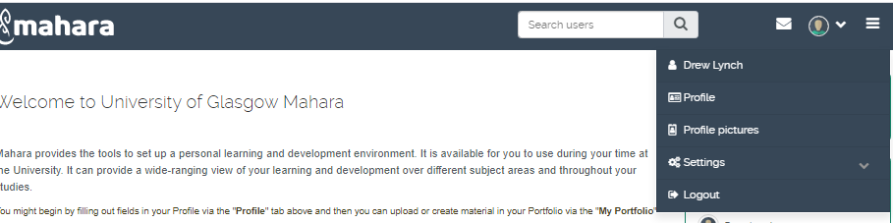

How much you put in is up to you and will depend on how much you wish to co-operate with other people using Mahara. You must at least give **first and last name** details. You can also add a student ID and give some information about yourself by the typing in the **Introduction** text box. You can format this text too. Click **Save Profile** when you are done.

### **Task 1**

#### **Now access the Profile page.**

#### **Using the options here (About me, Contact information, etc.) add/edit some of your personal details.**

#### **Your name and email address should be here: add them if they are not.**

#### **Add a brief line of text about yourself under Introduction.**

## Profile Pictures

If you wish, you may add an image of yourself to replace the standard default image. Select **Profile Pictures** from the **User** menu.

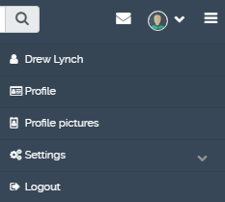

By default you will have at least one profile which you can replace, up to a maximum of five profile choices at any one time. Go to **Upload profile picture**, then click on **Choose file** and when the usual dialog box opens, find and select the image file you wish to use. Once selected, use the **Upload** button to add it to your collection of icons.

**\*Note the pixel and file size constraints for these profile pictures**

The image will now appear. Select it by clicking the **Default** radio button.

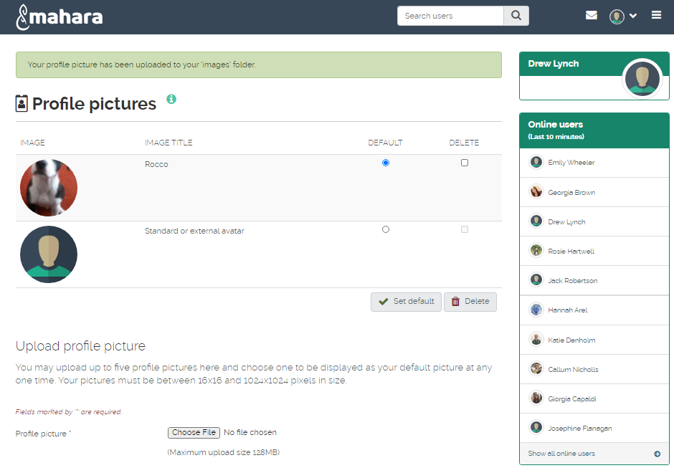

Finally click the **Set** **Default** button to make it the image others will see when they view your Mahara pages. You can change this whenever you wish.

### **Task 2**

#### **Now using the steps mentioned above, add an icon to your Profile.** To see how your profile looks (that is how others will see it) go to your **Profile** **page**.

From the **Main** **menu**, select **Create** 🡺 **Pages and collections** and then select the link **Profile page** box

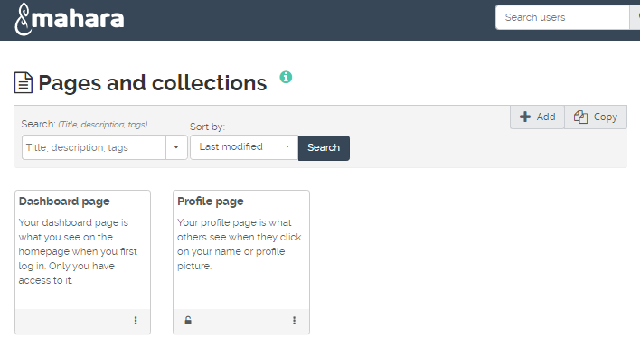

You can edit your Profile details at any time in the same way that you set them up. You can also edit your Profile page: change its layout, add or remove extra content or other items such as files and images.

You edit the Profile page in the same way that you edit any other page you create, so we will leave off looking at this till later when we look at creating new Mahara pages.

## Résumé, Goals and Skills

An important use of Mahara is for **PDP** and this involves (among other things) maintaining an up-to-date **Résumé** and keeping a record of your **Goals** and **Skills**.

As you can see from the next image, these can be added to Mahara via the various options found along the bar at the top of the **Introduction |** **Résumé** page (e.g. **Education and Employment, Achievements, Goals and skills** and **Interests**). Access the **Résumé** page from the **Main menu drop-down** 🡺 **Résumé**.

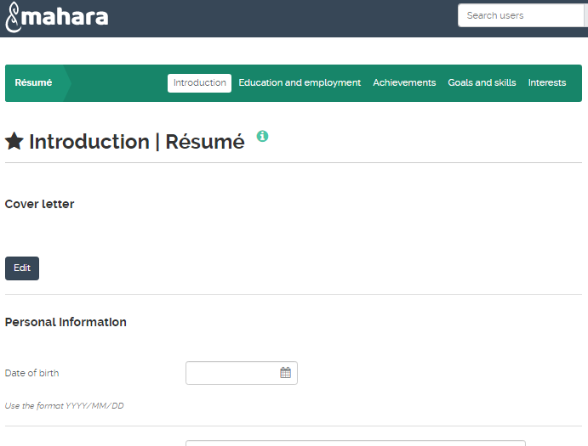

Each of the **Résumé** options allows you to enter suitable information into text boxes (where the text can be formatted).

Your Résumé will also let you add personal information and other typical Résumé elements in different style text entry areas.

### **Task 3**

#### **From the Main menu, go to +Create and Résumé**

#### **Here enter some interests and some personal details (e.g. DoB, Gender). You can fill in the rest later, this is all that’s required for now.**

#### **Access and view the Goals and Skills areas.**

#### **Add a single sentence in each and save. There’s no need to add anything more just now. Note: all these areas are only going to be useful if you keep them up-to-date. Get into the habit of doing so at least once a week.**

#### **Save your changes.**

## Files

In Mahara you can upload **Files** (which can be viewed by others), add **Journals** and **Plans**. You can then create new **Pages** arranging these resources into **Views** for different audiences, or simply for your own records.

## Upload a file

From the **+Create** drop-down option within the **Main menu** select **Files**: you will see the following:

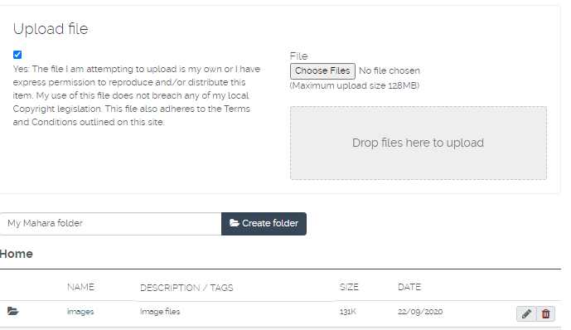

**Note:** the **Choose Files** button won’t be active until you click on the **Upload File** checkbox, *which means you are confirming you have the right to use the file uploaded*.

To upload a file, click the **Choose Files** button.

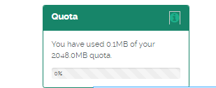The normal dialog box will open to allow you to choose a file. Find and select your file and when you click **Open**, it will be uploaded to Mahara.

The uploaded file will now appear on your **My Files** page. You can upload up to 500 megabytes of files to your file storage area. You can keep track of your storage by viewing the **Quota** icon on the right hand side of the Mahara window.

If you expect to upload a lot of files, create **Folders** to organise them. To do this, enter a name in the **Create Folder** box then click the **Create Folder** button.

Move a file into a folder by “dragging and dropping” *the thumbnail* *icon* *of the file* with the mouse.

To access the file once it is in a folder, click on the folder name. To rename a folder or change description or tags, click the **Edit pencil** button.

### **Task 4**

#### **Go to the Filespage,**

#### **Upload a file on to your computer. (If you don’t know what to upload you can save a file from the IT Training web** [**course resources page**](https://www.gla.ac.uk/myglasgow/it/training/courseresources/)**)**

#### **Create a folder – give it a suitable name.**

#### **Now drag the file you just uploaded into this folder.**

## Plans

Plans are simple **To-Do lists**. They are particularly well-suited to plan medium and long-term endeavours. A plan can consist of a number of individual activities with which completion dates are associated.

To make a plan, select the **Main** menu and choose **+Create**, **Plan**

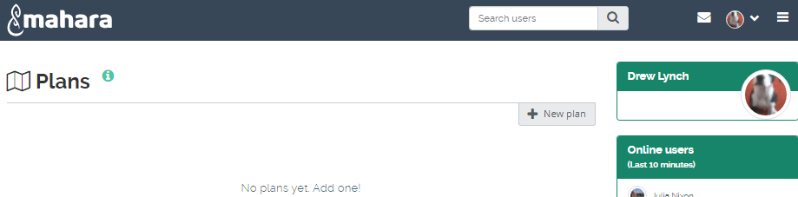

Click **+** **New plan** to make your first Plan.

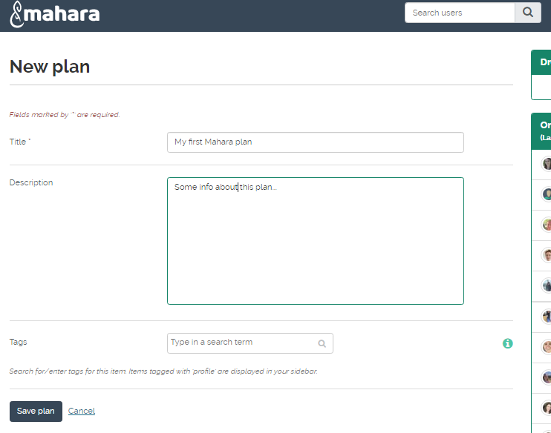

Give your plan a **Title**. This field is mandatory. Next, give your plan a description. This is visible when you select a plan for inclusion into a **Portfolio** page. Click the **Save plan** button to keep your new plan. *Now you add individual tasks to your plan.*

When you save a new plan the option appears to add a **New task**.

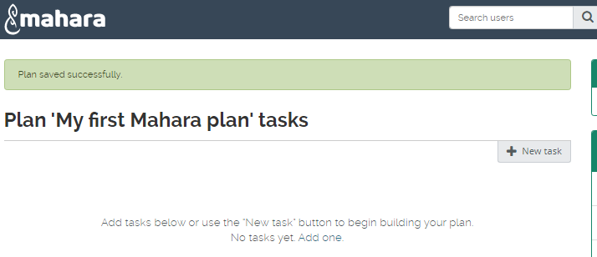

You can keep adding tasks until you have listed all the elements required to complete your plan.

Your plan appears as a list of tasks (which you will see any time you look at the **Plans** page). As each task is complete you can edit it (using the **Edit** icon) and mark it as **Completed**. When a plan it totally completed, you can delete it using the **Delete** icon.

### **Task 5**

#### **Go to the Planspage,**

#### **Create a plan – for instance for some project you may have to do for your studies.**

#### **Give it a suitable title and add a brief description.**

#### **Add 2 or 3 tasks and save the plan.**

#### **Use the Edit option to add a new Task**

#### **Mark one completed.**

## Journals

Journals provide commentary or news on a particular subject; you can discuss study, research, coursework or just about anything of interest to you. A typical Journal combines text, images, and links to other web pages and media related to its topic.

To add or edit a Journal in Mahara, open the **main** menu, **+ Create** and choose **Journals**. Starting is straightforward. Select the **+ New entry** button. The **New Journal** window will appear.

Each Journal must have its own title. Enter this, then type a brief description of what your Journal is about in the text **Entry** area.

### **Task 6**

#### **Go to the Journalspage**

#### **Create a Journal – for instance about some topic you may have to cover for your studies.**

#### **Give it a suitable title**

#### **Add a brief description.**

#### **Add some suitable Tags**

#### **Save the Journal settings.**

## Editing a Journal entry

Text and other items can be added to a Journal entry, e.g. web links to other sites and images. On the **Journals** page, select the **Edit** pencil button.

You can format your text using the format toolbar above the text entry box. Here the usual listings for **bold**, *italic*, **font colour**, lists and paragraph alignment are available.

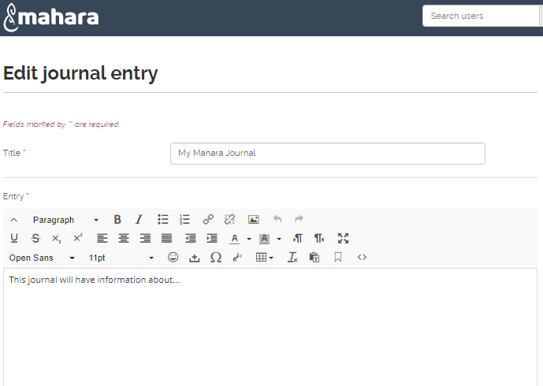

Note the full formatting toolbar has been toggled here.

This toolbar also contains the buttons for opening the dialog boxes which let you add tables, links and pictures.

To add an image you must upload it clicking the **Insert/edit image** button in the **entry** text box.

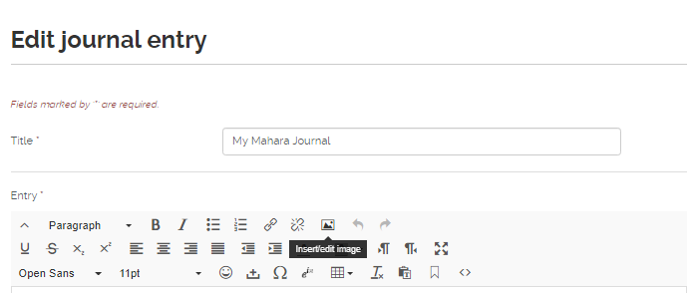

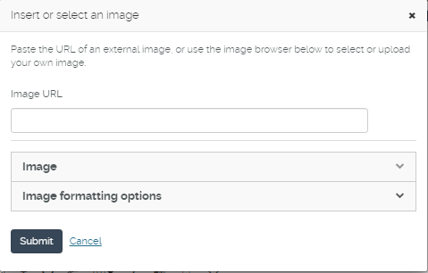This opens a dialog box with drop down options for the image and formatting. It includes an **upload file** sectionsimilar to the one you saw earlier.

You can select from files you uploaded previously, accessing them from folders, or upload a new image file directly by clicking on **Choose Files**.

When you’ve uploaded a number of images, they will all be available for selection and you can choose one of them to insert into your Journal by clicking the **Submit** button.

The URL of the pathway to the image will appear in the **Image URL** box.

To change the Journal heading and intro, click the **Title** on the **My Journals** page then click on the **Settings** button.

On the Journal page you can also delete or edit posts or add new ones. You can delete a whole Journal.

Links to web resources can easily be added when you create or edit a Journal. Type in the text that will form the link; then ***select it*** and click the **Insert/edit link** button. The following window will open:

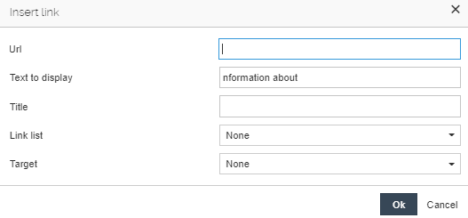

Type in (or paste) your link into the **Url** box.

Enter some **Text to display** then select an option from the **Target** menu, and then click the **OK** button.

If you want to check your text before it goes live, toggle the yes/no **Draft** button. This will hide it from view (except to yourself) even after you’ve saved it. Finally click on **Save entry**.

When you are ready for it to be seen, click the **Publish** option on the **Journal** page.

After you’ve added a few Journals you’ll see them listed together whenever you access your **Journals** page. Simply click on the **Title** of any Journal to view it and edit its entries or add new entries.

### **Task 7**

#### **Add a short Journal entry – no more than a couple of lines of text.**

#### **Add an internet Link to your post: use the university home page URL if you can’t think of anything right away.**

#### **Add an image to your post if you need to, download one from the IT Training web site.**

## Groups and Friends

An important aspect of Mahara is that you can work in a co-operative way online with others who have Mahara access. This can be organised in groups of people (e.g. students in a class, fellow participants in a project) or individual people (one or several) with whom you might share an interest.

When you first access Mahara you will have no **Groups** and no **Friends** There are two ways you can become a group member and two ways in which make a friend.

### Groups

Youcan request to join an existing group or you can set up a new group yourself (which you naturally will be a member of). From the **Main menu**, select **Engage** 🡺 **Groups**. From here you will see all the Groups you’re a member of. Naturally this will be empty the first time you view it.

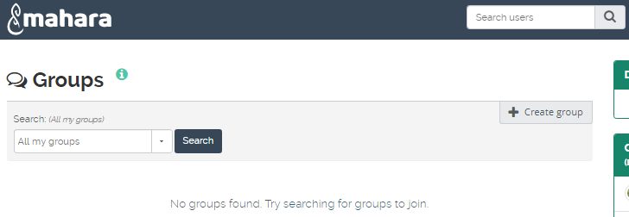

**Finding a Group:**  you can’t join a Group if you don’t know it exists. Very likely someone will invite you – although some Groups are open for anyone to join.

Choose a group option from the **Search (all my groups)** drop-down list, then type into the Search box. Click the **Search** button to find the group.

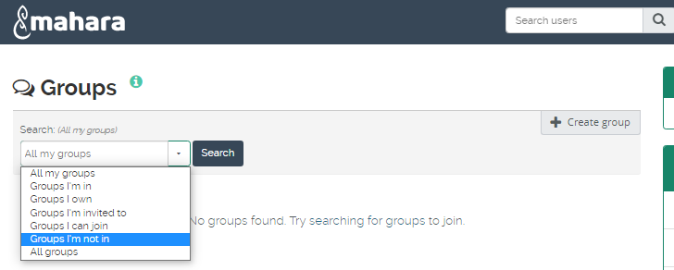

Some Groups can be joined immediately. These will have a **Join this group** button. Groups marked **Request to join this group** require you to state your reasons for wanting to join, then click the **Request** button. The message will go to the owner of the Group who will let you know if your request has been accepted.

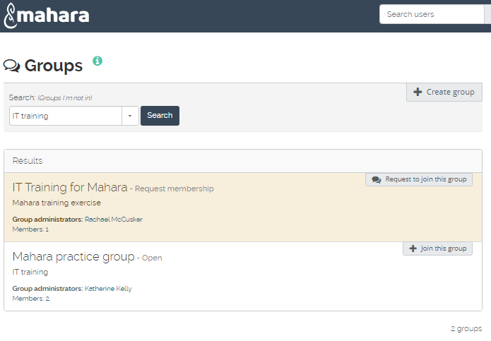

Once you’ve joined you’ll see the following page:

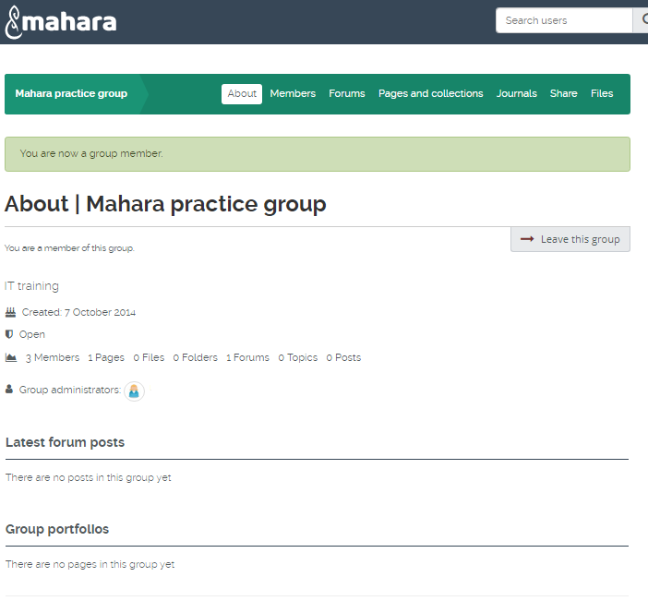

Note the tabs: **About**, which tells you about the Group; **Members**, which gives links to members’ details and allows you to communicate with them; **Forums**, if there are any; **Pages &** **Collections**, **Journals**, **Share** and **Files**.

Note finally there is the **Leave this group** link which allows you to stop being a member of the Group (you can join up again later if you wish).

### Creating your own Group

Under **Groups**, click the **Create Group** button.

The **Create Group** page will appear, as shown here:

A name for the **Group** is essential and though it’s not forced you should add some text in the **Group Description** box – who’s going to join your **Group** if they don’t know what it’s about?

You must decide what kind of membership you want to offer. You do this by clicking the **Settings** option above the **Save group** button.

The options are:

**Open** – anyone who sees the Group on Mahara can join up by simply clicking the **Join this group** button. This must be OFF before you can activate some other options.

**Request** – people who find the group must send you a request, saying why they want to join.

**Friend invitations** – only people that you specifically invite can join

**Recommendations** – Allow members to send a recommendation for joining this group to their friends from a button on the group homepage.

### **Task 8**

#### **Select Groups**

#### **Search for Test Mahara and make sure the search area is set to All groups.**

#### **When you find the Group, click on the Join this group button.**

#### **(You should get access to the Group before the course session is over: if not, try again later).**

#### **Now create your own Group**

#### **Give it a name**

#### **Type one line of text description.**

#### **Save and view your Group.**

There are other options regarding Group members editing and sharing pages belonging to the Group but this is all you need to know initially.

### People: finding and adding friends.

You can’t add a friend unless they have set up their Profile on Mahara where you can search for them and send a **Friend Request**. To do this, go to the **main menu** 🡺**Engage** 🡺 **People**.

Enter the name of the person you want to send a Friend Request to and click the **Search** button. When their details appear, click **Send friend request**.

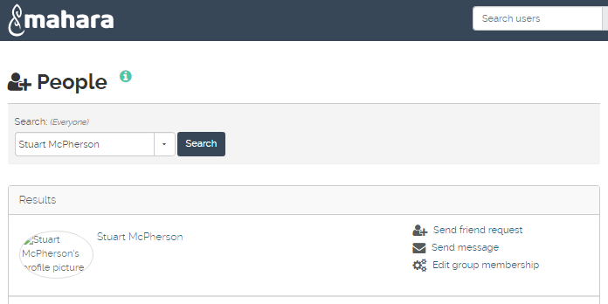

Type a brief message asking if they will be your Friend and then click the **Send message** button. If accepted they will appear in your Friends listing next time you look at your Profile.

From the other point of view, if someone requests you to be their friend you will get an email informing you of the request and a link to your **My Friends** page where you’ll see the request and the options to **Approve Request** or **Deny Request**.

### **Task 9**

#### **Select ‘Everyone’and search for a name Swap names with your neighbour or use the tutor’s name.**

#### **When you find it, click on the name link to see their *Profile*.**

#### **Now use the Request friendship link here to ask them to be your friend ☺. Make your request text brief.**

#### **When your neighbour’s request appears, click the Approve request link.**

#### **Then view your list of friends (My Friends).**

## Creating a new Page

**Note:** when you first access this section your **Dashboard** and **Profile** pages will already exist. Any pages you create later can be edited or deleted at any time.

From then **Main menu** 🡺 **+ Create**, click on **Pages and collections** then click the **+ Add** tab

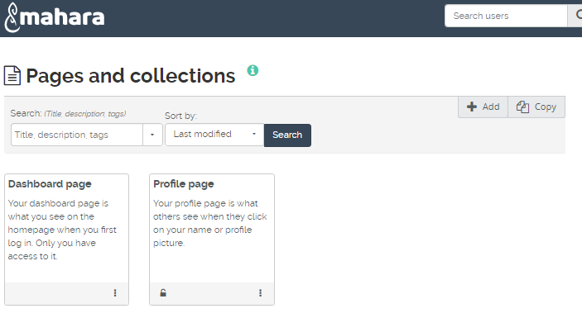

Choose **Page** from the pop-up box 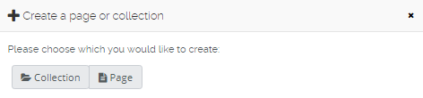

This takes you to a page where you enter a **PageTitle** and **Page description** (and if necessary, **Tags**) for your new Page.

The next thing to do is choose the layout of the Page. Click the **Layout** drop-down tab and you will see thumbnails of the Layouts available: **1 column**, **2 columns**, **3 columns**, etc.

You can also choose from a selection of **Skins** here.

When you’ve done this click on the **Save** button.

### **Task 10**

#### **From the Main Menu 🡺 +Create, select pages and collections then + Add tab**

#### **Choose the page button.**

#### **Add a Title and Page description**

#### Under **Layout** select either a **2 columns** or **3 columns** layout.

#### Click **Save**.

## Editing page content

After you’ve chosen your Layout, the **Edit content** tab is now activated and it is in this area that you can add items to your Page.

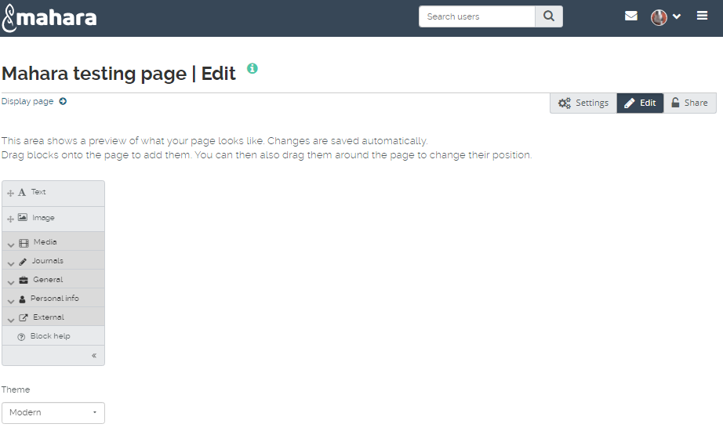

There are several options under Edit content: Text; Image; Media; Journals; General Personal info; External and a separate Theme options box.

It is a good idea to begin with a **Text box** and add brief content explaining what the page is all about.

You should familiarise yourself with all the options before you begin. You select individual items by clicking on them and dragging them down to the Layout area.

When you add an item to a Page a dialogue box will open up that you will be required to complete.

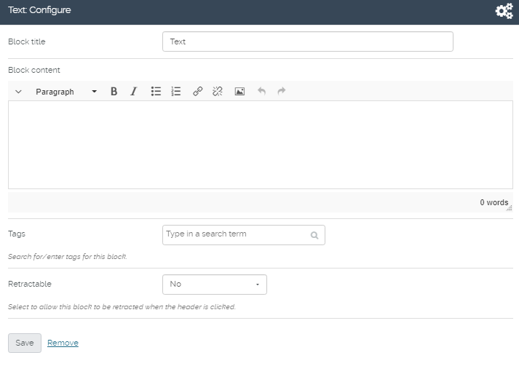

Enter an explanatory **Block Title** and some suitable text in the **Block Content** area. Then click **Save** to add it to the Page.

Note also the options for formatting and even adding images. Use this where the image is closely associated with the text added. If the image has a more general purpose you should add it using **Image** or **Media**.

You can add any item under the various tabs to your page. Remember, you can only add items that you’ve actually uploaded or created (except in the case of the external content options). So you must add some items before you create a meaningful page. Again, you can have different pages for different groups of people.

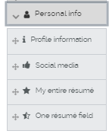We’ll look at a few more typical Artefacts you can add to a Page. For instance, if you wish to show something about yourself, you can select items from your **Profile** to display in the Page (all this comes under **Personal info**).

**Personal info** options **Profile Information** and **One résumé field** require you to select information you have added that you wish to display.

You can choose all of it if you wish but you’ll usually want to leave something out.

For example here contact information (First name, Last name and email) is selected.

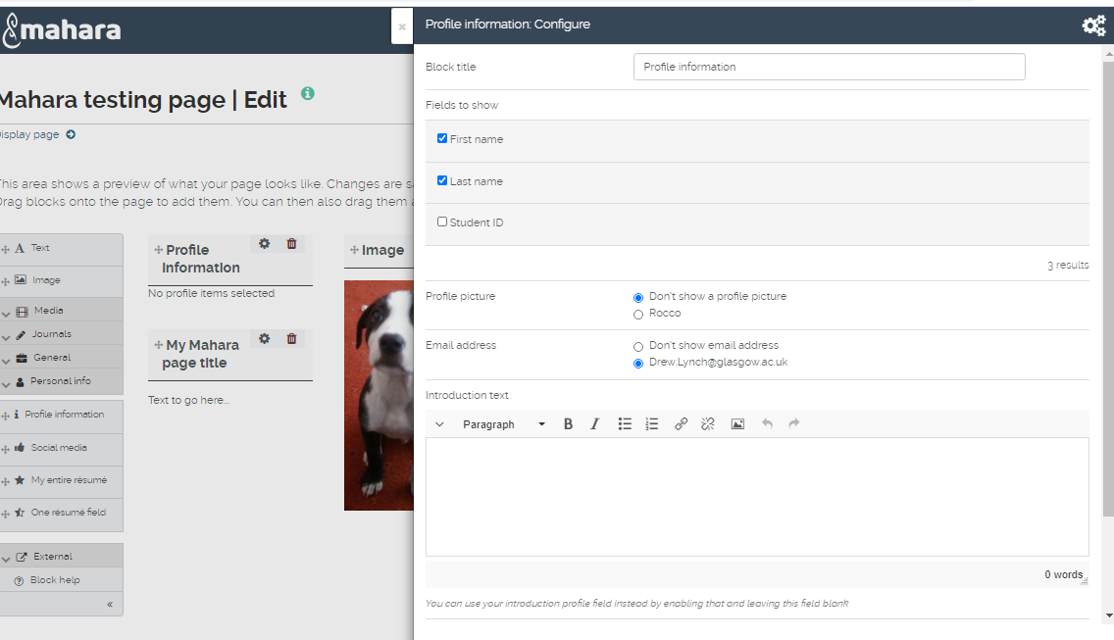

Click the **Save** button at the bottom when you have made your selections.

**Note**: options require you to have something in them already or they will show nothing but a heading.

Adding Journals to a Page

One thing you’ll very likely want to show is a **Journal**. When you click on the **Journals** tab you will see the following options:

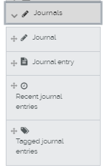

You can drag-and-drop any of these across to the areas within your page that you had specified earlier.

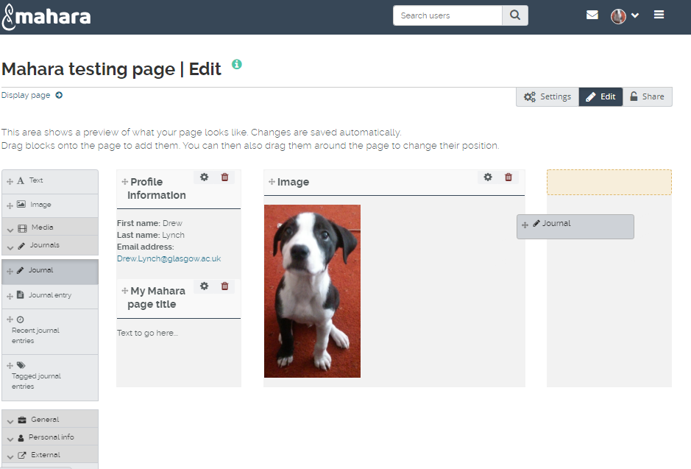

You can also rename the Journal if you wish – just for this Page. This is under **Set a** **Block title**. If you ignore that option the Journal’s own title will be used.

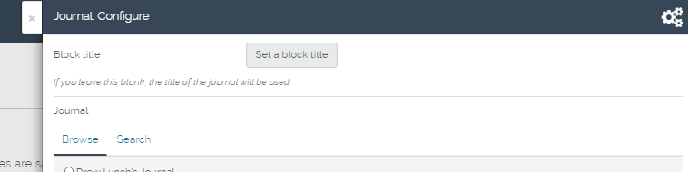

Click the **Save** button to add the selected Journal to your Page.

### **Task 11**

#### **Under the Edit content tab add a Text box to your Page.**

#### **Give it a suitable title and some content: keep this consistent with whatever you’ve decided the Page is about.**

#### **Select Personal info**

#### **Add items from your Profile information.**

#### **Add a Journal entry to your Page.**

#### **Use the Configure button to open the Journal entry: configure box and give the entry a Block title.**

## Adding Images to a Page

You can **display images** or **multimedia files** such as **mp3 audio files** or **videos** – in your Pages. You can also put up files (or folders) which can be downloaded by people you allow to share your Page. Open the **Media** tab.

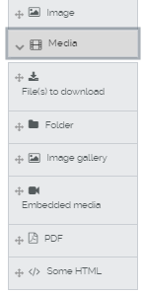

To add an image: drag from either the **Image** icon or from the **Image gallery** icon in **Media**. Both options are pretty much the same except that the Image option includes the facility to upload new images.

As before, drag-and-drop your selection across to an area within your page that you had specified earlier.

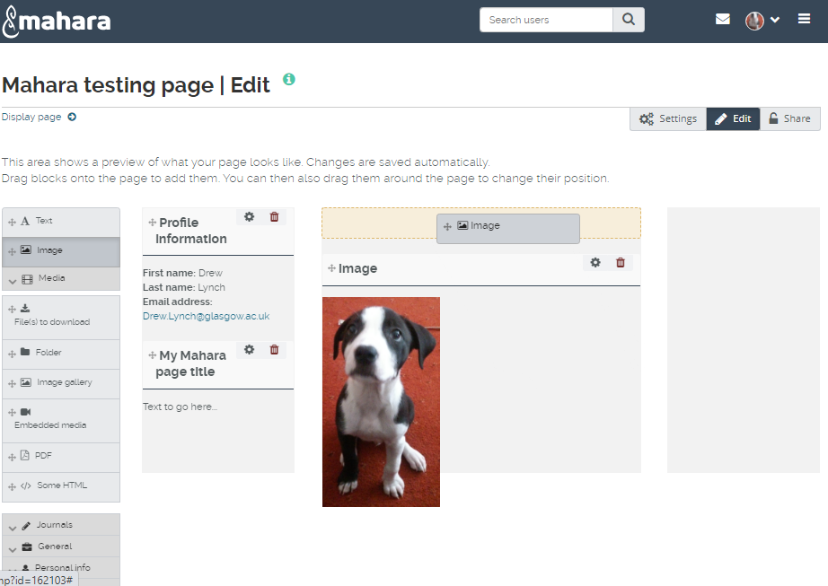

As an example we show the view after the **Image** option has been chosen.

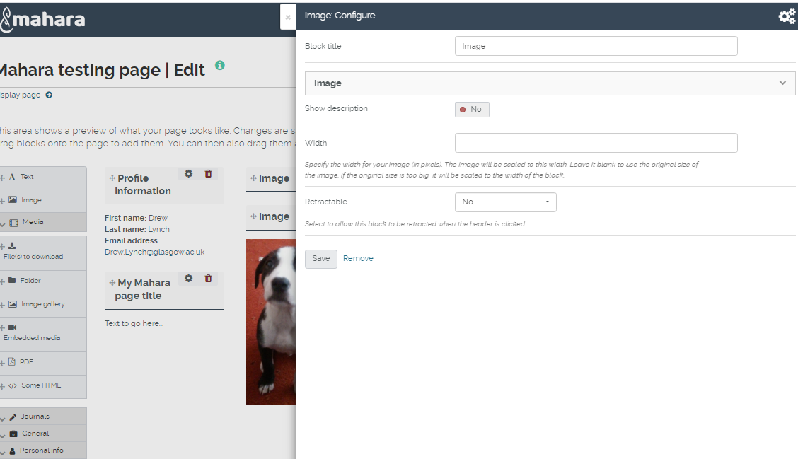

Add a **Block title** for the image – this describes what it is or why it’s there. Choose your image to display by clicking the **Image** drop-down.

You can choose to show a file description (if you’ve given one) or you can set the size of the image display in your Page. Click **Save** when you’ve done all this.

**Note**: you can only select files that you have uploaded. You can only select one image to a block but you can add several blocks if you wish, repeating the process, to a Page.

Adding **Files**, **Folders** and **Embedded Media** is very similar to the above, except with files you can select several files to your Page all at once.

As you add items, you may feel that the layout doesn’t ‘work’ for you. You don’t need to remove items and add them again in a different position: you can simply drag a block with the mouse and place it in a new area on your layout page.

### **Task 12**

#### **Add an Image to your Page.**

#### **Now try moving the image and placing it in a new position.**

#### **Now add block of files to your Page.**

#### **Edit your Files block: remove one file and replace it with a different one.**

## Embedded media

This option is also found within the **Media** menu. You can use this option, for instance to embed a **podcast** or video file into your Page.

Although you can use the **Embedded Media** option for video files you own, video files can be very large. There is an option (under **External** which we cover below) to link to a video held elsewhere, e.g. on *YouTube*.

**Some HTML** allows you to place a block which links to a web page; this must be used with care as it may list the entire contents of a site when you may only require one page.

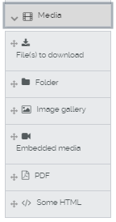

## Adding external content

The **External** option allows you to add **RSS** (or **Atom**) **feeds**, **External media** (this includes presentations and videos) and **Google Apps**.

Before you can add an external feed you must know it exists.

So the first thing is to find the URL for the feed. Click the subscribe icon then copy the URL.

Go to your Mahara Page where you want to place the feed.

Then drag the icon down to the area where you wish to place the block for the feed.

You then paste/type in the feed URL into **Feed location**.

Usually this is enough though for some feeds you may need to enter a username and password.

## External video

Adding an external video is different from adding video as embedded media where you upload a file and it exists in your Mahara file store.

It is far better whenever possible to use an external video source than fill up your file storage with uploaded videos.

To place an external video on your Page you must add a URL of where the video is located to the dialog box (e.g. *youtube.com, teachertube.com*).

Note the icons in the centre of the dialog box: these tell you what sites you may use (run the mouse over them for this information) and whether you can use a **URL** or need an **embed code**.

Give a **Block Title** as usual and, if you wish, set the width and height of the video display.

Click **Save** when you’re done.

The video will appear in a media player embedded in your Page: simply click the **Play** button to run it.

### **Task 13**

#### **Do a web search on: “How to Embed a YouTube Video in Mahara’ then r**efine the search to obtain a list of suitable videos

#### Now copy the URL and return to your Mahara page.

#### Drag the Embed external content icon down to create a new block.

#### Add the URL or embed code

#### Save the block.

## Page Access

Pages can be for your own use only or you may want them to be available to everyone or to a more limited audience.

Select the **Share button** option when you wish to decide who will be allowed to view your Pages.

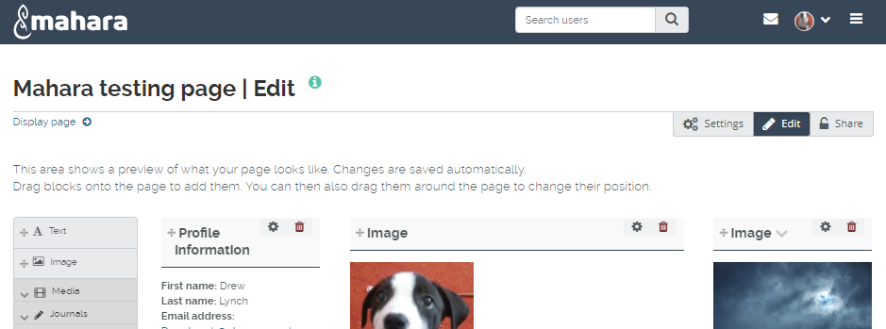

From here you can choose page access options under **Share with others** or create a **Secret URL**

We’ll look at **Secret URL** first. The secret URL is created when you click on the **Secret URL** button. You can copy this using the **copy** button and send to whoever you wish to be able to use it. The **edit** pencil button will allow you to set a timeframe for when this Url will be accessible

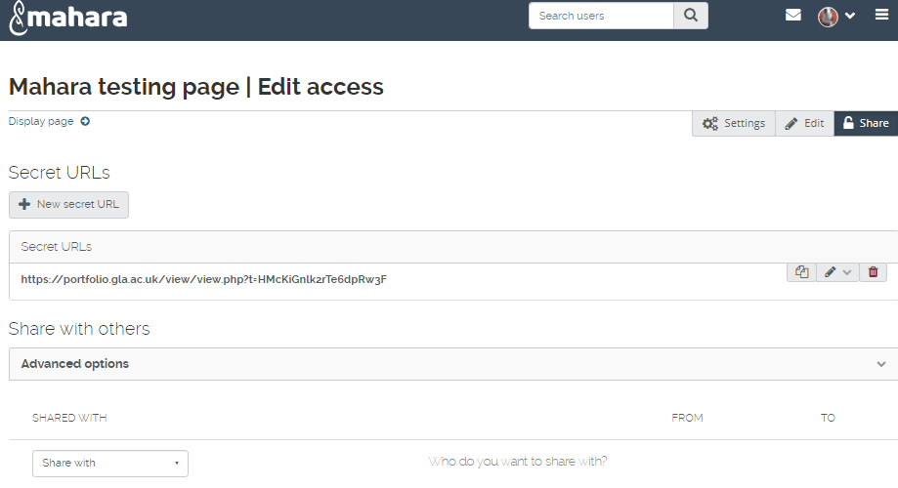

### **Task 14**

#### **Create a Secret URL for one of your Mahara Pages.**

#### **Set a start date when it will be active and an end date when it will cease to be active.**

#### **Use the Share with drop-down and choose User – search for one of your classmates**

#### **Save any changes made.**

## End of tutorial notes