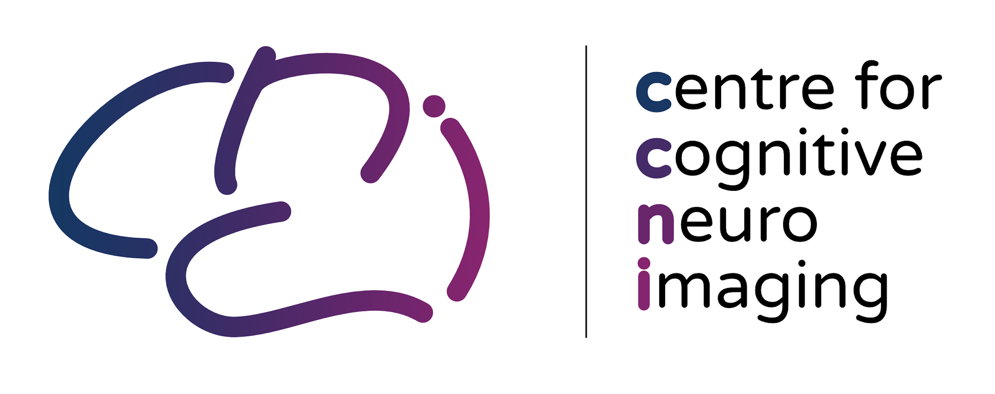

Project Number:
Participant Identification Number:
Title of Project:

Name of Researcher(s):
Note: The statements below are examples. Keep only those relevant to your research project and add any missing project specific details. Statements in Bold are recommended for all consent forms

CONSENT FORM |  |  |  |  | Please initial box
I confirm that I have read and understood the Participant Information Sheet dated 2024. I have had the opportunity to think about the information and ask questions and understand the answers I have been given.
I understand the risks and contraindications which includes pregnancy.
I understand that my participation is voluntary and that I am free to withdraw at any time, without giving a reason, without my medical care or legal rights being affected, while being entitled to my per/hour payment.
I agree that my name, contact details and data described in the information sheet will be kept in University archiving facilities in accordance with relevant data protection policies and regulations.
I understand that all personal data and information I provide that identifies me will be kept confidential and will be seen only by study researchers, administrators that handle financial remuneration for participation and regulators who oversee processes.
I understand that my brain scan data will be anonymised. After anonymisation brain data may be shared. The data sharing is described in the Open Brain consent form (further below) and contains explanations that there are small possibilities of identification.
I understand that if I withdraw from the study, my data collected up to that point will be retained and used for the remainder of the study, in anonymised format.
I understand that this is not a diagnostic scan but that should, by chance, something abnormal be suspected, my anonymised MRI data will be reviewed by a non-NHS neuroradiologist (or occasionally from an NHS neuroradiologist), and further imaging may be recommended. This imaging would be performed at the QEUH campus by NHS staff and the NHS staff involved would be able to identify me from my scan images at this point. The results would be shared with my GP and be part of my medical record. There is no guarantee, however, that if there is an abnormality, it will be detected. If an insignificant finding is discovered, I will not be informed. If a significant finding is discovered which is of potential benefit for me to know, I will be contacted and given the opportunity to discuss the findings with a clinician. I agree to my personal information being given to health diagnostic personnel.
I understand that the research data may be accessed by researchers working at or in collaboration with the College of MVLS in similar ethically approved studies but that at all times my personal data will be kept confidential in accordance with data protection guidelines.
I consent to the unlikely event that my data will be shared with the scanner manufacturer Siemens for technical or marketing purposes. I understand that my images will be anonymized prior to sharing but that there is a small chance that structural information in my scan allows me to be identified by facial features.
I agree to take part in the study.

General practitioner (GP) details:
Full name: ______________________________________________________________________
Address: ______________________________________________________________________
Phone number: ______________________________________________________________________

Name of participant Date Signature

Name of Person taking consent Date Signature
(if different from researcher)

Researcher Date Signature
(1 copy for participant; 1 copy for researcher)

OPEN BRAIN CONSENT FORM MRI

We will give public access to all the data from this project via an open online database and scientific journal articles. This will allow other researchers to check our analyses, or apply their own analyses to our data. The data might be used to address topics other than those of the current project – for instance to develop or validate new analysis methods. Thus, open data sharing can help improve the impact of our research and avoid duplication of research efforts.
Letting us use and share your data is voluntary. However, you must be willing to share your data in this way to participate in this study.
The data we share publicly will not have your name on it, only a code number, so people will not know your name or which data are yours. In addition, we will not share any other information that we think might help people who know you or guess which data are yours.
If you change your mind and withdraw your consent to participate in this study (see study information sheet), we will not collect any additional data about you. We will delete your data if you withdraw before it was deposited in the database. However, any data and research results already shared with other investigators cannot be destroyed, withdrawn or recalled.
By agreeing to participate, you will be making a free and generous gift for research that might help others. It is possible that some of the research conducted using your information eventually could lead to the development of new methods for studying brain, new diagnostic tests, new drugs or other commercial products. Should this occur, there is no plan to provide you with any part of the profits generated from such products and you will not have any ownership rights in the products.
All brain data is anonymised prior to sharing. It is unlikely that you will be identified by your anonymised brain data. If we write a report or article about this study or share the study data set with others, we will do so in such a way that you cannot be directly identified. However, by using additional data linked to your name (for example brain scans obtained from your medical records), one could potentially associate your imaging or other information in our database back to you. In addition, a security breach (break in or cyber-attack) might lead to someone being able to link you to your data. This risk is very low because your data are stored in a secure database, and the information about your identity is stored separately from the data themselves, linked only through a code. Lastly, it is possible that structural information in your images allows your facial features to be identified. This risk of facial identification is low. Firstly, often (but not always) the investigators and/or database curators use procedures to remove this structural information. Secondly, there is no current commercial use of facial recognition from the free and open magnetic resonance imaging databases used by researchers.

We will keep the private portion of your data (name & contact information) in a secure location for 10 years, and then destroy this information to protect your privacy.
I agree to provide my data for future research:

Name of participant Date Signature

Researcher Date Signature

Participant ID:

