Turnitin Options for Online Exams
Turn Editing On

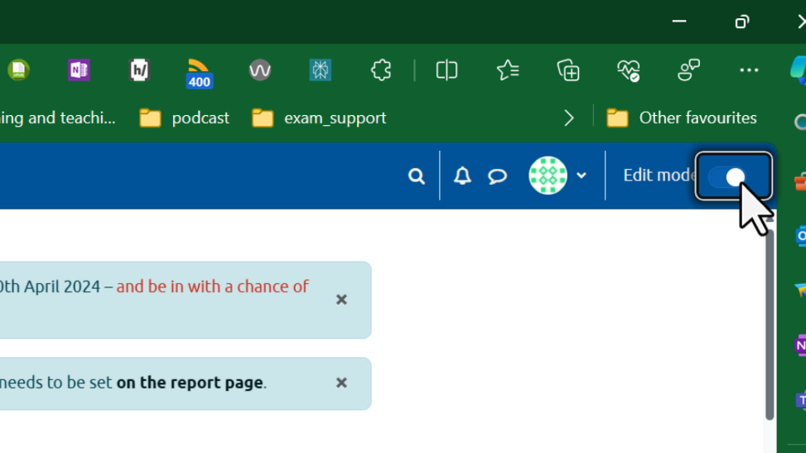

Scroll down to the required exam. Select the three dots.

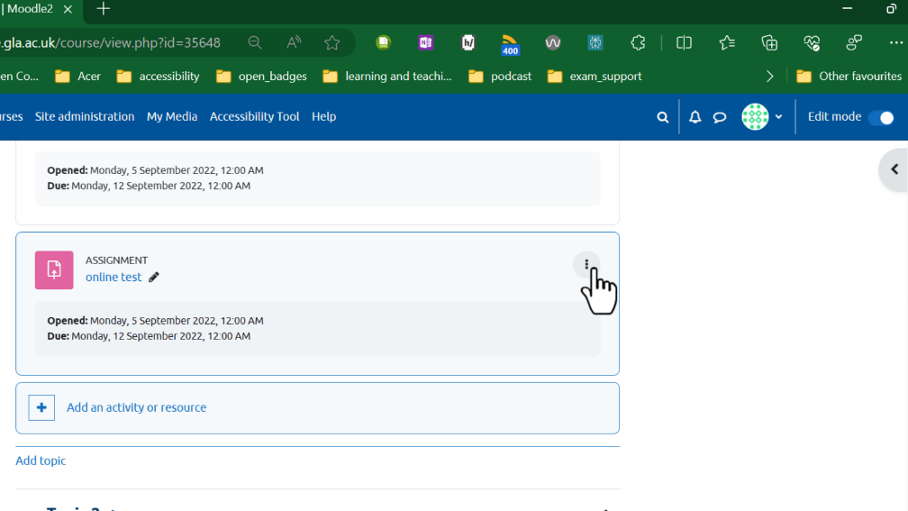

Select "Edit Settings".

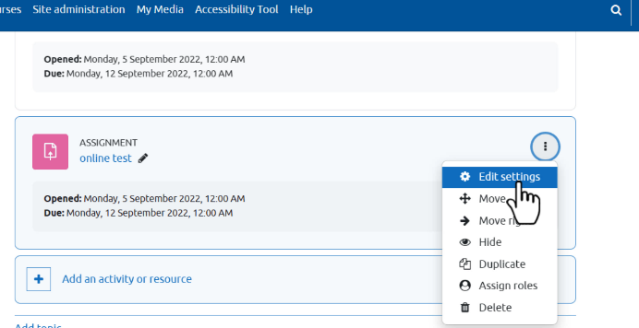

Scroll down to the Turnitin options.

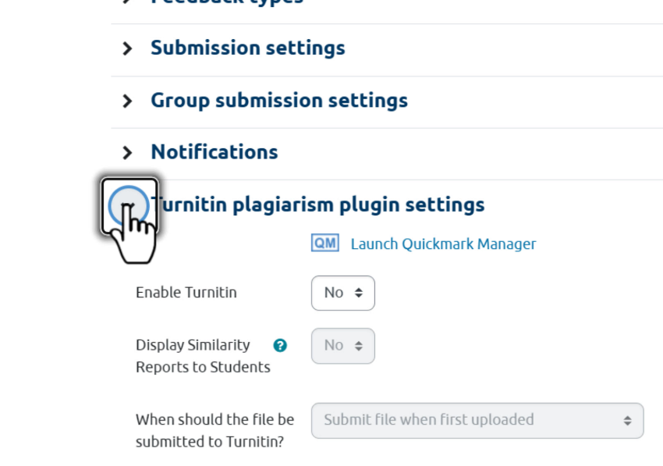

At the "Enable Turnitin" option, select "Yes".

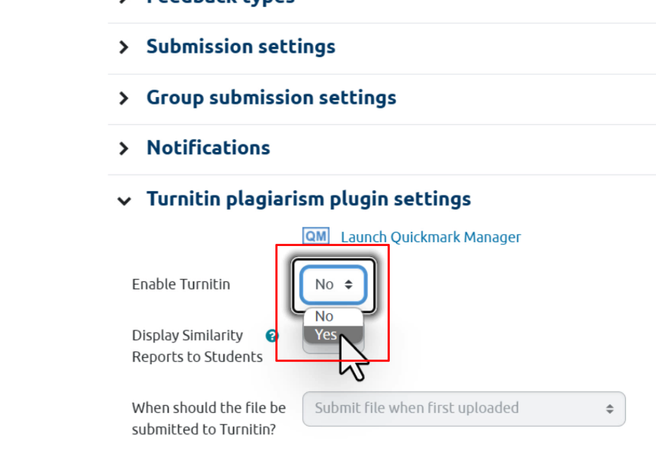

At the "Display Similarity Reports . . ." option, select
“No”.

At the "Allow submission . . ." option, select "Yes".

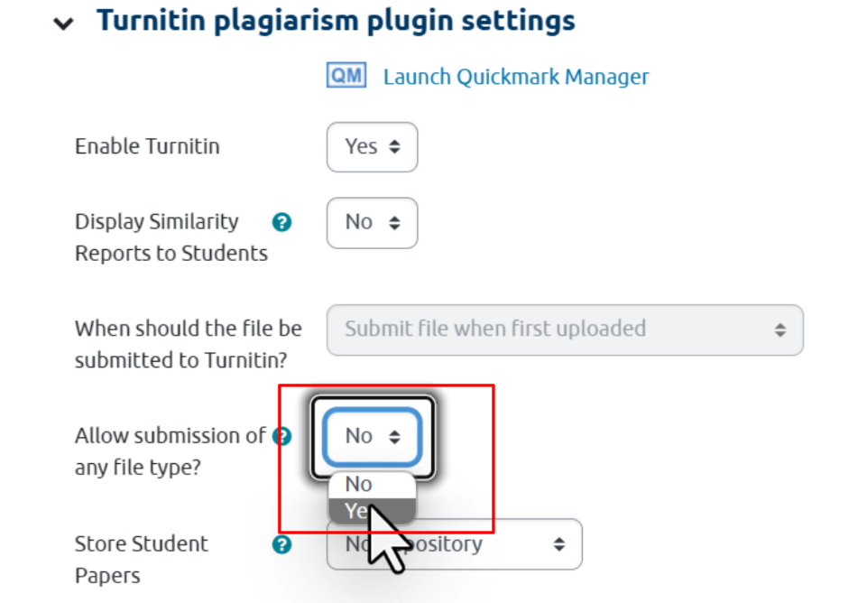

At the "Store Student Papers" option, select "Standard
Repository".

Select "Save and return to course".

