Adding Additional Time for an Individual in an Online Exam
To give an individual user more time in a quiz, go to the quiz and select the “More” dropdown
.
Select “Overrides”.
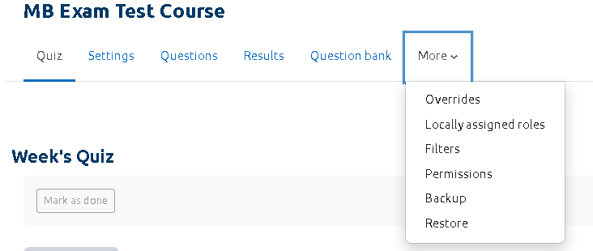
On the next screen, select “Add User Override”.
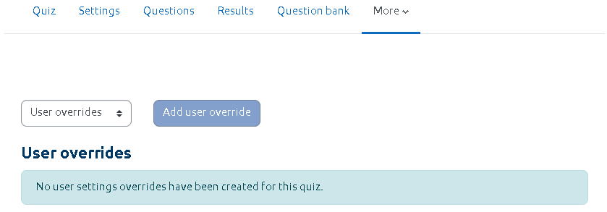
Use the search option or the dropdown list to find the student.

You can now change the Due Date and Submission Date as required.
Remember to update the Cut off Date to be 15 minutes after the Due Date time.
Select “Save”.
The new Due Date and Cut off Date for the selected student will be shown.

