Adding Additional Time for an Individual in a Moodle Quiz
To give an individual user more time in a quiz, go to the quiz and select the “More” dropdown.
Select “Overrides”.
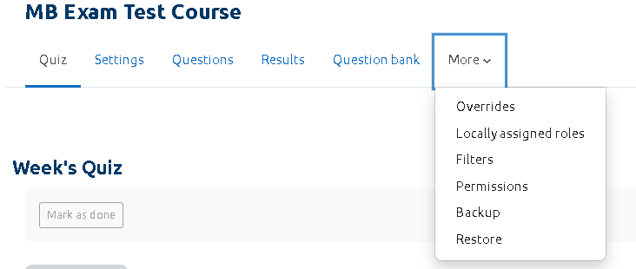
On the next screen, select “Add User Override”.
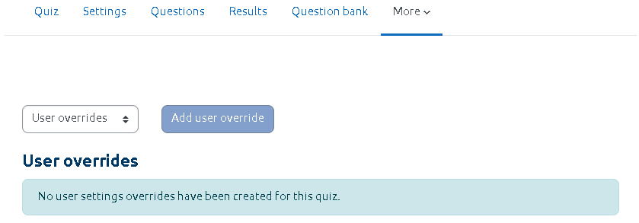
Use the search option or the dropdown list to find the student.

You can now change the quiz time limit. Select “Save”.

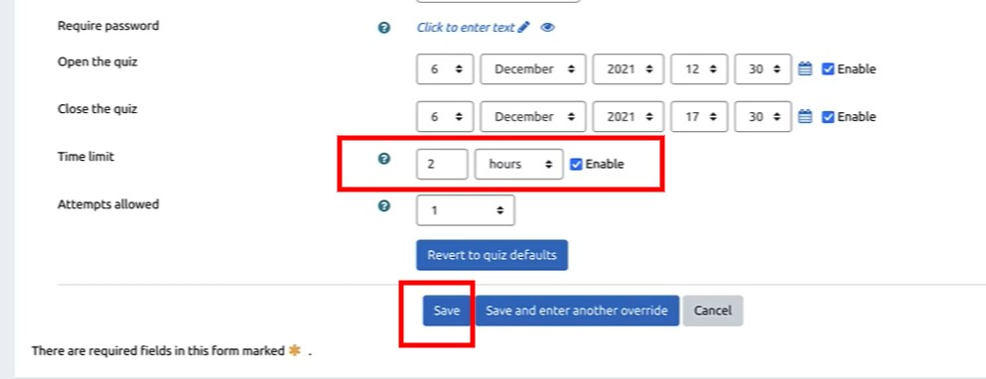

The new time limit for the selected student will be shown.

