Adding a Timed Exam to Moodle
Contents
Adding a Timed Exam to Moodle 1
Turning On Course Completion 1
Adding text to your exam topic area 3
Adding a student information file 4
Adding the exam booklet 5
Setting up the originality statement 6
Add exam paper with restrictions 9
Adding Restrictions to Exam Question 11
Adding the submission area 13

Turning On Course Completion
To turn on course completion you need to go into the course settings.
Select the “Settings” tab
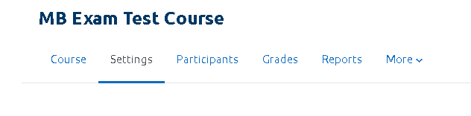
Scroll down to down to the “Completion Tracking” setting.
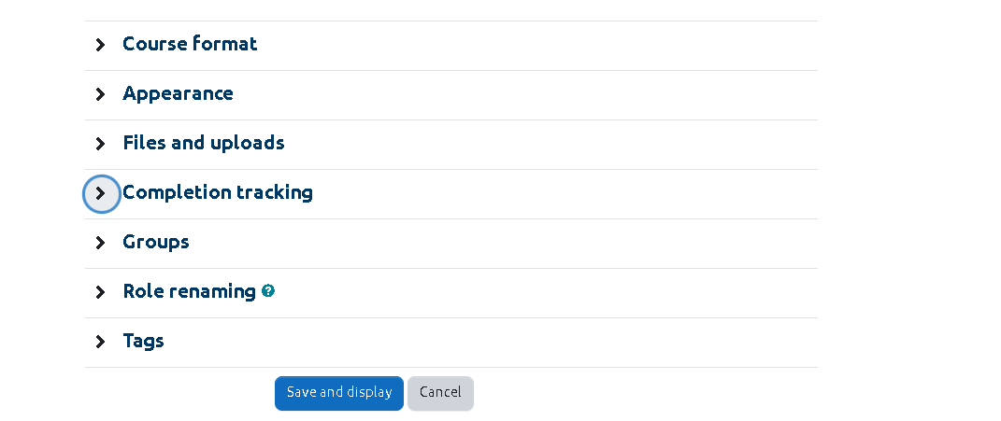
Select to open the menu.
Change the dropdown option to “Yes”.
Select Save and display button.
Course completion tracking will be switched on.

Adding text to your exam topic area
Set up the topic area in Moodle that you want to use for your exam and assessment purposes. The first thing you want to do is add initial information to your topic.
Make sure you have editing turned on
Select “Add an activity or a resource”.
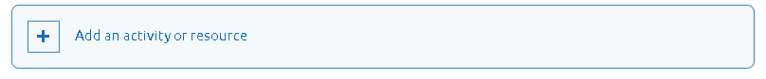
From the pop up menu search for “Text and Media Area”. Click to add
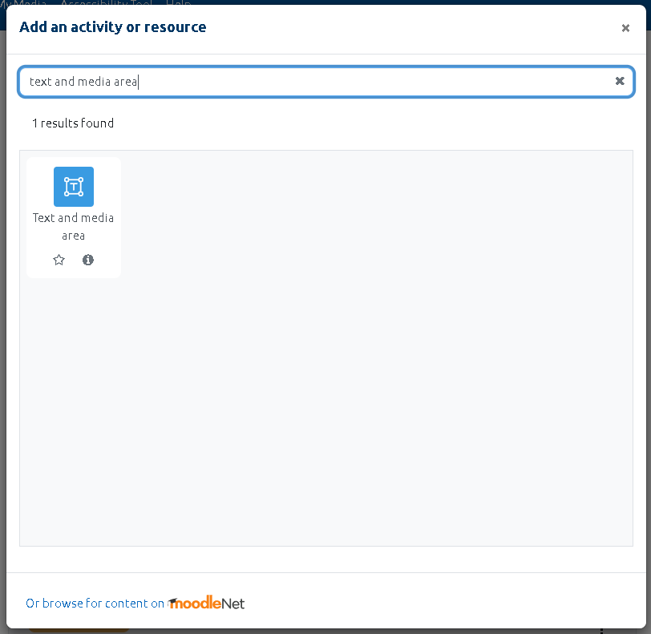
Paste the text you wish to use from:
Course: How To Moodle (HTM) (gla.ac.uk)
or type directly into the dialog box.
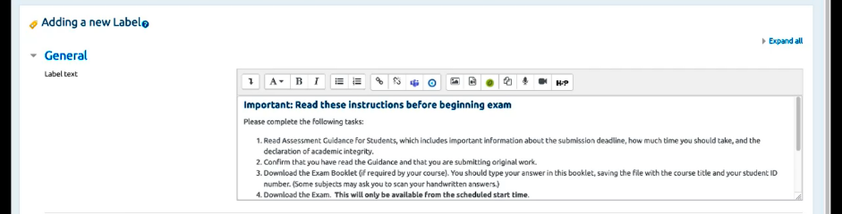
Save your changes. You have the information for your assessment.

Adding a student information file
Make sure that you have editing turned on in your Moodle course.
Locate the document that you wish to add. Drag this onto your course page.
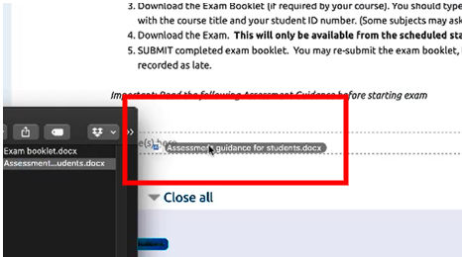
Select the pencil icon to update the title of the document if necessary.
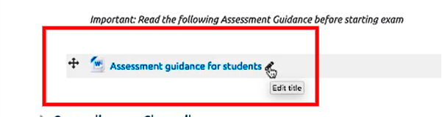

Adding the exam booklet
Make sure you have editing turned on.
Locate the file on your computer and then drag it into Moodle.
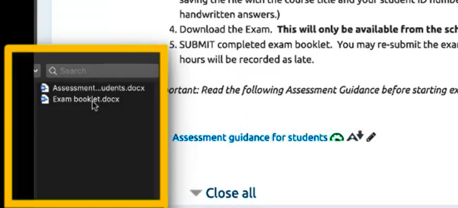

Setting up the originality statement
To add the “Declaration of Originality Statement” use the choice activity.
Have editing turned on.

Select “Add an activity or a resource”.
From the pop up menu search “Choice”. Click to add
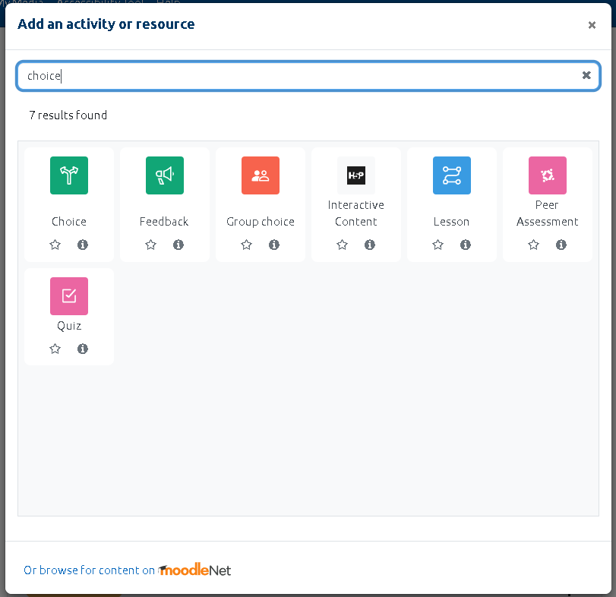
Give your choice a name - in this situation is it “Originality Statement”.
You will then go on to give a description. This text will be provided to you.
Course: How To Moodle (HTM) (gla.ac.uk)
It will also depend on the type of exam you are setting up.
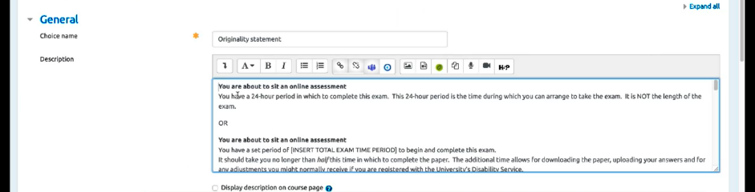

Scroll down to the section marked “Options.” Leave all defaults set to “No”.
In “Option 1” enter the text from Course: How To Moodle (HTM) (gla.ac.uk)
This is the text that indicates that the student has understood and accepted the originality statement.
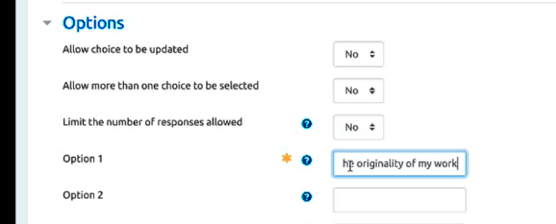
Next go down to the section called “Activity completion”.
In the “Completion tracking” section select “Show activities as complete when conditions are met” from the dropdown menu.
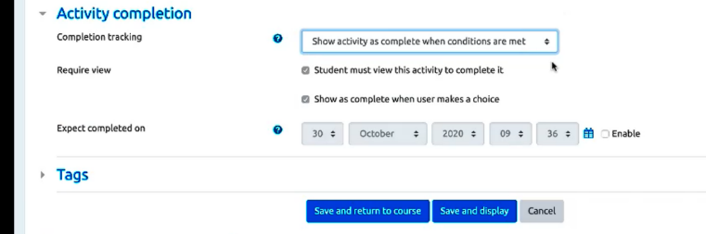
New options will appear.
Enter a tick in the “Show as complete when user makes a choice” checkbox.
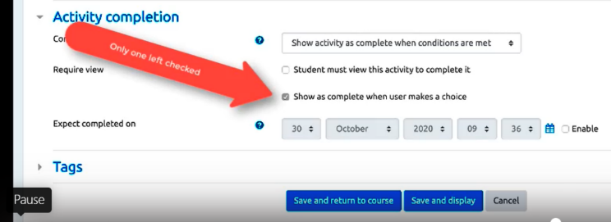
Select the “Save and display” button.
You now have set up your originality statement.
This is a step that students must complete before they can progress further into the exam.

Add exam paper with restrictions
To add your exam paper choose file from “Add an activity or resource”.
From the pop up menu search “File”. Click to add
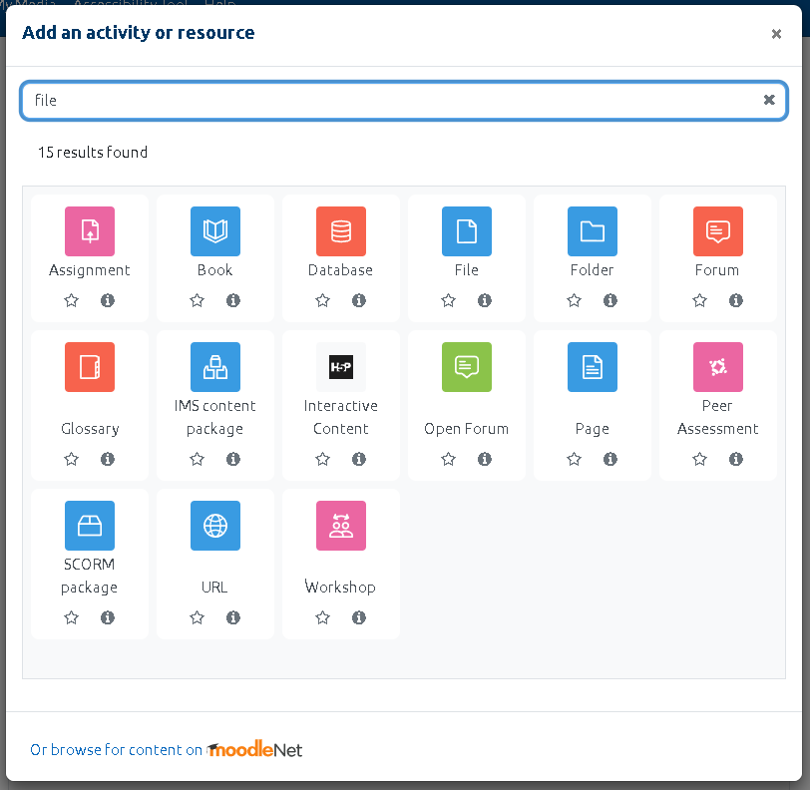
Give your resource a name. In the description field add the required text from Course: How To Moodle (HTM) (gla.ac.uk)
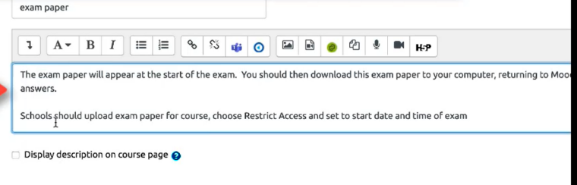
Copy and paste in here then add the file containing your exam question by dragging and dropping into Moodle.
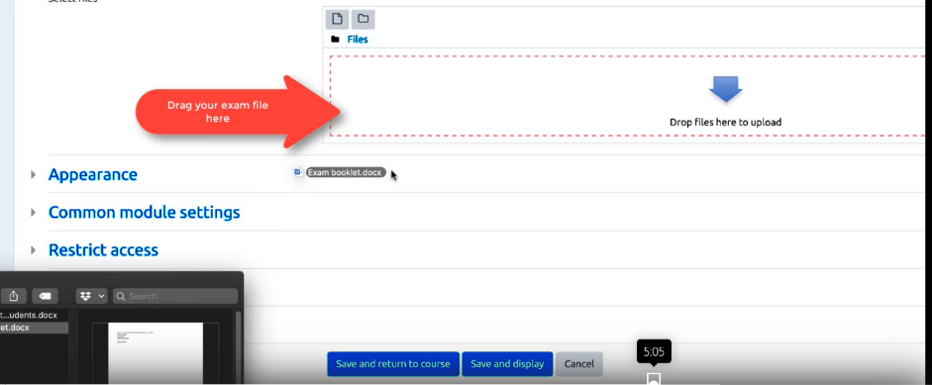

Adding Restrictions to Exam Question
We will now add restrictions to the exam question.
Scroll down to the “Restrict Access” option. Select the “Add restriction” button.

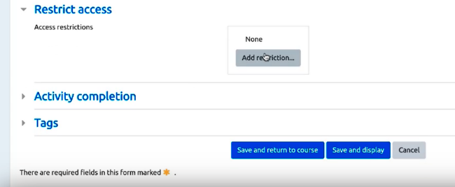

A pop up menu will appear. Select “Date”.
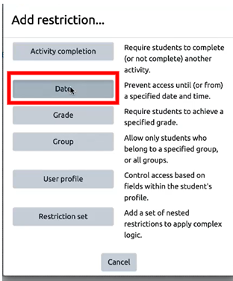
This date and time must be reached before the student can view the exam questions.
It is important to let the students know that if they are on the page when the date and time are reached they may have to refresh Moodle before they can see the paper.
Enter the date and time.
Select the “Add restriction” button.
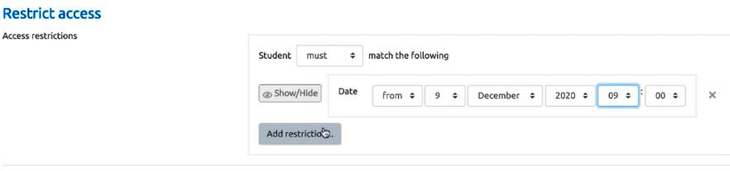

A pop up menu will appear. Select “Activity completion”.
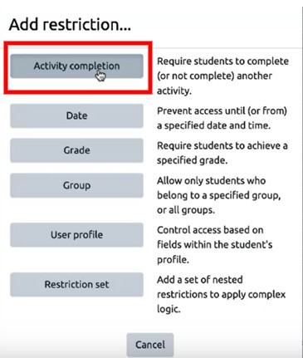
The second restriction is an activity completion restriction. This means that the student must complete the originality statement that you have set up as a choice activity before they can view the exam script.
Select the Choose menu. A list of options will appear. Select “Originality statement”.
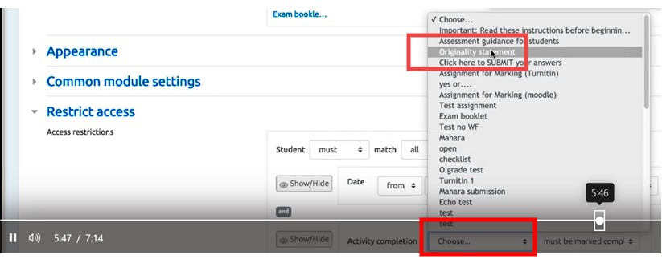
Select “must be marked complete” from the second option.
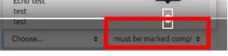
Save your changes.
Your exam script has now been added.

Adding the submission area
Select “Add an activity or a resource”.
From the pop up menu select “Assignment”. Click to add
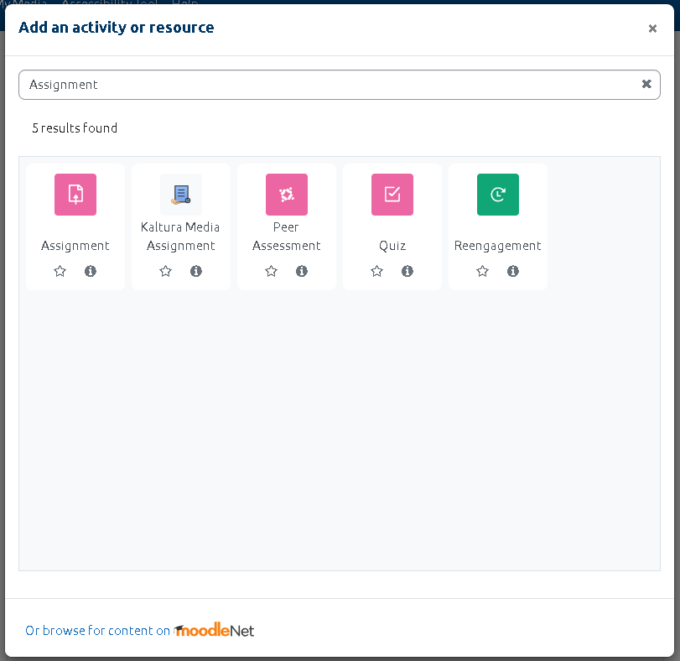

Give the assignment a name and a description. Again the description text will be found in Course: How To Moodle (HTM) (gla.ac.uk)
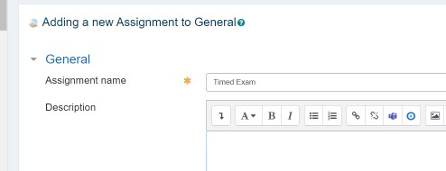
You then need to set your dates.
Scroll down to the Availability options.
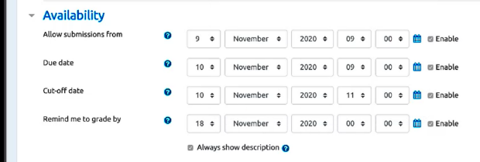
In the “Allow submission from” date picker enter the date when the exam opens for submission. Select the tick for Enable.
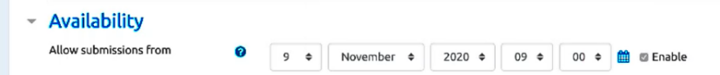
The second date is from the “Due date” picker.
It is important to add an additional 30 minutes for uploading. For example, if the submission period is 2 hours add 2 hours and 30 minutes.
This is when the exam must be submitted by or it is marked late. Select the tick for Enable.
The third date is the “Cut off date”.
Allow two hours when students can still submit but will be marked as late.
Select the tick for Enable.
Save your changes.
When you go to the front page of the course you will see your exam submission setup and a due date.
