Hiding Course Participants
To protect the anonymity of group members from other group members, it is important to update the Participants Settings.
Go to the front page of your course. Select participants from the left-hand menu.
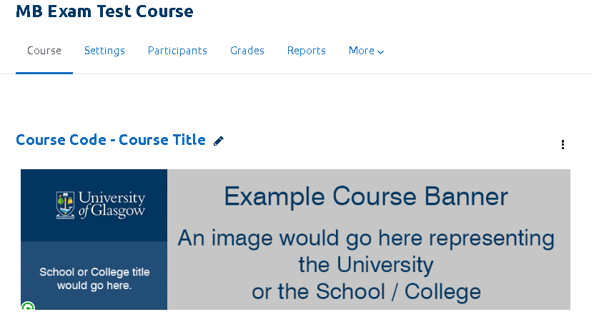
On the Participants page use the cog go to the Actions menu. Select “Permissions”.
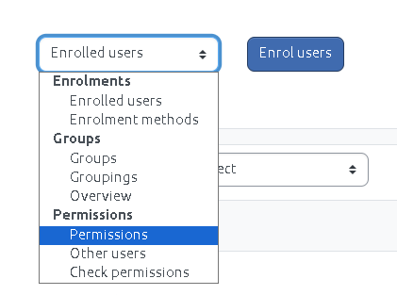
Use the search box to find user. Select the Delete icon beside “Student” to remove that role.
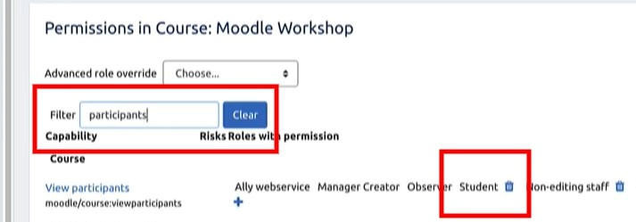
This means that students will no longer be able to see the participants on the course, or participants in individual groups.

