Taster Week & University Experience Week 2024

Instructions for using the Direct Admissions System

To apply for Taster Week or University Experience Week you will need to complete your registration through the University’s Direct Admissions System.

Part 1 – Register for an Account

- Visit www.gla.ac.uk/tasterweek and click the Apply Now link to access the Direct Admissions Systems.

- Select Create New Account

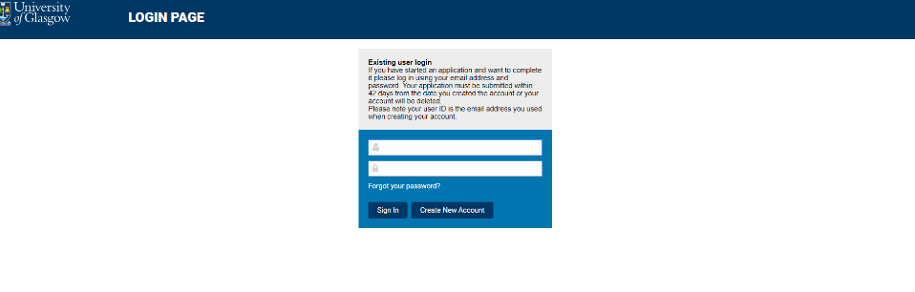

- We will communicate with you using email so please ensure that your email address works and you check it regularly.

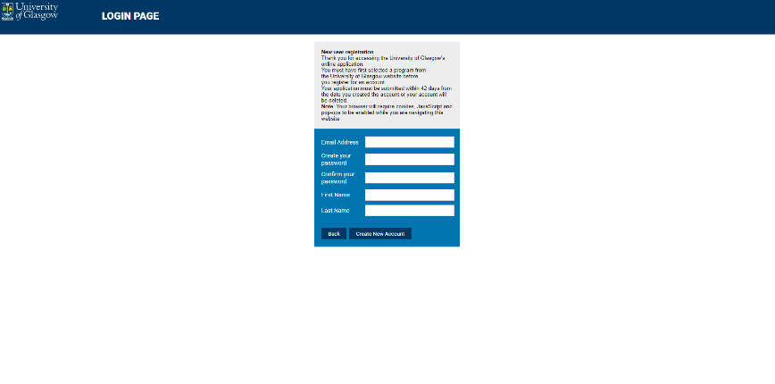

- Please review the Privacy Notice and click Agree to move to registration.

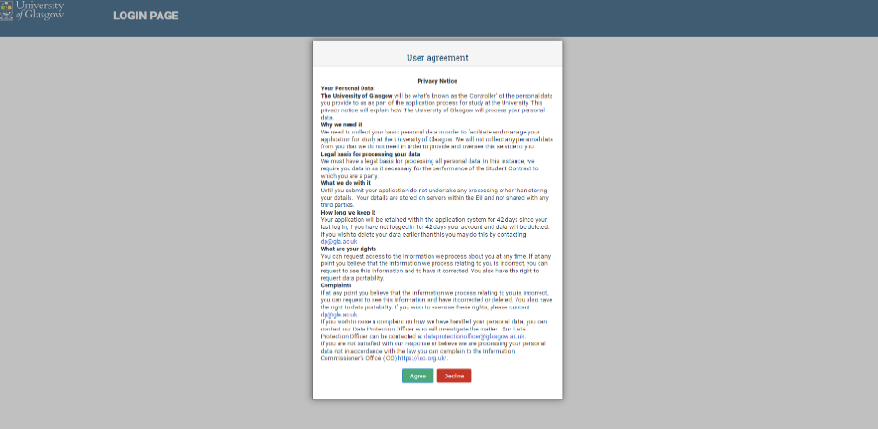

- Select your Country of Residence from the drop-down menu. Scotland is listed as United Kingdom – Scotland. The Entry Date is June 2024 and the Mode of Study is Part-Time.

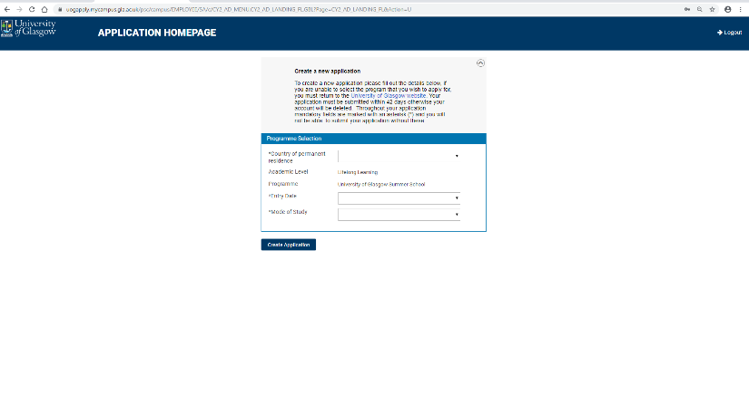

Part 2: Personal Details and Contact Information

- Some information should automatically be included. Fill in any gaps and click Save and then Next Step. Any missing essential information will be highlighted in pink.

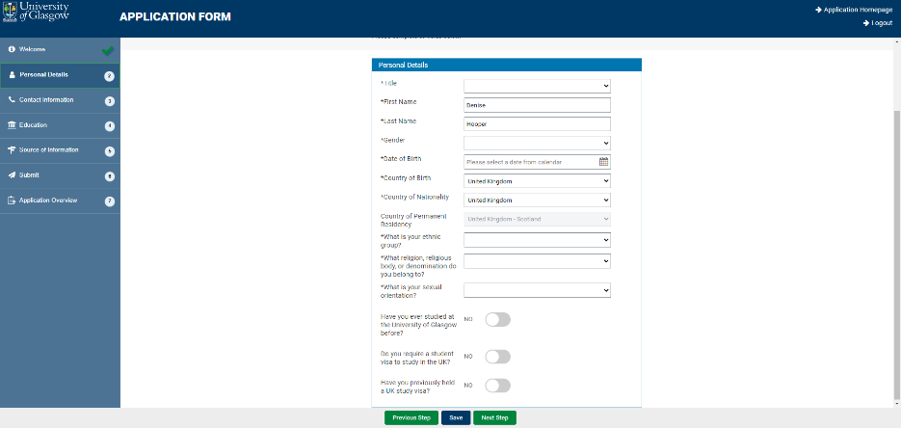

- Complete your Home Address details.

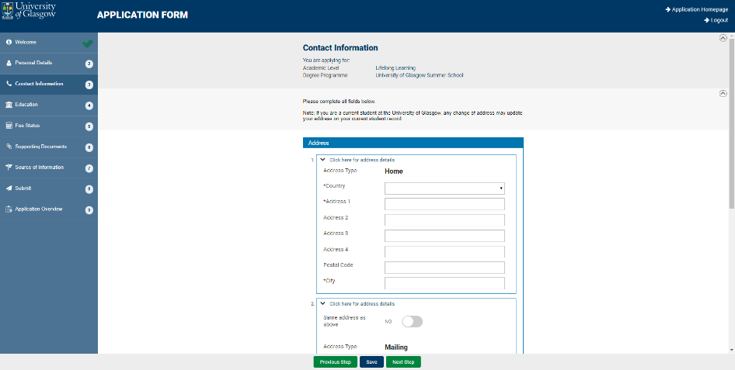

- Add your contact Telephone Number(s). Your email address should automatically populate. Click Save and Next Step.

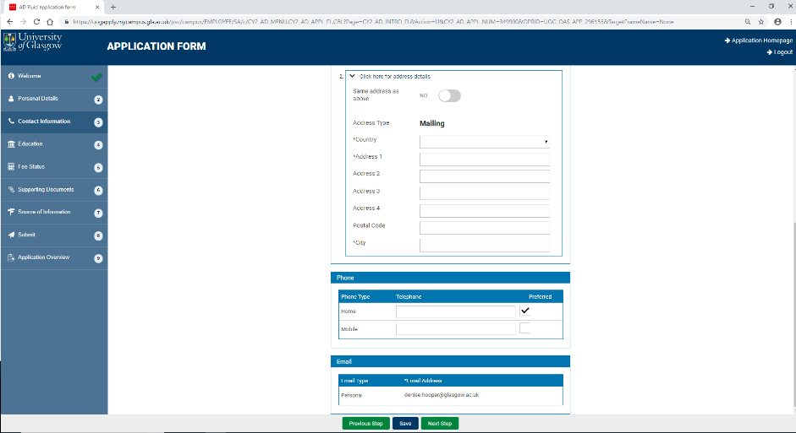

- Add your previous Education details. Click Add Previous Education.

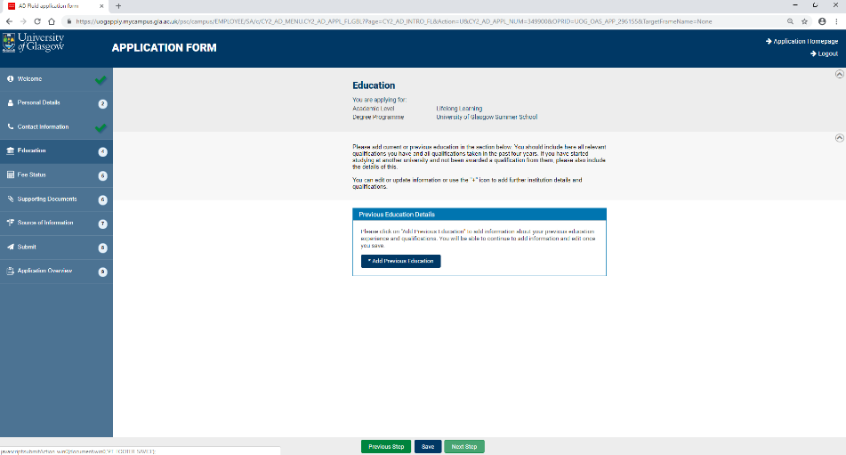

- A pop-up should appear. Select the country and start typing the name of your School/College.

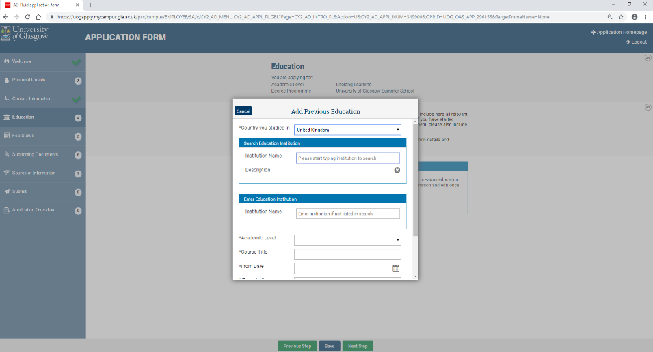

- Select your School/College and appropriate Academic Level. Course Title is Higher

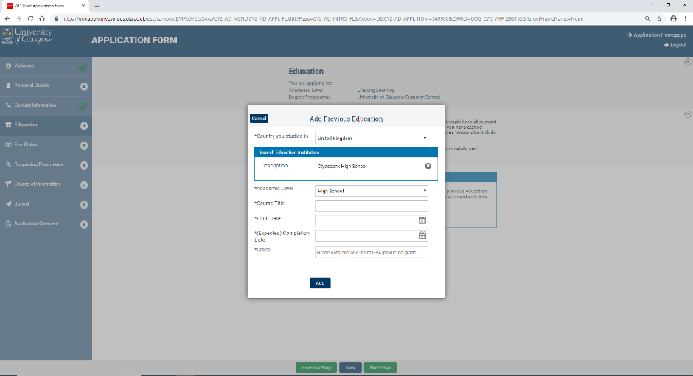

- Estimated dates of education will do, and an overview of grades obtained is sufficient (e.g. AABB). Please do not list your qualifications separately.

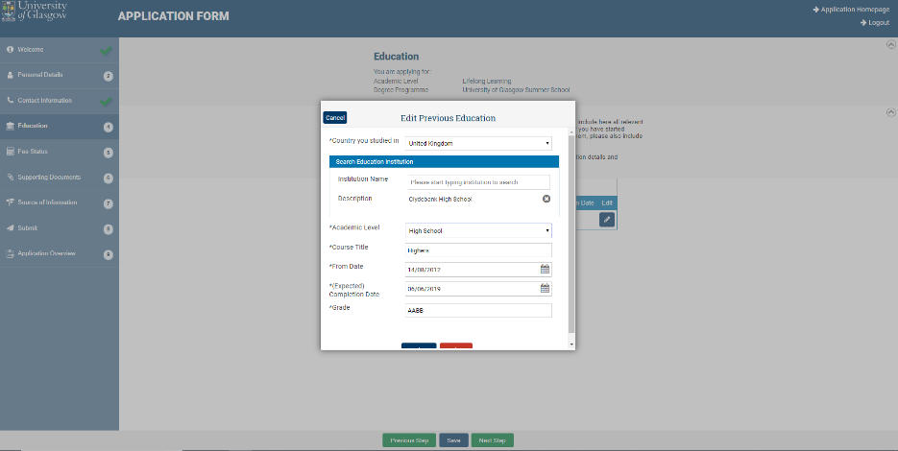

- You should now have a list of places of Education. Click Save and Next Step.

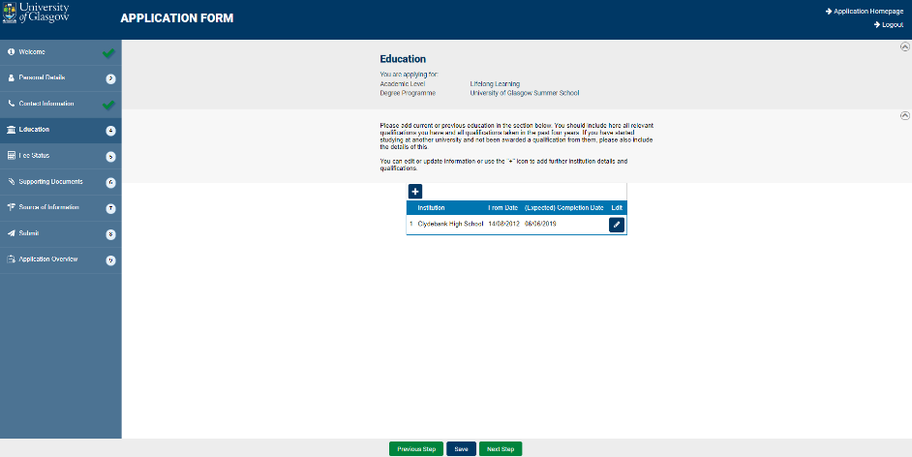

- The Source of Information question is just for information. Select the most relevant choice from the drop-down menu.

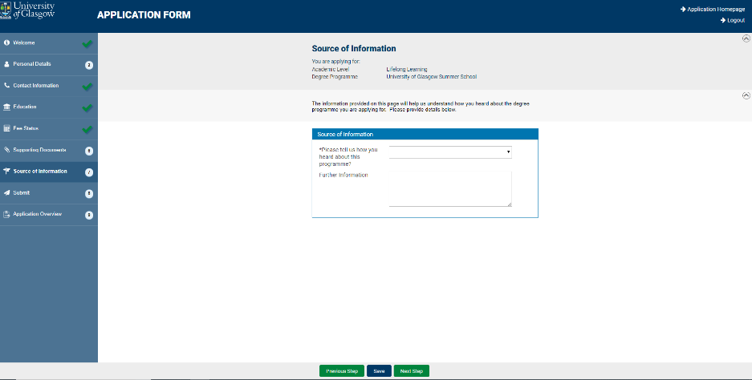

- Read the Declaration and Privacy Notice. Click Agree.

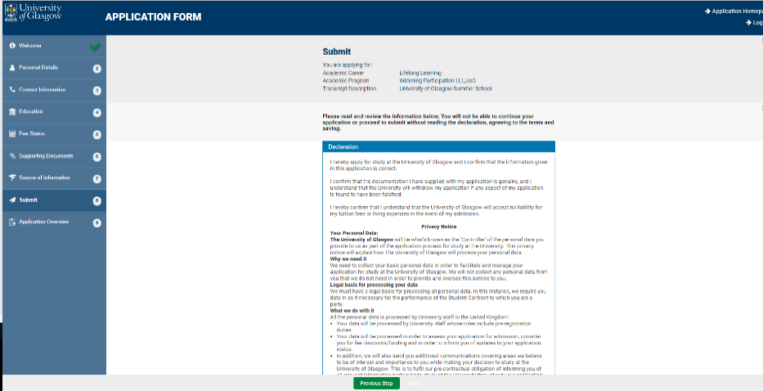

- The Application Form will load a summary of the details you have provided. Please check these details are correct and click Confirm details and submit.

Note: Your application is incomplete until you submit it.

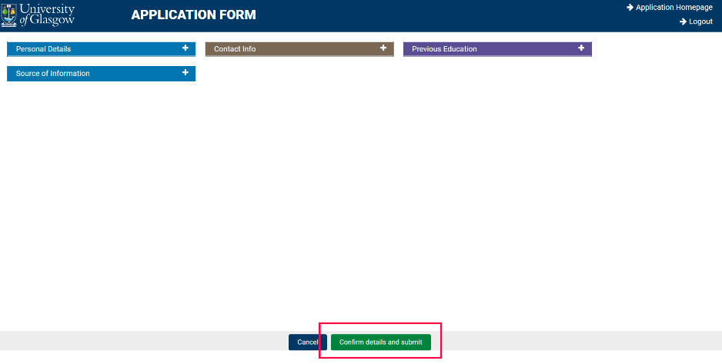

Once you submit your registration, you will receive an automated email confirming that we have received your completed form. This should arrive within 24 hours of submission of your application and will come from mycampus-admissions@glasgow.ac.uk. The subject of the email will be Application Acknowledgement from the University of Glasgow.

At the top of the email is your Unique Glasgow University Identifier (GUID / Student Number). Please note this down as you will need it. Within the email there is a link to a second form, which is there to collect further details including any additional support needs you may have to allow us to make the appropriate plans and arrangements for your participation at Taster Week or University Experience Week. We will contact you before the beginning of the programme to confirm which week and subject stream you have selected.

Students are required to complete the full programme.

The Taster Week will run from Monday 3 June to Friday 7 June 2024. This is for students who are currently in S4 and who will move into S5 in June 2024. Students will attend the campus on Monday, Tuesday, Thursday and Friday and will join online on university Teams channels on Wednesday.

The University Experience Week will run from Monday 10 June to Friday 14 June 2024. This is for students who are currently in S5 and who will move into S6 in June 2024. Students will attend the campus on Monday, Tuesday, Thursday (for the university Open Day) and Friday and will join online on university Teams channels on Wednesday.

If you have any problems or questions, please do not hesitate to get in touch with the Summer Programmes team at wpsummerschool@glasgow.ac.uk. This inbox will be monitored Monday to Friday, 09:00-17:00. Emails will be replied to as soon as possible, but please allow three working days for replies due to large volumes of enquiries being received. Please indicate that your query relates to the Taster Week or University Experience Week.

