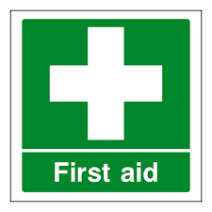

First aid and emergency support

If you need first aid or other support in an emergency:

- A first aid box is kept {state location(s)}.

- Several staff based within the building hold first aid qualifications. {State where information on local first aiders can be found}. (They may not always be present.)

- You can get first aid or emergency support 24/7 by contacting Security. You can do this by either:

- Phoning 0141 330 4444

- Using the First Aid or Emergency button on the SafeZone app. (Staff are encouraged to download this app and register as a UofG user.)

- Security will alert the nearest first aider to attend using a SafeZone paging system that is in operation or will send a trained Security first aider.

- The nearest defibrillator is located {state location – see UofG life app to find this.} Other defibrillator locations can be found on the UofG Life app ‘Near Me’ section.

