Summer School 2024

Instructions for using the Direct Admissions System

To register for Summer School, you’ll need to complete your registration through the University’s Direct Admissions System. Please note this application does not replace your UCAS application and is only used for registering for Summer School. UCAS remains your go-to portal for your University application.

Please ensure that you are logged out of the Applicant Self-Service portal before accessing the Direct Admissions System as you’ll need to create a new account for Summer School registration.

Part 1 – Register for an Account

- Visit www.gla.ac.uk/summerschool and click the Apply Now link to access the Direct Admissions Systems.

- Select Create New Account

- Please register with the same email address as the one on your UCAS application. We will communicate with you using this email so please ensure that it works and you check it regularly.

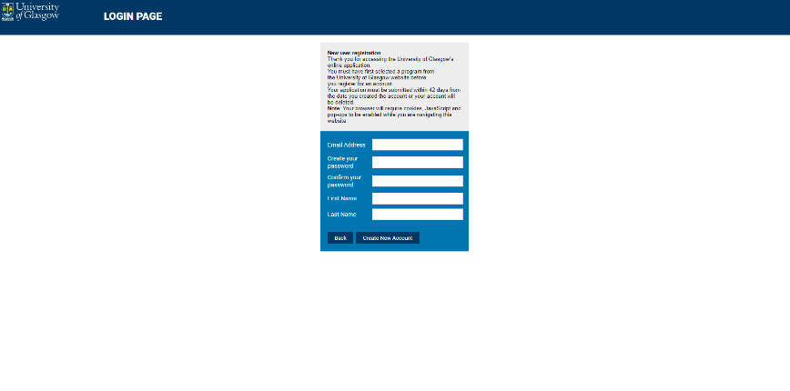

- Please review the Privacy Notice and click Agree to move to registration.

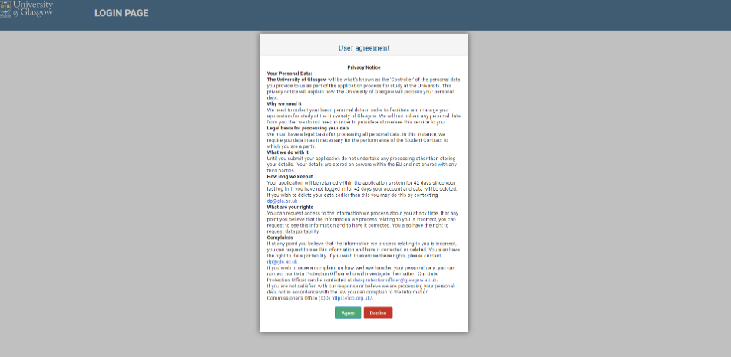

- Select your Country of Residence from the drop-down menu. Scotland is listed as United Kingdom – Scotland. The Entry Date is June 2024 and the Mode of Study is Part-Time.

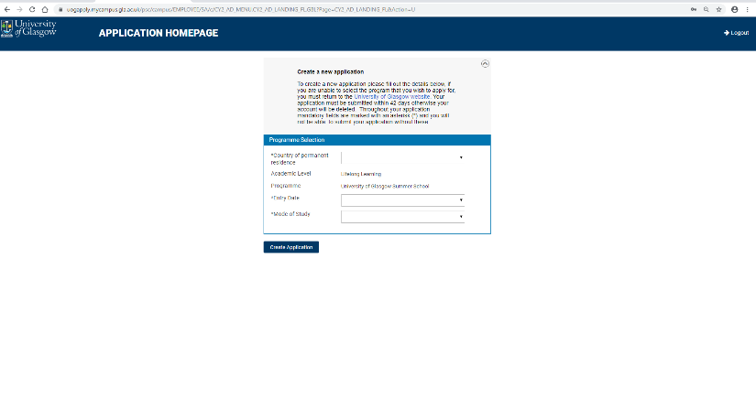

Part 2: Personal Details and Contact Information

- Some information should automatically be included. Fill in any gaps and click Save and then Next Step. Any missing essential information will be highlighted in pink.

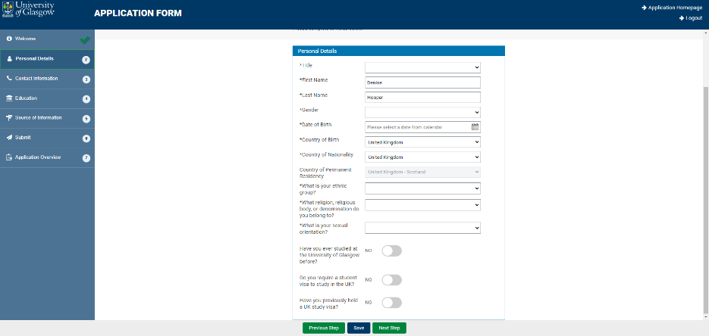

- Complete your Home Address details.

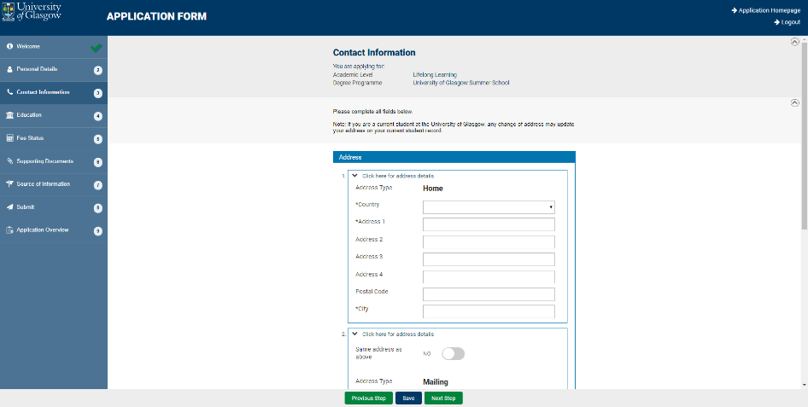

- Add your contact Telephone Number(s). Your email address should automatically populate. Click Save and Next Step.

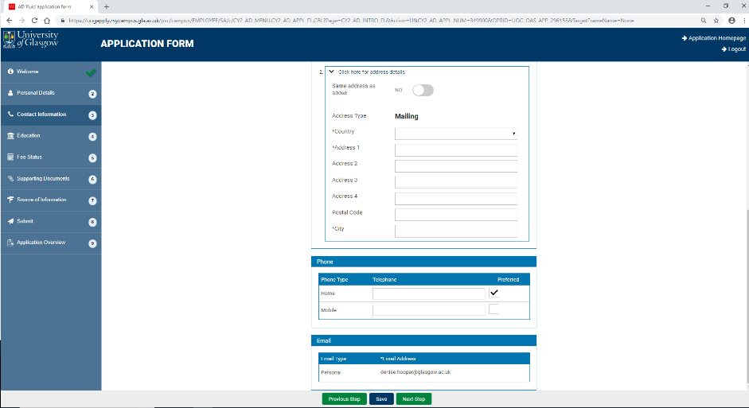

- Add your previous Education details. Click Add Previous Education.

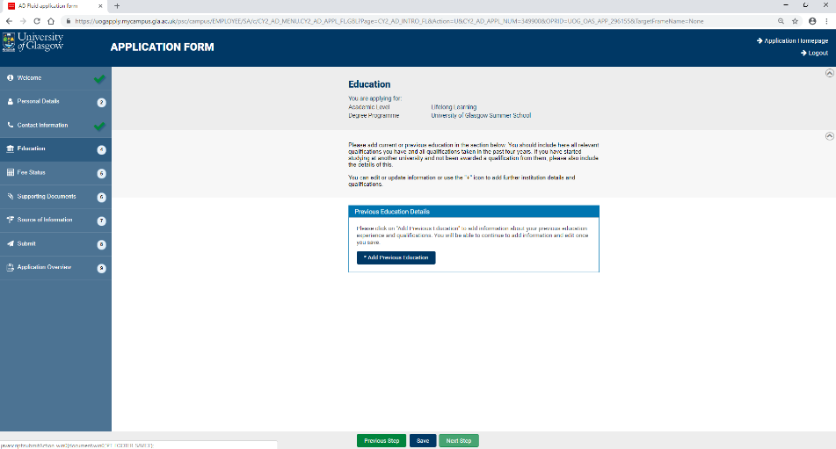

- A pop-up should appear. Select the country and start typing the name of your School/College.

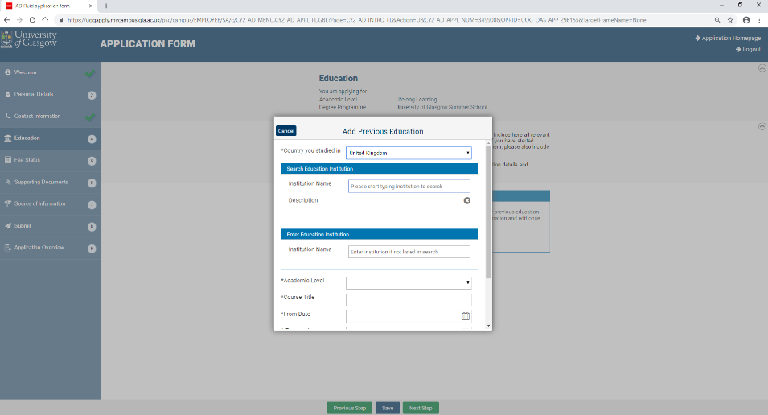

- Select your School/College and appropriate Academic Level. Course Title is Higher or HNC.

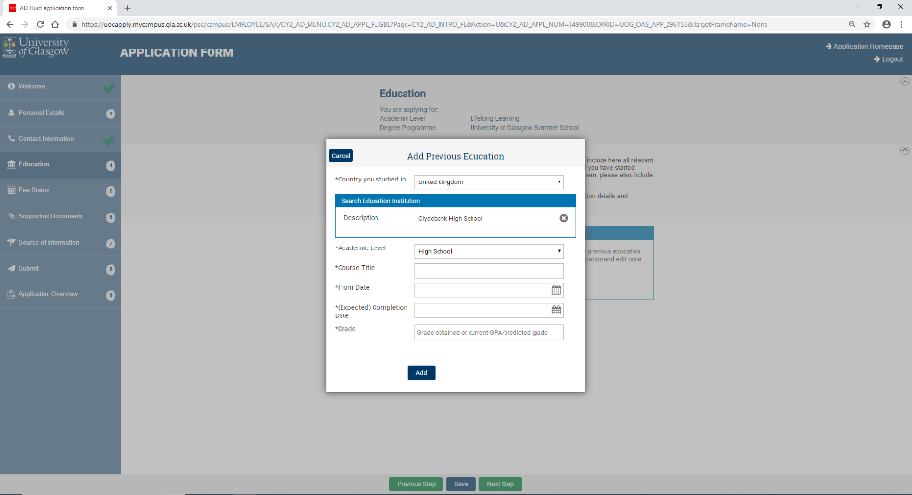

- Estimated dates of education will do, and an overview of grades obtained is sufficient (e.g. AABB). Please do not list your qualifications separately.

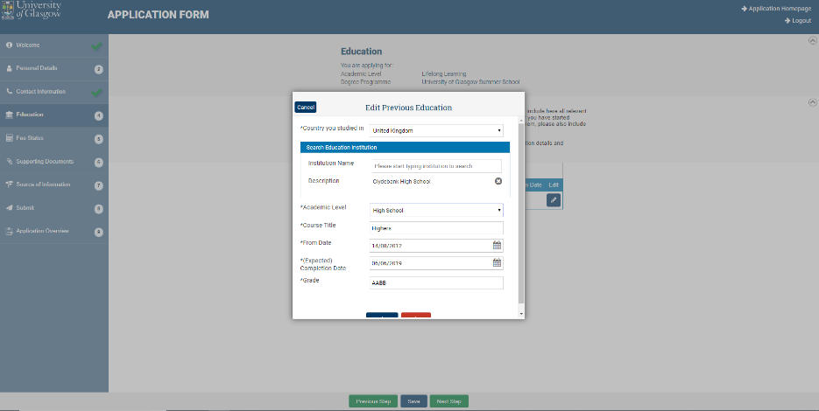

- You should now have a list of places of Education. Click Save and Next Step.

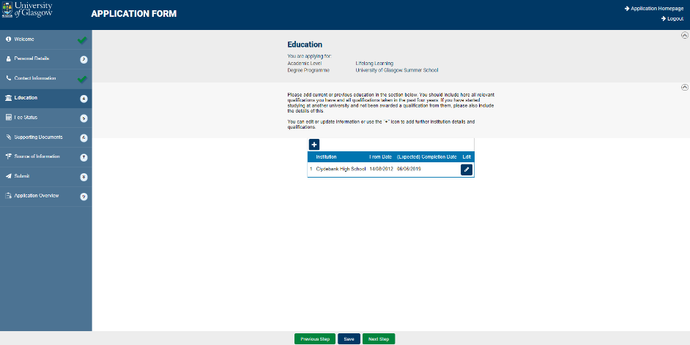

- The Source of Information question is just for information. Select the most relevant choice from the drop-down menu.

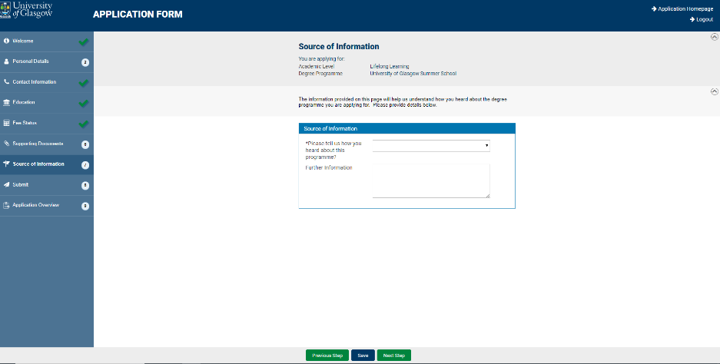

- Read the Declaration and Privacy Notice. Click Agree.

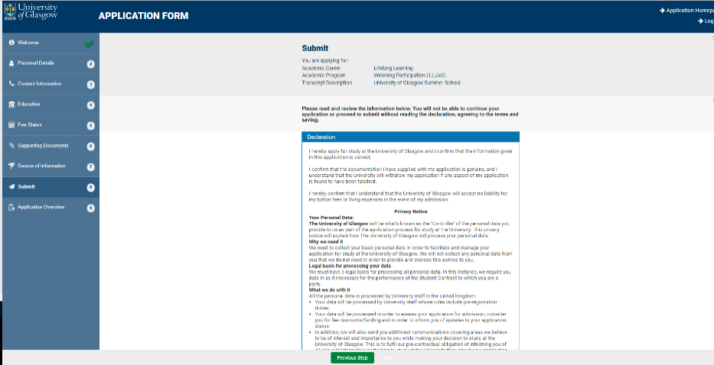

- The Application Form will load a summary of the details you have provided. Please check these details are correct and click Confirm details and submit.

Note: Your application is incomplete until you submit it.

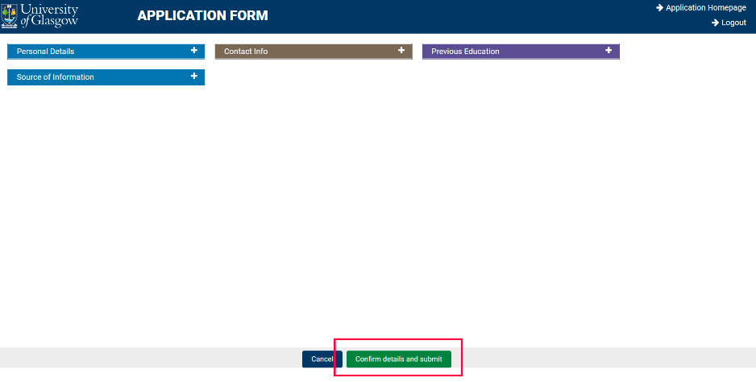

Once you submit your registration, you will receive an automated email confirming that we have received your completed form. This should arrive within 24 hours of submission of your application and will come from mycampus-admissions@glasgow.ac.uk. The subject of the email will be Application Acknowledgement from the University of Glasgow.

At the top of the email is your Unique Glasgow University Identifier (GUID / Student Number). Please note this down as you will need it. Within the email there is a link to a second form, which is there to collect further details including any additional support needs you may have to allow us to make the appropriate plans and arrangements for your participation at Summer School. We will contact you before the beginning of the programme to confirm which subjects you have been allocated to.

Students are required to complete an Induction Session. These will be held online and in-person from 5 June and information will be sent to you about these nearer the time. As part of the Summer School, you will complete an online Academic Skills module. You can begin working on this module after you attend the Induction Session.

The Summer School will run from Monday 17 June to Friday 12 July 2024. All students are required to complete all modules in order to successfully complete the course. Students should plan on attending every class. All students will be required to complete all assessments by the deadlines. Late submissions will be subject to deductions in grades. Some applicants may be required to complete the academic skills module only. This means that you will not be required to attend live subject classes. The version of Summer School required will be clearly detailed in your conditional offer.

If you have any problems or questions, please do not hesitate to get in touch with the Summer School team at wpsummerschool@glasgow.ac.uk. This inbox will be monitored Monday to Friday, 09:00-17:00. Emails will be replied to as soon as possible, but please allow three working days for replies due to large volumes of enquiries being received.

You can submit your Summer School application before you have made your UCAS decision. If Summer School forms a part of your conditional offer, then you will be guaranteed a place on the programme. Some Summer School subjects will be in high demand and therefore students will be assigned subjects most appropriate for their degree programme choice. If Summer School forms a part of your offer and you do not attend, you will not fulfil the conditions of your offer of entry to the University.

If you have any questions about your conditional offer of entry, please contact the Summer School team at wpsummerschool@glasgow.ac.uk.

