CHEMICAL WASTE.
Contact Name |  |  |  |  | School / Service
Contact Number |  |  |  |  | Manager / PI
Chemical Name(s) / Type of Waste
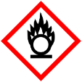
Physical form (e.g. liquid, solid, contaminated consumables)
Hazard Properties (Check all that apply)
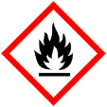  Flammable ☐ | Oxidiser ☐ |  | 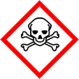  Toxic ☐ | 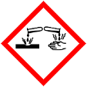  Corrosive ☐ |  | 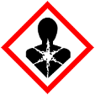  Health Hazard ☐ |  | Other (Specify) ☐
Hazardous waste containers should be filled to no more than ¾ of their capacity and must be properly sealed. Incomplete or illegible labelling, unsealed or leaking containers may result in the collection being rejected.

CHEMICAL WASTE.
Contact Name |  |  |  |  | School / Service
Contact Number |  |  |  |  | Manager / PI
Chemical Name(s) / Type of Waste
Physical form (e.g. liquid, solid, contaminated consumables)
Hazard Properties (Check all that apply)
Flammable ☐ | Oxidiser ☐ |  | Toxic ☐ | Corrosive ☐ |  | Health Hazard ☐ |  | Other (Specify) ☐
Hazardous waste containers should be filled to no more than ¾ of their capacity and must be properly sealed. Incomplete or illegible labelling, unsealed or leaking containers may result in the collection being rejected.

