Formalin Waste.
Contact Name |  | School / Service
Contact Number |  | Manager / PI
Chemical Name(s) / Type of Waste
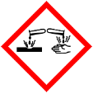
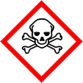
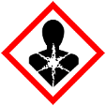
Formalin Waste

Physical form (e.g. liquid, solid, contaminated consumables)
Hazardous waste containers should be filled to no more than ¾ of their capacity and must be properly sealed. Incomplete or illegible labelling, unsealed or leaking containers may result in the collection being rejected.

Formalin Waste.
Contact Name |  | School / Service
Contact Number |  | Manager / PI
Chemical Name(s) / Type of Waste
Formalin Waste

UN2099

Physical form (e.g. liquid, solid, contaminated consumables)
Hazardous waste containers should be filled to no more than ¾ of their capacity and must be properly sealed. Incomplete or illegible labelling, unsealed or leaking containers may result in the collection being rejected.

