Non-Halogenated Solvent Waste.
Contact Name |  |  |  | School / Service
Contact Number |  |  |  | Manager / PI
Chemical Name(s) / Type of Waste
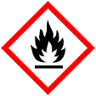
Mixture of non-halogenated, flammable
waste solvents

Physical form (e.g. liquid, solid, contaminated consumables)
Hazard Properties (Check all that apply)
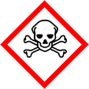  Toxic ☐ |  | 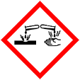  Corrosive ☐ | 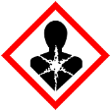  Health Hazard ☐ |  |  | Other (Specify) ☐
Hazardous waste containers should be filled to no more than ¾ of their capacity and must be properly sealed. Incomplete or illegible labelling, unsealed or leaking containers may result in the collection being rejected.

Non-Halogenated Solvent Waste.
Contact Name |  |  |  | School / Service
Contact Number |  |  |  | Manager / PI
Chemical Name(s) / Type of Waste
Mixture of non-halogenated, flammable
waste solvents

Physical form (e.g. liquid, solid, contaminated consumables)
Hazard Properties (Check all that apply)
Toxic ☐ |  | Corrosive ☐ | Health Hazard ☐ |  |  | Other (Specify) ☐
Hazardous waste containers should be filled to no more than ¾ of their capacity and must be properly sealed. Incomplete or illegible labelling, unsealed or leaking containers may result in the collection being rejected.

