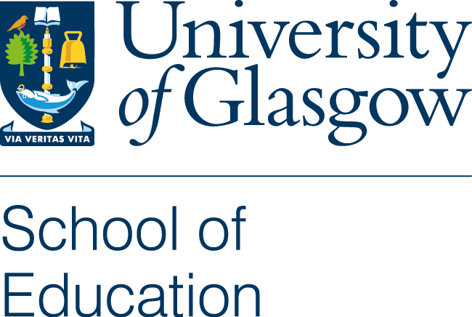 | Application Number C  (for office use only)

Conference Support Attendance - Application for Funds – Session 2023/24
The application should be sent in the first instance to your Research and Teaching Group Leader for review and authorisation. Once your application has been approved, please email to the RTG Academic Support Office, education-rtg-office@glasgow.ac.uk, at least three weeks in advance of the Conference and not after the event. Retrospective applications are unlikely to be funded. Where a late submission is unavoidable a covering letter providing an explanation must be attached to the application. Funding will not be available to any staff member whose T4 individual profile is not up to date and funding will not be provided to any staff member who is a PI who has not produced and updated the profile of their project(s).
There is a maximum allocation per financial year of one conference, regardless of whether national or international, where funds permit. The conference will count in the financial year it takes place. The financial year is 1 August to 31 July. PLEASE NOTE: you must submit expense claims through the HR Core Portal within two months of the conference taking place. It is official University policy that the Finance Office will not process any claims more than two months old. Claims for conferences in June and July must be submitted no later than mid July to ensure payment. Staff must read the “Staff Conference Support Guidelines” available from the School’s website.
www.gla.ac.uk/schools/education/informationforstaffresearchstudents/conferencesupport/#/staffconferencesupport
Please complete ALL sections.
Name:
RT Group:
Position:
Contact Details:

STAFF TO NOTE: If you are presenting a paper and do not attach a copy of your abstract your application will not be sent for vetting and will be returned to you. Where possible confirmation of your paper’s acceptance should also be attached.

Purpose of visit: (Tick as appropriate)

Reading a Paper of which you are author or co-author -
current maximum award £1500.

Conference Organiser,

Executive officer of Society Please confirm status. Maximum award is £1500.

Full title of conference
or meeting of learned society:
Venue:
Date:
Title and authors:

Please list refereed publications arising directly from your last conference support application:
Please ensure that you provide full publication references, including ISBN/ISSN.

Budget
Please note: The School is unable to pay for membership of associations and will only support the attendance at one social event.

Claims for expenditure should not exceed the amount of funding originally approved and should have original receipts attached. Claims must be made within two months of the expense being incurred.

Travel | £
Subsistence ( days) | £
Registration | £
Other (please specify) | £
TOTAL | £

If you have applications for support from other sources please provide details of them below:

Funding agency/amount requested | Amount granted/date result due

Please tick as appropriate

Copy of abstract attached? |  | Proof of paper's acceptance attached? |  | RTG Leader comments and signature?

Date: ______________ Signed: _______________________________

To be completed by Research and Teaching Group Leader

Do you support this application? YES NO

If yes, please state amount of funding awarded: £_______

Comments:

Date: ____________ Signed: _______________________________

NOTE TO APPLICANT:

Once the form has been approved by your RTG Leader, please email the form and supporting documentation to the RTG Academic Support Office:
education-rtg-office@glasgow.ac.uk

Thank you.

