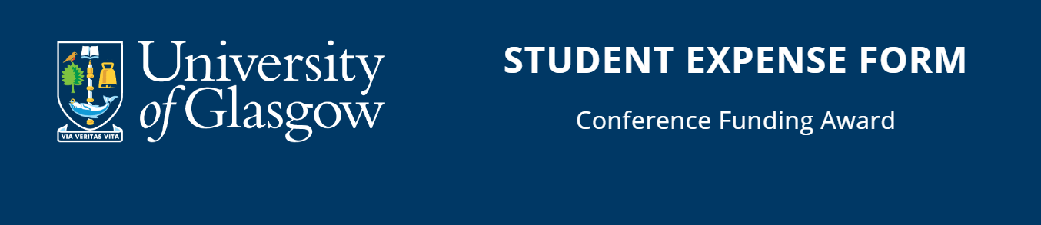
Return this completed form to mvls-gradschool@glasgow.ac.uk, within two months of the event, or by July 31st in the current academic year, whichever is soonest.
If you wish to split payment between your bank account and a project/budget code, complete both sections below.
Student Personal Details:
Name
ID
Email
Address
(Including full postcode)
Country
Event Attended
Date Attended
Amount claiming as stated in award letter

UK Bank Details:
Account Name (if different from above)
UK Bank Name
Bank Branch / Address
Sort Code (6 digits)
Account Number (8 digits)

You must attach a redacted copy of your personal bank details required to make payments as supplied by your bank.
This can be either:
• a pre-printed account pay-in slip,
• a copy of cheque (scored through) or,
• a partial bank statement (details visible, no financial information).

Project/Budget Code (if you wish to receive money via non-reversing journal):
Project code
Project code

Complete expenses below.

Bank Details (for non-UK bank accounts only)
Account Name (if different from above)
Bank Name
Bank Address
Country
Beneficiary's SWIFT Code / BIC Code
Beneficiary's IBAN / Account No.
Canada Only - 5-digit transit code & 3 digit bank code
Australia Only - 6-digit BSB number
China (supplier only) CNAPS code if paying in CNY
Intermediary Bank details (if required)
Swift code
Bank account/IBAN no
Your local currency

You must attach your personal bank details required to make international payments as supplied by your bank.
This can be either:
• a pre-printed account pay-in slip,
• a copy of cheque (scored through) or,
• a partial bank statement (details visible, no transactional information).

Note – the bank account evidence must show your name/bank account and sort code numbers.
This should include IBAN and BIC/SWIFT numbers for EU accounts and a SWIFT and Routing Number for US accounts.
This information can also be found on statements or through on-line banking which you can print or scan and attach to this form. Handwritten details cannot be accepted.
Payment will be made in GBP, so it is important that you check your bank can accept GBP payments. If not, you will have to use an intermediary bank and must also provide details of the intermediary bank being used

*** IMPORTANT – your bank account evidence must show your name/bank account and sort code numbers ***

Complete expenses below. Add more rows if required.

Summarise your expenses and return copies of receipts with this form:
Expense Type | Claim Amount (in GBP)
TOTAL

DECLARATION

I certify that this claim:

a) is to reimburse expenditure incurred by me on behalf of the University of Glasgow
b) has not & will not be met by any other outside source
c) should be paid to the bank details quoted above

Signature: Date:

PRINT NAME:

Return this completed form to: mvls-gradschool@glasgow.ac.uk

CHECKLIST:
Have you attached:
- Bank details – Y/N
- Receipts – Y/N
- Report – Y/N

