CIPS Sustainable Procurement Review

CIPS Sustainable Procurement review certification (Gold) provides an independent, rigorous audit of the economic, social and environmental impact of an organisation’s procurement and supply.

Procuring sustainably helps organisations to eliminate waste, become more energy efficient and save money.

For further information please see CIPS web page:-

http://www.cips.org/sustainable-procurement-review

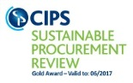

University of Glasgow, CIPS Sustainable Procurement Review Gold Award
Valid to June 2017

