# Library Annual Review 2014-15

**From the University Librarian**:

Helen Durndell retired from the post of University Librarian at the end of July 2015. Helen had been in post for over 10 years and had oversight of significant changes to the building and the massive shift to the provision of electronic content. I was delighted to be appointed to take over as University Librarian in August 2015 and to have the opportunity to lead this fantastic Library Service. Library staff continue to deliver excellent services which support the strategic aims of the University. The highlights below are just some of the initiatives which have been delivered by staff from across the whole Library Service.

*This year’s highlights:*

* Ingenious Impressions exhibition which ran at The Hunterian Art Gallery from 27th February to 21st June 2015.
* £92,000 funding awarded from the Heritage Lottery Fund to support building the textile collections of the Scottish Business Archive.
* Participation in the Wellcome Trust Medical Heritage Library digitisation project, sending around 5000 volumes to be digitised.
* Digitisation of the Mental Healthcare Archives Project
* The ReadingLists@Glasgow service was launched, incorporating list creation, digitisation of course materials and review of lists.
* The Research Data Management service was launched offering support across the University for managing research data sets through the research lifecycle. This service includes the new Enlighten Research Data Repository.
* The High Demand Collection, focussed on course materials and reading lists, opened in October 2014.

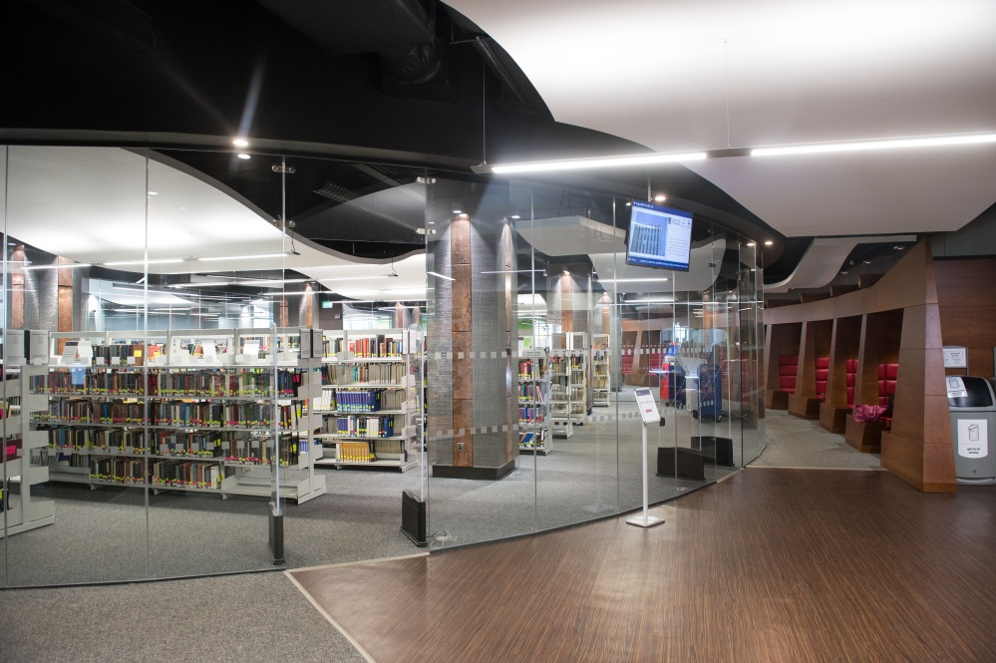

**Exhibitions and Events**

‘Awesome’ ‘brilliant’ and ‘amazing’ were just some of the comments we received from visitors to the Ingenious Impressions exhibition which ran at The Hunterian from 27 February to 21 June 2015. Curated by Julie Gardham, this was the first major exhibition of Special Collections material to be held at The Hunterian for ten years. Drawing on the extensive research of the Glasgow Incunabula Project, sixty four 15th century printed books (‘incunabula’) were showcased in a truly innovative display that explored the revolutionary impact of printing and the subsequent afterlives of these earliest of printed books.

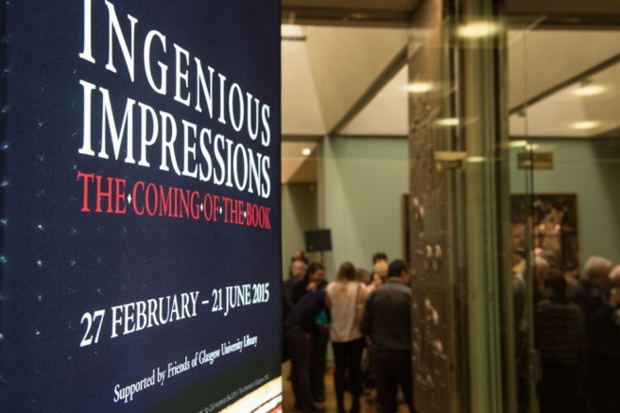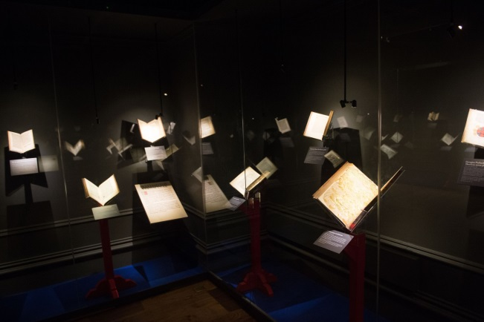

The exhibition was enthusiastically embraced by a wide public resulting in very healthy Hunterian visitor figures (over 24,000) for what is traditionally a quiet period of the year. The exhibition was even complimented in a Scottish Parliament motion as a ‘stunning display’ and ‘valuable part of the city’s cultural heritage’. Interest in the exhibition was sustained throughout by a dynamic social media campaign and extensive programme of public events. As well as special receptions with curator talks for various Friends and alumni, Special Collections staff undertook numerous tours for a variety of groups ranging from sixth year school students to rare book librarians. A series of lunchtime was delivered by a mix of academics, students and Special Collections staff. Covering everything from medieval notions of death to Italian embezzlement, astronomy, singing and cutting up books, these were very well attended. The highlight of all the events, however, were the ‘sell out’ printing and type casting demonstrations given by Martin Andrews from the University of Reading and print historian Alan May. These practical and fun sessions were undertaken in the exhibition space on the replica Gutenberg press that was kindly loaned by the University of Reading for the duration of the exhibition. After an entertaining introduction to the beginnings of printing on the ‘one pull press’, participants were able to create their own page of the Gutenberg Bible and cast a piece of type from molten lead – an immensely satisfying experience.

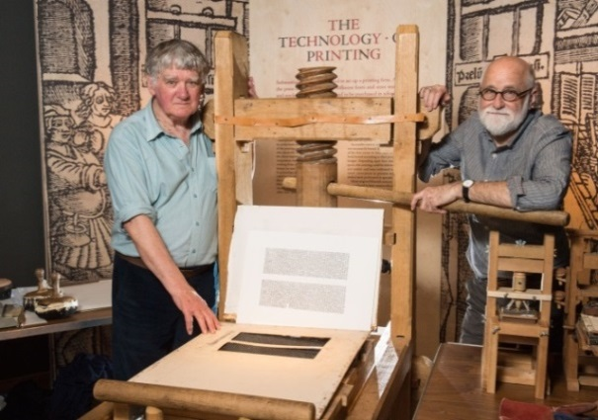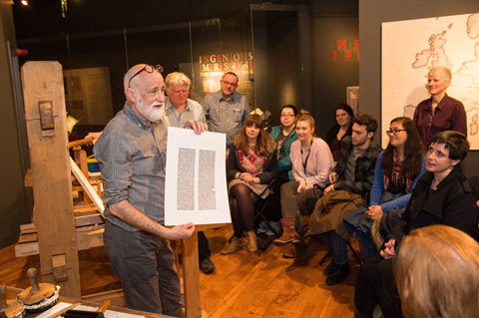

Last year’s report noted the ongoing work by James McGonigal and Dr John Coyle (English Literature) towards an edition of selected letters of Edwin Morgan (1920-2010), Scotland’s former National Poet, The Midnight Letterbox (Carcanet Press) was published at the end of March and we held the official launch party in Special Collections, attended by the editors and invited guests, including Alasdair Gray and Liz Lochhead. There were readings from the book - the fascinating collection includes letters to other writers, editors, publishers, artists, University colleagues and friends - and we showcased the rich variety of material in Morgan’s papers held here in the Library. The launch attracted coverage in The Times newspaper as well as the Glasgow Herald and Scotsman and subsequent positive reviews for the book itself.

2014 marked 200 years of organised psychiatric care in the West of Scotland and 25 years since the death of Glasgow-born psychiatrist and author Ronald David Laing (1927-1989). We supported two events to mark these significant anniversaries. In collaboration with Dr Cheryl McGeachan (School of Geographical & Earth Sciences) and supported by the Wellcome Trust, the conference [‘Encountering R D Laing: Mental Health, Care and Creativity’](http://www.mhfestival.com/what-s-on-2014-archive/845-encountering-r-d-laing-mental-health-care-and-creativity-conference) considered Laing’s legacy, transitions in mental health care, and Laing as a ‘renaissance man’ who was influenced by and influenced the Arts. This was promoted as part of the Scottish Mental Health Arts & Film Festival. Given the importance of Laing’s archive in understanding his life and work, Special Collections also hosted a creative writing workshop. This rewarding day provided an opportunity for a group of people with diverse experiences and interests to explore the collection through discussion and writing. A collection of the workshop writing was subsequently edited and distributed.

Now into its second year the Glasgow University’s Great War: A Centenary Project with the Centre for Battlefield Archaeology and the History subject area continues. This has two main aims of enhancing the Roll of Honour website and building a community history project to enhance understanding of the impact of the Great War on Gilmorehill. The archive collections feature strongly as we tell the stories of the 761 who died and the 4500 who served. It has been greatly beneficial having History’s Dr Jennifer Novotny based with us. A new development this year is working with the HLD Digging In Project to create WW1 Trenches in Pollok Park as a space to undertake schools and public engagement activities. Glasgow students will have the opportunity to participate in the project. They will, for example, be encouraged to undertake research and to share stories from the University collections with the Digging In visitors. The Great War Project has been supported by the Friends of Glasgow University Library who have provided support for digitisation and for students to create online exhibitions to showcase the wealth of resources the Library holds for the study of the First World War.

The Hunterian’s *Lusitania: Torpedoed at Sea* exhibition ran from 7 May to 23 August and our collections featured heavily. On 7 May 1915 the RMS Lusitania, a British ocean liner operated by the Cunard Line and carrying over 1000 passengers and crew, was sunk on her return voyage from New York to Liverpool by a German submarine. The exhibition curated by Donal Bateson centred around medals originating in both Britain and Germany with the John Brown Lusitania archives as supporting materials. This exhibition was part of the University’s WW1 commemoration programme and also featured related talks by Donal Bateson and [Professor Nick Pearce](http://www.gla.ac.uk/events/lectures/?action=details&id=7101) and a [Night at the Museum](https://storify.com/HRHSteph/hunterian-night-at-the-museum) event on 15 May, part of the national Festival of Museums 2015.

As a result of her Club 21 Placement, UG Arts student Jennifer Stewart was a narrator of the Great War son et lumiere in George Square, 11/11/14 and made a film on remembrance for STV Glasgow:

<https://www.flickr.com/photos/uofglibrary/sets/72157646715186133/>

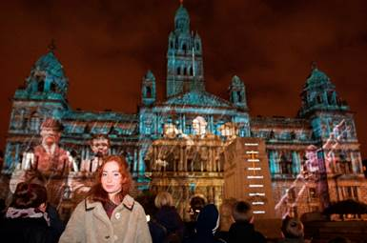

In July, we hosted both a small drop in display and a larger scale evening exhibition of Gaelic related material for the International Congress of Celtic Studies, the foremost international gathering of scholars researching the languages, literatures and cultural traditions of the Celtic-speaking peoples. A reception for around 100 delegates was held in the library’s level 3 café area, with small groups shuttled up and down to level 12 to view a display featuring material such as a 15th century copy of Welsh Laws, the 17th century Fernaig Manuscript of Gaelic verse, and the first Minute Book of the Glasgow University Ossianic Society.

**The Digital Library**

The [Scottish Theatre Archive](http://special.lib.gla.ac.uk/collections/sta/)’s web presence was significantly upgraded: <http://special.lib.gla.ac.uk/collections/sta/index.html>

The emphasis has been on making the pages lively and appealing by providing a wide range of visual content, together with some short essays designed to serve as introductions to the subjects and to material held in the [Scottish Theatre Archive.](http://special.lib.gla.ac.uk/collections/sta/) The website aims to appeal to a range of users, from secondary school pupils to older generations and is highly visual, with media rich content including interviews with some of Scotland's Theatre Stars along with video clips of shows from the National Theatre of Scotland. These are exclusive to the Scottish Theatre Archive website and the National Theatre of Scotland has never allowed video clips to be used in this way before.

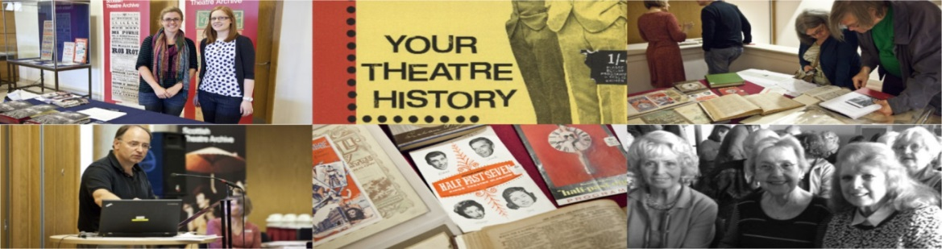

Acquisitions & Access prepared successfully for the launch of the single Reading Lists @ Glasgow service, incorporating list creation, digitisation of course materials and review of lists. The purpose is to create a single point of online access for students for course materials and a simplified means of academics accessing what were previously three services. There were 496 lists added to Reading Lists @ Glasgow in 2014-15, a 58% rise on previous year, and over 25,000 items were linked via the system. We purchased the Talis Digitised Content module which will improve the student experience, as digitised content will be fully integrated within the reading list, accessible via GUID, removing the need for separate systems and separate authentication.

This year saw the successfully completed changeover to digital exam submission from hard copy. This has taken shape over the last two main exam diets and has allowed more efficient working for academic and Print Unit staff. PDF files are securely delivered through a submission and management system developed by the MIS section of IT Services. For the main diet, over 1000 exams take place over about 6 weeks during April and May.

The College Librarians were involved in the project teams who delivered two of the University’s first Massive Open Online Courses (MOOCs). This involved providing advice on rights management and information skills training. Feedback from the Cancer MOOC highly rated the information skills videos developed by members of the team.

**Conservation**

A grant from the National Manuscripts Conservation Trust enabled 680 of the University's earliest drawings in the William Simons Shipyard Archive to be repackaged to current standards. Four drawings of American Civil War blockade runners also underwent conservation treatment to stabilise them for the use of researchers: <https://www.flickr.com/photos/uofglibrary/sets/72157646183297229/>

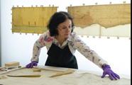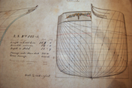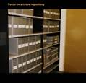

**Digitisation**

The Library received funding from the Wellcome Trust for a number of projects:

In August 2014 the Photographic Unit began work on the *Digitisation Mental Healthcare Records* project, due to be completed by November 2016. Selected material from the archives of two psychiatric institutions, Gartnavel Royal and Crichton Royal, will generate 350, 000 digital images and 13TB of data. These digitised records will be accessible via the Wellcome Trust Digital Library, supporting the University’s vision of enhancing research strengths. This year the project delivered over 100,000 images to the Wellcome Trust and these are already accessible to researchers.

We also received funding from the Wellcome Trust Medical Heritage Library Digitisation Project, undertaken in association with 8 other partner libraries, whereby a very extensive collection of 19th century texts covering the history of medicine, in its widest terms, are being digitised and made freely available to researchers. Work included the preparation of lists of relevant material for submission for de-duplication, the amendment of our own catalogue records, the dispatch of material to London and a proper record of the work-flow. It is likely that, overall, we will be sending around 5,000 volumes for a digitisation programme which aims to run to 15 million pages

The University of Glasgow possesses what is perhaps the third strongest collection in the United Kingdom of printed works on syphilis produced before the early nineteenth century, containing many extremely rare medical treatises, some of which are unique in Britain. In terms of number, depth, and variety the collection ranges from the earliest syphilis incunabula at the end of the fifteenth century to dissertations and debates on whether syphilis and gonorrhoea were separate diseases - a debate in which Scottish surgeons, principally John Hunter and Benjamin Bell, took centre stage. However, this excellent collection has flown under the radar until now due to it being poorly catalogued and dispersed throughout several collections, making it difficult for researchers to access. Recognising its significance and research potential, funding was obtained from the Wellcome Trust to have ca. 250 items catalogued to international standards to improve discovery and accessibility. As well as cataloguing the books and maintaining a high project profile via twitter and informative blogs, the Library created a web-based teaching resource and hosted a symposium to promote the collection.

**Research Data Management and Open Access**

The Library launched a new service to support Research Data Management across the University. Many research funders now require that data generated during the course of research is preserved and, where feasible, made available to other researchers. The Library Research Data Management service provides support for data management planning, providing storage for datasets, helping to assign costs for data management into grant applications. The Library has also created a Research Data Registry (<http://researchdata.gla.ac.uk/>) where researchers can record details of their datasets and can obtain a persistent Digital Object Identifier (DOI) for their datasets. The Library continues to offer significant support for open access, in particular for the requirements of research funders and the Research Excellence Framework.

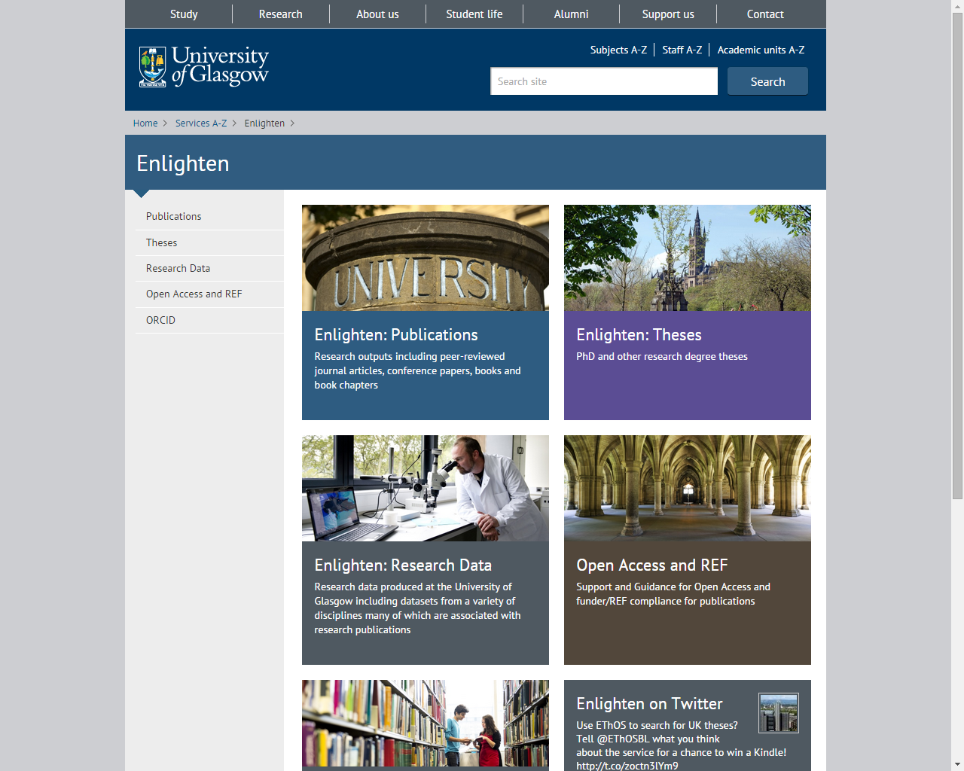

**Key Library Facts & Figures**

* Demand and use of the University Libraries continued to increase in 2014-2015 with a total of 2,055,752 visiting the physical buildings. User visits to the Main Library increased by 3% to 1,955,377, a further 34,655 visited the Adam Smith Library, 31,144 visited the James Herriot Library, 33,047 visited the James Ireland Memorial Library, 1,257 visited Archive Services and 172 visited the Library Research Annexe.
* The average visits per FTE student increased by 5% to 89 per student (85 visits per FTE to the Main Library, 89 visits per FTE to all Libraries with figures available). Although this trend is not unique to Glasgow, the SCONUL average number of visits per FTE user throughout the previous ten year period has remained relatively stable at 52-53 visits per FTE user.
* Borrowing from the High Demand collection exceeded all expectation and was over 3 times (158%) higher than material with the same loan periods in 2013-2014.
* We now provide access to over 900,000 e-books, a 6% increase on the previous year, and use of this material has increased by 46% year on year.
* The number of full-text downloads of publications from Enlighten and use of the Theses collection available from the repository increased by 19% to 2,614,521.

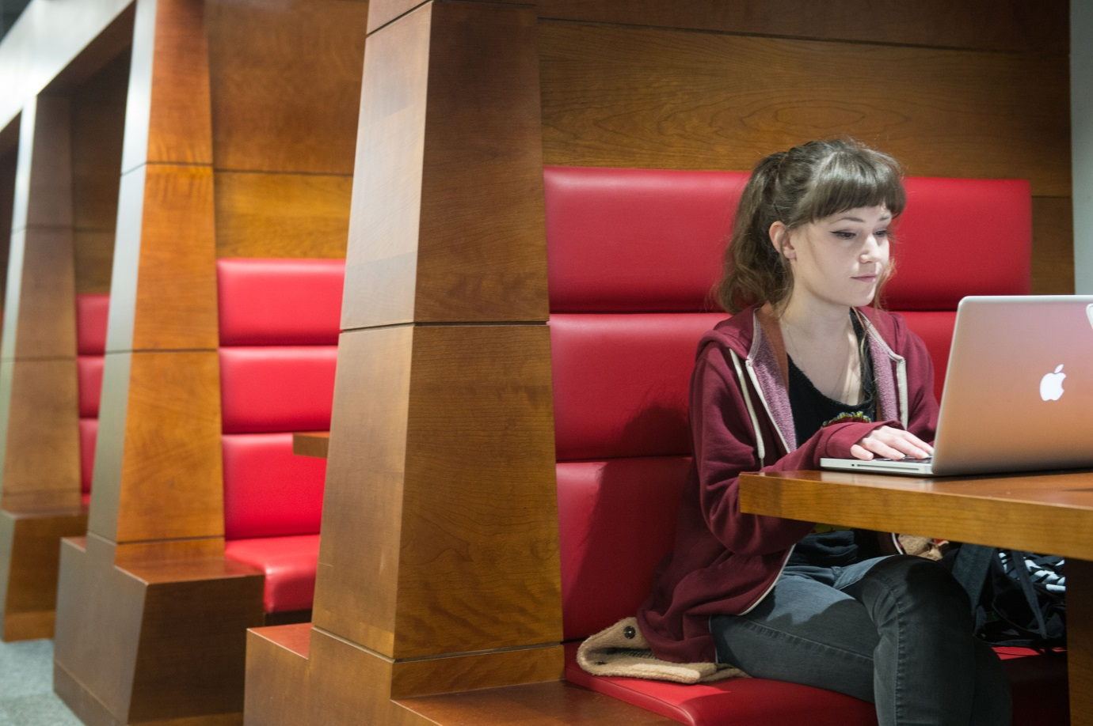

**Annual Library Statistical Report**

Membership

Membership has decreased slightly due to a 1% drop in the Undergraduate FTE figure from last year which equated to a 3% drop in the Undergraduate Headcount from 19,851 to 19,161 in 2014-2015. Conversely, the Postgraduate Research headcount increased by 4% to 2,136, which together with an increase in staff members has changed the membership population profile with undergraduate percentage reduced from 52% to 47%, postgraduates increased from 20% to 21% and staff increased from 20% to 24%.

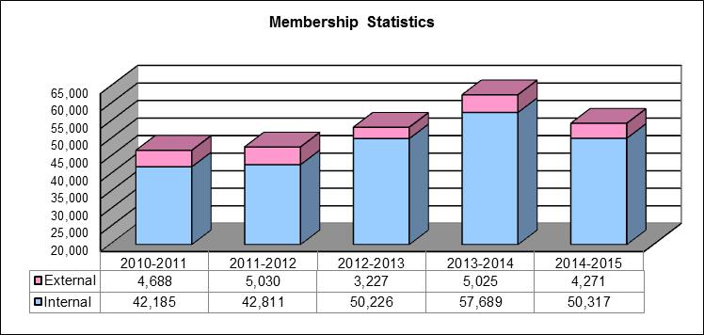

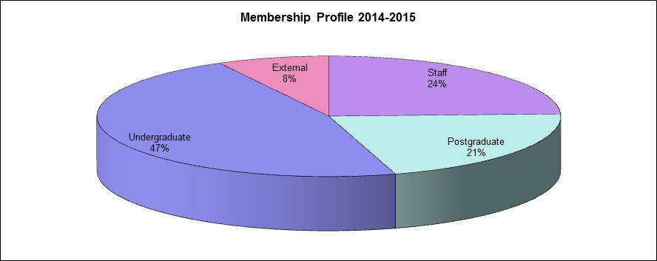

**Visitors to the Library: Physical**

Demand and use of the University Libraries continued to increase in 2014-2015 with a total of 2,055,752 visiting the physical buildings. User visits to the Main Library increased by 3% to 1,955,377, a further 34,655 visited the Adam Smith Library, 31,144 visited the James Herriot Library, 33,047 visited the James Ireland Memorial Library, 1,257 visited Archive Services and 172 visited the Library Research Annexe.

The average visits per FTE student increased by 5% to 89 per student (85 visits per FTE to the Main Library, 89 visits per FTE to all Libraries with figures available). Although this trend is not unique to Glasgow, the SCONUL average number of visits per FTE user throughout the previous ten year period has remained relatively stable at 52-53 visits per FTE user.

The most frequent visitors are from the College of Social Sciences followed by the College of Arts.

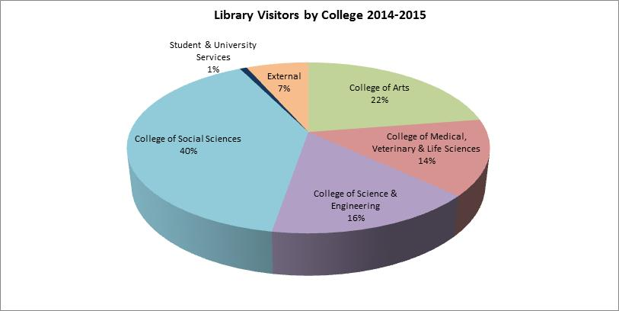

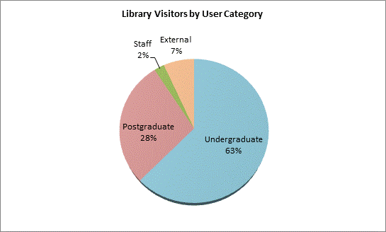

**Use of Information Resources**

Use of Information Resources continues to grow with use per FTE Student up 14% from 412 to 469 uses per FTE. This is mostly due to the increase in the use and provision of E-books. Although borrowing of the physical stock continues to decline, however the increase in use of the newly formed High Demand Collection (Undergraduate texts restricted to 4 hour or 24 hour loan period) exceeded all expectation (further details below). The number of full-text downloads of publications from Enlighten and use of the Theses collection available from the repository increased by 19% to 2,614,521.

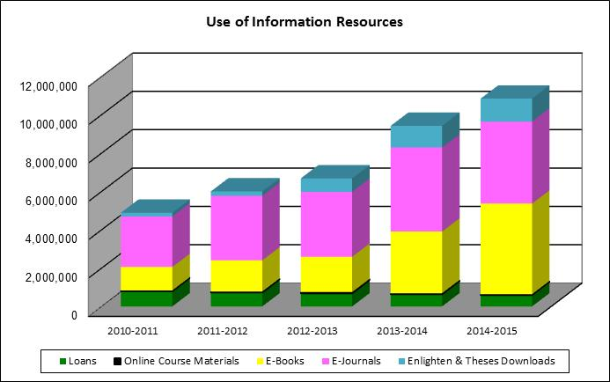

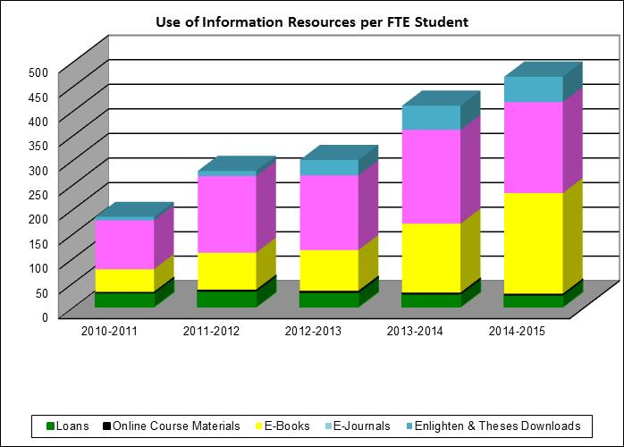

**Use of Undergraduate Collections**

The undergraduate Short Loan Collection was disbanded in the summer of 2013 and a new High Demand Collection of print items available for 4 hour and 24 hour loan was accumulated and located in the refurbished Level 3 of the Main Library. The success of this collection is illustrated in the figure below showing the increase of 158% in borrowing from the collection

**Use of Closed Collections**

The Library has three closed access collections, Special Collections, Archives and the Research Annexe. In most cases the material is only available for in-situ consultation with the exception of some stock in the Research Annexe which may be borrowed or made available for consultation in the Special Collections Reading Room.

