Transaction Coding
https://mivision.hsbc.co.uk/1/mv-m3-ugg-prod
To access this portal, you must have your 8 digit security number that you created during the registration process.
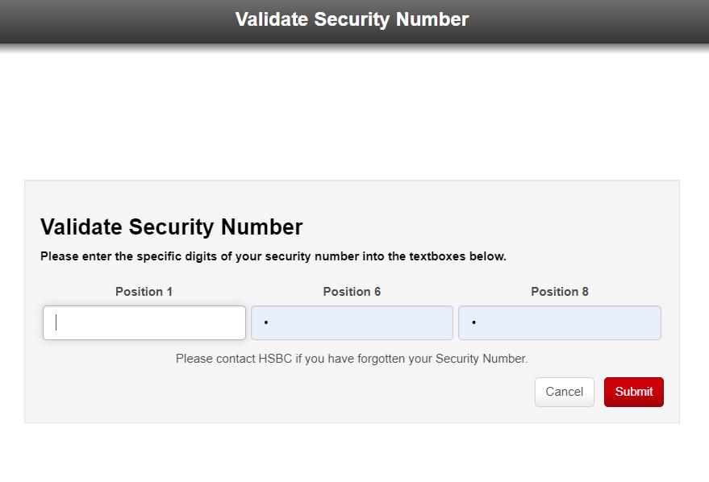
Please enter the requested digits of your 8-digit security number and click submit.

