Compressed Gas Cylinder Safety
1 Introduction
Specialist gases are used across the University with a range of applications in research, operation of analytical instruments, welding and fire suppression and many others. They are usually supplied as compressed gases in metal or composite cylinders allowing a large quantity of gas to be stored in a compact, convenient form which can be easily transported and stored. For example, consider a typical gas cylinder standing approximately 1.5m tall with a diameter of 23cm. At a pressure of 230 bar this cylinder will contain just over 11 cubic metres of gas at standard temperature and pressure. The convenience of storing large amounts of gas at high pressures is not without some drawbacks and gas cylinders can present a variety of potential hazards to staff and students including:
- The hazardous properties of the gas itself (e.g. flammable, toxic, corrosive, asphyxiant)
- The possibility of leaks and releases of gas into confined spaces due to faulty connections / equipment
- The stored energy associated with a gas stored under pressure
- Manual handling risks associated with cylinders (which can weigh in excess of 100kg)
- Toppling of improperly stored cylinders leading to injury to individuals or damage to the cylinder
- The effect on fire, impact or other unexpected events on pressurised gas containers
- Noise (hearing damage) due sudden releases of gas
There have been a number of high-profile incidents in industry and in higher education where individuals have lost their lives or been severely injured due to incidents involving cylinders. It is therefore extremely important that compressed gas cylinders are stored, transported, used and disposed of safely.
Note: All procedures involving compressed gas cylinders including storage, transport and connecting and disconnecting accessories should be covered by a prior risk assessment. Only users who have been trained by a competent person and are deemed to be themselves competent should be permitted to work with compressed gases.
Types of Compressed Gas Cylinder
Gas cylinders come in a variety of different designs depending on the gas required and the application, with the properties of the gas dictating in some cases the type of cylinder required. Some common types are described below (see Appendix 1 for further examples):
Standard Most compressed gas cylinders consist of a metal or composite skin formed into a rough cylinder shape, usually with a flat base and rounded top which contains the cylinder valve. Cylinders of this type are used for most compressed gases and generally contain the gas at pressures of up to 230 bar. They are often fitted with a sturdy guard at the top to protect the valve and regulator. The cylinder valve will be designed with the valve on the top or the side of the cylinder head which will determine what design of regulator is required.
EVOS Cylinder EVOS cylinders are a relatively new type of compressed gas cylinder. Which are quite similar to standard gas cylinders but are designed to contain gases at a much higher pressure (up to 300bar). They also include an integrated pressure gauge, improved ergonomic valve guard

to improve protection and make the cylinder easier to churn. The cylinder valve is easier to open and close with a lever used to replace the normal cylinder key / spanner and a special regulator which can be attached without the need for any tools.
LPG Cylinder LPG (propane or butane) is usually supplied in the liquid form under pressure readily evaporating into a gas when released from its container. Because of this the pressure within the cylinder is much lower than for compressed gases (2 bar for butane and 8 bar for propane). LPG cylinders have thinner walls than high pressure cylinders and have a short, squat design to allow stability without requiring a stand.
Acetylene Cylinder Acetylene (C₂H₂) is an extremely volatile, explosive gas which is used primarily for cutting and welding. It is extremely unstable when compressed and can explode spontaneously meaning it cannot be stored in a standard cylinder. To reduce the risk, acetylene cylinders contain a porous ceramic matrix with the acetylene added as a solution in acetone. As a result, they tend to be much heavier than other types of cylinder.
Lecture Bottles Lecture bottles are small, easily transported cylinders (typically around 10cm in diameter and around 30-45 cm long designed to contain a small volume of gas. However, this does not mean they should not be treated with the same respect as larger cylinders. Lecture bottles often contain specialist gases which may be more hazardous than those found in more conventional cylinders.
Compressed Gas Cylinder Identification
Modern gas cylinders are usually colour coded to make the contents easy to identify at a glance. Currently in the EU and UK where a gas presents a single hazard the cylinder will be colour coded in accordance with BS EN 1089-3 as follows (in descending order of hazard presented by the gas):
Single Hazard | Colour Coding
Toxic and/or Corrosive | Yellow
Flammable | Red
Oxidising | Light Blue
Inert | Bright Green
Where mixtures of gases with different hazards are present in the cylinder as a mixture then more than one colour will be used on the outside of the cylinder. The following colour combinations may also be encountered:
Toxic and flammable Yellow and red
Toxic and oxidising Yellow and light blue
However, different types of gases (e.g. medical gases) may be assigned different colours depending on their intended use and the nature of the mixture. Others may have been assigned a colour on a historical basis for example helium cylinders are traditionally brown and acetylene cylinders are traditionally maroon / claret in colour.
While for the most part gas cylinders can be identified by their colour coding this is not always possible. Some cylinders may contain complex gas mixtures and therefore may have a standard specialist gas mixture livery. Others may be old, corroded or have been repainted concealing their identity meaning that colour schemes cannot always be relied upon as a means of identification.
Modern gas cylinders will be clearly labelled in a standard format which clearly identifies the supplier, the gas contained and the hazards associated with the gas in the form of the standard GHS Hazard Pictograms. The cylinder label is the most reliable means of identifying a gas cylinder and these should never be removed, defaced or obscured (see appendix 2 for some examples of cylinder labelling and colour coding).

Note: Gas cylinders from non-EU/UK sources will rarely be encountered within the University but it is worth being aware that cylinders sourced from international suppliers (especially specialist gas mixtures) may not conform to the expected cylinder colours and should always be identified using the label.
2 Compressed Gas Cylinder Stores
When not in use compressed gas cylinders should be stored in a safe, secure location to reduce the risk of an accident. Where large numbers of cylinders are required a dedicated cylinder store will be required. The precise design of a gas cylinder store is dependent on the available space, number of cylinders required and ease of access amongst many other factors. However, the BCGA guidance provides important principles for safe storage of gases (see BCGA Code of Practice 44 for a more comprehensive discussion of gas cylinder storage).
The first (and most important) part of designing and operating a gas cylinder store is to carry out a site-specific risk assessment that covers the location and design of the store as well as the activities undertaken there. Remember that the risk assessment will need to cover not only activities carried out by University of Glasgow staff and students but also tasks undertaken by delivery / collection drivers and other people who might have reason to access the area.
Store Location and Layout
The most suitable location for a gas cylinder storage area is outside in the open air in a location with good natural ventilation. This prevents a build-up of gas in the event of a leak as any gas which does escape can quickly dissipate, the presence of adjacent walls and building can have an effect on the efficiency of ventilation. The following should also be considered:
- Stores should not be located in low-lying areas where gases may accumulate, in particular gases that are heavier than air may persist in low lying areas.
- While good drainage is desirable, it is better if drains are not located inside gas cylinder stores to prevent accumulation of gases in drains and associated pipework. Standing water in gas cylinder stores can increase the risk of corrosion of cylinders as well as introducing a slip hazard and stores should be designed to eliminate this where possible.
- Outside cylinder stores should be located away from emergency exits to reduce the risk of such areas being compromised in the event of an accident. In turn it should always be possible for an individual to escape from the store easily in the event of an emergency.
- While gas cylinders are designed to withstand the elements, weatherproofing should be present where practical to reduce the impact of wind, rain etc. on cylinders. Roofs should allow adequate ventilation and not give rise to a risk of gas accumulation in the event of a leak with sloping roofs being the best choice. Peaked roofs where present should include a means of gas escape.
- The cylinder store should be level, accessed via a step-free route and provide ease of access for both users and delivery / collection drivers. Cylinder stores should be placed such that delivery vehicles can access them easily and have sufficient space for loading and unloading safely.
- Gas cylinder stores should be clearly signed to indicate the presence of gases, entry requirements and should be clearly identified as no-smoking areas (even when only non-combustible gases are present). For examples of signage see Appendix 3.
- Gas cylinder stores should be locked to prevent unauthorised access. To allow for deliveries cylinder stores are usually locked with a combination padlock or equivalent with the code being provided to the delivery company.
- Adequate lighting should be provided to ensure the safety of staff and students working with cylinders when the light level is low e.g. during the winter months.

BCGA recommend against locating gas cylinder stores inside buildings and where possible this should be avoided to reduce the risk to individuals working in the area in the event of a leak. Where an internal gas store cannot be avoided the following hierarchy should be used to select a location (as given in BCGA CP44):
- A bespoke, stand-alone dedicated, adequately naturally ventilated building
- A dedicated room sealed from the rest of the building, adequately naturally ventilated to the outside and only accessible from an external door.
- A dedicated room, adjacent to an outside wall, inside a building, adequately naturally ventilated to the outside, sealed from other areas of normal occupancy.
- A dedicated room, inside a building, with forced air ventilation, sealed from other areas of normal occupancy.
- In a building, as far as is practicable away from normal work locations.
Note: Where an internal store is required, the number of cylinders should be kept to the minimum necessary and consideration given to both the ventilation requirements and the need for atmospheric monitoring within the store. Further advice on the design and location of compressed gas cylinder stores is available from SEPS.
Management of Cylinders in Storage
Gas cylinder stores and their contents should be organised with a view to reducing the risks to users while maintaining ease of access for both delivery / collection drivers and users. The following points should be considered (see also Appendix 4):
- The gas cylinder store should be arranged to allow ease of access to cylinders both for users and delivery drivers, considering the need for sufficient space to load and unload cylinders onto trolleys. Walkways should be at least 1m wide and kept clear of obstructions.
- Gas cylinders should be segregated such that incompatible gases are stored in separate areas of the store i.e. flammable gases should not be stored with oxidising gases (e.g. oxygen). It is usually sufficient to separate incompatible gases by distance and clear signage should be employed to indicate the correct storage location for each type of gas.
- A designated area for “empty” gas cylinders for collection should be established. This should be clearly marked to make it easy for collection drivers to identify which cylinders are to be removed from site.
- All gas cylinders should be securely fixed in the upright position to a robust frame or wall fixing point with a chain (or suitable strap) at around 2/3rds of the height of the cylinder. For smaller cylinders a suitable rack or stand may be used. Sufficient chains (or rack space) should be available for all gas cylinders stored in the area. It is recommended that gas cylinder stores are regularly inspected to ensure that all cylinders have been secured (including those recently delivered) and that the store remains in good condition.
- The housekeeping of gas cylinder stores should be monitored, and efforts made to keep walkways and storage areas clear. This is the responsibility of the owner of the store.
- Gas cylinders belonging to individual research groups can be stored in communal cylinder storage areas but should be clearly labelled with the owner’s name. Note that gas cylinders must be segregated by type and not by research group.
- It is acceptable to have more than one cylinder in storage bay within a store but unless the stock is actively managed this can result in cylinders at the rear of bays being ignored. Consider how cylinders are used and whether there is a need to rotate stock to ensure newly delivered cylinders aren’t always used in favour of others that have been in storage for a while. Remember that some gases will be supplied with a return date and that all cylinders must be regularly inspected by the supplier to ensure they remain safe to use.

Note: Nitrous oxide is used as a recreational drug and cylinders are occasionally stolen. Therefore, additional security arrangements may be required in storage areas where nitrous oxide cylinders are located to prevent unauthorised access.
Note: Gas cylinder stores should be used only for storing compressed gas cylinders and should never be used for storing any other material. Flammable liquids should not be stored with gas cylinders and other materials e.g. waste furniture, electrical appliances or general rubbish could pose a fire risk and should not be stored in the same area.
3 Moving Compressed Gas Cylinders Safely
Compressed gas cylinders (especially larger sizes) can be both heavy and awkward to move. If the proper equipment and techniques are not used they can easily cause musculoskeletal injuries during handling operations. In the event that a cylinder falls on someone the risk of a fracture or other injury is high.
Anyone involved in the movement of cylinders should have been trained in proper manual handling techniques and be fully aware of the risks. Remember that while most people with proper training are capable of moving cylinders safely some individuals (e.g. those with pre-existing medical conditions) may find it more difficult and require some assistance. The movement of cylinders in a particular area should be subject to an appropriate risk assessment (this can be a general risk assessment for an area covering all cylinder movements). Things to consider as part of the risk assessment include:
- The size and weight of the cylinder (some cylinders can weigh in excess of 100kg) should be considered along with the shape and size which will affect the ease of movement.
- The availability and design of appropriate cylinder trolleys e.g. is a stair climbing trolley needed? Do trolleys have 2 or 4 wheels?. Consideration should also be given to regular inspection of cylinder trolleys which may fail during use if not properly checked and maintained.
- The distance over which the move will take place and the quality of the surface e.g. is it rough, slippery, are there steps or other obstructions that may need to be navigated.
- The environment over which the move will take place (e.g. the weather if outside, the surface, slopes etc.) is the lighting sufficient to ensure hazards can be identified.
- The capabilities of the individual (and whether they might require assistance) are very important. Cylinders can be heavy and awkward to move and people, should be encouraged to ask for (and provide) assistance when it is required.
- The availability of a second person to open doors and keep people out of the path of the cylinder should also be considered. Moving cylinders alone is extremely dangerous and should be avoided.
- The timing of the move should also be considered to reduce risk (to both staff and students. It is usually good practice to avoid lecture changeover times due to the number of people moving around the campus.
- Emergency procedures should be developed in advance to ensure users know what actions to take in the event a cylinder leaks, falls or is dropped. These should be easily understood and communicated to anyone who might be affected.
- PPE is required when moving cylinders (generally lab coat, gloves, safety goggles and safety footwear). Safety overshoes with steel toecaps can be purchased and stored in a central location where issuing safety footwear to all users is impractical.
When moving compressed gas cylinders an appropriate cylinder trolley is usually required. The trolley should be designed for the purpose and keep the cylinder secure and upright while it is moved. Improvised trolleys, sack barrows etc. should not be used for the transportation of cylinders. Various designs of cylinder trolley are available,

but most people find the four wheeled variety easier to use as it removes the need for the user to support the weight of the cylinder during the move.
Stair climbing trolleys (with rotating wheel assemblies) can be used to help bring cylinders up curbs, rises and small sets of stairs but in general transporting cylinders up staircases should be avoided. All cylinder trolleys should be regularly inspected for damage and wear and removed from service if necessary.
When moving gas cylinders from one floor to another the use of lifts will most likely be required. The use of lifts is acceptable when moving cylinders but where possible cylinders should only be moved using a suitable goods lift avoiding the use of passenger lifts. Care should be taken to ensure that no-one travels in the lift with the cylinder including the person(s) involved in the move. This rule applies irrespective of the contents of the cylinder i.e. people should no accompany gas cylinders even if the gas is deemed low risk (e.g. compressed air). Physical barriers and key control of lift controls can help prevent people accidentally entering the lift with a cylinder, using one person to send and one to receive a cylinder on the destination level is also good practice.

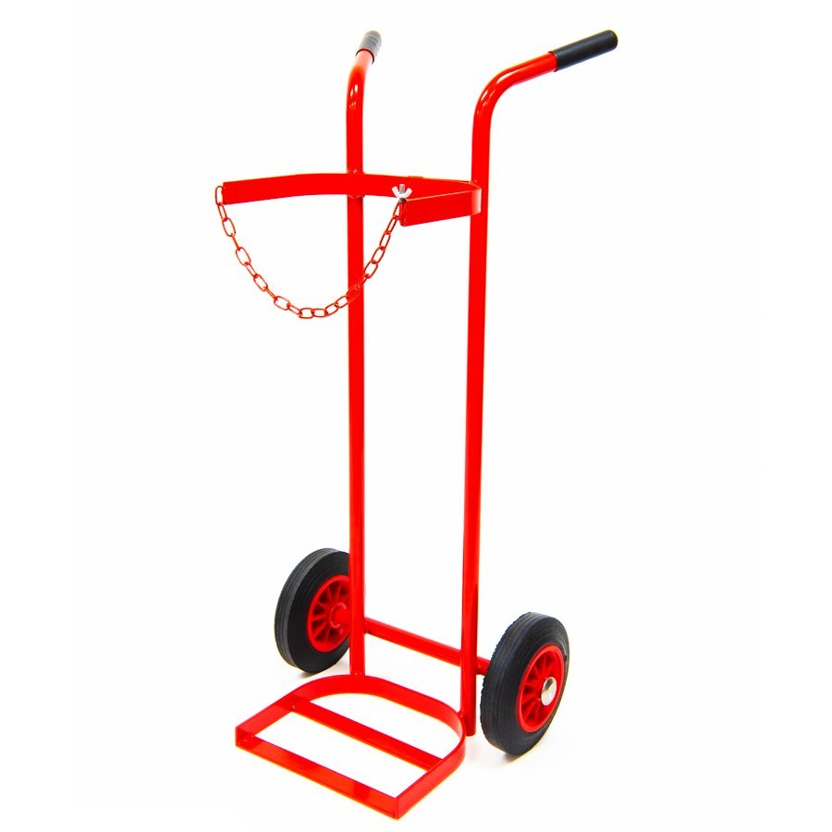
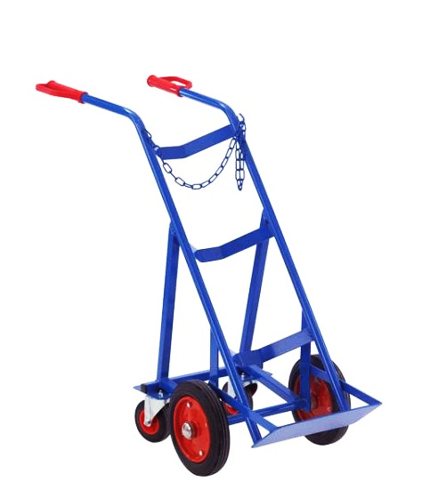

Figure 1: Typical cylinder trolleys, the four wheeled version (left) is generally considered easier to use. Stair climbing trolleys (right) should only be used for curbs and / or small numbers of steps.

Note: When moving a cylinder to and from a cylinder trolley the cylinder should be firmly gripped and tilted before “churning” it into position, larger cylinders should never be lifted. This process should be minimised to the shortest practical distance.
Note: Compressed gas cylinders should never be moved with accessories such as regulators attached to them. In the event that a cylinder was dropped or struck against another item during transit these could easily be damaged or sheared off causing a sudden release of stored energy and/or gas.
4 Compressed Gas Cylinders in Laboratories and Workshops
It is common practice in for gas cylinders to be stored in laboratories and workshops in particular when they are connected to a piece of equipment such as a welding set or analytical instrument. Cylinders in laboratories should always be the subject of a risk assessment and alternatives such as gas manifold systems connected to outside cylinders or gas generators should be used where practical. Where there is a need for gas cylinders to be located in laboratories consider the following:
- Suitable locations should be identified for the storage of cylinders in laboratories. They should be stored vertically in clearly visible locations away from walkways. Cylinders should be secured to a suitable fixing point with a chain or strap at around 2/3 of the height of the cylinder.
- Bench clamps and straps where present should be securely fixed to a wall or piece of furniture with sufficient weight to prevent them from being dislodged. Improvised straps and fixings must not be used to secure gas cylinders. It should always be possible to identify the contents, and owner / user of a cylinder.
- It is not recommended that cylinder trolleys are used for long term storage of gases in laboratories with the exception of welding sets where the mobility of the equipment is important.
- Free standing cylinder racks / stands can be used if they provide sufficient stability but care should be taken to ensure that they are sufficiently tall to secure the cylinder and secured to the floor where the supplier recommends that this is required.
- Gas cylinders should be orientated in such a way that staff and students are not at risk in the event that a protective device such as a pressure relief valve were to operate.
- Where gas cylinders are stored inside in large quantities or in small rooms consideration should be given to whether local gas detection is required to warn of leaks. This is particularly important when flammable, toxic or asphyxiant gases are in use. Personal gas monitors may be used when gases are only present in a lab for short periods of time. These should not be viewed as a long-term replacement for fixed monitoring systems. If unsure then a calculation should be carried out to determine the potential consequences of a leak.
- All laboratories or other areas where gas cylinders are present should have clear signage at all points of entry to warn users, visitors and the emergency services of the hazard (see appendix 6 for examples of suitable signage).
- Anyone working in a laboratory containing a gas cylinder should have some basic training in gas safety and emergency procedures even if they do not work directly with compressed gases. This allows individuals to act appropriately should a fault arise. Consideration should also be given to what instructions should be given to visitors, contractors and other members of staff (e.g. cleaning services).
Note: Some laboratories use compressed gas storage cabinets to contain cylinders within laboratories. These are regarded unfavourably by the emergency services due to the difficulty in identifying cylinders and cooling them if required. The current position of the BCGA is that they recommend against gas cylinder storage cabinets unless required for specialist uses (e.g. temperature control of gases, specific safety requirements for hazardous gases). Where present, cylinder cabinets should be ventilated and very clearly marked with the contents, signage should also be present on the door to the laboratory.
5 Safety Devices and Accessories
Pressure Regulators
Pressure regulators are devices which connect to gas cylinders and reduce the gas pressure in the cylinder (typically 230 300bar) to a lower working pressure for use. Single-stage regulators do so in one stage and tend to be inaccurate with pressure often creeping upwards as the pressure in the cylinder reduces. They are used for applications where a constant pressure isn’t that important.
Two-stage regulators are much more accurate giving a consistent output and are much more suitable for precision operations. When choosing a regulator, it is important to ensure you select one suitable for the gas and the pressure (both in the cylinder and application) and that meets the appropriate standard (EN ISO 2503). For a comprehensive pre-use checklist compatible with most common regulators see Appendix 5.
Cylinder regulators should be clearly marked with their use-by date although in some cases this may be in form of a code number. Regulators do degrade over time and it is recommended that they are not used beyond this date. Regulators should be regularly inspected by a competent person to ensure they remain safe to use. Regulators

should only be attached and removed by competent, trained staff due to the risk of serious accidents if not connected properly.
It is worth noting that regulators operate as safety devices with the back of the pressure gauges designed to operate as pressure relief valves. These should always be orientated away from areas where people work. Damaged and/or expired regulators should be removed from service immediately.
Note: Regulators should only be used for the specified gas and should not be treated with greases, oils or PTFE tape. They should not be swapped between gas types to avoid cross contamination.
Note: Current industry guidance is that all compressed gas regulators irrespective of the gas for which they are used should be changed after five years due to degradation of components whether they have been used or not. Regulators are generally supplied with a use-by date stamped into the metal. It is good practice to supplement this with an easily visible tag which clearly states the use-by date and date of next inspection.
Other Accessories
Flashback Arrestors Often fitted to flammable gas cylinders such as acetylene these are designed to prevent a flame entering the gas cylinder in the event that the gas catches fire.
Non-return Valve Similar to the above a non-return valve is intended to prevent an unintended gas mixture (or air) from flowing into a cylinder or piece of equipment.
Cylinder Key Tool designed to open cylinder valve connection (not required for EVOS cylinders). Cylinder keys should be available for all cylinders while they are in use to allow them to be isolated in quickly in the event of a leak.
Hose Assembly Hoses are usually made of plastic, rubber or metal and are designed to provide a flexible connection between the gas cylinder and the equipment to which it is connected. Hoses should be inspected before use and should be of the correct type for the gas being used as some gases can cause degradation of incompatible hoses (in particular LPG which can act as a solvent). Jubilee clips and other “worm-drive” screws should never be used on gas hoses as they can easily be overtightened damaging the hose and increasing the risk of leaks.
6 Manifolds and Piped Gas Supplies
Although gas cylinders can be stored within laboratories it is good practice to do so only when there is no other alternative. A safer alternative is to store gas cylinders in a suitable outside location and connect them to laboratory equipment or gas supply valves via a pipeline known as a manifold. Manifolds may be connected to a single gas cylinder or multiple cylinders to provide an uninterrupted supply by switching from one cylinder to another (either manually or automatically). Gas cylinders are commonly attached to manifolds via a two-stage regulator to provide a constant reduced pressure to the pipeline. The flow can then be adequately controlled at the point of use using a single-stage regulator. Note that gas cylinders connected to manifolds are subject to all the same storage requirements as discussed previously.
Pipework and fitting should be made of a material that is suitable for the gas being carried (and where the pipework ins located outside able to stand exposure to the elements without corrosion). The pipework should be sufficiently robust to withstand the maximum foreseeable pressure within the system (pressure relief valves and other protective devices are likely to be required to mitigate the risk of over-pressurising the system).
Pipework should be clearly labelled with the contents and securely attached to walls in areas where it will not be subject to mechanical shock (e.g. due to vehicle collision). In the event that construction, repair or other works are undertaken in the vicinity of piped gas systems the system care should be taken to communicate the risks to workers and where practical take the system out of operation for the duration of the project. The system should be tested prior to reinstating the gas supply.
Gas supply manifolds should be designed to allow the gas supply to be turned off at the cylinder in the event that a leak is detected from the system.
Anti-whip cables (sometimes referred to as “rat tails”) should be connected to gas supply hoses to prevent them from flailing around in the event of a pressure release. These should be subjected to regular inspections by a competent person to identify any possible degradation / damage. Other safety devices should also be fitted as required.
Note: Where pipework passes through unventilated compartments and enclosed spaces within a building there may be a need of fixed gas monitoring equipment to be installed to detect leaks.
Note: Gas supply manifolds are considered under the PSSR Regulations and therefore require regular inspection by a competent person. However, due to the low volume of such systems the pipework itself is usually exempt from the need for a although safety systems such as pressure relief valves will usually be included in a Written Scheme of Examination.
7 End of Life and Disposal
For the most part gas cylinders are rented from a supplier and do not belong to the user meaning that when they are no longer required, they can simply be returned to a designated collection area (often within the cylinder storage pound) and collected by the supplier. Informing the supplier as soon as the cylinder is no longer required helps to ensure that this process works efficiently helps to reduce the number of “empty” cylinders present on site and reduces costs by ensuring that the user is not paying rent on a cylinder they no longer require.
To ensure that the process runs smoothly cylinder stores should be designed to be easily accessible by delivery / collection drivers. Cylinders for collection should be clearly identified and segregated from other cylinders in a separate area of the store so that they can be easily recognised by the driver. For smaller stores where clear segregation is not possible, empty cylinders should be clearly identified with a weatherproof sign/label attached to the cylinder.
For the most part returning a cylinder to the supplier is a straightforward process. So long as the supplier of the cylinder can be identified they are required to remove them from site. However, there are some circumstances which can complicate the process:
- If the supplier of cylinder cannot be identified or is no longer trading, then it will not be possible to arrange a straightforward collection. In this event the cylinder will need to be removed by the University’s chemical waste contractor.
- Rarely there may be a situation where a regulator becomes jammed on a gas cylinder due to mechanical damage or a jammed valve making it impossible to safely depressurise the system. In the event that this happens the cylinder should be taken out of service and left in place (remember that cylinders should never be moved by University staff with the regulator in place). The supplier of the cylinder should then be contacted who will make arrangements for it to be uplifted by a competent person for disposal.
- If a cylinder is corroded and the supplier cannot be identified, then it should be left in place and disposal can be arranged via the University chemical waste contractor using the normal process.
Note: The cost of removing unidentified cylinders or cylinders that are in poor physical condition is likely to be significant. However, cylinders that are in poor condition are more likely to pose a hazard and every effort should be made to remove these from the University when they are identified.
Note: Although we often refer to cylinders as empty there is almost always some gas remaining within the cylinder even if the pressure is very low. Once a cylinder has been taken out of service it must not be opened to atmosphere to vent any remaining contents.
8 Emergency Planning
Anyone working with compressed gases should have carried out a risk assessment before starting work. A key part of any risk assessment is identifying what actions will be required in the event of an emergency. When working with compressed gases this is extremely important due to the potential consequences of an accident. When preparing the risk assessment consideration should be given to the following possibilities:
- Major leaks and releases of gas due to faulty valve connections or other equipment
- Small / persistent leaks from valves, equipment or hoses
- Leaks of gas into enclosed / poorly ventilated areas
- Explosions due to catastrophic failure of equipment or overpressures
- Gas cylinders involved in fires (even inert gas cylinders can explode when heated).
- Jammed valves / regulators which may trap pressure in the system or become stuck in position.
- Toppling of cylinders (or dropping them during transport)
- Mechanical damage to compressed gas cylinders (e.g. dropped cylinders, vehicle impact)
- Failure of cylinder trolleys during transit
- Theft of compressed gas cylinders
The first priority should be to prevent faults and failures that might lead to any of the above situations with safe systems of work, training and supervision, selecting the right equipment, locating it correctly and ensuring regular maintenance and inspections are completed usually proving critical in preventing accidents.
One important consideration for working with gas cylinders in laboratories / workshops is what might happen in the event of a leak, consider how the leak would be detected, what the consequences might be (toxicity, asphyxiation, fire and explosion), how people would be evacuated from the area, how the gas supply could be safely turned off and how a compartment could be ventilated. Consideration should also be given to how users could confirm it was safe to reoccupy an affected area.
9 Further Information
Most of the guidance in this document is taken from Codes of Practice and Guidance Notes published by the British Compressed Gases Association (BCGA). A list of the most relevant documents used in producing this guidance is included below:
Code of Practice 18 The safe storage, handling and use of special gases
Code of Practice 44 The storage of gas cylinders
Code of Practice 47 The safe use of individual portable or mobile gas supply equipment

Guidance Note 3 Safe cylinder handling and application of the manual handling operations regulations to gas cylinders
Guidance Note 11 The management of risk when using gases in enclosed workplaces
Guidance Note 23 Gas safety information, instruction and training

Technical information Sheet 6 Gas cylinder identification label and colour requirements
Technical information Sheet 16 The storage of gas cylinders containing corrosive gases at users’ premises
Technical information Sheet 22 Connecting gas cylinders
Technical information Sheet 44 Human factors

For further information on working safely with compressed gases or to discuss training requirements please contact the SEPS team.
General Office: 0141 3305532
Chemical Safety Adviser: 0141 3302799

Appendix 1: Common Cylinder Types

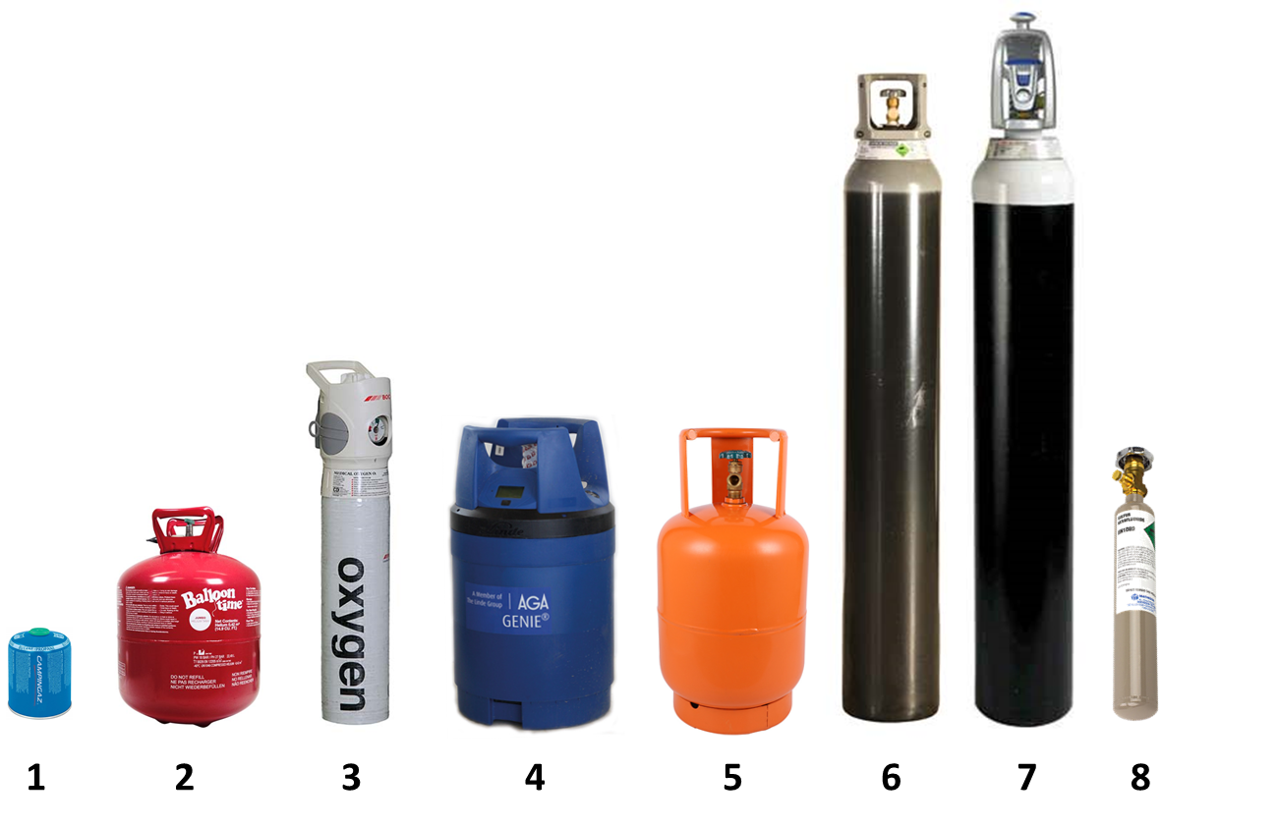
- Camping gas fuel canister
- Balloon gas canister
- Medical oxygen cylinder
- “Genie” portable gas cylinder
- LPG cylinder (propane)
- Standard compressed gas cylinder
- EVOS high pressure cylinder (300 bar)
- Typical lecture bottle

Appendix 2: Cylinder Identification
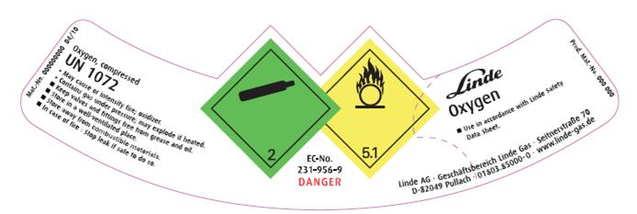

Figure 1: Typical cylinder collar label showing contents and warning signs (Linde / BOC)

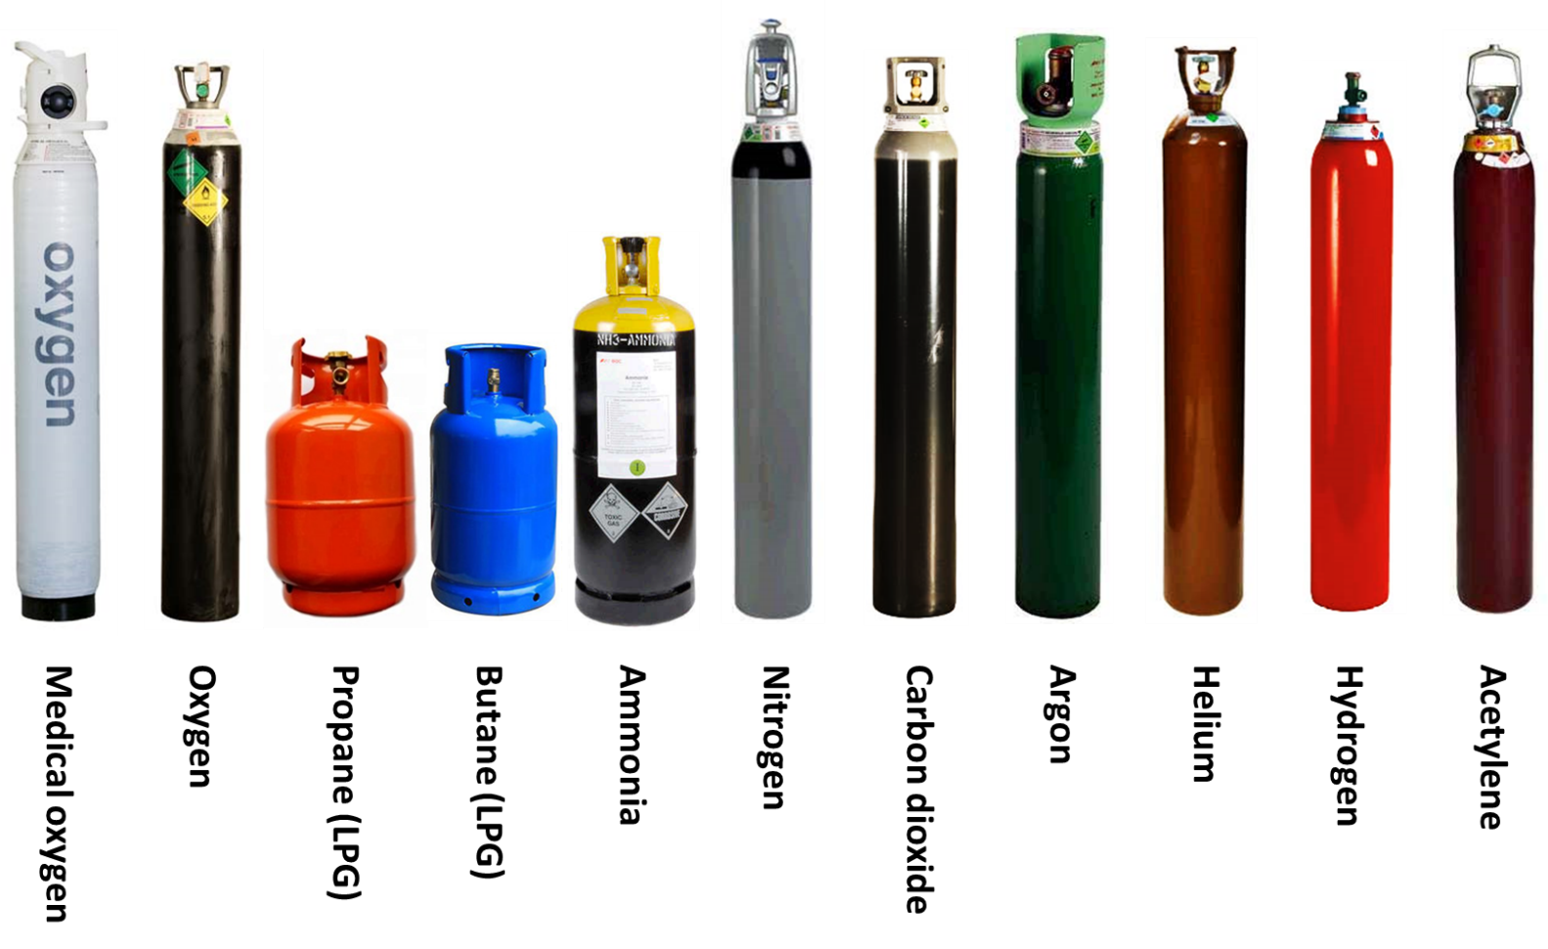

Figure 2: Standard cylinder colours for some common gases (BOC)

Appendix 3: Example warning signs

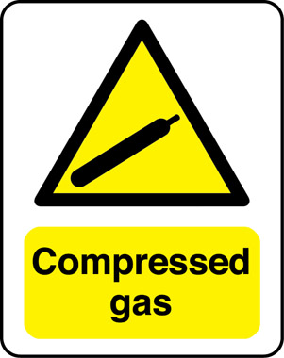

Figure 1: Typical warning signs used at the entrance to laboratories or workshops.

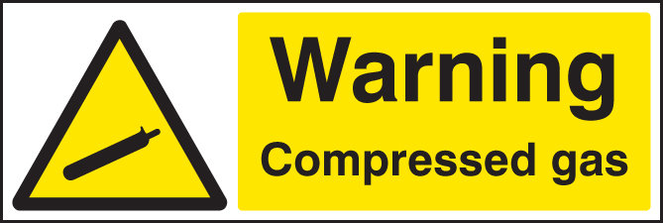

Figure 2: Variant warning signs for inert and flammable compressed gases in laboratories or workshops.

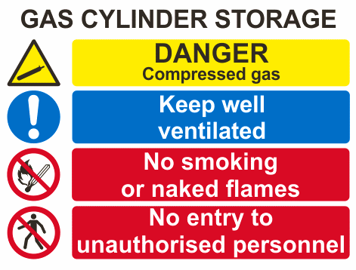

Figure 3: Example of warning signage suitable for bulk storage areas including cylinder pounds.

Appendix 4: Example gas cylinder storage area

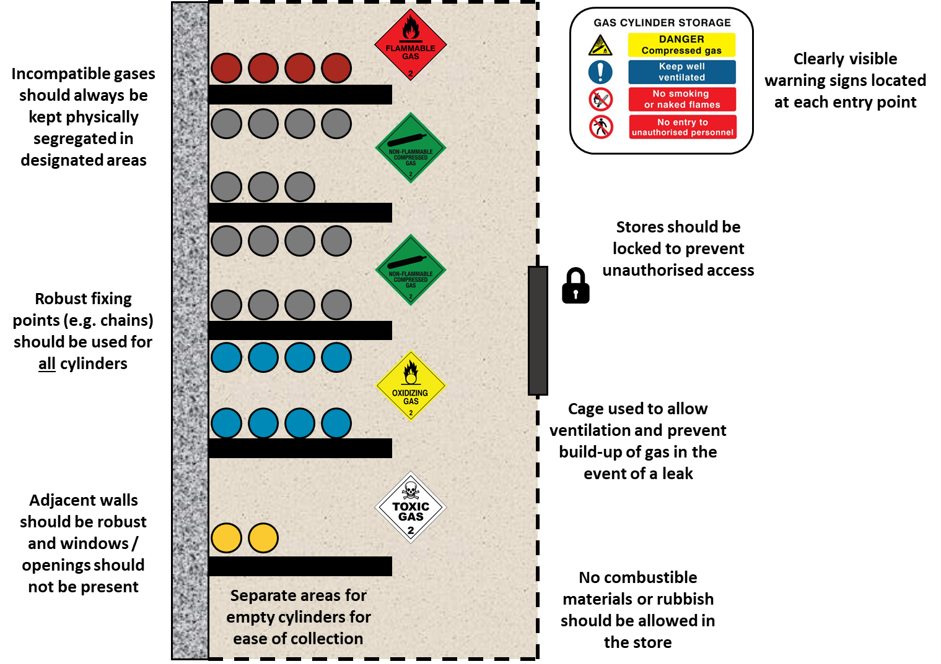

Appendix 5: Gas regulator pre-use checklist
Before a regulator is attached to a gas cylinder it should be visually checked by the user to make sure it is in good condition and is suitable for the application. The following checklist should help to make sure that all of the relevant checks have been completed. If the regulator fails any of the checks below it should not be used:
- Check that the regulator is the correct type for the gas cylinder valve (i.e. top or side fitting)
- Check that the regulator is clearly marked with the correct gas for which it is to be used. Regulators should not be interchanged between cylinders of different gases
- Check the age of the regulator, it should not be more than five years old from the date of manufacture (even if the regulator has not been used)
- Check that the maximum inlet pressure of the regulator is sufficient for the pressure of the gas in the cylinder to be used
- Check that the maximum output pressure of the regulator is suitable for the required application
- Check that the manufacturer’s name/logo is visible, and the regulator is from a reputable supplier
- Ensure the pressure adjusting screw is captive on the regulator (attached when fully unscrewed)
- Check the inlet and seat for signs of contamination or damage
- Check there is no damage to the inlet or outlet threads
- Check that the inlet is at 90° to the body of the regulator
- Check that the regulator is clearly marked with correct standard (EN ISO 2503)
- Check the body of the regulator for damage
- Check that the HP nut is in place and in good condition (do not tamper with or unscrew the nut)
- Check the pressure relief valve (where fitted) is in good condition
- Check the gauges are in good condition with no damage to the front or back
- Check that the gauge needles are undamaged and resting at zero on top of the rests.
- No evidence of modifications and/or repairs to the regulator

Note: The BCGA recommend that regulators that are more than five years old should not be used even if they have only been used for inert gases or have been in storage for part of that time.
Note: Regulators should be formally inspected by a competent person on an annual basis to ensure that they remain fit for use. Note that the above checklist should not be considered a substitute for this annual examination.

