Design and Location of Compressed Gas Cylinder Storage Areas
1 Introduction
Compressed gas cylinders are used routinely across the University of Glasgow in research, teaching and a wide range of other activities, with over four hundred gas cylinders present across the organisation at any given time. Gases can pose a risk to staff and students if they are released into the workspace through leaks from poorly sealed pipework, badly designed or faulty equipment or poor working practices. Gases can cause harm to individuals based on their physical and chemical properties:
- Simple asphyxiants (e.g. helium, nitrogen, argon) can displace oxygen from the air leading to a risk of asphyxiation in poorly ventilated spaces.
- Flammable gases (e.g. hydrogen, methane, propane) pose a risk of fire or explosion if they encounter a potential ignition source.
- Toxic gases (e.g. ammonia, chlorine, hydrogen cyanide) interact with the normal functioning of the body potentially causing ill health, injury or even death depending on the level and duration of exposure.
- Pyrophoric gases (e.g. silane) which may spontaneously ignite when released into the air leading to a risk of fire along with any other hazards such as toxicity.
Gas cylinders come in all shapes and sizes from 300bar EVOS cylinders containing large volumes of gas to small lecture bottles which may only contain a few litres. This paper will cover the safety aspects of storage of gas cylinders in dedicated storage areas with a focus on designing gas cylinder stores to ensure adequate ventilation and has been developed based on the recommendations in the BCGA Code of Practice 44 The storage of gas cylinders (Revision 1: 2022). CP44 was developed by BCGA technical experts and represents industry best practice. For our purposes we will consider the following four categories of gas cylinders:
- Full gas cylinders that are not currently in use and are in storage as “stock” ready for transportation to the point of use (such as a laboratory or workshop) or connection to an external gas supply manifold.
- Gas cylinders stored in a dedicated area and connected to a gas manifold which in turn supply building gas distribution systems, pieces of equipment in laboratories / workshops etc.
- Full (or partially full) cylinders stored in laboratories or other workspaces which are connected to pieces of equipment or used to supply specialist gases for chemical processes.
- Empty gas cylinders which are in storage pending removal from site by a specialist company (e.g. BOC). Note that cylinders are rarely truly “empty” and some residual gas is usually present within.
2 Requirements for Outdoor Gas Storage Areas
Ensuring adequate ventilation in gas storage areas should be a priority to minimise the risk of a harmful build-up of gas in the event of a leak or other unplanned release of gas. Guidance on the design and location of gas cylinder storage facilities can be found in the BCGA publication Code of Practice 44 The Storage of Gas Cylinders” (CP44). This document strongly recommends against locating gas cylinder stores inside buildings to reduce the risk to individuals working in the area in the event of a leak. The following principles are taken directly from CP44:
- Compressed gas cylinder stores should be located outdoors (where this is not possible other control measures will be required)
- The cylinder store should be well-ventilated.

- The store must have adequate security to manage access.
- The store should meet required separation distances (see CP44 section 5.4).
BCGA CP44 sets out strict criteria as to what is required for a gas cylinder store to be considered “outdoors”. To qualify, one of the following two conditions must be met:
  - A minimum of 30% of the perimeter area of the store must be open (i.e. naturally ventilated) where a cylinder store does not have a roof.
Or
  - A minimum of 50% of the perimeter area is open (naturally ventilated) where the cylinder store includes a roof.
In each case there is a need to ensure adequate through and thorough ventilation meaning that “open” sides of a cylinder store must present no obstacle to the free flow of air and may consist of chain-link fencing, bars/grilles, louvred doors / walls etc. Nearby buildings, walls and other obstructions may affect the free flow of air and should be considered when designing a gas cylinder store.
3 Requirements for Internal Gas Storage Areas
Internal (non-outdoor) storage facilities can be used but these are not recommended and should be avoided where practical. Internal storage areas can present significant risks to individuals and property in the event of a leak / release of gas including (but not limited to) the risk of death by asphyxiation, fire and explosion and in some cases may meet the definition of a “confined space” requiring a more robust risk assessment. The technical requirements of designing and maintaining an indoor gas cylinder store (especially one that relies on mechanical ventilation systems) which is both compliant and safe can be very demanding and potentially more expensive than a comparable, naturally ventilated outdoor facility.
Any internal gas cylinder storage area should be subject to a suitable and sufficient prior risk assessment to ensure that the associated hazards have been identified and the risks can be adequately controlled. The following considerations should be included in the risk assessment for an internal cylinder storage area:
- Proposed location of the store and the infrastructure requirements
- An assessment of the ventilation and atmospheric monitoring requirements
- Determination of which people (groups and individuals) may be at risk from the hazards of the store and associated operations.
- Impact on the store from other unrelated activities and hazards
- The logistics of moving cylinders
- Hazardous properties of the gas and quantities present
- Suitable segregation of incompatible gases
- Appropriate hazard warning signage
- Security of the store and provision of access to delivery drivers out of hours
- Provision of separate storage facilities for LPG cylinders. HSE guidance indicates Flammable liquids, combustible, corrosive, oxidising materials, toxic materials and compressed gas cylinders should be kept separate from LPG containers in general.
4 General Principles of Gas Cylinder Storage
The most suitable location for a gas cylinder storage area is outside in the open air in a location with good natural ventilation. This prevents a build-up of gas in the event of a leak or unplanned release as any gas which does escape will quickly become diluted as it mixes with fresh air minimising the risk from asphyxiant, flammable or toxic gases.

The presence of adjacent walls and building can influence the efficiency of ventilation and will need to be considered when designing the storage area. The following should also be considered:
- Cylinder stores should not be located in low-lying areas where gases may accumulate, gases that are heavier than air may accumulate and persist in low lying areas such as basements, drains and sewers.
- While good drainage is desirable, it is better if drains are not located inside gas cylinder stores to prevent accumulation of gases in drains and associated pipework. Standing water in gas cylinder stores can increase the risk of corrosion of cylinders as well as introducing a slip hazard and stores should be designed to eliminate this where possible.
- Outside cylinder stores should be located away from emergency exits to reduce the risk of such areas being compromised in the event of an accident. In turn it should always be possible for an individual to escape from the store easily in the event of an emergency.
- While gas cylinders are designed to withstand the elements, weatherproofing should be present where practical to reduce the impact of wind, rain etc. on cylinders. Roofs should allow adequate ventilation and not give rise to a risk of gas accumulation in the event of a leak with sloping roofs being the best choice. Peaked roofs, lean-tos and any roofed storage area should include a means of gas escape such as a hole or vent at the peak of the roof or intersection with a wall.
- The cylinder store should be level, accessed via a step-free route and provide ease of access for both users and delivery / collection drivers. Cylinder stores should be placed such that delivery vehicles can access them easily and have sufficient space for loading and unloading safely.
- Gas cylinder stores should be clearly signed to indicate the presence of gases, entry requirements and should be clearly identified as no-smoking areas (even when only non-combustible gases are present).
- Gas cylinder stores should be locked to prevent unauthorised access. To allow for deliveries and collection of empty cylinders, stores are often locked with a combination padlock or equivalent with the code being provided to the delivery company.
- Adequate lighting should be provided to ensure the safety of staff and students working with cylinders when the light level is low e.g. during the winter months. Lighting should be adequate to allow easy identification of cylinders and facilitate safe delivery and removal of cylinders by delivery drivers. Where combustible gases are present, a DSEAR risk assessment should be undertaken to consider the possibility of fire and explosion and the need for additional control measures (e.g. ATEX rated electrical installations).
5 Recommendations for Design And Location of Compressed Gas Storage Facilities
- The preferred option when designing a compressed gas cylinder storage facility is to ensure the store is located outdoors in a well-ventilated space. Traditionally compressed gas cylinders are stored in open caged areas to allow a free flow of air through the store, examples can be seen in photographs 1 and 2. While aesthetically not very pleasing “cylinder pounds” of this type offer the safest solution. Stores of this type can be partially disguised by thoughtful design and use of materials such as louvred walls / doors creating an open (unroofed) compound (see photograph 8). Smaller cylinder cages (photograph 3) can be used to store small numbers of cylinders and to provide adequate storage for gases such as LPG which require separate storage facilities.
- As an alternative to a traditional fenced “cylinder pound” prefabricated, modular cylinder containers can also be used (see photograph 4) as either a temporary or long-term storage facility. Containers may be considered as outdoors or indoors dependent on the percentage of the perimeter open to the elements and the presence or absence of a roof. Containers meeting the criteria for an “outdoor” storage facility should be used wherever possible.
- It may be possible to create a facility that technically meets the definition of an “outdoor” store given in BCGA CP44 but which is located within the footprint of a building allowing adequate natural ventilation

- through the facility due to the use of fencing, barred areas, louvred walls etc. (see photographs 5,6,7,8). Note that facilities of this type will require a minimum percentage of the perimeter to be “open” as noted in Section 2 and should only be considered where an “outdoor” store cannot be accommodated.
- Cylinder stores located inside a building with no source of natural ventilation should be avoided where possible, this includes stores forming part of facilities fully located inside a building such as loading bays etc. (see photograph 5 for an example of an internal store based on the criteria set out in CP44). Facilities of this type are much more likely to pose a risk to occupants, users and infrastructure in the event of a fault or failure and will often require complex mechanical ventilation and gas monitoring systems to fully control the risk.
- In previous versions of BCGA CP44 a hierarchy of internal storage locations was included and while this is not included in the latest version of the code of practice it is still a useful guide to the suitability of potential storage solutions. The hierarchy recommends the following options (in order of suitability):
- Outdoor, naturally ventilated storage facility (e.g. cylinder pound).
- Bespoke stand-alone dedicated, adequately naturally ventilated building.
- A dedicated room, sealed from the rest of the building, adequately naturally ventilated to the outside and only accessible from an external door.
- A dedicated room, adjacent to an outside wall, inside a building, adequately naturally ventilated to the outside, sealed from other areas of normal occupancy.
- A dedicated room, inside a building, with forced air ventilation, sealed from other areas of normal occupancy.
- In a building, as far as is practicable away from normal work locations.
- Where practical, gas cylinders connected to building, laboratory and equipment gas supplies that are in use or stored for ready use should be sited externally to the building and piped to the point of use via a suitable manifold including regulators, safety devices etc. This reduces the number of cylinders which need to be housed inside the building and the risk of a leak, fault or failure inside the workplace. Examples of this are common on campus (see photographs 2 and 4).
- Where gas manifolds are used, care should be taken to ensure these are covered by a Written Scheme of Examination under PSSR which may specify the need for safety devices and other equipment to be subject to a regular Thorough Examination and Test (TExT) by a competent person (this is currently undertaken on our behalf by Zurich Engineering).
- Storage of individual gas cylinders inside laboratories and workspaces can be permitted where other alternatives are not practical although this should be subject to a robust risk assessment. Storage of excess or “stock” gas cylinders inside laboratories and workshops should not be permitted with only the minimum number of gas cylinders necessary permitted in the workspace. Gas cylinders in workspaces should be properly secured and appropriate signage present at the points of access to indicate the presence of cylinders in the area.
- Safe use of gas cylinders in the workplace will often require the use of specialised safety equipment e.g. gas detection systems, oxygen depletion monitors, mechanical ventilation systems etc. and adequate provisions should be made for any required safety systems. This should include arrangements for ongoing inspection, testing and maintenances that may be required.

6 References
- BCGA Code of Practice 44 “The Storage of Gas Cylinders” Revision 1: 2022
- SEPs GN-CHEM09 Pressure Systems
- SEPS GN-CHEM19 Compressed Gases

Dr Philip JA Rodger
University Chemical Safety Adviser
Safety and Environmental Protection Service
Appendix: Digital Photographs
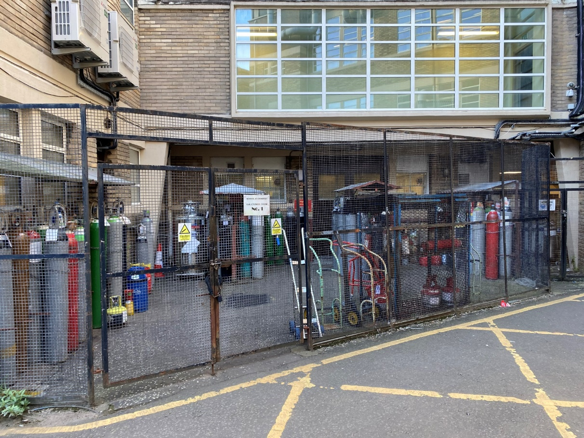
Photograph 1: Outdoor, naturally ventilated cylinder store (Joseph Black Building)
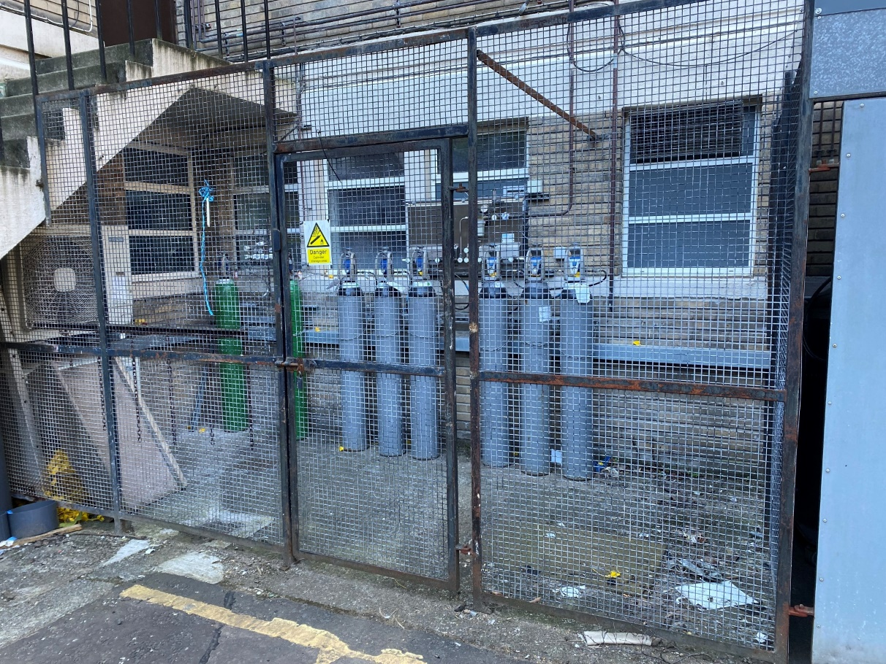
Photograph 2: Small outdoor, naturally ventilated cylinder store and manifold (Joseph Black Building)

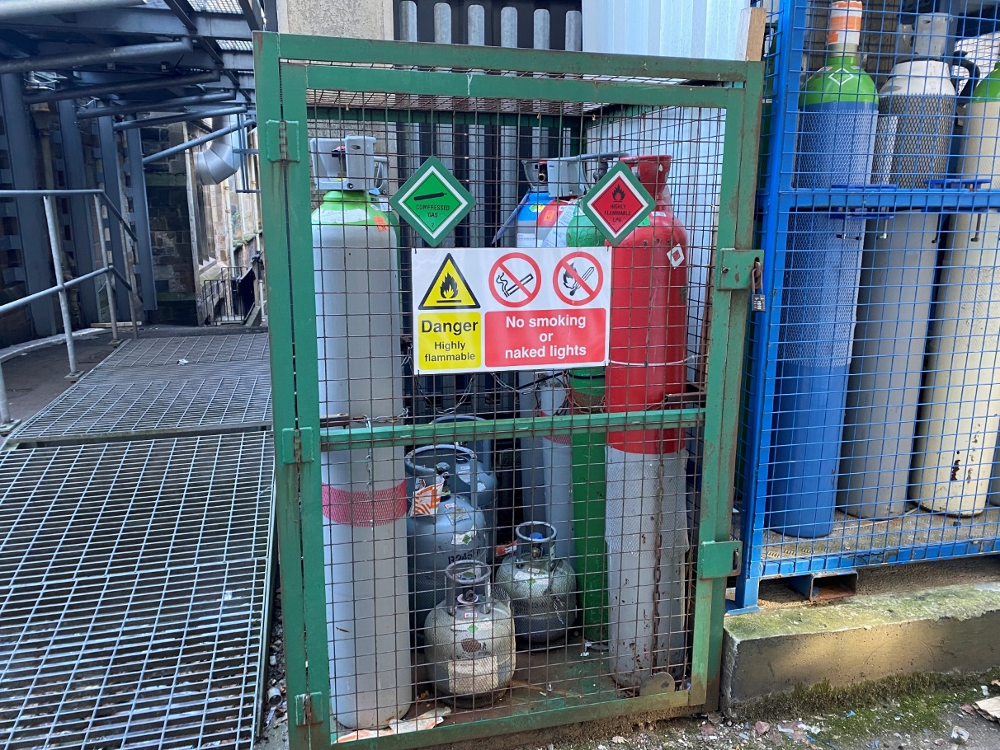
Photograph 3: Typical outdoor, naturally ventilated cylinder cage (James Watt South Building)
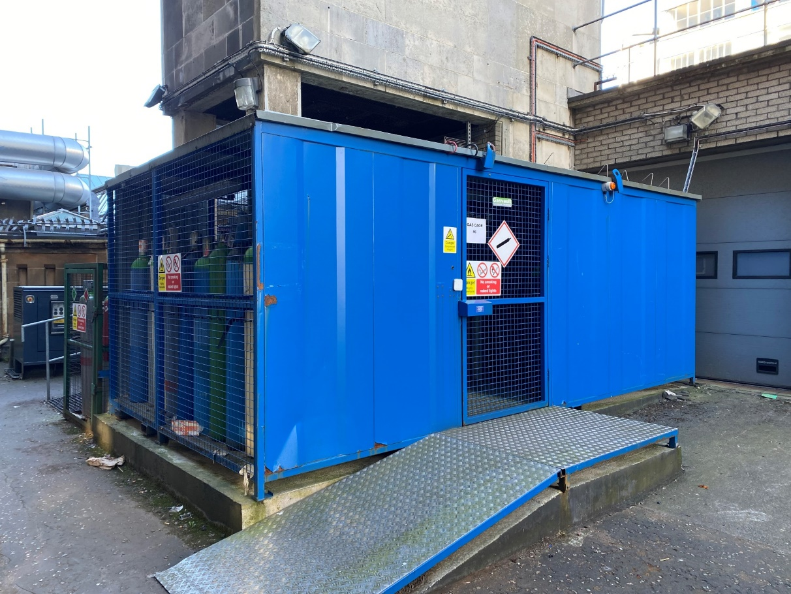
Photograph 4: Modular outdoor, naturally ventilated cylinder store with manifolds (James Watt South Building)

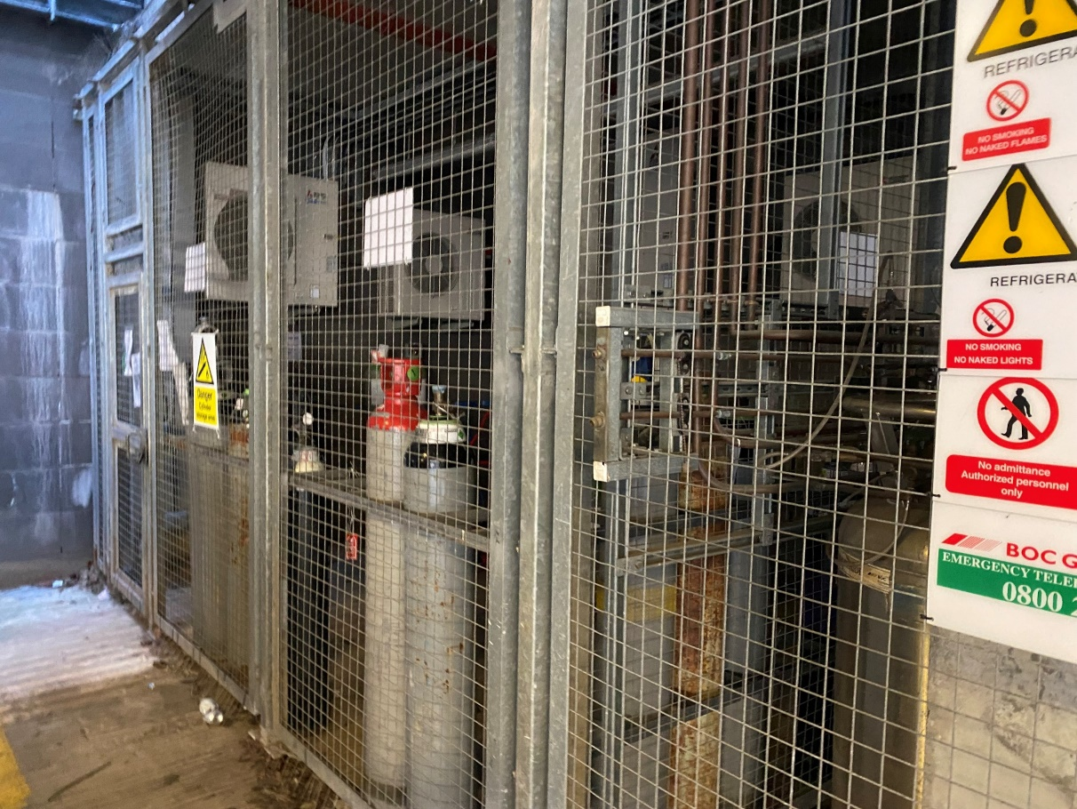
Photograph 5: Outdoor, naturally ventilated cylinder store in car park area (Sir Graham Davies Building)
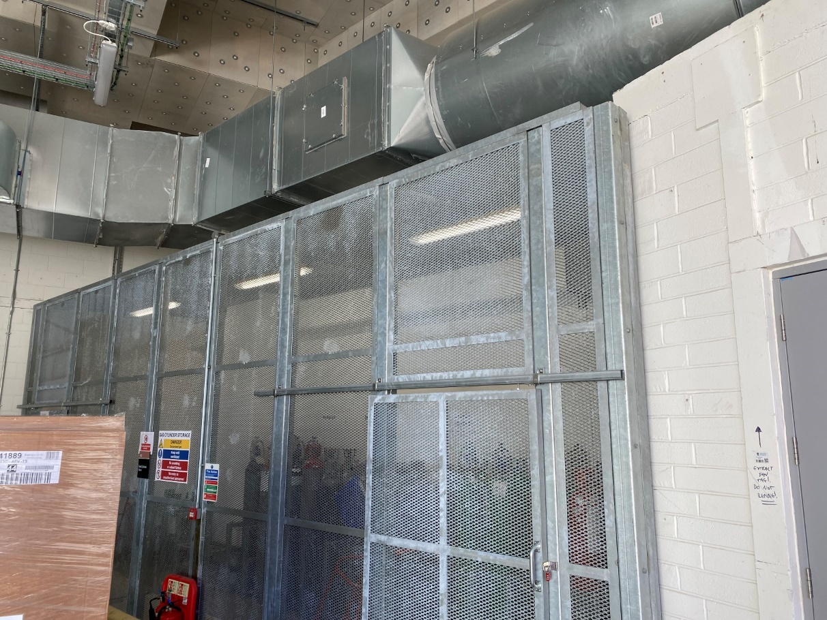
Photograph 6: Indoor, naturally ventilated cylinder store (ARC, Loading Bay)

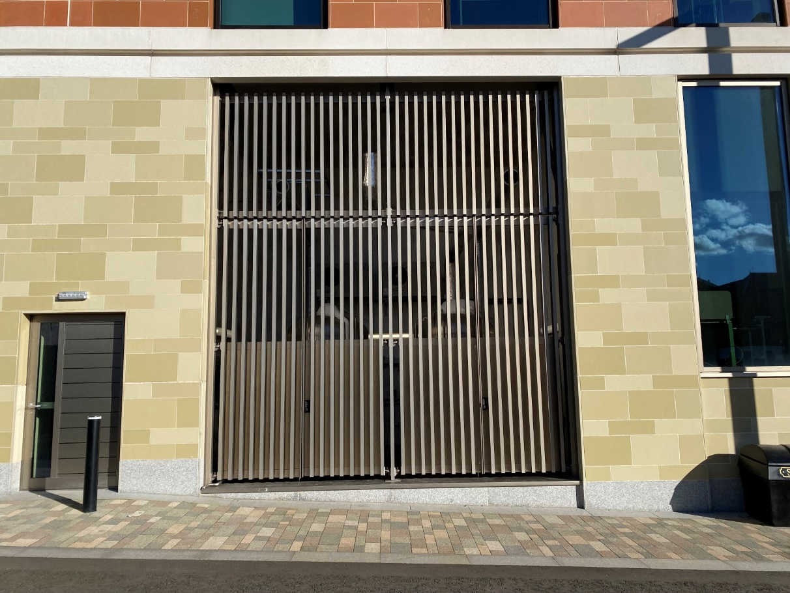
Photograph 7: Indoor, naturally ventilated liquid nitrogen store within building footprint (ARC)
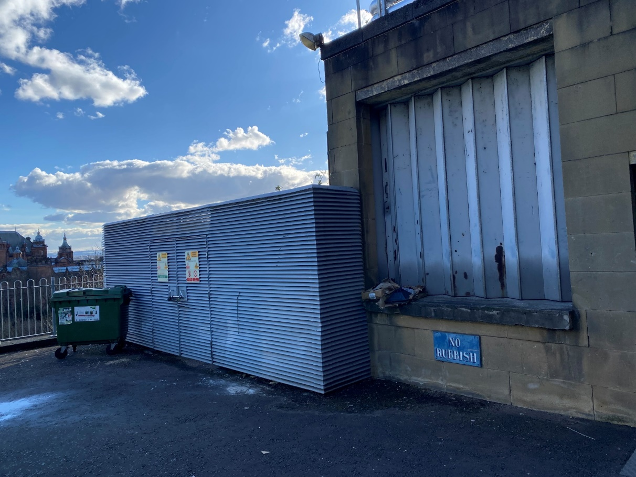
Photograph 8: Outdoor, naturally ventilated cylinder store in separate structure (Davidson Building)

