Life Sciences Preferred Email Signatures

To add our new email signature, please follow this eight-step guide:

- Open your email account using the Outlook app

- Click the ‘home’ tab at the top left of the page

- Click ‘New Email’

- Click ‘signature’

- From the drop down menu, click ‘signatures…’

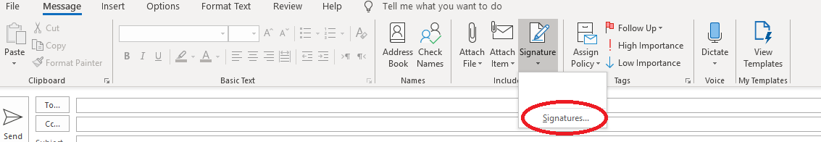

- Click ‘New’ from the four grey buttons

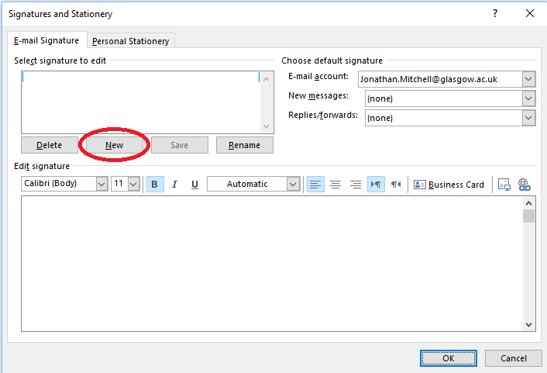

- Copy and paste the text and images from one of the signature variants (see a-f) and paste into the empty signature box:
You must copy the signature directly from this document

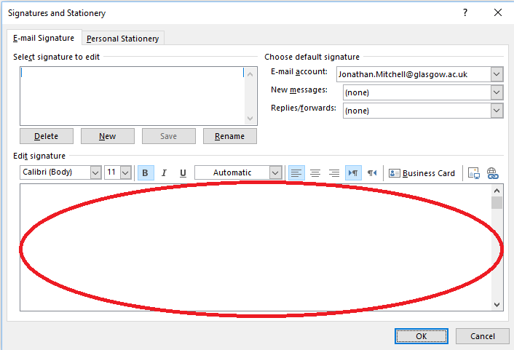

a) Original
b) With flexible working hours note
c) With British Sign Language link
d) With Pronouns/Name Pronunciation

a)

Jonathan Mitchell

Information & Media Officer
Life Sciences Undergraduate Office
College of Medical, Veterinary and Life Sciences
University of Glasgow
Charity number SC004401
Room 335, Sir James Black Building
Tel: +44 (0)141 330 3402

b)

Jonathan Mitchell

Information & Media Officer
Life Sciences Undergraduate Office
College of Medical, Veterinary and Life Sciences
University of Glasgow
Charity number SC004401
Room 335, Sir James Black Building
Tel: +44 (0)141 330 3402

If this email has been sent outside normal working hours, a response is not expected until you return to work.

c)

Jonathan Mitchell

Information & Media Officer
Life Sciences Undergraduate Office
College of Medical, Veterinary and Life Sciences
University of Glasgow
Charity number SC004401
Room 335, Sir James Black Building
Tel: +44 (0)141 330 3402

d) To create your own name pronunciation, visit: https://namedrop.io/#signup

Jonathan Mitchell (he/him) (pronounce)

Information & Media Officer
Life Sciences Undergraduate Office
College of Medical, Veterinary and Life Sciences
University of Glasgow
Charity number SC004401
Room 335, Sir James Black Building
Tel: +44 (0)141 330 3402

- Now, personalise with your own contact details, and then click ‘OK’

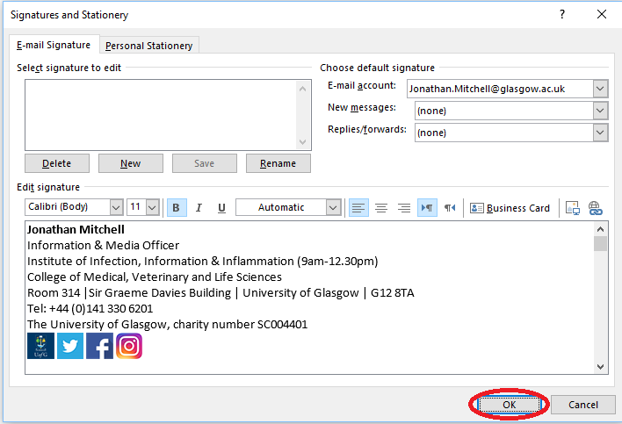

If you have any problems or questions, or would like to request a new variant, please don’t hesitate to contact me by emailing jonathan.mitchell@glasgow.ac.uk.

